TERMS OF REFERENCES

Consultancy Services for the Design and Development of a Bespoke Laboratory Information Management System (LIMS)

Client: Ministry of Environment, Waters, and Forests - Project Management Unit

Country: ROMANIA

Project: Prevention and Reduction of Pollution in Rural Areas Project (RAPID)

Date: July ……., 2025

- Background
Romania has received a loan from the International Bank for Reconstruction and Development (IBRD) to support the implementation of the Rural Pollution Prevention and Reduction Project (RAPID Project).
The Romania Rural Pollution Prevention and Reduction Project is an initiative aimed at addressing environmental challenges in the rural areas of Romania. Focused on mitigating pollution and promoting sustainable practices, this project seeks to safeguard the country's rural landscapes, preserve natural resources, and enhance the overall well-being of local communities.
The Loan 9505-RO for the Project was ratified by Romania by the Law no. 332/2023 on November 7th, 2023, and it became effective on December 13th, 2023. The project closing date is June 30th, 2028.
The National Administration "Romanian Waters" (NARW) currently operates a network of forty-two (42) laboratories, organized into regional or basin-level laboratories under the Water Basin Administrations, along with local laboratories overseen by Water Management Systems. This network includes one National Water Quality Laboratory, three Regional Water Quality Laboratories, eight Basin Water Quality Laboratories, and thirty Local Water Quality Laboratories. The Ministry of Environment, Waters, and Forests, through its Project Management Unit for the "Prevention and Reduction of Pollution in Rural Areas Project" (PMU "RAPID")—referred to as The Beneficiary—plans to allocate a portion of the RAPID Project funds to support consultancy services. These services will focus on developing a Laboratory Information Management System (LIMS) to digitally streamline and centralize operations across all NARW laboratories, which referred to as The Beneficiary.

Stakeholders:
- Primary Stakeholders:
  - Beneficiary (NARW and ABAs): The National Administration of Romanian Waters (NARW) and its associated Basinal Water Administrations (ABAs) are the primary stakeholders. They will use LIMS to improve laboratory processes, manage inventory, and ensure regulatory compliance.
  - Laboratory Personnel: Laboratory managers, operators, and analysts who will directly interact with LIMS for sample tracking, data analysis, and reporting.
- Secondary Stakeholders:
  - IT Department (NARW): Responsible for maintaining IT infrastructure, integrating the LIMS with existing systems (e.g., ASIS, ECA-RO, Active Directory, Exchange), and ensuring security and compatibility.
  - Compliance and Quality Assurance Teams: Ensure the LIMS meets regulatory standards and facilitates audit trails, traceability, and data integrity.
  - Management and Decision-Makers: Oversee the implementation process, approve budgets, and monitor contract performance.
  - Consultant (System Consultant): Provides the LIMS, manages implementation, and ensures the system aligns with the contractual requirements and technical specifications.
- External Stakeholders:
  - Regulatory Authorities: Require the LIMS to comply with local and international regulations related to water quality and laboratory management.
  - Consultants/Partners: Provide hardware, software, and other components necessary for LIMS deployment.

Acronyms Used in These Technical Requirements
Term | Description
RAPID | Romanian Rural Pollution Prevention and Reduction Project
The Project | the Rural Pollution Prevention and Reduction Project, referred to as the "RAPID" Project
MEWF | Ministry of Environment, Waters and Forests
ADR | The Authority for the Digitalization of Romania
PMU | Project Management Unit represents the unit established within the Ministry of Environment, Waters and Forests, which manages the implementation of the Rural Pollution Prevention and Reduction Project
NARW | Represents the institution of the National Administration "Romanian Waters".
Beneficiary | Represents the final beneficiary, the National Administration "Romanian Waters" (“ANAR” in Romanian) as institution.
ESMP | Environmental and Social Management Plan elaborated for each beneficiary
LIMS | The Laboratory Information Management System project intended for implementation across all NARW laboratories.
The Contract | Outlines the agreement to be signed with the selected Economic Operator, referred to as the Service Provider or Consultant.
The Consultant/ Consultant (System Consultant) | Refers to an individual entity or a joint venture partnership of two or more entities collaborating under a formal agreement to fulfill contractual obligations. In a joint venture, members share responsibilities, resources, risks, and outcomes to deliver the agreed-upon services.
Client (interchangeably also called Client) | The term refers to the organization or entity responsible for initiating, managing, and overseeing a procurement process, such as the acquisition of goods, services, or works. In this case, the Client is the Ministry of Environment, Waters and Forests through the RAPID Project Management Unit
ABA | Basinal Water Administration (or “Administraţia Bazinalǎ de Apǎ” in Romanian) unit within NARW organization.
SGA | Represents the Water Management System (or "Sisteme de Gospodărire a Apelor") unit within NARW organization.
LRCA | The Regional Water Quality Laboratory, referred to as "Laboratorul Regional de Calitatea Apei" in Romanian, is a unit within the NARW organization. Currently, there are only four (4) laboratory units known as LRCA.
LCA | The Water Quality Laboratory, known as “Laboratorul de Calitatea Apelor” in Romanian, is a unit within the NARW organization. These laboratories may be subordinate to either the ABA or SGA. For details on the distribution of units within the organization, please refer to Annex 1 documentation.
LNCA | The National Laboratory, known as “Laborator Naţional” or “Laborator Naţional de Calitate a Apei” in Romanian, serves as the central laboratory unit under the River Basin Administration (ABA) for Ilfov County, within the NARW organization.
SGA GRA | Represents the Water Resources Management, Monitoring, and Protection Service unit within the NARW organization, specifically for the Water Management System (SGA).
ABA GMPRA | Represents the Water Resources Management, Monitoring, and Protection Service unit within the NARW organization, specifically for the River Basin Administration (ABA).
Central GMPRA | Represents the Water Resources Management, Monitoring, and Protection Service central unit within NARW organization.
SCAR | Represents Central Headquarters of Romanian Waters (NARW).
ASIS | Represents the existing financial IT system implemented and managed independently by each ABA unit.
ECA-RO | Represents the current IT system operated by the Central GMPRA unit, which will function as the client for future LIMS by placing internal orders.
MO | The Annual Operating Manual ("Manual de operare"), defined by the monitoring units, outlines all internal sampling and analysis orders on an annual basis.

- Objective(s) of the Assignment
The objectives of the project are to strengthen the institutional capacity of selected public entities, monitor pollution in agriculture, and transfer knowledge on agricultural pollution reduction to participating farmers. The project consists of three components:
- Modernization of Public Institutions: Enhance the institutional capacity of the Ministry of Environment, Waters, and Forests (MMAP) to monitor, evaluate, and report investments, including those related to environmental aspects of the National Recovery and Resilience Plan (NRRP). This involves increasing the national capacity for monitoring, prevention, and reduction of pollution from agricultural sources in rural areas, including the National Administration "Romanian Waters" (ANAR), the National Phytosanitary Authority (ANF), and the Directorate for Land Consolidation and Land Fund (DÎFFF) within the Ministry of Agriculture and Rural Development (MADR).
- Knowledge Exchange and Awareness: Facilitate knowledge exchange, awareness, and information/innovation transfer to participating farmers. This includes establishing role model farms to promote the best agricultural practices for pollution prevention and reduction, farms that will be supported by the RAPID Project through grants. The project also involves creating national knowledge transfer networks and conducting information and awareness campaigns for the public regarding project activities, including other environmentally focused interventions funded under NRRP.
- Project Management: Ensure effective project management to oversee and coordinate the various components and activities outlined in the project.

Specifically, this project aims to develop or enhance an existing Commercial Off-The-Shelf (COTS*) application into a modern, cloud-based Laboratory Information Management System (LIMS) for the National Administration “Romanian Waters” (NARW). The goal is to digitalize, standardize, and optimize the full range of laboratory activities while ensuring compliance with ISO/IEC 17025:2017.
The system will streamline laboratory operations, reduce manual processes, and support NARW laboratories in generating accurate, traceable, and timely reports through a fully integrated digital data framework. This will be achieved through the following key outcomes:
- Operational Efficiency – Automation and optimization of laboratory workflows to reduce effort and increase throughput.
- Data Reliability – Generation of high-quality, consistent, and validated data for internal use and external reporting.
- Traceability – End-to-end visibility and auditability of laboratory activities, from sample registration to result distribution.
- System Integration – Seamless data exchange and interoperability across laboratory instruments, internal IT systems (e.g., ASIS, ECA-RO), and the central NARW infrastructure.
Note*: If the proposed system is based on a Commercial Off-The-Shelf (COTS) platform, all custom workflows and functionalities must be developed to fully meet the Beneficiary’s requirements. The source code for all custom developments will be owned by NARW. The ConsultantConsultant must also provide a perpetual, unrestricted license for the COTS platform, with no limitations on the number of users or workflows.

The project is structured around the following key objectives:
- Comprehensive Digital Management of Laboratory Activities
  - Develop and deploy a unified digital platform to manage all core laboratory processes, including the intake and scheduling of orders, sample registration, assignment of analyses, result capture, validation, and report distribution.
  - Enable real-time monitoring of sample progress and data access across all NARW Water Quality Laboratories.
- Standardization and Automation of Laboratory Workflows
  - Automate essential workflows—from sample collection to result reporting—tailored to various types of water samples (e.g., wastewater, groundwater, river/lake water).
  - Support consistency, accuracy, and process efficiency by replacing manual tasks with standardized, digital procedures.
- Advanced Inventory and Resource Management
  - Implement a centralized system for tracking laboratory materials, consumables, and equipment.
  - Integrate with the ASIS financial system to ensure accurate resource planning, minimize shortages, and reduce waste.
- Integration with Existing IT Ecosystem
  - Ensure seamless interoperability with internal systems such as:
    - ECA-RO – for automated registration of annual test orders and structured transfer of test results.
    - ASIS – for inventory and procurement alignment.
    - SCAR (Central Data Center) – for secure data storage, system backup, and enterprise connectivity.
  - Support integration with laboratory instruments to automate data capture, reduce errors, and enhance traceability.
- Strengthen Compliance with SR EN ISO/IEC 17025:2017 and Internal Standards
Ensure that the Laboratory Information Management System (LIMS) fully aligns with the ISO/IEC 17025:2017 accreditation requirements* and NARW's internal procedures. This includes key processes such as "Analysis of Requests, Offers, and Contracts," "Sampling," "Handling of Test Objects," "Reporting of Results," and "Control of Records." Full alignment with these standards will help maintain comprehensive regulatory and procedural compliance across all NARW Water Quality Laboratories.
*For practical guidance on implementing compliant data control and information management systems, see Annex 8 representing sample of ensuring conformity with ISO/IEC 17025:2017 standard, clause 7.11 which quotes chapter 7.11 LIMS requirements under ISO/IEC 17025:2017.
- Robust Data Integrity, Validation, and Reporting
  - Provide mechanisms for traceable, accurate, and verifiable data handling throughout the testing lifecycle.
  - Implement electronic validation and approval workflows to ensure data is reviewed and released in accordance with quality and regulatory standards.
  - Facilitate automated generation and distribution of customizable, standardized reports.
- Cloud-Based, Scalable, and Secure Architecture
  - Host the LIMS in a secure and high-performance cloud infrastructure, compatible with the ADR Government Private Cloud (based on Microsoft Azure Stack Hub) or an equivalent environment.
  - Collaborate with NARW to size and design the IaaS-based (virtual-machine) cloud environment in which LIMS will be hosted.
  - Consultant’s role is limited to defining the technical parameters (CPU, RAM, storage, network, security controls, etc.) required by the LIMS and verify and validate compatibility with ADR Government Private Cloud (based on Microsoft Azure Stack Hub) or equivalent.
- Training, Support, and Long-Term Sustainability
  - Deliver structured training sessions for laboratory personnel to ensure effective system usage and compliance awareness.
  - Provide go-live support and a 20-months maintenance and support period, covering system optimization, troubleshooting, and ongoing enhancements.

- Scope of Services, Tasks (Components) and Expected Deliverables

Business Requirements to Be Met by the System
The purpose of this section is to provide an overview of the future Laboratory Information Management System (LIMS) modules requested for implementation by the Consultant, tailored to meet both current and future requirements as agreed upon with the Beneficiary during the analysis phase.
The future LIMS for NARW laboratories shall include and integrate, as necessary, and without being limited to, the several key functions to streamline laboratory operations. This may include, as needed, managing material and equipment inventories, either directly extracted from the financial IT solution or imported through predefined templates, registering internal orders via the annual operating manual or between laboratories, and recording analysis requests from external clients. The system shall include, as necessary, the handling and scheduling of orders and sample collections, track requested and collected samples, manage sample analysis, and ensure the determination, validation, and approval of results in compliance with regulations. The system will conclude by generating reports and delivering digital results, ensuring efficient, traceable, and compliant laboratory workflows, with the option to export the data into the existing NARW IT system, ECA-RO.
It is acknowledged that the future elements of the proposed Laboratory Information Management System (LIMS) are intended solely for informational purposes. Their definitions may be revised by mutual agreement among the parties involved, following a thorough business analysis conducted by the Consultant.
Any deviation/alternative solution from/for the requirements presented in this Terms of Reference can be accepted by the Client based on arguments clearly presented in the progress reports by the Consultant, with prior approval / request by the Client. Proposals intended to enhance or optimize the Consultant’s IT system must be formally submitted for review, including an assessment of implementation effort and impact on project objectives. Approval from all relevant parties is required, as long as the proposed changes contribute positively to the project's success.
The future Laboratory Information Management System (LIMS) shall include, as needed and without being limited to, the following IT components detailed below, along with their interoperability with existing NARW IT systems, such as ASIS, ECA-RO, and existing identity and mailbox systems:
- Master Data Management (1)
- Laboratory Administration (2)
- Laboratory Inventory (3)
- Laboratory Analytical Equipment (4), which may be part of Laboratory Inventory
- Laboratory Orders Management (5)
- Laboratory Workflow (6)
- Document Manager (7)
- Alerts & Notifications (8)
- Audit trial (9)
- Reporting (10)

Components such as Document Manager, Alerts and Notifications, Audit Trail, and Reporting serve as essential support elements for the core components. Their processes are represented graphically in Figure 1 below, differentiated according to the legend:

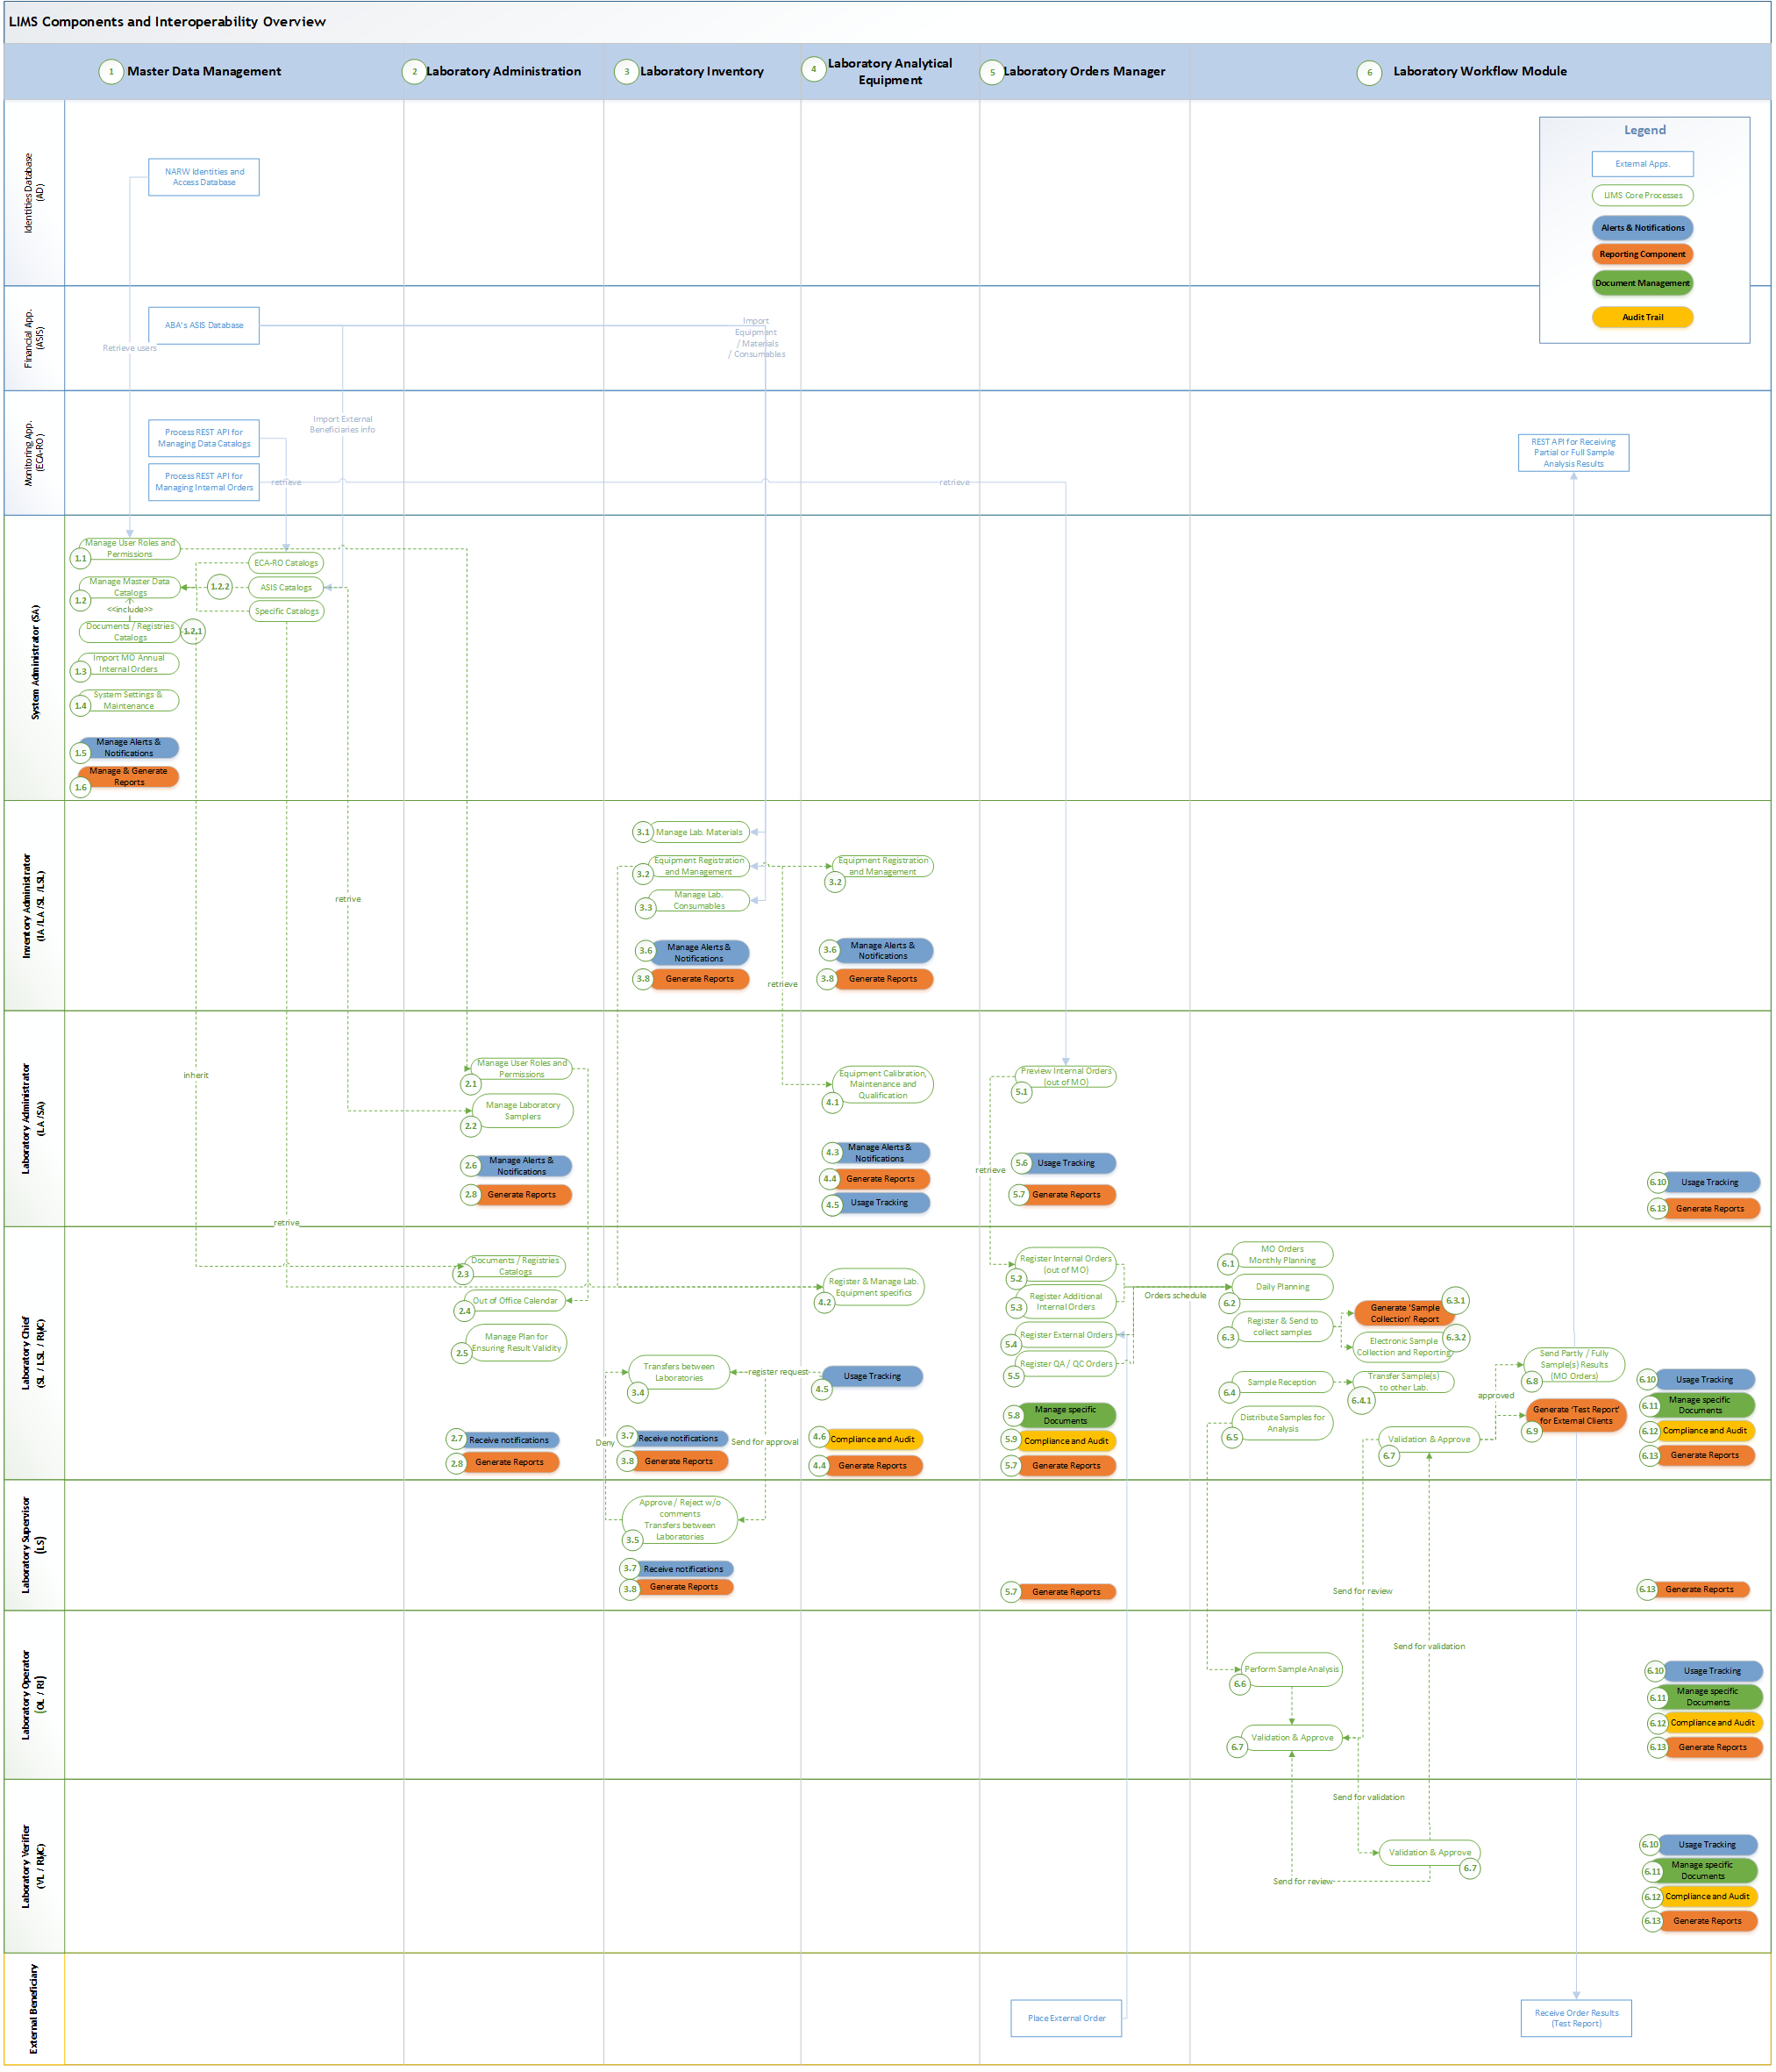
Figure 1 – High-level architecture illustrating the processes associated with LIMS components, categorized by roles, and showcasing their interoperability with existing NARW applications

Functional Requirements of the System

3.2.1 The Key Users of future IT system

No. | Abbreviation | Role in LIMS | Description | Role Mapping in the Current Framework  (Annex 1, chapter Roles & Terms)
1 | SA | System  Administrator | A person with full rights to manage user roles and permissions, core catalogs, needful integrations and configurations within the LIMS application.  For example, staff from SCAR and the IT units of ABAs' departments would be designated for this role.
2 | LA | Laboratory Administrator | An individual with full authority to: manage user roles and permissions; configure system settings required for ASIS inventory integrations; oversee laboratory-specific catalogs and documents; monitor audit trail logs; manage alerts and notifications; and generate specific reports and modules for their assigned laboratory unit.  Each ABA must have at least one user assigned to this role, responsible for overseeing all laboratories under the respective ABA.
3 | IA | Inventory Administrator | An individual authorized to oversee and manage all laboratory-specific stocks, materials and equipment within the LIMS application.  Each ABA would have a minimum of one user assigned to this role. It may overlap with Laboratory Administrator role.
4 | OL | Laboratory Operator | An individual authorized to conduct sample analyses, record laboratory results, and prepare test reports for both internal and external clients, ensuring they are submitted to RMC or VL for validation. | OL / RI
5 | VL | Laboratory Verifier | An individual authorized to oversee, analyze, and verify test results before submitting them for approval to the Laboratory Chief. In the Laboratory Chief's absence, this individual may act as the Laboratory Chief's Deputy, with the authority to approve test reports or cancel non-compliant ones. | VL / RMC
6 | SL | Laboratory Chief | A person authorized to validate and approve results entered into the LIMS application | SL
7 | LSL | Laboratory Chief Deputy | The Deputy Chief of Laboratory will automatically have the same authorizations and permissions as the Laboratory Chief (SL). | LSL
8 | LS | Laboratory Supervisor | An individual or group authorized to centrally access all laboratory inventory stocks, approve transfers, and view management reports, including metrics such as the number of sample analyses by status, with filtering options by matrix, laboratory, order type, and more.  Note: The Supervisor will not have access to analysis results.
9 | RMC | Quality Management Responsible | The "Responsabil cu Managementul Calității" may also serve as the Verifier or Deputy Laboratory Chief, overseeing test reports, approving them when the Laboratory Chief is absent, and canceling non-compliant reports. | May overlap with VL/SL
10 | RI | Authorized Testing Officer | The role of “Responsabilul de încercare autorizat” may overlap with that of the Laboratory Operator, who, according to internal authorization, is responsible for preparing test reports for both internal and external Clients and forwarding them to RMC for validation. | May overlap with OL
11 | Sampler | Sampler | Or “Prelevator” is the laboratory personnel responsible for collecting samples from the field in accordance with the laboratory's schedule and requirements.

Note: The final data beneficiaries will be the Water Resources Management, Monitoring, and Protection Service unit (GMPRA / GRA) within the NARW organization, as well as external Clients who have requested sample analysis orders.
Derived from Figure 1*, which illustrates the high-level architecture of LIMS components, Table 1 outlines the minimum key business processes expected to be involved in the future Laboratory Information Management System (LIMS). These processes, which may consider, as needed, additional functionalities, are organized into core and supporting modules, including Master Data Management for user access control and catalog administration, Laboratory Administration for managing workflows and ensuring compliance, and Laboratory Inventory for handling analytical equipment and materials. Additional modules may consider, as needed, such as Laboratory Orders Management for processing test requests and sample logistics, and Laboratory Workflow for automating and tracking laboratory activities, ensure seamless functionality integration to optimize operational efficiency.
(*) The correlation between Figure 1 and Table 1 links business process abbreviations with their corresponding UC codes. For example, the business process abbreviation 1.1 from Figure 1 is associated with UC1.1 in Table 1, and similarly for other corresponding entries.

Table 1
the minimum key business processes, which may, as needed, be involved in the future LIMS
Abbr. | Component | Business Process | Description | Role | Ref. in  Attachments
UC1.1 | Master Data Management | Manage Users, Roles and Permissions | Establish and manage user accounts, roles, and access controls at the organization level (NARW) to ensure secure and compliant system usage. | SA | “Roles & Terms” “Distribution of NARW Laboratory Units” from Annex 1
UC1.2 | Master Data Management | Manage Master Data Catalogs | Retrieve data from existing NARW systems or create and update LIMS-specific catalogs. Define and organize at least 27 data catalogs, including water sections, body of water, indicators, templates, and others. | SA | Annex 4  “Estimated Master Data Catalogs with References “  Annex 6 “Analysis Standards by Indicator in NARW Laboratory”
UC1.3 | Master Data Management | Import MO Annual Internal Orders | Import and manage annual internal orders to streamline planning and allocation processes. | SA | “Internal Orders” from Annex 1  Annex 2  “Templates Included in the Annual Operating Manual”
UC1.4 | Master Data Management | System Settings & Maintenance | Configure system settings, including REST API connectivity, NARW Active Directory and Exchange integration, and other relevant parameters, while performing routine maintenance to ensure optimal system functionality. | SA
UC1.5 | Master Data Management | Manage Alerts & Notifications | Set up and manage component-specific alerts and notifications to monitor critical events and updates effectively. | SA
UC1.6 | Master Data Management | Manage & Generate Reports | Create and manage component-specific reports for analysis, compliance, and decision-making. | SA
UC2.1 | Laboratory Administration | Manage Users, Roles and Permissions | Manage user accounts and roles specific to laboratory administration, building on and extending the functionality of "Manage Users, Roles, and Permissions" from BR1.1 to meet the unique needs of laboratory operations. | LA/SA | “Roles & Terms” from Annex 1
UC2.2 | Laboratory Administration | Manage Laboratory Samplers | Oversee and manage laboratory sampler assignments and activities. | LA/SA
UC2.3 | Laboratory Administration | Documents / Registries Catalogs | Maintain and organize catalogs for laboratory documents and registries to ensure efficient recordkeeping, extending UC1.2 "Manage Master Data Catalogs" to encompass both document and registry catalogs. | SL/ LSL/RMC
UC2.4 | Laboratory Administration | Out of Office Calendar | Manage schedules and record periods of unavailability for laboratory personnel. If no backup is assigned, alerts and notifications are sent to the SL for planning and adjustments. | SL/ LSL/RMC
UC2.5 | Laboratory Administration | Manage Plan for Ensuring Result Validity | Involves defining, implementing, and tracking laboratory-specific standards, methods, and protocols for sample analysis. It includes selecting, verifying, and validating analytical methods, establishing annual protocol plans, and setting indicator limits. This process ensures consistent, reliable results, supports regulatory compliance, and maintains quality assurance, with each laboratory adapting methods to its specific equipment and operational requirements. | SL/ LSL/RMC | “Monitoring Validity of Test Results” from Annex 1
UC2.6 | Laboratory Administration | Manage Alerts & Notifications | Configure and maintain alerts specific to laboratory administration tasks. | LA/SA
UC2.7 | Laboratory Administration | Receive notifications | Ensure designated users receive relevant system notifications promptly. | SL/ LSL/RMC
UC2.8 | Laboratory Administration | Generate Reports | Create detailed reports for laboratory operations, performance, and compliance. | LA/SA  SL/ LSL/RMC
UC3.1 | Laboratory Inventory | Manage Lab. Materials | Oversee the management of laboratory materials, including tracking, storing, and updating inventory data retrieved from the existing financial system (ASIS). | IA /LA /SL /LSL | “Stage 0: Inventory Setup” from Annex 1  Annex 3  “NARW Laboratory Equipment”
UC3.2 | Laboratory Inventory | Equipment Registration and Management | Register and manage laboratory equipment, including tracking usage, maintenance schedules, and calibration. Equipment information is retrieved from the existing financial system (ASIS) for inventory management. | IA /LA /SL /LSL
UC3.3 | Laboratory Inventory | Manage Lab. Consumables | Manage the inventory of consumables, including chemicals, reagents, and disposable items, to ensure sufficient stock levels. Core information data is retrieved from the existing financial system (ASIS) to support inventory management. | IA /LA /SL /LSL
UC3.4 | Laboratory Inventory | Transfers between Laboratories | Initiate and track requests for materials and/or consumables from other laboratories, triggering an approval workflow. Coordinate the transfer of materials and consumables between laboratories, ensuring accurate documentation, tracking, and compliance with internal procedures. | SL/ LSL/RMC
UC3.5 | Laboratory Inventory | Approve / Reject w/o comments  Transfers between Laboratories | Review and approve or reject inter-laboratory transfers of materials or consumables, with or without requiring additional comments or documentation. | LS
UC3.6 | Laboratory Inventory | Manage Alerts & Notifications | Set up and manage alerts for critical inventory events such as low stock, equipment maintenance, or transfer requests. | IA /LA /SL /LSL
UC3.7 | Laboratory Inventory | Receive notifications | Ensure designated users receive timely notifications related to inventory, equipment, and transfer activities. | LS/SL/ LSL/RMC
UC3.8 | Laboratory Inventory | Generate Reports | Generate detailed reports on inventory levels, equipment status, transfers, and consumables usage for analysis and compliance. | LS/SL/ LSL/RMC
UC4.1 | Laboratory Analytical Equipment | Equipment Calibration, Maintenance and Qualification | Ensure laboratory equipment is properly calibrated, maintained, and qualified for accurate results. | LA /SA | “Select, Verify and Validate the Analytical methods”,  “Intermediate Equipment Verification” from Annex 1
UC4.2 | Laboratory Analytical Equipment | Register & Manage Lab. Equipment specifics | Register and manage the specifics of laboratory equipment, including detailed data and operational characteristics. | SL/ LSL/RMC
UC4.3 | Laboratory Analytical Equipment | Manage Alerts & Notifications | Set up and manage alerts for equipment-related events such as maintenance schedules or calibration deadlines. | LA /SA
UC4.4 | Laboratory Analytical Equipment | Generate Reports | Create reports related to equipment performance, maintenance, and calibration for analysis and compliance. | SL/ LSL/RMC LA /SA
UC4.5 | Laboratory Analytical Equipment | Usage Tracking | Track the usage of laboratory equipment to ensure proper functioning and scheduling. | SL/ LSL/RMC LA /SA
UC4.6 | Laboratory Analytical Equipment | Compliance and Audit | Ensure all equipment usage complies with internal protocols and regulatory standards, with audit capabilities. | SL/ LSL/RMC LA /SA
UC5.1 | Laboratory Orders Manager | Preview of Internal Orders (out of MO) | Review internal orders derived from the Operating Manual (MO) before processing. | LA /SA | “Internal Orders” from Annex 1  Annex 2  “Templates Included in the Annual Operating Manual”  Annex 5  “Sample Calculation Formulas for Indicators”
UC5.2 | Laboratory Orders Manager | Register Internal Orders (out of MO) | Register internal orders based on the MO for laboratory testing and analysis. | SL/ LSL/RMC
UC5.3 | Laboratory Orders Manager | Register Additional Internal Orders | Register additional internal orders beyond the standard MO requirements. | SL/ LSL/RMC
UC5.4 | Laboratory Orders Manager | Register External Orders | Register orders from external clients or entities for laboratory services. | SL/ LSL/RMC | “External Orders” from Annex 1
UC5.5 | Laboratory Orders Manager | Register QA / QC Orders | Register Quality Assurance/Quality Control orders to ensure testing accuracy and quality. | SL/ LSL/RMC
UC5.6 | Laboratory Orders Manager | Usage Tracking | Track the progress and usage of orders within the laboratory. | SL/ LSL/RMC LA /SA
UC5.7 | Laboratory Orders Manager | Generate Reports | Generate reports on order status, usage, and outcomes for analysis and decision-making. | SL/ LSL/RMC LA /SA /LS
UC5.8 | Laboratory Orders Manager | Manage specific Documents | Handle documents related to orders, ensuring proper organization and traceability. | SL/ LSL/RMC
UC5.9 | Laboratory Orders Manager | Compliance and Audit | Ensure all orders comply with regulatory and internal standards, with audit capabilities for accountability. | SL/ LSL/RMC
UC6.1 | Laboratory Workflow Module | MO Orders Monthly Planning | Plan the monthly internal orders registered in UC5.1 based on the Operating Manual, ensuring effective scheduling of laboratory tasks. | SL/ LSL/RMC | “Stage 2: Monthly & Daily Planning” from Annex 1
UC6.2 | Laboratory Workflow Module | Daily Planning | Following the monthly planning, proceed with daily scheduling for sample collection, incorporating all types of orders. This process acts as the laboratory's master plan for the entire year, assigning samplers, indicators, inventory materials, and other necessary resources to each planned sample collection. | SL/ LSL/RMC | “Stage 2: Monthly & Daily Planning” from Annex 1
UC6.3 | Laboratory Workflow Module | Register & Send to collect samples | Register and assign personnel for sample collection based on the laboratory schedule outlined in UC6.2. This process offers two collection methods: manually, by providing the sampler with a printed document to complete, or electronically, where the sampler accesses LIMS via a tablet to enter field information directly. | SL/ LSL/RMC | “Stage 2: Monthly & Daily Planning” from Annex 1
UC6.3.1 | Laboratory Workflow Module | Generate 'Sample Collection' Report | This is a sub-process of UC3.1, where, based on the laboratory schedule in UC6.2, the Sample Collection report is generated, printed, and assigned to the Sampler for field sample collection on paper. | SL/ LSL/RMC  Sampler | “Stage 2: Monthly & Daily Planning” from Annex 1
UC6.3.2 | Laboratory Workflow Module | Electronic Sample Collection and Reporting | This is a sub-process of UC3.1, where, based on the laboratory schedule in UC6.2, the Sample Collection report is generated, printed, and assigned to the Sampler for field sample collection on paper. | SL/ LSL/RMC  Sampler
UC6.4 | Laboratory Workflow Module | Sample Reception | Manage the reception of samples, ensuring proper handling and logging. | SL/ LSL/RMC  Sampler | “Stage 3: Sample Collect & Receipt” from Annex 1
UC6.4.1 | Laboratory Workflow Module | Transfer Sample(s) to other Lab. | Coordinate and document the transfer of samples between laboratories when the assigned laboratory is unable to proceed with sample analysis. This process ensures proper documentation and tracking of the transferred samples, maintaining data integrity and supporting timely analysis. | SL/ LSL/RMC
UC6.5 | Laboratory Workflow Module | Distribute Samples for Analysis | Distribute received samples to the appropriate laboratory personnel or equipment for analysis. | SL/ LSL/RMC | “Distribution of Samples for Analysis (or sub-sampling)” from Annex 1
UC6.6 | Laboratory Workflow Module | Perform Sample Analysis | Conduct laboratory analysis on collected samples, using the appropriate methods and equipment to generate test results. | OL / RI | “Sample Analysis” from Annex 1
UC6.7 | Laboratory Workflow Module | Validation & Approve | Validate the accuracy of analysis results and approve them for further processing or reporting, applicable to all levels of laboratory personnel. | OL / RI /VL SL/LSL/RMC | “Stage 5: Sample Validate & Approve” from Annex 1
UC6.8 | Laboratory Workflow Module | Send Partly / Fully Sample(s) Results  (MO Orders) | Send partial or full results from sample analyses, based on the Operating Manual (MO) orders, to the ECA-RO system via REST API. The process includes previewing, validation, and tracking the results. Throughout the process, from order registration to result submission, the samples must retain the same unique ECA-RO code. | SL/LSL/RMC
UC6.9 | Laboratory Workflow Module | Generate ‘Test Report’ for External Clients | Create and provide detailed test reports for external clients, summarizing the results of the sample analysis. The report is printed and sent to external clients in accordance with internal compliance procedures, using a signed paper-based format. | SL/LSL/RMC | “Reporting Results to External Orders” from Annex 1
UC6.10 | Laboratory Workflow Module | Usage Tracking | With generated reports track the usage of resources, equipment, and personnel across all processes from UC6.1 to UC6.9 in sample analysis, ensuring proper utilization and efficient scheduling. | OL / RI /VL SL/LSL/RMC
UC6.11 | Laboratory Workflow Module | Manage specific Documents | Manage and store documents related to sample analysis, including protocols, results, and, when necessary, laboratory personnel information. | OL / RI /VL SL/LSL/RMC
UC6.12 | Laboratory Workflow Module | Compliance and Audit | Ensure all sample analysis processes from UC6.1 to UC6.9 are fully traceable and comply with regulatory standards and internal procedures, providing audit trail capabilities for accountability and compliance. | OL / RI /VL SL/LSL/RMC
UC6.13 | Laboratory Workflow Module | Generate Reports | Create and distribute reports summarizing sample analysis results, usage, and compliance for internal and external stakeholders. | OL / RI /VL SL/LSL/RMC

To ensure a comprehensive understanding of the business requirements and their impact, the general functional requirements and each 10 IT components detailed at the Scope of Services chapter, will present a detailed list of both functional and non-functional requirements and may consider, as needed, additional aspects relevant to the system’s scope and performance. The functional requirements shall, where applicable and without limitation, encompass the requirement outlined in the below list:

Seq.  No. | Functional requirement shall include, as necessary, and without being limited to, the following requirements
 | GENERAL FUNCTIONAL REQUIREMENTS
1 | In line with European Union (EU) Directives, the following objectives serve as the core guiding principles of this project.  Consultant`s are expected to consistently prioritize and adhere to these objectives:
1.1 | Ensure system access through standard Internet browsers, aligned with EU Directives for e-government systems.
1.2 | Enhance fraud detection and control using advanced tools for data storage and extraction.
1.3 | Reduce administrative costs by using a centralized "data repository" for shared organizational data.
1.4 | Adopt standard, open development platforms and technologies to lower maintenance costs and avoid vendor lock-in.
1.5 | Provide specialized consultancy and support services to aid NARW in building internal expertise.
1.6 | Allow real-time status tracking of support requests through a single data source.
1.7 | Facilitate quick and easy modification of the user interface to comply with current or future web standards.
2 | User and Access Management
2.1 | The system must incorporate flexible user and access management features, allowing controlled access for multiple users with varying authorization levels. Integration with the NARW Active Directory system must be supported for efficient role assignment based on the organizational structure.
2.2 | The system must provide a flexible administration model that enables controlled access for multiple users. This includes capabilities to add new users, organize users into groups, and assign granular permissions at both the user and role levels. A minimum set of roles is outlined in Chapter 3.2.1, “The Key Users of the Future IT System”.
2.3 | The system must facilitate Single Sign-On capabilities, allowing users to authenticate through existing identity management system to ensure a seamless login experience and enhance security by minimizing the need for multiple credentials.
2.4 | Access to various functionalities and data must be governed by assigned user roles, with mechanisms in place to restrict or grant access to maintain data integrity and security.
2.5 | Access to interlaboratory functions shall be allowed but limited to a specific group of authorized users, ensuring that sensitive information is protected while enabling necessary collaboration. For instance, a designated group of users from ABA may have authorized permissions to access and view data from their subordinate SGA laboratory units.
2.6 | The system must be accessible from an unlimited number of computers within the NARW laboratories network.
3 | Usability  Note: During the analysis phase, the Consultant is expected to deliver diagrams and models to give the Beneficiary a clear understanding of the anticipated interface design.
3.1 | Provide consistent interface behavior across all modules to reduce learning time for users.
3.2 | The system must provide an intuitive interface that supports easy navigation and efficient task completion.
3.3 | Provide flexibility in configuration and use to accommodate varying user needs and preferences.
3.4 | The system must provide clear error messages with explanatory text and maintain a server log to track potential issues for technical support.
3.5 | The system must provide a default tabular view that enables end-users to sort records in both ascending and descending orders, supporting both single-column and multi-column sorting for efficient data organization and analysis. This tabular view should also facilitate various actions, such as initiating workflows, submitting transfer requests, and enabling seamless interaction with master data catalogs (see Annex 4).
3.6 | Validation mechanisms must be implemented wherever feasible to minimize errors and promote consistent data entry. The Consultant must ensure flexibility in the setup and configuration of various validation methods, which will be specified and refined during the analysis phase.
3.7 | The interface must resemble Windows platforms, providing user-friendly experience with options for adding extended information.
3.8 | The system may support function keys (F1-F12 in combination with Alt and/or Ctrl) and keyboard shortcuts (e.g., Ctrl + S for saving and Ctrl + L for loading) for improved usability and efficiency.  The system may differentiate between uppercase and lowercase letters.
3.9 | Support for customizing user interfaces to present additional information as needed would be a valuable feature.
3.10 | The system must utilize worklists and automatic modes to enable quick execution of individual tasks.
3.11 | Search capabilities  The system must offer an intuitive advanced search feature across all functional modules, supporting both single and multiple record searches. This feature should include fuzzy search capabilities to improve flexibility in locating records.  It must incorporate a powerful internal search engine capable of conducting searches based on various keywords, ensuring detailed data retrieval.  Note: During the analysis phase, the Consultant is expected to provide recommendations and design proposals for optimizing search capabilities. This includes strategies for data structuring, storage, and modification to ensure data is easily identifiable and searchable, even in large datasets, while minimizing the number of clicks required for end-users.
4 | Modular Structure, Interoperability
4.1 | The system must be designed with a modular architecture that allows for seamless integration and communication between different modules. This structure will enable the efficient exchange of data across various functional areas of the Laboratory Information Management System (LIMS).
4.2 | Interoperability with existing systems and technologies is crucial. LIMS must support standard data exchange formats and protocols (e.g., XML, JSON) to enable seamless integration with external applications and services, enhancing data sharing and collaboration. Ideally, this integration should be facilitated through an API management service, such as Microsoft Azure API Management or similar tools, to ensure flexibility, scalability, and ease of future system integrations.
4.3 | Each module within the LIMS shall operate independently while being able to share data with other modules as needed. This will provide flexibility in functionality and enable users to access relevant information without navigating through multiple systems.
4.4 | The system must support future integrations with third-party tools and platforms, allowing for scalability and adaptability to evolving laboratory needs and technologies.
4.5 | The system must maintain a detailed audit trail of user login activities, including timestamps, IP addresses, and data transfers between components, to monitor access patterns, track data movement, and strengthen overall security.
5 | Access and Extensibility
5.1 | The system must be accessible from an unlimited number of computers within the NARW laboratories network.
5.2 | The system must support extensibility based on evolving user needs.
5.3 | The Consultant's proposed solutions for laboratory equipment integration, or any other scenarios, must be designed to avoid the need for additional licenses once the software development is completed. This ensures that the system remains fully operational without incurring extra licensing costs post-go-live.
5.4 | Automatic Data Pre-Population  All catalog data (e.g., section codes, indicator information)  must be automatically prefilled from centrally stored component Master Data Catalogs (Annex 4) or data registered specifically for each laboratory within the Laboratory Administration module.  To enhance efficiency, the system must provide an option for authorized users to "clone" previously entered records. For users without edit permission, the system shall allow them to submit requests to change. These requests will be routed through an approval workflow, with configurable notifications sent to designated users or groups, as defined by the detailed requirements identified during the analysis phase.
6 | Home Page*  Note: The page layout and details MUST be agreed with the Beneficiary during the business analysis phase, ensuring the design aligns with their needs. The interface language must be Romanian.
6.1 | The home page of the LIMS system shall cater to all user roles by presenting a personalized overview of relevant activities, tasks, and notifications that require attention. From the home page, each system end-user will be able to easily identify their activities for the current day as well as any follow-up tasks for the upcoming period.
6.2 | The system must provide a “Dashboard” that displays key reports derived from the Reporting component in a summarized format, including graphs, charts, and tables. Multiple dashboards will be customized to meet the needs of various management levels, corresponding to the end-user access levels within NARW and addressing specific informational requirements.
6.3 | Home Page must highlight "Today's" tasks requiring attention, utilizing the Alerts and Notifications component to ensure timely awareness.
6.5 | On the Home Page, scheduled future actions should be displayed in a calendar format or a similar layout, offering a clear and organized view of upcoming tasks.
6.6 | The Home Page should provide quick access to key actions, with customization tailored to the user's access level and the specific needs identified by NARW during the requirements analysis phase.
*Essential Components of a Home Page: 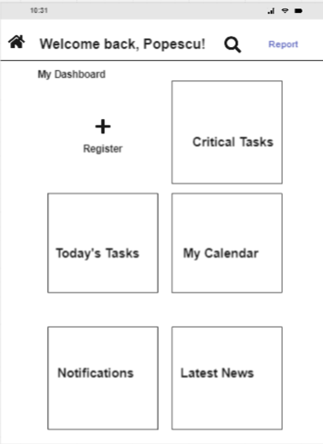

Master Data Management (the 1st IT component outlined in the Scope of Services chapter)

This component is intended to centrally manage the institution's core data essential for the LIMS platform, such as data catalogs, dictionaries, and administrative information (like roles, users, and permissions). It will also include necessary configurations for integration with existing NARW IT systems, such as ASIS, financial application and ECA-RO monitoring system.
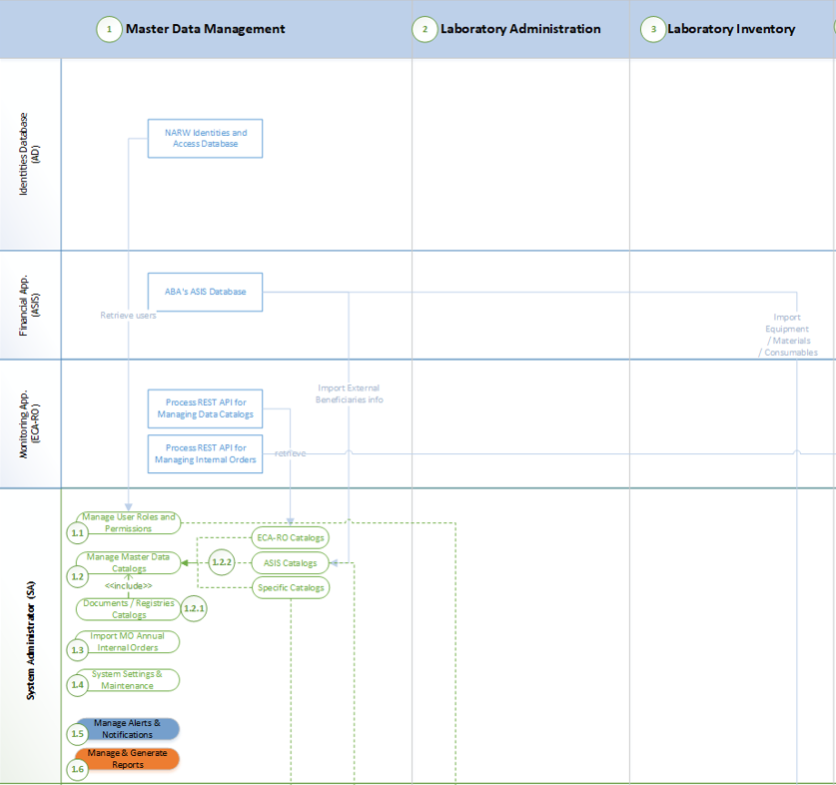
- Manage Users, Roles and Permissions (UC1.1) represents the area where individuals with the "System Administrator" role have full access rights to define and manage core entities such as "Role," "Permission," and "Group" for entire system. Each entity must have editable attributes, such as Code, Name, and Description, as well as audit trail attributes to log changes.
- The system shall establish a user registration process to categorize NARW users into specific groups, assign granular permissions, and collect basic user information within the LIMS system. Each user entity would be synchronized with existing identity system, including details like email address, manager, and department, to ensure system-wide consistency.
- In the System Settings & Maintenance (UC1.4) section, all necessary configurations for identity system integration should be accessible through an interface for viewing, modification, and status tracking (e.g., connected or not). The goal is to ensure that the NARW internal team can manage the integration in the future, such as handling IP address changes.
Attribute Name | Attribute Description
Name | The full legal name of the entity (user of LIMS) refers to an individual who is part of the organization, such as an employee or collaborator. This individual typically has access to internal resources and information relevant to the organization’s operations.
Entity ID | LIMS user identification number (e-mail address).
Role | A specific predefined role within LIMS listed in table Annex 1 documentation., could be corelated with the user role from organization (e.g. Laboratory Chief)
Organization Unit | Laboratory code (subdivision) within NARW typically provided by the identity management IT system.
Manager | The individual (user) designated as the manager responsible for overseeing the activities and performance within the unit (OU).
Deputy | A designated user who serves as a secondary point of contact or support, assuming responsibilities or access privileges in the absence of the primary user.
Additional information | Such phone, address if needed

- Currently, there are over 27 catalogs named as “Master Data Catalogs” (UC1.2) in use, each labeled similarly but modified over time through various laboratory operational processes. As a result, each laboratory has developed its own method for utilizing these catalogs. Therefore, as an initial step, these catalogs should receive close attention, beginning with the analysis phase. While some of these catalogs should be collected, stored, and maintained centrally, others, such as laboratory-specific documents, may continue to be managed on a unit-based level. Refer to Annex 4: Estimated Master Data Catalogs with References, where master data catalogs are displayed alongside sample values, estimated references, and primary data sources.
- Currently, catalogs are managed in a decentralized way with multiple "sources of truth." The Consultant is expected to begin with a detailed analysis, followed by proposals to centralize, govern, and maintain data effectively.
- The core data catalogs for the LIMS will integrate terminology and entries directly from the ECA-RO application. This integration will occur via a REST (Representational State Transfer) API (Application Programming Interface) provided by ECA-RO, facilitating efficient data transfer and ensuring consistent catalog information within the LIMS.
- The following is a baseline list of essential core catalogs required for the LIMS. These catalogs, which will be integrated into the master data module, represent the minimum mandatory set but are not exhaustive:
  - Monitoring Units
Attribute Name | Attribute Type | Attribute Description
Unit_ID | Number | Distinct identifier for each Monitoring Unit associated with ABA or SGA
Unit_Name | Text | Name of the Monitoring Unit.
Unit_Code | Text | Code of the Monitoring Unit.
Contact_Person | Text | Name of the primary contact person at the unit.
Phone_Number | Text | Contact phone number for unit
Email | Text | Contact the email address for the unit
Region | Text | Geographic region or area served by the unit.
Status | Text | Current operational status of the unit (e.g., Active, Inactive, Under Review).
  - River Basin Administration Units (aka ABA)
Attribute Name | Attribute Type | Attribute Description
Unit_ID | Number | Unique identifier for each River Basin Administration Unit.
Unit_Name | Text | Name of the River Basin Administration Unit.
Unit_Code | Text | Code of the River Basin Administration Unit.
Monitoring_Unit_ID | Number | Identifies the monitoring unit (also known as GMPRA) responsible for receiving internal orders and delivering the corresponding results (refer to the illustrated figure in the "Distribution of NARW Laboratory Units" chapter from Annex 1).
Location | Text | Physical address or location of the unit.
Contact_Person | Text | Name of the primary contact person at the unit.
Phone_Number | Text | Contact phone number for unit
Email | Text | Contact the email address for the unit
Operating_Hours | Text | Operating hours of the unit (e.g., Mon-Fri, 8 AM - 6 PM).
Region | Text | Geographic region or area served by the unit.
Status | Text | Current operational status of the unit (e.g., Active, Inactive, Under Review).
  - Water Quality Laboratories (aka LN, LCA)
Attribute Name | Attribute Type | Attribute Description
Lab_ID | Number | Unique identifier for each laboratory.
Lab_Name | Text | Name of the water quality laboratory.
Unit_ID | Number | Indicates the unit to which it belongs
Monitoring_Unit_ID | Number | Identifies the monitoring unit (also known as GMPRA) responsible for receiving internal orders and delivering the corresponding results (refer to the illustrated figure in the "Distribution of NARW Laboratory Units" chapter from Annex 1).
Location | Text | Physical address or location of the laboratory.
Contact_Person | Text | Name of the primary contact person at the laboratory.
Phone_Number | Text | Contact phone number for the laboratory.
Email | Text | Contact the email address for the laboratory.
Accreditation_Status | Text | Indicates if the laboratory is accredited (e.g., ISO/IEC 17025:2017).
Certification_Date | Date | Date when the laboratory received its accreditation or certification.
Expiry_Date | Date | Expiration date of the laboratory's accreditation or certification.
Testing_Capabilities | Text | List or description of water quality parameters the laboratory is capable of testing (e.g., pH, turbidity, metals).
Capacity | Number | Maximum number of samples the laboratory can process within a specified time frame.
Operating_Hours | Text | Operating hours of the laboratory (e.g., Mon-Fri, 8 AM - 6 PM).
Region | Text | Geographic region or area served by the laboratory.
Date_Added | Date | Date the laboratory was added to the database.
Last_Inspection_Date | Date | Date of the most recent inspection or audit of the laboratory.
Status | Text | Current operational status of the laboratory (e.g., Active, Inactive, Under Review).
  - For catalogs such as Basins, Water Bodies, Water Courses, and Sections, the following minimum attributes should be considered, in addition to specific attributes that will be established during the analysis phase of implementation by the Consultant. For instance, attributes for Sections include:
Attribute Name | Attribute Type | Attribute Description
Section_ID | Number | Unique identifier for each section within the river or lake.
Section_Name | Text | Name of the section (e.g., Upper Section, Lower Section).
Section_CODE | Text | Alphanumeric code serves as a unique identifier (e.g., RO100010).
Basin_ID | Number | Identifier linking the section to its parent river basin.
Water_Course_ID | Number | Identifier linking the section to its parent water course.
Water_Body_ID | Number | Identifier linking the section to its parent water body.
Length | Number | Length of the section in kilometers.
Width | Number | Average width of the section in meters.
Area | Number | Total area of the section in square kilometers.
GPS Coordinates | Number | Longitude and Latitude Values
Protected Area | True /False | Indicate whether the area is protected or not.
Main_River | Text | Name of the primary river or waterway flowing through the section.
Land_Use | Text | Description of predominant land use types within the section (e.g., Urban, Agricultural, Forest).
Water_Quality_Status | Text | Status of water quality in the section (e.g., Good, Fair, Poor).
Key_Sampling_Sites | Text | Names or identifiers of key water quality sampling sites within the section.
Management_Entity | Text | Organization or authority responsible for the management of the section.
Last_Monitoring_Date | Date | Date of the most recent monitoring or assessment conducted in the section.
Status | Text | Current operational status of the laboratory (e.g., Active, Inactive, Under Review).
Note: To ensure comprehensive audit trails and maintain version control of the catalogs, each catalog should include the following additional attributes:
Attribute | Attribute description
Version | Maintain the version number, which can be either numeric or alphanumeric.
Version References | This attribute serves as a link to related documents that provide context for changes made to the catalog. It may include references to certification documents, modification logs, or revision histories that detail the specific changes applied to the catalog's attributes or structure. Each entry should specify the version number, the date of the change, and a brief description of the modifications, ensuring transparency and traceability for users reviewing the catalog's evolution over time.
References information | Details of the unique identifier (ID) for establishing relational references between catalogs.
Audit Trail information | Represents all relevant audit trail attributes must be considered, such Created Date, Action, Modified Date, Modified By etc.
- Another relevant example imported from the ECA-RO catalog is the 'Indicators Catalog,' which may include the following minimum attributes:
Attribute Name | Attribute Type | Attribute Description
ID | Number | Unique indicator identifier
Definition | Text | Represents the indicator description
Code | Text | A unique code is assigned to facilitate searches, which is recognized across all laboratories.
Reference to Parameters | Number | Identifier linking the Parameters Catalog imported also from ECA-RO.
Reference to UM | Number | Identifier linking the Unit Measures Catalog imported also from ECA-RO.
Reference to Formula | Number | Identifier linking the Formulas Catalog imported also from ECA-RO.
Level of Processing | Number | Not in scope of LIMS
Reference to Parameter Category | Number | Reference to Parameter categories
Para Reference to Parameter Group | Number | Reference to Parameter group
Minimum Estimated Value | Number | Minimum Estimated Value
Maximum Estimated Value | Number | Maximum Estimated Value
ACC_VAL_NEG | Number | Actual value negative
ACC_VAL_ZERO | Number | Actual value zero
CRITIC_POTABILIZARE | Number | Referring to Critical Drinking Water Quality, be used to evaluate whether the water meets the necessary standards for potability (safety for drinking).
ORDINAL | Number | Reference to Parameters table from ECA-RO
LOQ | Text | Organization or authority responsible for the management of the section.
- For reference and to enhance understanding of the “Indicators Catalog”, the table below outlines the current Parameters table schema as presented in the existing ECA-RO IT system:
Attribute Name | Attribute Type | Attribute Description
ID | Number | Unique indicator identifier
Code | Text | Represents the parameter code
Additional Description | Text | Parameter description 1 in ECA-RO scope
Accepted Description | Text | Parameter description 2 in ECA-RO scope
Alternative description | Text | Parameter description 3 in ECA-RO scope
Level | Number | Hierarchical order level
Reference to Parameters | Number | Identifier that links to the same Parameters table, organized in a hierarchical structure
Sample Zone | Number | Reference to sample area in scope for ECA-RO.
Sample Zone Value | Decimal | Value of the sample area in scope for ECA-RO.
Functional Biological Groups | Number | Classifies organisms into functional groups
Water Flow Type | Number | Categorizes the type of water flow in each environment, such as laminar, turbulent, or intermittent.
Biological Family | Number | identifies the taxonomic family to which a particular organism belongs,
Biological Group | Number | defines a broader classification of organisms within a specific category, grouping them based on shared characteristics or ecological roles.
Growth Type | Number | Maximum Estimated Value
Ordinal | Number | Actual value negative
WQO2 | Text | Water Quality Objective 2
HTOL | Text | High Tolerance
REPRO | Text | Reproduction
HABSP | Text | Habitat Specific
Note: The above tables (Indicators and Parameters) should be regarded as a guideline and reference for the primary data extracted from ECA-RO, which forms part of the core data catalogs. Not all attributes listed will be required for LIMS; consequently, only the core data specified by version and version determined during the analysis phase conducted by the Consultant—will be imported into LIMS.

Important: The catalogs outlined in Annex 4: Estimated Master Data Catalogs with References are expected to be clearly identified and well documented during the business analysis phase executed by the Consultant.
- In addition to the detailed catalogs mentioned above, the Master Data Catalog (UC1.2) also includes the Documents Catalog (UC1.2.1). This catalog allows users with the System Administrator role to manage the document categories defined within LIMS, along with its core documents (Word, Excel, PDF). These categories and documents can be further customized and expanded at each laboratory level while maintaining a reference to the master catalog. Each entity, including Document Categories and Documents, must include the following editable attributes:
    - Code: A unique identifier for each document category.
    - Name: A descriptive title for the document category.
    - Description: A detailed explanation of the document category's purpose and use.
  - LIMS must maintain an audit trail to log on to any changes made to these attributes, including:
    - Timestamp of Change: The date and time when the change was made.
    - User ID: The identifier of the user who made the change.
    - Previous Value: The value before the change was applied.
    - New Value: The value after the change was applied.
Table of Document Categories sample values:
Code | Name | Translation in native language (Romanian)
CL | Laboratory notebook | Caiet de laborator
FT | Field sheet | Fișă de teren
FL-7.1 | Sampling note | Notă de prelevare / Raport de prelevare
PV-R | Receipt-Delivery report of reagents | Proces-verbal primire-predare reactivi
FL-7.8 | Testing report | Raport de încercare
FL-7.8 | Simplified testing report | Raport de încercare simplificat
RL | Laboratory register | Registru de laborator
RL-7.9 | Complaints register | Registru de reclamații
RL-7.1 | External orders register | Registru comenzi externe
Note: The term "document" refers to electronic templates in formats such as PDF and Word, designed to be automatically populated with relevant metadata during LIMS processes. This functionality improves data entry efficiency and ensures accurate documentation. Additionally, the "code" attribute for Document Categories and Documents follows the standard terminology and abbreviations commonly used by NARW Laboratories, in strict compliance with established internal procedures.
- Via Import MO (Operating Manual) internal orders process (UC1.3), the expectation is that authorized personnel, typically those with administrative roles such System Administrator, should be able to easily import internal orders from the existing NARW monitoring system (ECA-RO) into the new system. This process will help prepare the necessary orders for sample analysis at NARW laboratories for the upcoming year. The system should ensure full visibility and control over the import process, allowing any issues or errors to be quickly identified and resolved. Additionally, the integration with the ECA-RO system should be properly managed and monitored to ensure seamless operation and maintenance, through the System Settings & Maintenance section (UC1.4).
- As outlined previously, the future LIMS system is expected to integrate with several key systems, such as ECA-RO for master data catalogs, ASIS for specific catalogs like the Sampler list, and Active Directory for identity management and additional data. Each of these systems will require its own configuration. The System Settings & Maintenance process (UC1.4) will manage these integrations. To ensure smooth operations, an interface restricted to System Administrator will be needed to configure the system, test connections, monitor data transfers, and allow for starting, pausing, or restarting the import processes for catalogs and internal orders. The specifics of this process will be defined and agreed upon by both parties during the analysis phase. The goal is to equip internal technical teams with the tools they need to easily integrate with existing systems and independently manage system configurations for their region, including making necessary adjustments such as updating IP addresses or other settings.
Interoperability with support processes: For each process, the System Administrator (SA) will have the ability to configure alerts and notifications (UC1.5) to be sent to relevant groups based on their areas of interest, enabling proactive monitoring and resolution of potential issues with integrations. Additionally, the System Administrator should be able to manage and generate various types of reports (UC1.6), such as lists of imported catalogs over a specified period or the status of order imports. Reporting (UC1.6) and Audit & Notifications (UC1.5) components need to support all processes to ensure comprehensive tracking and oversight.

Master Data Management Functional Requirements (the 1st IT component outlined in the Scope of Services chapter)

The following functional requirements should be regarded as the minimum standards, focusing on the components detailed above in this chapter. These requirements will serve as the foundation and may consider, as needed, additional relevant aspects, which will be further enhanced and refined in collaboration with the Consultant during the analysis phase. The approach must ensure alignment with project goals while incorporating the Consultant's detailed analysis, insights, and industry best practices.

Seq.  No. | Functional requirement shall include, as necessary, and without being limited to, the following requirements
MASTER DATA MANAGEMENT *
Serves as a centralized hub for managing all core data catalogs. It allows for the seamless import of LIMS catalogs from external applications such ECA-RO and ASIS or the addition of new data entries, specific to laboratories. This component ensures that all key data sets are consistently organized and available for use across all LIMS processes.
7 | General Requirements
7.1 | The system must support multi-user concurrency, ensuring consistency and accuracy of data.
7.2 | The system must provide real-time status and unlimited usage reports for catalogs and configurations.
7.3 | Comprehensive error handling must be implemented to identify, log, and resolve system issues and retrieving data issues from existing applications such ECA-RO, ASIS or identity system.
7.4 | The system MUST integrate with the existing ECA-RO application to retrieve most system catalogs (as referenced in Annex 4). This integration will ensure consistency and alignment of master data across both systems.
7.5 | The system must support integration with the ECA-RO API, with configuration management based on authorized access. Beneficiary designated personnel are expected to be instructed and empowered by the Consultant to update integration interface settings independently, without requiring intervention from the Consultant.
7.6 | The system should be adaptable to support the addition of new, LIMS-specific data catalogs as identified post-analysis. The addition of these catalogs will include the configuration of role-based and module-specific permissions to define where and how these entries are utilized within the LIMS system.
8 | Manage Users, Roles and Permissions
8.1 | Access to this module must be restricted exclusively to end-users with the System Administrator role, with full control to manage, update, and maintain the integrity of the data within the system.
8.2 | The system must allow the creation, management, and assignment of roles, groups, and permissions. Each user entity (roles, groups, permissions, and assigned users) must be fully configurable within the system.
8.3 | Access controls must include granular permissions to ensure secure and appropriate access based on role or user type.
8.4 | Audit logs must be maintained for all changes made to user access controls.
8.5 | The system must be capable of retrieving user details and their associated organizational information from the NARW existing identity system.
9 | Master Data Catalogs
9.1 | The module must support import, store, archive, and manage at least 27 data catalogs as referenced “Annex 4: Estimated Master Data Catalogs with References” which needs to be manageable further withing the system.
9.2 | The system must offer an intuitive, user-friendly interface, for viewing and navigating imported catalog data in a read-only mode. For example, documents should be viewable alongside their associated categories to provide context and enable easy navigation.
9.3 | The system must support the integration and synchronization of master data catalogs sourced from ECA-RO.
9.4 | It also must allow manual creation, editing and activate / deactivate of master data catalogs within LIMS.
9.5 | The system must implement version control and audit logs for all data catalogs.
9.6 | The system must enable the creation of approval workflows for changes to each master data catalog and automate the flow of documents and records. Each workflow should support multiple statuses and associated actions or conditions that trigger transitions between statuses.
9.7 | The system must validate imported catalogs to ensure data accuracy and consistency based on predefined rules. It should provide end-users with suggestions for correcting data or display explicit error messages that guide the System Administrator on the necessary corrective actions.
9.8 | As for Document Catalogs  - The system must manage document and document category catalogs, ensuring all required attributes included.  - The system must support metadata management for documents, including descriptions, creation dates, and versioning.  - Search and filter functionalities must be provided for efficient access to documents and categories.  - Document catalogs must include security measures to restrict access based on user roles and permissions.  - The system must maintain a version history of document templates, marking the most recent version as the default (active) template applicable across all LIMS operations.  - The system must support and integrate an approval workflow process (see previous 10.6 requirement), including alerts and notifications, to ensure that sensitive documents requiring approval are routed to the Laboratory Supervisor for review and authorization.
10 | Import MO internal orders process
10.1 | The system must allow authorized personnel, such as the System Administrator, to easily import internal orders from the existing NARW monitoring system (ECA-RO) via REST API described further in technical requirements chapter.
10.2 | The system must provide full visibility and control over the import process, enabling the identification and resolution of issues or errors in real time.
10.3 | The system must provide an intuitive, user-friendly interface for viewing and navigating imported orders with flexible and dynamic display options, including the ability to show/hide columns and mark records as editable or read-only.
10.4 | The system must provide an intuitive, user-friendly interface for viewing and navigating imported orders with flexible and dynamic display options, including the ability to show/hide columns and mark records as editable or read-only.
10.5 | The system must provide role-based granular access to records, such that, for example, ABA System Administrators have full access (view and edit) to all laboratory orders, while individual laboratory administrators have read-only access to orders associated with their laboratory for sample analysis or collection.
10.6 | The interface must support role-specific customization to ensure secure, efficient, and tailored navigation for all users.
10.7 | The system must support logging and auditing of all import activities for accountability and troubleshooting purposes.
11 | System Settings & Maintenance
11.1 | The interface must be intuitive, restricted to authorized administrative roles to ensure security, and designed to manage, at a minimum, system functions such as:  - Configure system integrations (e.g., update IP addresses, API keys, and endpoints).  - Test connections with integrated systems.  - Monitor data transfers to ensure accuracy and consistency.  - Start, pause, or restart import processes for catalogs and internal orders.
11.2 | The system shall integrate according to technical requirements mentioned in chapter 3.5 with the following key systems:  - ECA-RO for master data catalogs.  - ASIS for specific catalogs, such as the Sampler list.  - Existing identity management (Active Directory) and its related data.  - Existing email management system (Exchange) for sending notifications and alerts via email.  Each system integration must have its own configurable settings within the System Settings & Maintenance module.
11.3 | The system must provide capability for NARW internal technical teams for:  - Managing integrations with existing systems independently.  - Making necessary adjustments to configurations specific to their region (Central, ABA, Laboratory).
11.4 | The system must include monitoring features to track the status of integrations and data imports in real time.
11.5 | Alerts and notifications must be implemented to inform administrators of issues or changes in the integration processes.
11.6 | Detailed logs must be maintained to provide traceability and facilitate troubleshooting.
*Note: Following the analysis phase, the Consultant must provide interface designs especially for the Import MO (11) and System Settings & Maintenance (12), sections through detailed mockups. These designs should prioritize usability and efficiency, enabling the Beneficiary's personnel to effectively manage and maintain the LIMS system in the future.

Laboratory Administration (the 2nd IT component outlined in the Scope of Services chapter)

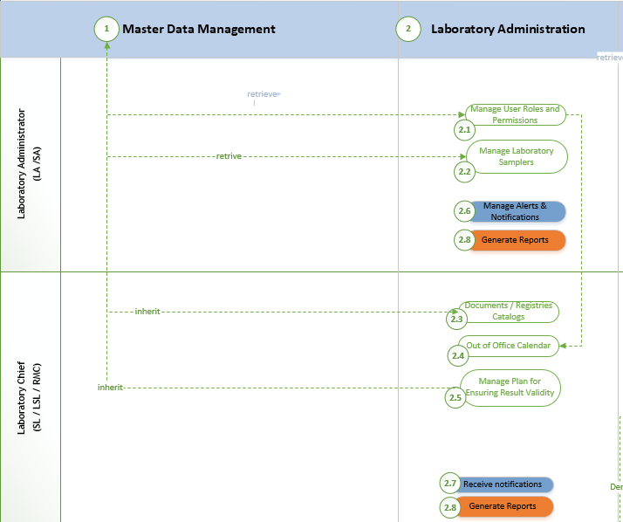
This component is designed to facilitate the creation and management of data specific to NARW laboratories, enhancing the configuration and administration of laboratory operations. Consequently, the database will store and track all essential elements of the laboratory, including:
- The Users Administration (UC2.1) section will inherit roles, permissions, and user groups from the Master Data Management Module and allow customization at the laboratory level. This inherited database will be expanded to include laboratory-specific elements, such as:
Attribute | Attribute description
Reference to Master Data Users Catalog | Link to core user profile
Deputy 1 | This attribute identifies an individual designated to replace another person during out-of-office periods (such as medical leave or holidays). By default, when the "Primary" user is marked as out-of-office, the system automatically transfers all permissions to the assigned Deputy 1.
Deputy 2 | This attribute designates an individual who will replace another person during out-of-office periods, such as medical leave or holidays. By default, when both the "Primary" user and Deputy 1 are marked as out-of-office (as per the Out of Office Calendar), the system automatically transfers all permissions to the designated Deputy 2.
- The expected LIMS will allow the Laboratory Administrator (LA) to retrieve the Samplers catalog (imported from the ASIS system) along with associated information in Manage Laboratory Samplers process (UC2.2). Administrators shall have the capability to select and assign samplers to the laboratory or create new entries if necessary. During management process, the system will enable authorized users to modify assignments as needed, while also ensuring that all changes are tracked, and historical data stored.
- The Documents/Registries Catalog (UC2.3) shall build upon and enhance laboratory-specific document templates derived from the Master Data Management Module, while enabling individual laboratories to independently manage their own templates.
Attribute | Attribute description
Reference to Master Data Documents Catalog | Inherit the unique identifier assigned by LIMS from the Core Documents Catalog whenever the Laboratory Administrator creates a new laboratory document.
Preview core template | The capability to preview the core document template in read-only mode, allowing users to decide whether to use the original template or create an extended version by cloning and adapting it to specific needs.
Reference to Laboratory | Details such as code, name, and description of the laboratory and its associated ABA affiliation.
Laboratory Code | Unique identifier laboratory specific (e.g. “ 01”)
Laboratory Document | A version inherited from the core template, adapted to meet specific laboratory requirements.
Reference to other Documents | Links to core or laboratory-specific registered documents as required.
Retention period | Defines the length of time that specific documents must be retained and accessible before they are eligible for archiving or disposal. This period is often determined by regulatory, legal, or operational requirements and varies depending on the type of data, document, or record.
Version | Automatically proposed by the system and manually adapted if necessary
Alerts & Notification Reference | Enables scheduling of alerts or dispatching notifications to communicate document registration events. This integration ensures timely communication to relevant users and administrators, allowing for proactive tracking and acknowledgment of newly registered documents or updates.
Audit Trail information | Represents all relevant audit trail attributes must be considered, such Created Date, Action, Modified Date, Modified By etc.

In conjunction with the Documents Catalog, the Laboratory Chief will define laboratory-specific codes and document references to manage and process digital records, functioning as an "electronic registry." During this process, the Laboratory Chief will have the capability to select relevant core information from the centralized registry catalog established at the NARW level, utilizing data stored in the Master Data component.

Attribute | Attribute description
Reference to Master Data Registry Catalog | Number, unique identifier assigned by LIMS for Core Registry Catalog
Reference to Laboratory | Details such as code, name, and description of the laboratory and its associated ABA affiliation.
Laboratory Code | Unique identifier laboratory specific (e.g. “ 01”)
Reference for Compliance | References to documents providing evidence of compliance and conformity, if required.
Audit Trail information | Represents all relevant audit trail attributes must be considered, such Created Date, Action, Modified Date, Modified By etc.
- The Out of Office Calendar (UC2.4) will serve as a straightforward database where key personnel in the LIMS (Laboratory Information Management System) can input their planned periods of unavailability. This allows for the assignment of deputies to ensure that laboratory workflow processes remain uninterrupted.
Attribute | Attribute description
Reference to Master Data Users Catalog | Link to core user profile
Period | The start and end dates indicate when the user will be unavailable.
Justification | This attribute represents a brief text explanation of an individual's unavailability, such as a holiday or medical leave.
- The "Manage Plan for Ensuring Result Validity" (UC2.5) process will create, store, plan, and track laboratory-specific data, including standards and methods for sample analysis, yearly protocol planning, and the establishment of indicators or indicator groups with specific limits based on equipment and laboratory requirements.
Each NARW laboratory applies its own specific analysis methods and standards for laboratory testing procedures, which covers the selection, verification, and validation of analytical methods (referred to as "Analysis Standards" or “Analysis Method” though terminology may vary by laboratory). This encompasses a comprehensive set of protocols aimed at ensuring consistent and reliable outcomes across various analyses. These protocols are essential for maintaining the integrity of laboratory results, ensuring compliance with regulatory standards, and supporting quality assurance and control processes. For more details, refer to Annex 6, which provides a sample analysis of Standards by Indicator from one of the NARW Laboratories. In addition to analytical methods and standards, each laboratory must establish and maintain specific limits, such as detection limits, quantification limits, and associated uncertainties for each indicator or indicator class. Each method should be tailored to meet the unique requirements of the laboratory. Therefor at laboratory level the indicators database should encompass the following components:
Attribute | Attribute description | Notes
Class (group) of indicators | Reference to class of indicators catalog part of Master Data Module | No modifications are permitted at the laboratory level; limits must be inherited directly from the Master Data catalogs.
Indicator | Reference to indicator catalog part of Master Data Module | No modifications are permitted at the laboratory level; limits must be inherited directly from the Master Data catalogs.
Standard | References to the standard code (e.g., SR EN 14407:2014) and associated documents that provide evidence of compliance and conformity, as needed. | Additions and/or changes are permitted solely at the laboratory level due to its unique specifications.
Limits | Reference to the assigned limits for indicators, as defined in the Master Data catalogs extracted from ECA-RO system which is owned and managed by GMPRA unit. | Limits for indicators are derived from the Master Data catalogs provided by ECA-RO. However, any modifications at the laboratory level must be permitted, with a notification sent to GMPRA.
Audit Trail information | Represents all relevant audit trail attributes must be considered, such Created Date, Action, Modified Date, Modified By etc.
In a Laboratory Information Management System (LIMS), the database structure for Analysis Methods (or Standards) should be designed to thoroughly capture both the methods themselves and key performance parameters, including quantification limits and measurement uncertainty. Below is a reference example of how this database table could be organized for effective data tracking and analysis:
Key element | Type | Description
Method ID | Number, unique identifier | Unique identifier for each analytical method.
Method Name | Text | Descriptive name of the analytical method (e.g., “ICP-MS for Heavy Metals Analysis”).
Indicator ID | Number, unique identifier (referencing Indicators table) | Links the method to the specific indicator(s) or classes of indicators it is used to analyze (e.g., metals, organics).
Description | Text | Detailed description of the method, including any special handling requirements.
Standard Reference | Number, unique identifier (referencing Standards table) | Reference to the standard protocol or guidelines followed (e.g., ISO, EPA, ASTM standards).
Detection Limit | Decimal | Minimum detectable concentration or value for the method.
Quantification Limit | Decimal | Minimum quantifiable concentration or value with acceptable accuracy for the method.
Measurement Uncertainty | Decimal | Estimated uncertainty in measurements associated with this method, typically given in a specific range (e.g., ±2%).
Validation Date | Date | Date on which the method was last validated or verified
Calibration Frequency | Number | Interval (in days) between required calibrations of the method or equipment used. This element may vary from standard to standard.
Associated Equipment ID | Number, unique identifier (referencing Equipment table) | Links the method to specific equipment necessary for the analysis.
Lab-Specific Customization | Specific format (ex JSON) | Field to capture any lab-specific customizations, such as adjustments to detection limits or calibration details.
Status | Enum (e.g., Active, Inactive, Under Review) | It indicates the status of the method for tracking lifecycle stages.
Notes /Remarks | Text | Additional information or notes related to method usage, limitations, or troubleshooting.
References | Number, unique identifier (referencing Documents table) | Any related document reference.
Audit Trail information |  | Represents all relevant audit trail attributes must be considered, such Created Date, Action, Modified Date, Modified By etc.
The following format provides a structure which shall be considered as reference for the LIMS database, supporting flexible and comprehensive tracking of data for each analysis method. This layout forms a strong foundation for performance monitoring, regulatory compliance, and optimized lab operations.
Method ID | Method Name | Indicator ID / Code | Description | Standard Reference | Detection Limit (value) | Detection Limit (UM) | Quantification Limit (value) | Quantification Limit (UM) | Measurement Uncertainty
1 | ICP-MS Heavy Metals Analysis | 101 | Analyzes trace metals in water | EPA 6020A | 0.5 | µg/L | 1.0 | µg/L | ±1.5%
Validation Date | Calibration Frequency | Associated Equipment ID | Lab-Specific Customization | Status | Notes | References
2024-10-01 | 180 | 205 | {"Detection Limit": "0.6 µg/L for Pb"} | Active | Follow handling SOP | Internal documents references

Note: The Laboratory Chief must use LIMS to establish the following year’s Plan for Ensuring Result Validity (UC2.5) by cloning the current plan, making necessary adjustments, and scheduling it as active by default when required. For a clearer understanding of how standards and analysis methods are applied in the laboratory for sample analysis validation as part of the monitoring plan, please refer to the elements outlined in Annex 1: Sample Monitoring Plan for Ensuring Result Validity.
Interoperability with support processes: For each core process outlined above, the Laboratory Administrator (LA) will have the ability to configure alerts and notifications (UC2.6) to be sent to relevant groups based on their specific areas of interest. This will enable proactive monitoring and resolution of potential issues, such as unassigned backup personnel (UC2.4), unconfigured internal registries, samplers not assigned to the laboratory in the UC2.2 process, or delays in the result validity plan established by the Laboratory Chief in (UC2.5). Additionally, the Laboratory Administrator will have access to generate various types of reports (UC2.8) related to their activities, such as lists of users and laboratory permissions, user status, and laboratory user activity tracking.
The Laboratory Chief will receive alerts and notifications (UC2.7) configured by the Laboratory Administrator, triggering mandatory actions based on predefined processes, such as impending validation date expirations, equipment not linked to any standard or method, or unestablished limits for assigned laboratory indicators. All tasks and actions will be recorded in the audit trail component. Both the Laboratory Administrator and Laboratory Chief can generate reports related to these tasks. Reports accessible to the Laboratory Chief may include a variety of details, such as out-of-office calendar information, a list of laboratory documents with assigned registry codes, a comparison of the current year’s result validity plan against the previous year and so on.

Laboratory Administration Functional Requirements (the 2nd IT component outlined in the Scope of Services chapter)

The following functional requirements should be regarded as the minimum standards, focusing on the components detailed above in the current chapter. These requirements will serve as the foundation and may consider, as needed, additional relevant aspects, which will be further enhanced and refined in collaboration with the Consultant during the analysis phase. The approach must ensure alignment with project goals while incorporating the Consultant's detailed analysis, insights, and industry best practices.

Seq.  No. | Functional requirement shall include, as necessary, and without being limited to, the following requirements:
12 | LABORATORY ADMINISTRATION  Serves as the interface for managing laboratory internal / external orders, encompassing user roles, permissions, workflows, data catalogs, and system configurations to ensure streamlined and secure process management.
12.1 | The system must support the management and access setup for laboratory personnel, including administrators, laboratory chief, operators, and verifiers. It must be integrated with the Master Data Management Module to allow flexible expansion of user groups and permissions.
12.2 | The system must provide an intuitive interface for authorized users to maintain an "unavailability" calendar (e.g., out-of-office). This calendar must be integrated into the system to influence operational task assignments.  The system must include validation mechanisms to ensure that task assignments, whether initiated by the Laboratory Chief or a laboratory operator, consider calendar entries to prevent conflicts or errors.
12.3 | The system must support the assignment and management of at least two deputies for critical roles, such as the Laboratory Chief. Deputies must oversee operational duties during the Chief's absence. The system must integrate seamlessly with the "Out of Office" calendar and deputy assignments, ensuring uninterrupted laboratory operations.
12.4 | The system must maintain detailed audit logs of user activities, capturing timestamps, actions performed, and data modifications. Authorized users must have access to these logs via the Laboratory Administration module for compliance and traceability purposes.
12.5 | The system must enable the export of audit logs filtered by a dynamically defined period in Excel format. This feature is crucial for supporting audits conducted by the Laboratory Chief.
12.6 | The system must support the setup and configuration of lab-specific registries derived from the main organizational registries established in Master Data Module. These registries must include both internal-use-only versions (e.g., F-RS-3) and standard templates linked to the Master Data Module (see Table 2 below). The system must replicate current manual methods that follow internal naming conventions and procedures, ensuring consistency with existing practices.
12.7 | The system must support the setup and management of a document template catalog at the laboratory level, inheriting from the Master Data catalogs. It must be flexible, allowing laboratories to configure their own templates, such as report formats, tailored to meet their specific requirements. The Test Report document template serves as an example of the required functionality (see Table 3 below).
12.8 | The system must enforce access control rules and data validation based on the access rights and records managed in the core master data provided by ECA-RO in read-only mode. The interface must prevent modifications to primary data, while allowing laboratory administrators to create new entries based on existing records in the Master Data.
12.9 | Master Data Catalog Change Request Workflow  The system must provide an integrated, easy-to-use workflow that allows users to request changes to the Master Data Catalogs, directed at the System Administrator. The workflow must include automatic alerts and notifications throughout the entire approval process, from initiation to completion.  For example, the change request process may apply to catalogs such as Indicators, Standards, or Methods.
12.10 | The system must enable the creation, storage, planning, and tracking of laboratory-specific data, including but not limited to:  - Standards and methods for sample analysis.  - Yearly protocol planning.  - Indicators or indicator groups with specific limits defined by equipment and laboratory requirements.  For laboratories managing many indicators (e.g., over 200), the system interface must be highly user-friendly and intuitive. It must enable the Laboratory Chief to efficiently manage indicators by category, allowing for the straightforward configuration of minimum and maximum limits for each indicator.
12.11 | The indicator database at the laboratory level must encompass at minimum components such as analytical methods, standards, detection and quantification limits, uncertainty values and categories or classifications for indicators.  The system MUST support the establishment and management of specific limits for each indicator or indicator group, including at minimum: detection limits, quantification limits and associated uncertainties.  These limits MUST be customizable to meet the unique requirements of each laboratory, ensuring compliance with regulatory standards and quality assurance protocols.
12.12 | The system must allow the Laboratory Administrator (LA) to configure alerts and notifications for each core process. These alerts should be sent to relevant groups based on their areas of interest and assigned responsibilities. The LA should be able to set notifications for:  - Unassigned backup personnel (Process UC2.4)  - Unconfigured internal registries  - Samplers not assigned to the laboratory (Process UC2.2)  - Delays in the result validity plan established by the Laboratory Chief (Process UC2.5)
12.13 | The system must enable proactive monitoring of core processes by notifying the relevant stakeholders of issues like unassigned personnel, missing configurations, and delays. This will allow for timely resolution of potential problems.
12.14 | The Laboratory Administrator must be able to generate a variety of reports related to their activities, including but not limited to:  - Lists of users and laboratory permissions  - User status and activity tracking within the laboratory  - Laboratory user activity history
12.15 | The Laboratory Chief must be able to generate reports related to their tasks and responsibilities. These reports can include:  - Out-of-office calendar information for laboratory personnel  - A list of laboratory documents with assigned registry codes  - A comparison of the current year’s result validity plan against the previous year  - Equipment validation status and other relevant operational reports
12.16 | The Laboratory Chief must receive alerts and notifications configured by the Laboratory Administrator, triggering mandatory actions. Examples of alerts include:  - Impending validation date expirations  - Equipment not linked to any standard or method  - Unestablished limits for assigned laboratory indicators
12.17 | All tasks and actions performed, including alerts triggered and mandatory actions taken, must be recorded in the audit trail component to ensure compliance, traceability, and accountability.
12.18 | The system must allow for the customization of notifications and alerts based on key performance indicators (KPIs) such as the timeliness of regulatory compliance, system status, and other critical actions defined by the laboratory’s operating procedures.
12.19 | The system must ensure that all reports generated by both the Laboratory Administrator and Laboratory Chief provide accurate, real-time, and consistent data across processes. Any discrepancies or areas requiring attention must be clearly highlighted in the interface using visual cues such as red font, alerts, or warning notifications.
12.20 | The interface must allow for the bulk application of details based on filtered data. For example, if specific attributes, such as limits, need to be applied to multiple indicators, users can first apply search filters to select all relevant indicators and then apply the changes to all selected indicators at once.

Table 2- Registries inherit their structure and content from document catalogs and are customized with laboratory-specific documents and information to meet the unique needs of each laboratory.
Register (or Document) | Given Code  (primary) | Laboratory Code  (assigned by Laboratory Admin) | Laboratory Register Code
Laboratory Register for External Orders | RL-7.1 | 01 | RL-7.1-01
Laboratory Register for Internal Correspondence | not applicable | F-RS-3 | F-RS-3
Laboratory Register for Complains | RL-7.9 | 01 | RL-7.9-01
Laboratory Register for Samples  (Registration of Test Reports) | RL-7.4 | 01 | RL-7.4-01
Laboratory Register for Samples - RIVERS | RL-7.4 | 02 | RL-7.4-02
Laboratory Register for Samples - LAKES | RL-7.4 | 03 | RL-7.4-03
Laboratory Register for Samples GROUNDWATER | RL-7.4 | 04 | RL-7.4-04
Laboratory Register for Samples WASTEWATER | RL-7.4 | 05 | RL-7.4-05
Laboratory Register for Samples ACCIDENTAL POLLUTION / CHECKS | RL-7.4 | 06 | RL-7.4-06
Laboratory Register for Samples MACRONEVERTEBRATES | RL-7.4 | 07 | RL-7.4-07
Laboratory Register for Samples PHYTOPLANKTON FROM RIVERS | RL-7.4 | 08 | RL-7.4-08
Laboratory Register for Samples - PHYTOPLANKTON FROM LAKES | RL-7.4 | 09 | RL-7.4-09
Laboratory Register for Samples - BENTHOS | RL-7.4 | 10 | RL-7.4-10
Laboratory Register for Samples - Metal Analysis | RL-7.4 | 11 | RL-7.4-11

Table 3 – Examples of extended "TEST REPORT" template tailored for laboratory-specific analysis.
Document Name | Owner | Given Code (primary) | Laboratory Code | Document Code | Retention  Period
Test Report | Laboratory Administrator | FL-7.8 | - |  | 4 YEARS
Simplified Physico-Chemical Test Report | Laboratory Administrator | FL-7.8 | 01 | FL-7.8-01 | 4 YEARS
Simplified Test Report for Metal Analysis | Laboratory Administrator | FL-7.8 | 03 | FL-7.8-03 | 4 YEARS
Simplified Test Report for Micropollutant Analysis | Laboratory Administrator | FL-7.8 | 04 | FL-7.8-04 | 4 YEARS
Simplified Test Report for Biological Analysis of Rivers | Laboratory Administrator | FL-7.8 | 05 | FL-7.8-05 | 4 YEARS
Simplified Test Report for Biological Analysis of Lakes | Laboratory Administrator | FL-7.8 | 06 | FL-7.8-06 | 4 YEARS

Laboratory Inventory Management (the 3rd IT component outlined in the Scope of Services chapter)

For effective LIMS implementation, the Laboratory Inventory Management module should provide real-time, comprehensive visibility into laboratory equipment and materials. This component must support efficient tracking, precise reporting, and compliance with regulatory standards.
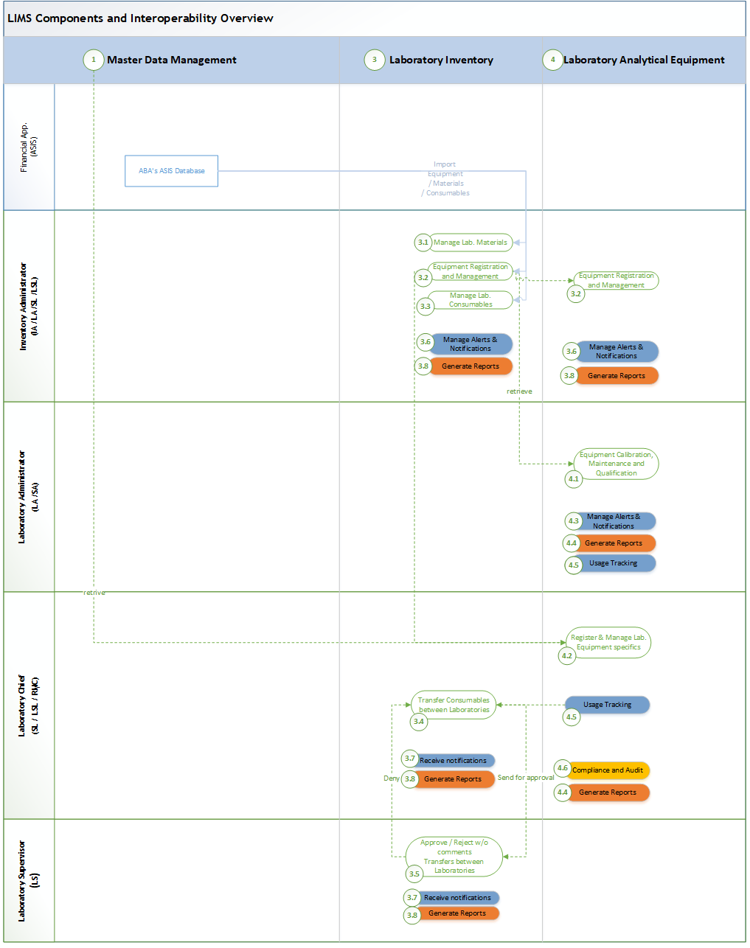
Figure 2 illustrates the processes of both the Laboratory Inventory (3) and Analytical Equipment (4) components, highlighting their interdependence and due potential for overlapping within a single component.
- The Manage Laboratory Materials process (UC3.1) involves extracting all laboratory materials from the existing financial system, ASIS, distributed across each ABA unit, with the ability to add new materials. These materials will be stored and monitored centrally at the laboratory, ABA, or NARW level, depending on the permissions granted to the Inventory Administrator. The system will track stock levels and usage of materials critical to laboratory operations, categorizing them into groups such as solvents, reagents, and others, to ensure efficient management and availability.
Attribute | Attribute description
ID | Number, unique identifier assigned by LIMS
ABA | Specifies the code (abbreviation) of the basin administration name of the laboratory, including unit details.
SGA | Specifies the code (abbreviation) of the water quality laboratory, including unit details.
Material Category | Classifies each item within the inventory based on its type or purpose, such as solvents, acids, reagents, or reference materials, enabling organized tracking and streamlined inventory management.
Product Name | Identifies the specific name of the product in the inventory. Additional contextual information, such as the type of product, may be included for easy categorization. An example of a product could be "Phosphoric Acid, 100 mL".
Packaging Type | Specifies the type and version of packaging used for the product, helping track packaging details that may be necessary for certain versions or batch records.
Catalog Code | A unique identifier (ID) assigned to each product, enabling efficient relational referencing across catalogs and facilitating quick lookups.
Manufacturer | The name of the entity that produced the product, providing traceability for sourcing and quality control.
Supplier | The entity supplies the product to the laboratory. This is essential for tracking supply chain and ensuring timely restocking.
Expiration Date | The date by which the product should be used, supporting quality control and ensuring only valid materials are used in testing processes.
Stock Quantity  (with real-time updates) | Tracks the current quantity of each product in inventory, with real-time updates to support accurate stock management and prevent shortages or overstock.
Inventory Entry and Exit Dates | Records the dates when products enter and exit the inventory, facilitating historical tracking and trend analysis for inventory turnover rates.
Usage Data | Logs consumption rates and usage data for each product, supporting planning and budgeting based on usage trends.
Funding Source | Identifies the source of funding for each inventory item, ensuring appropriate allocation and tracking of budget resources.
Stock Modification Justifications | Provides reasons for any changes to stock levels, such as adjustments, write-offs, or reallocations, to maintain accountability and accurate record-keeping.
Audit Trail information | Represents all relevant audit trail attributes must be considered, such Created Date, Action, Modified Date, Modified By etc.
- The Equipment Registration and Management process (UC3.2) involves extracting all laboratory equipment units from the existing financial system, ASIS, distributed across each ABA unit, with the ability to add new ones if needed. Laboratory Equipment will be registered, stored and monitored centrally at the laboratory, ABA, or NARW level, depending on the permissions granted to the Inventory Administrator. The system will track equipment usage, maintenance schedules, calibration statuses, and lifecycle information, categorizing equipment into groups such as analytical instruments, lab devices, and other essential tools. This approach ensures that laboratory operations are supported by well-maintained and available equipment, with full visibility into each item's status and history across the laboratory, ABA, or NARW level, depending on the granted permissions. The equipment attributes are detailed in the following chapter, 3.2.5 "Laboratory Analytical Equipment".
- The Laboratory Consumables Management process (UC3.3) involves extracting all laboratory consumables critical for laboratory operations from the existing financial system, ASIS, distributed across each ABA unit, with the ability to add new items if needed. Consumables will be registered, stored and monitored centrally at the laboratory, ABA, or Central level, depending on the permissions granted to the Inventory Administrator. The system will track stock levels, usage patterns, expiration dates, and reordering needs for all consumables critical to laboratory operations. Consumables will be categorized into groups such as chemicals, disposables, and other materials, ensuring efficient inventory management. The system will provide visibility into the availability and usage of consumables across the laboratory, ABA, or NARW level, depending on the granted permissions, to maintain seamless operations and prevent shortages.
Attribute | Attribute description
ID | Number, unique identifier assigned by LIMS
ABA | Specifies the code (abbreviation) of the basin administration name of the laboratory, including unit details.
SGA | Specifies the code (abbreviation) of the water quality laboratory, including unit details.
Product Name | Identifies the specific name of the product in the inventory. Additional contextual information, such as the type of product, may be included for easy categorization. An example of a product could be "Vârfuri pipetă 5mL Brand".
Stock Quantity  (with real-time updates) | Tracks the current quantity of each product in inventory, with real-time updates to support accurate stock management and prevent shortages or overstock.
Catalog Code | A unique identifier (ID) assigned to each product, enabling efficient relational referencing across catalogs and facilitating quick lookups.
Manufacturer | The name of the entity that produced the product, providing traceability for sourcing and quality control.
Supplier | The entity supplies the product to the laboratory. This is essential for tracking supply chains and ensuring timely restocking.
Expiration Date | The date by which the product should be used, supporting quality control and ensuring only valid materials are used in testing processes.
Inventory Entry and Exit Dates | Records the dates when products enter and exit the inventory, facilitating historical tracking and trend analysis for inventory turnover rates.
Usage Data | Logs consumption rates and usage data for each product, supporting planning and budgeting based on usage trends.
Stock Modification Justifications | Provides reasons for any changes to stock levels, such as adjustments, write-offs, or reallocations, to maintain accountability and accurate record-keeping.
Audit Trail information | Represents all relevant audit trail attributes must be considered, such Created Date, Action, Modified Date, Modified By etc.
- In the context of LIMS, the transfer of materials and consumables (UC3.4) between laboratories is facilitated by the system when a Laboratory Chief requests specific materials from another laboratory. If the system indicates that the required material is available, the transfer can proceed with the approval of the Laboratory Supervisor (UC3.5). The process begins when the Laboratory Chief initiates the request, which is then reviewed and approved by the Laboratory Supervisor. Once approved, the transfer is registered and tracked centrally, ensuring that both the Laboratory Chief from the requesting laboratory and the Laboratory Chief from the supplying laboratory can monitor the status. Additionally, the Laboratory Supervisor overseeing the transfer has full visibility into the process. Throughout the approval workflow, relevant reports (UC3.8) and notifications (UC3.7) are generated to keep all stakeholders informed and ensure accountability at each stage of the transfer.
Below are the primary components, though not exhaustive, that must be considered for one or more materials and/or consumables among laboratory units. For reference, the image below illustrates a document transfer model, highlighting the components marked with a yellow background.
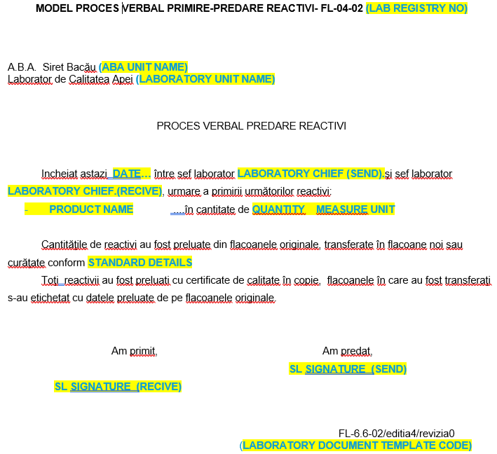
Attribute | Attribute description
ID | Number, unique identifier assigned by LIMS
Laboratory Registry Number | Autocomplete by LIMS with the next registration number from the predefined laboratory registry (referred to as FL-04-02).
ABA UNIT NAME | Specifies the name of the water quality laboratory, including unit details. In this case it represents the destination unit.
LABORATORY UNIT NAME | Specifies the name of the laboratory, including unit details. In this case it represents the destination unit.
DATE | Prefill automatically with registration date.
LABORATORY CHIEF (SEND) | The individual responsible for dispatching the products is the laboratory chief (SL).
LABORATORY CHIEF (RECEIVE) | The individual designated as the laboratory chief (SL) is responsible for receiving the products.
Product Name | Specifies the exact name of the product(s) involved in the transfer. For instance, an example of a product might be "Varfuri pipetă." Better to include the “catalog code” out of inventory – which is the unique identifier assigned to each product, enabling efficient relational referencing across catalogs and facilitating quick lookups.
Quantity | The current quantity of each product involved in the transfer.
Measure Unit | Refers to the standard unit of measurement employed to quantify a specific parameter or variable associated with a product, sample, or observation. In this context, examples of measured units include grams (g), milliliters (mL), and so forth.
Standards Reference  (STANDARD DETAILS) | This attribute specifies the standards and regulations that NARW laboratories adhere to while conducting their activities. These standards ensure compliance with industry guidelines and best practices, which are essential for maintaining the integrity and quality of laboratory work. This attribute is prefilled with the name and code of the relevant standard(s), providing clear reference points for users to understand the regulatory framework guiding laboratory operations.
Signatures | Includes the names of the parties involved, with designated spaces for physical or electronic signatures.
Laboratory Template Document Code | This attribute is a unique identifier for a specific laboratory template document, serving as a reference code to organize, retrieve, and manage various templates used for documentation within the laboratory. It enhances document handling efficiency and helps users easily locate the relevant template associated with specific processes or protocols. The values for this attribute are prefilled from the Laboratory Administration section.
Interoperability with support processes: For each core process outlined above, the Inventory Administrator (LA) will have the ability to configure alerts and notifications (UC3.6) to be sent to relevant groups based on their specific areas of interest.

Laboratory Inventory Management Functional Requirements (the 3rd IT component outlined in the Scope of Services chapter)

Below functional requirements shall be considered to digitalize the business processes outlined above in the current chapter. These requirements will form the foundation and will be refined in collaboration with the ConsultantConsultant during the analysis phase, ensuring alignment with project goals while incorporating the ConsultantConsultant's analysis, insights, and industry best practices.

Seq.  No. | Functional requirement shall include, as necessary, and without being limited to, the following requirements:
13 | LABORATORY INVENTORY MANAGEMENT  The module manages laboratory resources like chemicals, reagents, equipment, and consumables, supporting the import of stock data from financial systems. It enables the creation, updating, and categorization of inventory items, with key features including stock level tracking, material availability, movement management, and handling stock transfers and requests.
13.1 | The system must streamline and digitalize the processes outlined above, ensuring they are supported and executed in accordance with laboratory-specific requirements and access levels.  The system MUST restrict access to the inventory module exclusively to users assigned the "Inventory Administrator" role.
13.2 | The system must support varying levels of access and security for stored data based on user permissions. All entries in the laboratory inventory must be accessible in read-only mode for users affiliated with the laboratory or the ABA organizational unit to which the laboratory belongs.
13.3 | The system must facilitate the creation, management, and tracking of inventory lists and stock records for each laboratory. It should support adding, updating, deleting items, tracking stock levels, and managing reordering processes. The functionality should support item categorization, searching, filtering, and alerting for low stock levels.
13.4 | Import Requirements for Inventory Stocks  The system must facilitate the seamless import or direct retrieval of annual stock details from central and/or regional financial IT systems (ASIS). The import must at least stock information, such as:  - Product Code  - Product Name  - Measure Unit  - Quantity  - Catalog Code  - Lot Number  - Expiration Date  - Manufacturer  - Consultant  - Basin Administration Name (e.g., “Central”, “ABA Siret”)  - Laboratory Name (e.g., LN)  - Laboratory Location (e.g., 1st floor)
13.5 | In addition to data import, the system must allow users to download a template for stock entries and provide the option to import completed Excel files if direct import is unavailable for a specific ABA.
13.6 | The system must display imported entries in a table view, enabling end users to modify or correct them directly on that page. Upon successful validation, the system must "freeze" the data by changing the status from editing mode to read-only mode.
13.7 | The system must provide appropriate validations for update and delete actions on any data entity, including ensuring attributes such as catalog code or lot number are unique.
13.8 | The system must allow end-users to track stock levels organized by laboratories and grouped by categories. It should generate monthly and yearly summary reports, detailing actions such as entries, transfers, and exits.
13.9 | The system must by default reflect material stock availability and movements, including inventory entries and exits, with identification of personnel responsible for modifications.
13.10 | The system must send timely notifications and alerts for events such as impending product expirations (e.g., three months in advance), low stock levels, and stock transfer requests. These alerts should be managed by authorized personnel based on predefined intervals within the integrated Alerts & Notifications module.
Transfers between Laboratories
13.11 | The system MUST support the creation, updating, assignment, and closing requests for material transfers and equipment spare parts, electronically facilitating the process. Each transfer request should trigger a workflow with alerts and notifications for relevant stakeholders.
13.11.1 | Upon the issuance of a request, the system must verify the availability of requested products and automatically forward the request for approval to authorized laboratory users.
13.11.2 | The system must support different types of requests, including stock transfers and spare parts requests.
13.11.3 | The system must ensure unique identification of requests and centralize request data for tracking and management.
13.11.4 | The system must enable users to prioritize requests based on priority level and provide flexibility to modify priorities as needed.
13.11.5 | The system must enable the association of necessary details and notes with respective requests.
13.11.6 | Authorized users must have full access to relevant information, including request details, stages, actions, and associated resources. For example, a Laboratory Supervisor may have this level of access.
13.11.7 | The system must maintain a complete history of requests, including their resolutions.  Closed requests must remain accessible for monitoring and verification purposes.
13.11.8 | The system must record activities related to registered or under-review requests, including notes, comments, the person making the entry, and timestamps.
13.11.9 | The system MUST allow authorized users to print and export stock queries and reports in multiple formats (e.g., Excel, PDF) for local (ABA or laboratory level LCA) and national levels, with capabilities for customized queries.  Refer to the sample reports provided in the "Stage 0: Inventory Setup" section of Annex 1.
13.11.10 | The system MUST allow the generation of detailed inventory status reports, accessible to authorized personnel such as the Inventory Manager, Laboratory Chief, and/or Laboratory Supervisor. These reports should offer insight into stock levels, usage trends, and availability across laboratories.

Laboratory Analytical Equipment (the 4th component outlined in the Scope of Services chapter)

In the context of the LIMS, the Laboratory Analytical Equipment component plays a critical role in managing and centralizing all measurement equipment utilized across NARW laboratories. This component ensures that all equipment is systematically categorized within the Master Data Management system, with predefined categories such as chromatography, atomic absorption, and/or mass spectrometry. The LIMS integrates equipment management with related processes, as shown in Figure 2 under the Laboratory Inventory chapter. This integration allows the system to:
- Maintain an up-to-date inventory of analytical equipment across all NARW laboratories.
- Track equipment attributes, such as maintenance schedules, calibration records, and assigned laboratory locations.
- Ensure that equipment is linked to specific methods and standards critical to analytical processes.
- Facilitate alerts and notifications related to equipment status, such as upcoming maintenance or calibration due dates.
For the distribution of all analytical equipment across NARW laboratories, please refer to Annex 3, which includes the list of NARW Laboratory Equipment.
Attribute | Attribute description
ID | Number, unique identifier assigned by LIMS
ABA | Specifies the code (abbreviation) of the basin administration name of the laboratory, including unit details.
SGA | Specifies the code (abbreviation) of the water quality laboratory, including unit details.
Equipment Category | Classify equipment by type, such as chromatography, atomic absorption, or spectrometry, allowing for organized tracking within broader equipment groups.
Equipment Name | The specific name or model of the equipment provides a clear identifier for each item in the inventory.
Equipment Serial Number | A unique serial number assigned by the manufacturer, ensuring precise identification and tracking of each individual piece of equipment.
Purchase Year | The year the equipment was acquired, supporting lifecycle management, depreciation tracking, and planning for future upgrades or replacements.
Equipment Manufacturer | Identifies the manufacturer of the equipment, useful for warranty, support, and compatibility tracking.
Consultant | The vendor or Consultant from whom the equipment was purchased, facilitating procurement records and Consultant management.
Quantity (number of units) | Indicates the total number of units available in the inventory, aiding in tracking overall laboratory capacity and resource allocation.
Operational Status | Current functional status of the equipment, such as “operational,” “under maintenance,” or “decommissioned,” helping in scheduling and availability planning.
Maintenance Observations | Logs any maintenance activities, observations, or issues related to the equipment, supporting maintenance scheduling and equipment longevity.
Usage Methods | Specifies standard methods or protocols for equipment use, ensuring consistent operation and adherence to laboratory procedures.
Laboratory specific details | Details prefill by Laboratory Chief imply attributes such physical location, place, assigned to laboratory personnel.
Audit Trail information | Represents all relevant audit trail attributes must be considered, such Created Date, Action, Modified Date, Modified By etc.
- The Equipment Calibration, Maintenance, and Qualification (UC4.1) process ensures that laboratory equipment remains reliable and compliant with operational standards. The Laboratory Administrator is responsible for scheduling regular calibrations to verify that all equipment functions within specified tolerances. The system will:
  - Track calibration schedules throughout established alerts (UC4.3).
  - Notify designated personnel of upcoming calibration tasks, throughout established notifications (UC4.3).
  - Log and store calibration results (UC4.5), linking them directly to the corresponding equipment in the LIMS for traceability and compliance (UC4.6).
This process may serve as the basis for the Laboratory Chief to initiate QA (Quality Assurance) and QC (Quality Control) orders as part of process UC5.5 illustrated in Figure 1.
- Only the Laboratory Chief is authorized to register laboratory equipment (UC4.2) by selecting items from the existing list provided by the Inventory Administrator. This process ensures alignment with laboratory-specific requirements, such as assigning physical locations within the laboratory, designating responsible personnel, and establishing references for the calibration, maintenance, and qualification of the equipment.
Interoperability with support processes: For both core processes outlined above, the Laboratory Administrator (LA) will have the ability to configure alerts and notifications (UC4.6) to be sent to relevant groups based on their specific areas of interest. For example, the Laboratory Chief may receive notifications (UC4.5) about the materials used by specific equipment, with alerts prompting them to request additional materials and/or consumables from other laboratories. By default, the system provides a list of laboratories with available consumables for easy reference. A range of reports (UC4.4) will be available to Laboratory Administrator and Chief users, depending on their permission levels. These reports may include: listing of materials and consumables, including real-time stock levels and usage history as per equipment, tracking actions taken within the system, equipment related, list all actions planned for equipment calibration, maintenance, and qualification adhere to regulatory standards, highlighting any non-compliance issues and /or statistical reports for data-driven insights on equipment performance, material usage, calibration, and maintenance trends, helping the Laboratory Administrator and/or Chief to identify patterns and optimize operations.

Laboratory Analytical Equipment Functional Requirements (the 4th component outlined in the Scope of Services chapter)

The functional requirements outlined below are essential for digitalizing the business processes described above in the current chapter. These requirements will serve as a foundational framework and may consider, as needed, additional relevant aspects, which will be further refined in collaboration with the Consultant during the analysis phase, ensuring alignment with project objectives while leveraging the Consultant's expertise, insights, and industry best practices.
Seq.  No. | Functional requirement shall include, as necessary, and without being limited to, the following requirements:
14 | LABORATORY ANALYTICAL EQUIPEMENT MANAGEMENT  The module manages laboratory analytical equipment, ensuring proper usage, calibration, maintenance scheduling, and performance monitoring, with features that include equipment registration, status tracking, usage history, and integration with laboratory workflows for optimal operational efficiency and compliance.
14.1 | Integration with Analytical Equipment: Facilitate integration with equipment capable of exporting sample results like electronic files. The future LIMS IT system must be capable of integrating with the devices listed in Annex 3 document, which contains the NARW Laboratory Equipment table. If direct technical integration between the LIMS and the equipment is not feasible due to export format limitations, a user-friendly add-on shall be developed to allow retrieval of results in a digital, trackable format, thereby minimizing manual entries and reducing human errors.  Note that the list of laboratory equipment (Annex 3) is intended for reference purposes. Some instruments are newly acquired, and details regarding software and PC integration may be incomplete. It is mandatory for the ConsultantConsultant, during the analysis phase, to thoroughly review the provided list and supplement it with any missing or additional relevant details.
14.2 | LIMS must automatically retrieve results from connected devices, whether online or offline. In offline scenarios, the system should synchronize the pipeline data entries with the central database upon re-establishing an online connection.
14.3 | Provide an intuitive interface for creating and managing mappings between analytical equipment and laboratory indicators.
14.4 | Equipment Condition Tracking and Alerts: Enable tracking of equipment conditions and the creation of alerts for instruments inactivity and maintenance periods, which shall be managed through the Alerts & Notifications module.
14.5 | The system must enable real-time updates of equipment status and details, while preserving historical information for audit purposes, provided that the equipment is capable of integration for result extraction and functionality status. For technical specifications of the instruments, refer to Annex 3 document, which contains the NARW Laboratory Equipment table.
14.6 | Generate comprehensive reports on equipment status, maintenance, and usage, incorporating historical data for informed decision-making.
14.7 | This module shall be integrated by default with the Master Data Module, retrieving primary data from existing catalog information.

Laboratory Orders Manager (the 5th IT component outlined in the Scope of Services chapter)
In NARW, four distinct order types may emerge from the business processes outlined in chapter "Stage 1: Orders Register" of Annex 1 document, focused on water quality measurement analysis. The module’s purpose is to create a database where Laboratory Chiefs (SL or LSL) can register, store, and monitor all order types—both internal (from NARW laboratories) and external (from third-party clients)—from initial registration to archiving. The module will offer tools for managing each order type at the laboratory level, including functionalities for registration, storage, modification, and tracking.
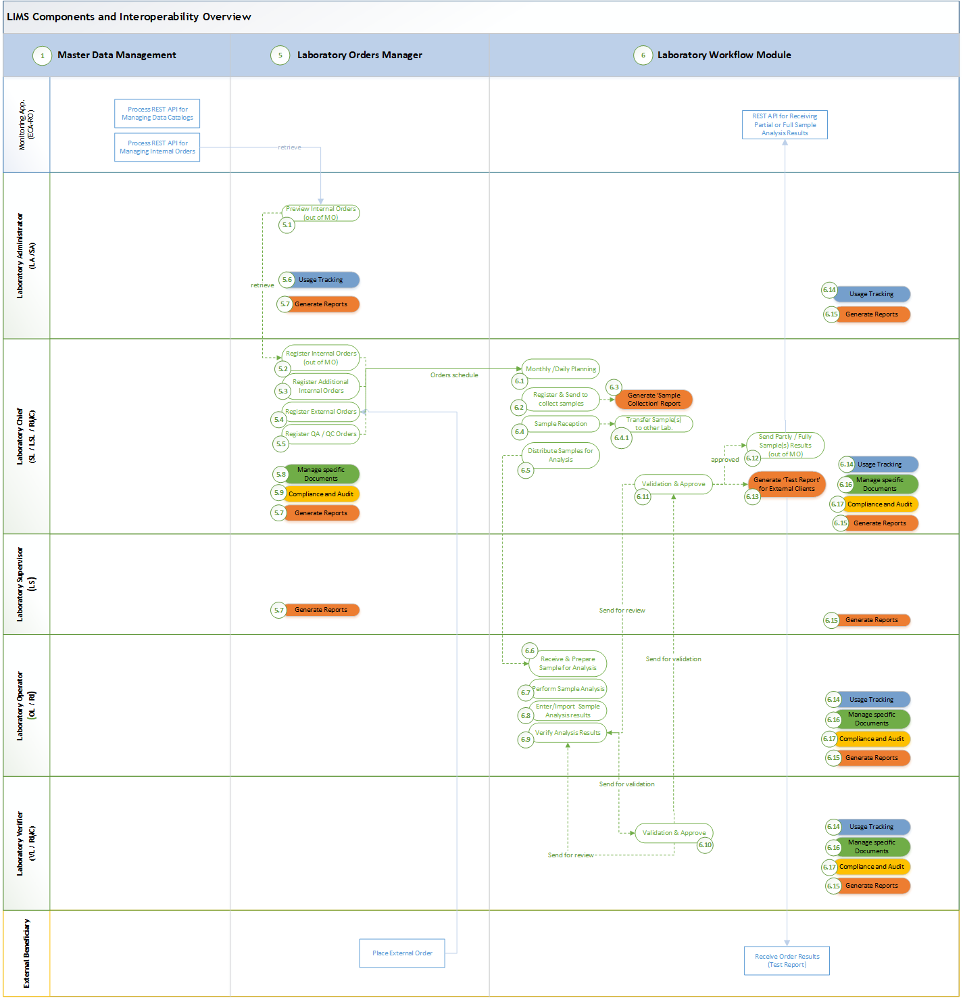
Figure 3
As part of Figure 1, above image Figure 3 illustrates the processes of both the Laboratory Orders Manager (5) and Laboratory Workflow (6) components, highlighting their interdependence and seamless integration with standard components such as Reporting, Document Manager, Alerts and Notifications, and Audit Trail. These components are visually represented with distinct markings for clarity.

Register Operating Manual Orders
As outlined in the "Internal Orders" chapter of Annex 1, the central monitoring unit (GMPRA) coordinates with local units (GRA) within the ABA to prepare the operating manuals for the upcoming year. GMPRA collects and centralizes these proposals, ensuring verification and approval before inclusion in the NARW Annual MO. Once approved, the ECA-RO system prepares MO orders internally and GMPRA notifies the LIMS Business Owner when annual orders ready be imported into the LIMS system via the ECA-RO REST API as detailed in Technical Requirements chapter (3.5).
Important: The process of gathering and consolidating data for the annual operating manual involves manual activities using Excel files and falls outside the scope of the LIMS, as highlighted in blue in the image below:
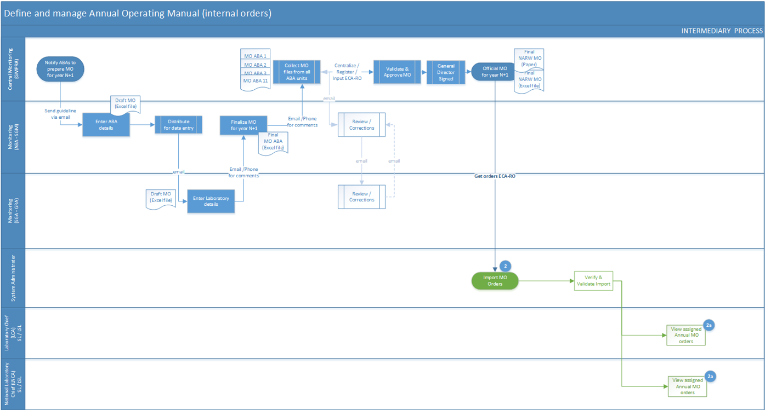
Given the complexity of the annual operating manual, as outlined and illustrated in Annex 2 regarding the templates included, it is recommended that the personnel with System Administrator role manage the order imports from the existing ECA-RO system, process emphasized in (UC1.3) Import MO Annual Internal Orders, as described above and illustrated in Figure 1.
- The (UC5.1) Preview of Internal Orders (from MO) process implies the Laboratory Administrator verifying and validating internal orders extracted from the Operating Manual (MO) to ensure they are accurate and fully retrieved from ECA-RO. The Laboratory Chief can only access these orders once they have been validated by the Administrator. If any errors or issues are identified during the validation process, the Laboratory Administrator will submit a request to the System Administrator to correct the imported data. The Administrator can only preview and validate orders for the laboratory(ies) they have access to, and the laboratory must be designated for sampling and/or sample analysis.
At any given time, the Laboratory Administrator can generate reports (UC5.7) to track the status of orders for the laboratory(ies) they are authorized to manage. Additionally, they will receive predefined alerts and notifications (UC5.6) as such when the System Administrator completes the internal orders import or when a response is received to any request raised.
Note: Predefined alerts and notifications, as well as monitoring reports for LIMS processes, will be discussed and agreed upon by the Consultant with the Beneficiary during the analysis phase.
Also, it is important to note that the details provided by the internal monitoring unit GMPRA/GRA as annual orders may vary slightly between laboratories due to their specific activities. Therefore, the Consultant should incorporate flexibility to adjust these elements based on the findings from the analysis phase and in consultation with the Beneficiary.
- The (UC5.2) Register Internal Orders (from MO) process involves the activities of the Laboratory Chief, typically carried out at the beginning of the new year (or at the end of the previous year), to ensure that all internal orders planned by the MO are correctly assigned to their laboratory. The Laboratory Chief will validate and update the records as necessary to reflect laboratory-specific details. The order list must first be validated by the Laboratory Administrator through the UC5.1 process; otherwise, it will not be available.
Using the REST API detailed Technical Requirements in chapter 3.5 from the existing system, ECA-RO, various types of internal MO orders will be received in LIMS, depending on the sample collection type, as below:

Primary Data for MO Orders
Attribute | Attribute description
ID (aka ECA-RO CODE) | A unique identifier assigned by ECA-RO, which is unique across the entire system. This identifier must be utilized by LIMS for all specific activities and sent back to ECA-RO along with all collected order details and results
Sample Collection Laboratory | This attribute designates the laboratory responsible for collecting samples from specific sections and indicators, typically using the ABA/SGA code (e.g., ABAS for ABA Siret) derived from Master Data catalogs. The National Laboratory does not participate in this activity.
Sample Analysis Laboratory | This attribute identifies the laboratory responsible for analyzing samples related to specific sections and indicators, generally utilizing the ABA/SGA code (e.g., ABAS for ABA Siret) sourced from Master Data catalogs. The National Laboratory (LNCA) receives analysis from other laboratories for this purpose.
Monitoring (aka Feature ID) | This attribute designates the monitoring unit (reference through unique ID) which sends the MO order.
Description | Text, additional details of the order.
Water Body | This attribute refers to a distinct accumulation of water, which can include various forms such as lakes, rivers and reservoirs. It encompasses several characteristics, including size, depth, surface area, and water quality parameters such as temperature, salinity, and chemical composition.  Note: Water Body as a catalog has a reference for the Water Course catalog.
Volume | Applicable for wastewaters only
Reference for Inventory unit (UI) | Reference to inventory unit’s codes and details.
Section | This attribute refers to a specific segment or subdivision of a larger environmental or geographical area, typically used for monitoring and assessing water quality and ecological conditions. A section can be defined by its physical boundaries, such as a stretch of a river, a segment of a lake, or a defined area of land surrounding a water body.  In terms of granularity, the Section Code serves as the unique identifier of the section and indicators intended for analysis under the MO in the upcoming year.
Section additional details | Offers details regarding the ecoregion, macrophyte type, latitude, longitude, and altitude of the section. This information will be included in the Sections Catalog (Master Data) sourced from ECA-RO, the IT system managed by GMPRA.
Number of Transects* | For specific section
List of indicators proposed be monitored | Referring to a comprehensive enumeration of indicators out of Master Data Catalog that are recommended for analysis in next year divided into compounds classes for a given and unique section. Indicators may include biological, chemical, and physical factors that reflect the health and quality of ecosystems or water bodies.
Audit Trail information | Represents all relevant audit trail attributes must be considered, such Created Date, Action, Modified Date, Modified By etc.
(*) A transect is a defined linear path or section within a larger area where systematic observations, measurements, or sampling are carried out. Commonly used in ecological and environmental studies, it helps assess variables such as species distribution, density, and habitat conditions. In the context of LIMS, it refers to the sampling sections or designated paths established for a study, supporting organized data collection and analysis.

Primary Data Specific to Each Sample Type
The tables above detail the primary references associated with each order, offering essential information for tracking and management.
- Primary data for physical-chemical indicators
Attribute | Attribute description
Reference for Order | Reference to the above Order table (using ECA-RO CODE as unique identifier)
Reference for Indicator | Reference through a unique ID linked to the indicator catalog within the Master Data catalogs.
Reference for Measure unit | Reference through a unique ID linked to the Measure Units (UM) catalog within the Master Data catalogs.
Reference for Calculated Formula | Reference through a unique ID linked to the Calculated Formulas catalog within the Master Data catalogs.
Measured Value (VM) | Decimal type: populated after the laboratory sends back the order with results and left empty upon registration
Limit of Quantification (LOQ) | Decimal type: populated after the laboratory sends back the order with results and left empty upon registration
LOQ_2 | Mark if lower than LOQ value
Reference for Investigation Environment | Reference through a unique ID linked to a table which keeps all Investigation Environment attributes.
Reference for Species | Reference through a unique ID linked to a table which keeps all-knowing Species.
Subsample | Free text for additional details related order.
Audit Trail information | Represents all relevant audit trail attributes must be considered, such Created Date, Action, Modified Date, Modified By etc.
- Primary data for macroalgae
Attribute | Attribute description
Reference for Order | Reference to the above Order table (using ECA-RO CODE as unique identifier)
Reference for Biological Element | Reference through a unique ID linked to the Biological Element catalog within the Master Data catalogs.
Reference for Species | Reference through a unique ID linked to a table which keeps all-knowing Species.
Density | Decimal type: populated after the laboratory sends back the order with results and left empty upon registration
Biomass | Decimal type: populated after the laboratory sends back the order with results and left empty upon registration
Audit Trail information | Represents all relevant audit trail attributes must be considered, such Created Date, Action, Modified Date, Modified By etc.
- Primary data for ichthyofauna (fish fauna)
Attribute | Attribute description
Reference for Order | Reference to the above Order table (using ECA-RO CODE as unique identifier)
Reference for Sample Collection type | Reference through a unique ID linked to the Sample Collection type catalog within the Master Data catalogs.
Reference for Species | Reference through a unique ID linked to a table which keeps all-knowing Species.
Total No of Units (individuals) | Decimal type: populated after the laboratory sends back the order with results and left empty upon registration
Total Biomass | Decimal type: populated after the laboratory sends back the order with results and left empty upon registration
No of Small Units (individuals) | Decimal type: populated after the laboratory sends back the order with results and left empty upon registration
Biomass for small individuals | Decimal type: populated after the laboratory sends back the order with results and left empty upon registration
No of Big Units (individuals) | Decimal type: populated after the laboratory sends back the order with results and left empty upon registration
Biomass for big individuals | Decimal type: populated after the laboratory sends back the order with results and left empty upon registration
Audit Trail information | Represents all relevant audit trail attributes must be considered, such Created Date, Action, Modified Date, Modified By etc.
- Primary data for macrophytes
Attribute | Attribute description
Reference for Order | Reference to the above Order table (using ECA-RO CODE as unique identifier)
Reference to Transect | Reference through a unique ID linked to the Transections catalog within the Master Data catalogs.
Reference for Inventory unit (UI) | Reference to inventory unit’s codes and details.
Value | Decimal type: populated after the laboratory sends back the order with results and left empty upon registration
Biomass | Decimal type: populated after the laboratory sends back the order with results and left empty upon registration
Audit Trail information | Represents all relevant audit trail attributes must be considered, such Created Date, Action, Modified Date, Modified By etc.

Register Additional Internal Orders

In special cases, such as accidental discharges or unforeseen circumstances, the GMPRA/GRA unit may issue additional orders outside the standard operating manual. These additional internal orders, as illustrated in Figure 3 under (UC5.3) Register Additional Internal Orders, typically include attributes outlined in the "Stage 1: Orders Register" chapter of the Annex 1 document. However, they also allow the Laboratory Chief the flexibility to register the orders directly in LIMS with only the minimum required attributes. The specific mandatory and optional attributes will be refined by the Consultant collaboration with the Beneficiary’s assigned team during the analysis phase.
Attribute | Attribute description
ID | Number, unique identifier assigned by LIMS
Sample Collection Laboratory | This attribute designates the laboratory responsible for collecting samples from specific sections and indicators, typically using the ABA/SGA code (e.g., ABAS for ABA Siret) derived from Master Data catalogs. The National Laboratory does not participate in this activity.
Analysis Laboratory | This attribute identifies the laboratory responsible for analyzing samples related to specific sections and indicators, generally utilizing the ABA/SGA code (e.g., ABAS for ABA Siret) sourced from Master Data catalogs. The National Laboratory (LNCA) receives analysis from other laboratories for this purpose.
Reference for the System | Denotes the types of water within the system (or subsystem) catalog, with possible values including surface water, groundwater, wastewater, and pollution, as specified in the MO instructions issued by GMPRA.
Type of investigation | Indicates the type of investigation for indicators proposed for analysis within the system or subsystem catalog. Possible values, as specified in the MO instructions from GMPRA, include water, biota, sediments, suspended matter, with the catalog commonly referred to as a subsystem or matrix.
Water Course | Usually divided into rivers and lakes, this attribute describes a defined channel through which water flows, typically referring to rivers, streams, or creeks. It encompasses various characteristics, including the water body's direction of flow, width, depth, and surrounding ecosystem.
Water Body | This attribute refers to a distinct accumulation of water, which can include various forms such as lakes, rivers and reservoirs. It encompasses several characteristics, including size, depth, surface area, and water quality parameters such as temperature, salinity, and chemical composition.
Section* | This attribute refers to a specific segment or subdivision of a larger environmental or geographical area, typically used for monitoring and assessing water quality and ecological conditions. A section can be defined by its physical boundaries, such as a stretch of a river, a segment of a lake, or a defined area of land surrounding a water body.  In terms of granularity, the Section Code serves as the unique identifier of the section and indicators intended for analysis under the MO in the upcoming year.
Section additional details | Offers details regarding the ecoregion, macrophyte type, latitude, longitude, and altitude of the section. This information will be included in the Sections Catalog (Master Data) sourced from ECA-RO, the IT system managed by GMPRA.
List of indicators proposed be monitored | Referring to a comprehensive enumeration of indicators out of Master Data Catalog that are recommended for analysis in next year divided into compounds classes for a given and unique section. Indicators may include biological, chemical, and physical factors that reflect the health and quality of ecosystems or water bodies.
Audit Trail information | Represents all relevant audit trail attributes must be considered, such Created Date, Action, Modified Date, Modified By etc.
(*) Internal orders may not include section details, so the system MUST also allow for the registration of orders in this case.

Register External Orders
Laboratories receive orders from external clients, which are subsequently processed and culminate in comprehensive testing reports. These reports provide detailed insights and findings based on the analyses conducted, ensuring that clients receive accurate and timely information regarding their specific requests. As outlined in chapter "External Orders" of Annex 1 document, these orders are generally received in paper format transferred to ABA/SGA Laboratory Chief.

The process (UC5.4) Register External Orders, as illustrated in Figure 3, involves the activities of the Laboratory Chief to register, update, and monitor orders raised by external beneficiaries. This ensures proper tracking and handling of the orders. The primary attributes for an external order, though not limited to, are as follows:
Attribute | Attribute description
ID | Number, unique identifier assigned by LIMS
Order type | Mark as external order
Registry Reference | This attribute represents the entry number in the laboratory’s internal registry, identified by code RL-7.1-01 and entry date.
Beneficiary (the External Client) | This attribute identifies the external client or beneficiary requesting a specific analysis order from the laboratory. It must include key information such as the client's name, organization, contact information, and any relevant account or reference numbers. This attribute helps to ensure clear communication and accurate tracking of orders and reporting back to the beneficiary. It is essential for managing client-specific requirements, ensuring compliance with agreed-upon standards, and maintaining a record of all interactions and deliverables associated with each external client.
Reference to Additional documents provided to External Client | Refers to supplementary documents attached to the standardized order form provided to external clients, known as the External Clients Analysis Order. These additional documents are detailed:  - Sample collection, preservation, and transportation requirements,  - The necessary sample quantity for each analysis,  - Analysis methods along with their performance parameters, including quantification limits and measurement uncertainty,  - The format in which results will be reported.  These documents ensure that external clients have comprehensive guidance on sample handling and analysis expectations.
Reference to Sample | This attribute provides detailed information about the sample, including its origin, physical characteristics, and any relevant contextual data such as collection date, location, and conditions. The sample description helps to accurately identify and track the sample throughout the analysis process, ensuring that all results are associated with the correct sample and that any specific handling or analysis requirements are met.
Reference to collected sample registry | This attribute links to the entry in the collected sample registry, serving as a unique identifier for each sample gathered for analysis. It ensures traceability by connecting the sample to its specific collection details, such as the date, location, and method of collection. This reference aids in tracking the sample’s lifecycle from collection through analysis, supporting data accuracy and integrity across laboratory processes.
Assigned “RI” | This attribute is automatically assigned by LIMS and includes the Sample Results Number (linked to the registered Test Report, "RI") and/or the unique Sample Code. These identifiers facilitate precise tracking and retrieval of sample results within the system, ensuring accurate documentation and traceability throughout the analysis process.
Relevant Annex Documents | This attribute refers to any pertinent annex documents associated with the analysis or order process. These documents may include supplementary information, guidelines, or protocols that support the main documentation. They provide essential context, clarify requirements, and ensure compliance with relevant standards and procedures. Users can reference these annex documents to access detailed information that may influence the interpretation of results, or the execution of tasks related to the order.
Audit Trail information | Represents all relevant audit trail attributes must be considered, such Created Date, Action, Modified Date, Modified By etc.

Register Quality Assurance / Quality Control orders

In the context of LIMS, registering QA/QC (Quality Assurance/Quality Control) orders process (UC5.5), as illustrated in Figure 3, involves the systematic entry of orders by the Laboratory Chief related to quality checks and compliance assessments into the laboratory information management system. This process ensures that all QA/QC activities are tracked and documented accurately. By registering these orders, laboratories can monitor the performance and reliability of testing processes, maintain compliance with regulatory standards, and ensure the integrity of analytical results. Proper registration also facilitates efficient data retrieval and reporting, ultimately supporting continuous improvement in laboratory operations.
Attribute | Attribute description
Sample Identification | Unique identifiers for each sample being tested, ensuring traceability throughout the QA/QC process.
Test Methodology | Specification of the analysis methods employed, encompassing protocols and standard operating procedures (SOPs). The corresponding values can be found in laboratory-specific catalogs.
Acceptance Criteria | Defined criteria that results must meet to be considered acceptable, ensuring that data quality standards are upheld.
Calibration and Maintenance Records | Documentation of equipment calibration and maintenance activities to verify that instruments are functioning correctly.
Control Samples | Information about control samples (such as blanks, spikes, or standards) is used to validate the accuracy and precision of testing results.
Corrective Actions | Records of any deviations from standard procedures and the corrective actions taken to address them, ensuring continuous improvement.
Audit Trails | Logs detailing the history of each sample and analysis, including who performed the work and any changes made to the data.
Results Reporting | Formats and methods for reporting results, including details on how findings are communicated to stakeholders.
Training Records | Documentation of personnel training on QA/QC procedures to ensure staff are qualified to perform their duties.
Data Review and Approval | Processes for reviewing and approving data before it is finalized and reported, ensuring that all results meet established quality standards.
Important: The elements listed above represent the minimum requirements for test reports issued today, whether to internal (NARW) stakeholders or external beneficiaries, primarily in paper format. The Consultant must ensure that all relevant details gathered during the business analysis phase are comprehensively integrated into these reports.
Note, applicable to External* Orders only:
According to internal regulations (IL 18), the Test Report for the internal Beneficiary GMPRA is prepared in three copies by an authorized testing officer, all regarded as original and verified by the laboratory chief. Copies 1 and 2 are given to the internal Beneficiary with a forwarding letter signed by the laboratory chief and approved by ABA/SGA management. Copy 3 is filed and archived by the RMC, and all test reports are retained as technical records for five years.
The Consultant must ensure that the future LIMS supports the use of digital signatures, provided the involved parties have electronic signatures and their use complies with legal requirements. Alternatively, the system should facilitate the printing and scanning of signed test reports, ensuring alignment with internal regulations.
(*) In certain cases, a similar approach may need to be applied to some internal orders as well.

Laboratory Orders Management Functional Requirements (the 5th IT component outlined in the Scope of Services chapter)

Below functional requirements must be considered to digitalize the business processes outlined above in the current chapter. These requirements will form the foundation and may consider, as needed, additional relevant aspects, which will be refined in collaboration with the Consultant during the analysis phase, ensuring alignment with project goals while incorporating the Consultant's analysis, insights, and industry best practices.
Seq.  No. | Functional requirement shall include, as necessary, and without being limited to, the following requirements:
15 | LABORATORY ORDERS MANAGEMENT  The module aims to digitalize the complex order registration process outlined in Chapter "Stage 1: Orders Register" of Annex 1 by incorporating at minimum business processes detailed above. It must streamline the entire order lifecycle, including order capture, tracking, and auditing, across central and regional monitoring units.
 | General Requirements
15.1 | The system must provide downloadable Excel templates for all order types, tailored to align with the Beneficiary’s specifications, see attributes listed above. These templates should be designed for offline completion by end users and allow direct import of prefilled Excel files into the system, subject to authorization. The templates will:  - Support manual input, copy-pasting, and selection from dropdown lists.  - Ensure data accuracy with checks before import.  - Allow direct record editing in the LIMS interface for validation failures, guided by Beneficiary-defined criteria.
15.2 | Authorized users must be able to register orders real-time through an intuitive interface and import records from prefilled Excel templates, as specified above. The interfaces for order registration and listing should be user-friendly, allowing users to hide or show columns and access predefined column lists populated with values from master data catalogs. These interfaces must adhere to predefined formats that meet order attributes mentioned above, including dedicated fields for related sections and indicators essential for analysis.
15.3 | The system must facilitate comprehensive order lifecycle management, enabling authorized users to create, update, and archive various types of orders. This process will be supported by an integrated audit trail module and an approval workflow, which includes the following features:  - The ability to add notes and comments throughout the order lifecycle.  - Security-based restrictions to control who and what can view, edit, or approve specific orders.  Both Laboratory Administrator and Laboratory Chief must have access to real-time tracking of order status, including order lifecycle stages.
15.4 | The system must enable the export of order data in a custom report format, such Excel, Word, or PDF, designed in collaboration with the Beneficiary. This functionality will ensure that the exported data is presented in a format that is both accessible and actionable for external use or archival purposes.
15.5 | All activities related to the orders import, validation, assignment, registration, updates and / or delete if would be the case must be logged for audit purposes.
15.6 | The system must support dynamic report generation for monitoring orders activities and listing orders records, accessible to both Laboratory Administrators and Laboratory Chiefs.
15.7 | The system must handle varying volumes of orders and support scalability to accommodate larger datasets as laboratory needs evolve.
15.8 | Clear role definitions must ensure that only authorized users perform specific actions (e.g., validation, assignment, error correction).
15.9 | The Laboratory Administrator’s access must be restricted to orders from laboratories explicitly assigned to them through permission. By default, this access is limited to laboratories designated for sampling and/or sample analysis. For example, an ABA Administrator may have read-only access to order records for all laboratories associated with the ABA.  Similar approach applicable to Laboratory Chief role.
15.10 | The system must enable authorized personnel (as specified in UC5.7, Table 1) to generate various types of reports to support comprehensive LIMS orders management. These reports should be accessible at any time and include:  - Import Status Reports: Track the progress and status of internal orders imported into the system.  - Order Summary Reports: Provide an overview of orders by type, date, laboratory, or status.  - Performance Metrics Reports: Analyze laboratory efficiency, including processing times and order completion rates.  - Statistical Reports: Offer aggregated data for trend analysis and decision-making, such as sample volume.  - Customizable Reports: Allow users to define specific criteria or filters for tailored reporting needs.
16 | UC5.1 - Preview of Internal Orders (out of MO)
16.1 | The Laboratory Administrator must have the ability to preview and validate internal orders extracted from the Operating Manual (MO) before they are processed. This validation ensures the completeness and accuracy of the extracted data.
16.2 | Internal orders must remain inaccessible to the Laboratory Chief until they have been reviewed and validated by the Laboratory Administrator.
16.3 | In cases where errors or inconsistencies are identified in the imported data, the Laboratory Administrator must be able to submit a correction request to the System Administrator. This functionality should allow the Administrator to:  - Highlight specific errors or discrepancies in the order data.  - Provide details and comments regarding the required corrections.  - Track the status of submitted correction requests.
16.4 | The system must notify the Laboratory Chief when validated orders are available and alert the System Administrator when a correction request is submitted. These activities must be managed through predefined workflows within the system.
16.5 | The system must notify the Laboratory Administrator of key events through predefined alerts, including:  - Completion of internal order imports by the System Administrator.  - Responses to requests made by the Laboratory Administrator.  These alerts must be integrated into predefined workflows and may be configurable to ensure timely updates.
17 | UC5.2 - Register Internal Orders (out of MO)
17.1 | The system must ensure that internal orders are first validated by the Laboratory Administrator through the UC5.1 process. Orders cannot be accessed or registered until they are validated.  Only the Laboratory Chief must have the authority to validate and register internal orders for the laboratory, ensuring that orders are assigned to the correct laboratory.
17.2 | The Laboratory Chief must have the ability to validate and update internal order records imported from ECA-RO and previously validated by the Laboratory Administrator, adding any necessary laboratory-specific details. This ensures the orders accurately reflect the laboratory's planned activities.
17.3 | The process of internal order registration must follow a defined workflow where orders are first validated by the Laboratory Administrator before being made available for the Laboratory Chief to register and manage.
17.4 | The system must automatically assign a unique code to each order when the Laboratory Chief validates imported orders from the annual MO. The system must support flexibility in assigning these codes, allowing for different naming conventions based on each laboratory's requirements.
17.5 | The system shall enable the generation of diverse reports detailing order volumes, categorized by their respective statuses such as registered, pending validation, and transferred.
18 | UC5.3 - Register Additional Internal Orders
18.1 | The system must enable authorized personnel, such as the Laboratory Chief, to register additional internal orders directly in the LIMS, with the flexibility to enter only the minimum required attributes as outlined in the "Stage 1: Orders Register" chapter of the Annex 1 document. It must support both manual registration through the web interface and import prefilled Excel templates for order entry. All order attributes shall easily accessible for end-users
18.2 | The system must automatically assign a unique identifier to each additional internal order to ensure proper tracking and differentiation from regular orders.
18.3 | The system must validate the minimum required attributes for additional internal orders before allowing submission to ensure completeness and accuracy.
18.4 | The system must allow the registration of internal orders with mandatory attributes, which will be refined during the analysis phase by the Consultant in collaboration with the Beneficiary's assigned team. It must also provide the option to include additional, optional attributes as needed.
18.5 | The system must provide flexibility in selecting which attributes to include during the registration of additional internal orders, ensuring that only the essential information is recorded for special cases, while allowing for further details when required.
18.6 | Additional internal orders must be seamlessly integrated into the LIMS with standard orders, ensuring consistent tracking, monitoring, and reporting within a centralized order database.
19 | UC5.4 - Register External Orders
19.1 | The system must enable laboratories to receive and register orders from external clients, typically in paper format, and allow the transfer of these orders to the ABA/SGA Laboratory Chief for processing when sample collection and/or sample analysis cannot be performed by the laboratory.
19.2 | The system must capture primary and relevant attributes for each external order, as specified in the "External Orders" chapter of Annex 1, including but not limited to:  - Client details  - Order specifics (e.g., test type, samples, etc.)  - Submission and delivery dates  - Unique order number  - Status of the order (e.g., registered, in progress, completed)
19.3 | The system must include validation checks to ensure that all required information for external orders is accurately entered, and no critical data is missing.
19.4 | The system must allow authorized users to search and filter external orders based on various criteria (e.g., order number, client, status, date), making it easy to locate specific orders or analyze order volumes.
20 | UC5.5 - Register QA /QC Orders
20.1 | The system must allow the Laboratory Chief to register QA/QC orders systematically within the LIMS, ensuring that all quality checks and compliance assessments are accurately captured.
20.2 | The system must ensure that all QA/QC activities are tracked and documented thoroughly, providing a reliable record of quality assurance and control measures for each order.
20.3 | QA/QC orders must be seamlessly integrated into the LIMS alongside other types of orders (e.g., internal or external orders), ensuring that all orders are managed within a unified system.
20.4 | The system must provide error detection and feedback mechanisms to ensure any issues with QA/QC orders files import or record registration, such as missing data or failed checks, are identified and addressed promptly.
20.5 | The system must allow the QA/QC registration process to be triggered at any time from other modules, such as the Analytical Equipment module or Laboratory workflow. All actions must be tracked, capturing details of who initiated the action, when, why, and from where.

Laboratory Workflow (the 6th IT component outlined in the Scope of Services chapter)

The Laboratory Workflow module in a Laboratory Information Management System (LIMS) manages the entire sample management and analysis process, from order registration to result reporting. It includes essential functions like order planning, sample collection, distribution, analysis, validation, and reporting. By integrating with audit trails, document management, alerts, and reporting tools, the module enhances data integrity, reduces errors, and ensures accountability and compliance.
The Laboratory Workflow component facilitates seamless tracking, efficient task assignment, and ensures data integrity throughout the process, enhancing productivity and compliance in laboratory operations. Figure 4 highlights major processes, with corresponding codes referenced in Table 1.
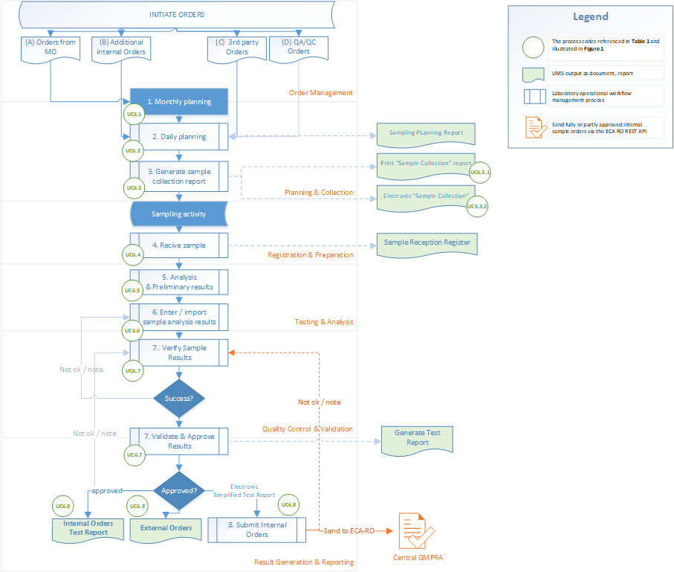
Figure 4
Here’s a concise overview of the workflow illustrated in Figure 4:
- Order Management: Internal or external orders initiate the workflow, specifying required analyses, sample types, and timelines. Orders are logged into the system, setting up the foundation for lab tasks and scheduling.
- Sample Planning & Collection: The module facilitates the planning of sample collection or reception based on order requirements. It assigns unique identifiers to each sample, ensuring traceability and maintaining a direct link to the corresponding order. LIMS must support two options for dispatching samplers to collect samples in the field:
- Traditional Method (UC6.3.1): The system generates a Sample Collection Report, which is printed and distributed to samplers as a paper-based document.
- Electronic Method (UC6.3.2): For samplers equipped with tablets, the Laboratory Chief can send the generated report in a smart, editable format (e.g., PDF). The sampler fills in only the fields assigned to them, streamlining data entry and minimizing errors.
- Sample Registration & Preparation: Upon arrival at the laboratory, samples are registered into the LIMS system, where details such as quantity, condition, and sample type are verified. Preparatory steps, such as labeling, are conducted in accordance with internal procedures. Notably, if samples were collected electronically (UC6.3.2), the Laboratory Chief may refuse them if the physical location, automatically retrieved via GPS coordinates, significantly differs from the sample coordinates specified in the assigned Sample Collection Report.
- Testing & Analysis: Samples move through the lab’s workflow, undergoing the specified tests. LIMS assigns tasks to lab personnel, records each step, and tracks status updates to monitor progress.
- Quality Control & Validation: Quality checks are automatically scheduled as needed, ensuring results meet lab standards. Test results are reviewed and validated to confirm accuracy.
- Result Generation & Reporting: Once validated, results are compiled and formatted into reports. LIMS generates final reports in line with the requirements outlined in the initial order.
- Approval & Distribution: Results are reviewed for final approval before distribution. The system sends the reports to the requester (internal or external) and archives them for future reference.

Step 1: Monthly MO Orders Planning (UC6.1)

Once the Operating Manual orders for the upcoming year are registered and imported by the System Administrator (SA) into LIMS, the Laboratory Chief (SL/LSL) can begin preliminary monthly planning. The following elements should be considered during this phase:
Attribute | Attribute description
Reference to registered Internal Order  (#1) from Figure 4 | Link to all registered orders details out of the annual operating manual.
Estimated Date  (#3) from Figure 4 | Represents the input (estimated date) proposed by SL / LSL for sample collection as part of specific order.  For example, as stipulated in order # “103/NL” of the annual Monitoring Order (MO), the indicator "IH" is designated for sampling 5 times a year for different sections, indicating that sample collection will be distributed across 5 months within the active year. As a result, the Laboratory Chief (SL) will plan and determine the specific dates (day and/or month) for conducting sample collections for this indicator over the designated 6-month period.
Sample collection number  (#2) from Figure 4 | Attributes such as section, sampler, matrix (subsystem), or compound classes can be grouped and sampled together or separated, each assigned a unique sample collection number. This number must be distinct for each laboratory and for each year. Currently, these are recorded in a paper-based internal registry.
TEST Report (“RI”) number  (#4) from Figure 4 | At this stage (estimated planning), to ensure traceability from orders to actual sample results, each Test Report is assigned a unique identification number ("RI") that is specific to each year and laboratory. Currently, these records are maintained in a paper-based internal registry.
Sample Laboratory Code  (#5) from Figure 4 | Each sample is assigned a unique alphanumeric identification code that is specific to each year and laboratory. In the LNCA, this code is a concatenation of the matrix ("Matrice") values (such as U/R/F/S/Bp) derived from master data catalogs, along with the value from the previous column, which is the "Test Report" ("RI") number. Currently, some laboratories maintain these records in a paper-based internal registry.
Mark indicator(s)  (#6) from Figure 4 | Each indicator planned be sampled and analyzed shall be marked (checked) in the database.
Sampler | Represents the name of the individual responsible for collecting the sample from the field.
Audit Trail information | Represents all relevant audit trail attributes must be considered, such Created Date, Action, Modified Date, Modified By etc.

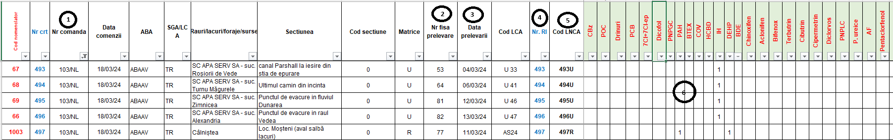
Figure 5 – This represents a model designed for table-based planning of estimated manufacturing order (MO) requests, used currently in LNCA.
Important: For further details on orders planning, "Sample Collection" report templates, and potential scenarios, please refer to “Stage 2: Monthly & Daily

Step 2: Daily Scheduling and Planning (UC6.2)

Except annual MO orders, for any other type of internal or external order, such as specific orders, third-party orders, or quality assurance orders, LIMS must facilitate registering and proceed with daily schedule planning, similarly with Step 1 the minimum set of data regarding new entered orders:
Attribute | Attribute description
Reference to registered Internal Order | Link to all registered orders except those out of annual manual
Estimated Date | Represents the input (estimated date) proposed by SL / LSL for sample collection as part of specific order. Flexible to be grouped with all types of orders.
Sample collection number | Attributes such as section, sampler, matrix (subsystem), or compound classes can be grouped and sampled together or separated, each assigned a unique sample collection number. This number must be distinct for each laboratory and for each year. Currently, these are recorded in a paper-based internal registry. It is flexible to be grouped with samples of different types of orders.
TEST Report (“RI”) number | At this stage (estimated planning), to ensure traceability from orders to actual sample results, each Test Report is assigned a unique identification number ("RI") that is specific to each year and laboratory. Currently, these records are maintained in a paper-based internal registry.
Sampler | Represents the name of the individual responsible for collecting the sample from the field.
Sample Laboratory Code | Each sample is assigned a unique alphanumeric identification code that is specific to each year and laboratory. In the LNCA, this code is a concatenation of the matrix ("Matrice") values (such as U/R/F/S/Bp) derived from master data catalogs, along with the value from the previous column, which is the "Test Report" ("RI") number. Currently, some laboratories maintain these records in a paper-based internal registry.
Mark indicator(s) | Each indicator planned be sampled and analyzed shall be marked (checked) in the database.
Audit Trail information | Represents all relevant audit trail attributes must be considered, such Created Date, Action, Modified Date, Modified By etc.
Important: For further details on orders planning, "Sample Collection" report templates, and potential scenarios, please refer to the "Stage 2: Monthly & Daily Planning" from Annex 1.
In addition to core monthly/daily planning for orders, future LIMS must incorporate comprehensive functionality to track sample transfers, manage multiple samples within containers, maintain accurate audit trails, and document all actions to ensure compliance with traceability standards. The system should also address existing scenarios such as:
- Handling Multiple Samples in the Same Container: The system should support tracking and managing multiple samples within the same container for a given order. It must be able to document and audit such cases, ensuring compliance with internal laboratory protocols.
- (UC3.4) Transferring or Requesting Containers/Materials to Another Laboratory: The system should allow the transfer of containers or materials between laboratories. It must provide a way to document these transfers, ensuring that relevant information (e.g., source and destination laboratory registry numbers, dates) is recorded and auditable.
- Transfers Between Laboratories for Sample Analysis: The system must support the ability to transfer samples between laboratories for analysis if justified. It should provide functionality for tracking these transfers, including the relevant registry numbers, dates, and any necessary justifications.
- Handling Different Indicators for Different Laboratories: The system should accommodate scenarios where some indicators for a given order are analyzed by the initially assigned laboratory, while others are transferred to different laboratories for analysis or sampling. It must track these transfers and ensure that all related information is documented.
- Auditing and Traceability: The system must ensure that all entries and exits (e.g., sample transfers, laboratory assignments) are auditable and traceable, as per laboratory standards. It should enable capturing and storing essential information for each action (such as source and destination laboratory details, registry numbers, and dates) to meet compliance and traceability requirements.

Step 3: Register and Dispatch for Sample Collection (UC6.3)

Using data from the daily planning database (compiled during Steps 1 and 2) and predefined document templates assigned by the laboratory to specific indicator groups, individual indicators, or each matrix (subsystem), LIMS should have capability to generate 'Sample Collection' reports through two methods:
- Paper-Based (UC6.3.1 out of Table 1): A traditional approach where the 'Sample Collection*' report is generated, printed, and physically handed to the sampler for fieldwork. This format is suitable for situations where electronic devices are unavailable or impractical.
- Electronic (UC6.3.2 out of Table 1): A modern approach where the 'Sample Collection*' report is generated in a smart, editable format (e.g., PDF) and electronically assigned to the sampler. The sampler can access and complete the report using a tablet or other compatible devices, filling in only the fields relevant to their assigned tasks.
These dual methods ensure flexibility and accommodate varying operational conditions while maintaining traceability and data integrity. Furthermore, the system shall support the creation and export of a comprehensive list of all Sampling Collection Reports prepared within a timeframe.
(*) For details on layout, attributes, and related information, refer to the "Generate 'Sample Collection' Report" section in Annex 1 – Current Laboratory Processes.

The minimal and mandatory attributes may differ between laboratories, so flexibility from the Consultant is expected in defining report column options for electronic export and in generating reports in PDF format. These requirements are expected to be refined and finalized in consultation with the Beneficiary during the analysis phase.

The essential and required fields included in this report are:
Attribute | Attribute description
Reference to registered Internal Order | Incorporating the unique order code, registration date, and/or any additional relevant order details. Note: For MO orders, the details must include a reference to the "ECA-RO Code," which is automatically assigned by default after the order import action.
Sample collection number | Represents the unique sample collection number assigned though planning phase – step 1 and/or step 2. The attribute must be unique for each laboratory and for each year.
Sample type | Typically related to subsystems like water, underwater, wastewater, etc.
Mark Indicators categorized on sampling matrix | Enumerated indicators (typically represented by codes or abbreviations) are categorized by matrix.
Recipients with details such  name / type / volume / quantity / measure unit | This attribute encompasses the individuals or entities designated to receive samples, data, or results. Each recipient is associated with specific details that facilitate effective communication and tracking within the system. It includes details such as the full name of the recipient, the classification of the recipient, the total volume of samples or data to be sent to the recipient, the number of samples or items to be delivered to the recipient and the unit of measurement for the volume and quantity attributes.
Standard | Specify the document or standard code to serve as a reference for internal laboratory standards.
TEST Report (“RI”) number | At this stage (estimated planning), to ensure traceability from orders to actual sample results, each Test Report is assigned a unique identification number ("RI") that is specific to each year and laboratory. Currently, these records are maintained in a paper-based internal registry.
Sample Laboratory Code | Each sample is assigned a unique alphanumeric identification code that is specific to each year and laboratory. In the LNCA, this code is a concatenation of the matrix ("Matrice") values (such as U/R/F/S/Bp) derived from master data catalogs, along with the value from the previous column, which is the "Test Report" ("RI") number. Currently, some laboratories maintain these records in a paper-based internal registry.
Mark indicator(s) | Each indicator planned be sampled and analyzed shall be marked (checked) in the database.
Audit Trail information | Represents all relevant audit trail attributes must be considered, such Created Date, Action, Modified Date, Modified By etc.

Paper-Based 'Sample Collection' Report process (UC6.3.1)
Using the registered 'Sample Collection' template (refer to Annex 1 for template variations), the Laboratory Chief generates reports for planned sample collection based on the daily schedule. These reports include at minimum key information such as indicators, recipients, applicable methods and standards, unique sample code numbers, and GPS coordinates for the collection site. All relevant data is prefilled in the report, ensuring that field personnel have the precise details needed, customized according to the type or group of sample indicators. Each sample receives a unique report that is generated, previewed, and printed, which includes the assigned exit registry number from the laboratory. This report is then handed over to the Sampler for field collection. The Laboratory Chief could create, export, or print various reports related to the generated internal orders, facilitating the tracking of sampling progress against the planned monthly or daily schedules. In situations where the 'Sample Collection' reports need to be redirected to another laboratory due to unforeseen circumstances, LIMS should offer flexibility for the Laboratory Chief to quickly intervene and adjust the planning, ensuring seamless coordination and uninterrupted workflow.

Electronic 'Sample Collection' process (UC6.3.2)
In this process, when the Sampler is equipped with a tablet and receives a notification from the Laboratory Information Management System (LIMS) about the 'Sample Collection' report generated by the Laboratory Chief, the Sampler can access the report directly on the tablet. The report is prefilled with essential details, including indicators, recipients, applicable methods and standards, unique sample code numbers, and GPS coordinates for the collection site. These fields are read-only for the Sampler, allowing them to only complete the fields designated for input. This ensures accurate and consistent data entry while maintaining control over the pre-configured information.
The tablet also enables the Sampler to update and complete the required fields directly within the system, even when offline. This ensures accurate data capture in the field, regardless of connectivity. Once the system is back online, the Sampler can sync the completed data with LIMS, ensuring the laboratory receives real-time updates. This process streamlines operations by reducing paper usage, improving accuracy, and providing flexibility for field personnel to collect and input data efficiently under varying connectivity conditions.
Additionally, the Laboratory Chief can track the progress of the sampling process against the planned schedule, and the system allows for quick adjustments to be made as needed, ensuring seamless workflow continuity and proactive management of sampling activities.
Important: During sample data collection, required from LIMS system to automatically capture and store the GPS coordinates of the physical sample collection location in the background. These coordinates will be verified and validated by the system once it is online, and the Sampler submits the completed 'Sample Collection' report to the Laboratory Chief. This approach ensures that the GPS data is accurate and consistent with the specified collection location, maintaining data integrity throughout the process.

Step 4: Receive and Acknowledge Samples (UC6.4)

At this stage, the collected samples are formally received in the laboratory. Based on the user's access level, the Laboratory Chief (SL) and/or authorized RMC will initiate the sample reception process as described in chapter "Sample Reception" out of Annex 1 document.
The following elements must be considered during this step:
Attribute | Attribute description
ID | Unique identifier system automatically assigned
Sample Code | Unique entry number assigned by the laboratory, for reference typically used concatenated unique codes.
Sample collection Date | The date and time at which the sample was collected.
Sample collection report reference | The Sample Collection report, completed by the Sampler, is scanned and attached as reference to the list of planned samples.
Reference to RI | This represents the unique sample collection number assigned during the planning phase—specifically in step 1 and/or step 2. This attribute must be distinct for each laboratory and for each year, allowing for reference to the initial order and its associated details.
Sampled indicators and their associated details | Identify the indicators that have been sampled and input the corresponding field-measured values for each indicator, such as Air Temperature, Water Temperature, pH, Colour, Odor, Transparency, Turbidity, etc.
Mark for Transfer* | If samples need to be transferred to other laboratories, indicate this requirement and initiate the transfer process.
Sample status | Indicate the status of each indicator, specifying whether the sample has been collected or not.
Container status | Indicate the status of each reserved container, specify whether the sample has been collected or not.
Reason | Indicate for each unreceived sample to provide a reason for unsuccessful collection.
Cancel Justify | Cancel a reception in accordance with specific rules and authorization requirements.
Audit Trail information | Represents all relevant audit trail attributes must be considered, such Created Date, Action, Modified Date, Modified By etc.

Step 5: Distribute Samples for Analysis (UC6.5)

In this step, the laboratory chief (SL) distributes the samples received to authorized laboratory personnel (RI role) to carry out the analysis activities.
The following elements must be considered during this step:
Attribute | Attribute description
ID | Unique identifier system automatically assigned
Sample Code | Unique entry number assigned by the laboratory, typically concatenated with the matrix for reference.
Reference to Containers | Link to containers with their details which will be used for analysis
Sample indicators | Indicators marked for being analysed
Assigned RI | Assigned laboratory personnel responsible for conducting the sample analysis.
Reference to Analysis Methods | Link to indicator assigned analysis methods catalog
Reference to Documents | Implies reference to any documentation related sample analysis determination and /or verify and validate analytical methods.
Reference to Determination Files | Implies excel calculation files based on results determined.
Audit Trail information | Represents all relevant audit trail attributes must be considered, such Created Date, Action, Modified Date, Modified By etc.
Important: For additional details regarding sample distribution, refer to the "Distribution of Samples for Analysis (or Sub-sampling)" section in Annex 1. This process must be fully integrated into the LIMS.

Step 6: Conduct Sample Analysis (UC6.6)

In this step, the assigned RI determines and calculates the values for the required indicators. Additionally, the elements table from step 5 should be referenced for any extra data inputs needed by the calculated indicators.
For instance, indicator 1 has a specific calculation formula for its results, which is derived from the laboratory equipment outputs and additional manually input data extracted from the sample collection report or based on laboratory-specific files. This process ultimately yields the result for the indicator.
Therefore, the minimal additional elements, in addition to those outlined in step 5, are:
Attribute | Attribute description
……….. | All above step 5 table attributes
Equipment results | Results extracted in read-only mode provided by equipment, contingent upon the availability of digital integration.
Entered results | If the indicator configuration permits the RI to adjust or correct the equipment results, then these adjusted values will be considered in place of the original equipment readings.
Reference to Formula | Link to marked for analyzed indicator formula
Reference to Input Parameters | The link to additional parameters must include relevant data inputs that are essential for calculating the results of the determined indicators. These parameters should provide necessary context and detail to ensure accurate computations and validation of the results.
Additional documentation | Files and/or documents that provide detailed evidence and justification for the determination of results made outside of the LIMS system.
Important: For additional details related to sample analysis, refer to the "Sample Analysis" section in Annex 1, along with the sample formulas for simple and complex indicators outlined in Annex 5. These processes must be fully integrated into the LIMS, with further details to be refined and agreed upon by the parties during the analysis phase.

Step 7: Validate and Approve Results (UC6.7)

At this stage, designated laboratory personnel—such as the Quality Management Responsible (RMC) and the Laboratory Chief (SL) as the next-level approver—will verify, validate, and approve each activity performed by the responsible analyst (RI), along with the results for each sample. The LIMS system must support this validation and approval process, as detailed in chapter "Stage 5: Sample Validate & Approve" out of Annex 1 document, through an integrated audit trail with alerts and notifications. This module enables tracking, logging, and notifying each action in the process, ensuring full compliance and traceability.
The following table outlines the key attributes involved in the validation and approve process:
Attribute | Attribute description
From Steps 4 and 5 | For each sample result, the RMC first and then the SL will access and review each outcome generated by the RI in Steps 4 and 5. Therefore, all elements from Steps 4 and 5 should be accessible and enhanced with below the following additional components.
Comments | This attribute allows for input of any observations, clarifications, or relevant notes provided by the Quality Management Responsible (RMC) or Laboratory Chief (SL) during the validation and approval stage. Comments can document decisions, highlight specific issues, or provide context for any adjustments made to the sample results. These entries ensure transparency in the review process and serve as a reference for future audits within the LIMS system.
Status | This attribute indicates the current stage of each sample's validation and approval process within the LIMS system. Status options may include values such as "Pending Review," "Reviewed by RMC," "Approved by SL," or "Rejected." Each status update provides a clear overview of the sample’s progress through the quality assurance workflow, ensuring traceability and enabling laboratory personnel to track the approval process efficiently.
Additional documentation | This attribute allows for the attachment or reference of supplementary documents that support the validation and approval process. These documents may include calibration certificates, equipment maintenance logs, procedural notes, or external test reports that provide context or verification for the sample results. Including this information in LIMS ensures that all relevant supporting documentation is accessible and linked to the specific sample, facilitating a comprehensive review and ensuring regulatory compliance.

Step 8: Submit Sample Analysis Results (UC6.8)

This process must be fully integrated into the LIMS in accordance with the details outlined in the “Stage 5: Sample Validate & Approve" chapter of Annex 1.
The table below outlines the key attributes required for the electronic reporting of results, as detailed in the “Reporting Results to Internal Orders (Simplified Test Report)” chapter of Annex 1. These attributes are transmitted to the ECA-RO system via REST API after the sample analysis results have been validated and approved within the LIMS.
- Transmission of Results for Physico-Chemical Tests on Water, Suspension Sediments
Attribute | Attribute description
ECA-RO Code | Represents the unique identifier code assigned to the order during the registration process. This code must be stored and maintained by the LIMS to correlate input and output sample test results with the specific internal order.
Reference to Section | Include information about the section where the results were collected and analyzed.
Reference to Water network | Provide details regarding the water body or watercourse associated with the section code where the results were collected and analyzed.
Laboratory | Provide details about the laboratory responsible for collecting the samples.
Sample Collected Date | The date on which the sample was collected by the designated laboratory.
Group (Class) of Indicators | The designated name/code for the group or class of indicators – part of Master Data Catalogs.
Indicator | The designated name/code for the indicator – part of Master Data Catalogs.
Measured Value | The actual numeric results obtained from the analysis of the sample for the specific indicator.
LOQ | The actual numeric LOQ result obtained from the analysis of the sample for the specific indicator.
- Transmission of Results for Physico-Chemical Tests on Biota
Attribute | Attribute description
ECA-RO Code | Represents the unique identifier code assigned to the order during the registration process. This code must be stored and maintained by the LIMS to correlate input and output sample test results with the specific internal order.
Reference to Section | Include information about the section where the results were collected and analyzed.
Reference to Water network | Provide details regarding the water body or watercourse associated with the section code where the results were collected and analyzed.
Laboratory | Provide details about the laboratory responsible for collecting the samples.
Sample Collected Date | The date on which the sample was collected by the designated laboratory.
Species | A unique code or identifier assigned to the species, ensuring accurate tracking within the LIMS (part of Master Data Catalogs).
Sub-sample | A unique code or identifier assigned to the sub-sample, ensuring accurate tracking within the LIMS (part of Master Data Catalogs together with Species)
Group (Class) of Indicators | The designated name/code for the group or class of indicators – part of Master Data Catalogs.
Indicator | The designated name/code for the indicator – part of Master Data Catalogs.
Measured Value | The actual numeric results obtained from the analysis of the sample for the specific indicator.
LOQ | The actual numeric LOQ result obtained from the analysis of the sample for the specific indicator.
- Transmission of Results for Phytoplankton, Phytobenthos Tests
Attribute | Attribute description
ECA-RO Code | Represents the unique identifier code assigned to the order during the registration process. This code must be stored and maintained by the LIMS to correlate input and output sample test results with the specific internal order.
Reference to Section | Include information about the section where the results were collected and analyzed.
Reference to Water network | Provide details regarding the water body or watercourse associated with the section code where the results were collected and analyzed.
Laboratory | Provide details about the laboratory responsible for collecting the samples.
Sample Collected Date | The date on which the sample was collected by the designated laboratory.
Species | A unique code or identifier assigned to the species, ensuring accurate tracking within the LIMS (part of Master Data Catalogs).
Indicator | The designated name/code for the indicator – part of Master Data Catalogs.
Measured Value | The actual numeric results obtained from the analysis of the sample for the specific indicator.
Algal unit density (ml) | Primary data obtained from the analysis of the sample for specific Species.
    - Specifics for Lakes
Attribute | Attribute description
… | All above attributes for Phytoplankton tests, adding the next one
Biomass (mg/l) | Primary data input obtained from the analysis of the sample for specific Species besides “Algal unit density (ml)” data entry.
- Transmission of Results for Macroinvertebrates
Attribute | Attribute description
ECA-RO Code | Represents the unique identifier code assigned to the order during the registration process. This code must be stored and maintained by the LIMS to correlate input and output sample test results with the specific internal order.
Reference to Section | Include information about the section where the results were collected and analyzed.
Reference to Water network | Provide details regarding the water body or watercourse associated with the section code where the results were collected and analyzed.
Laboratory | Provide details about the laboratory responsible for collecting the samples.
Sample Collected Date | The date on which the sample was collected by the designated laboratory.
Species | A unique code or identifier assigned to the species, ensuring accurate tracking within the LIMS (part of Master Data Catalogs).
Density (individuals/m²) | This attribute helps track and analyze the density of species collected during sampling, which can be essential for monitoring biodiversity, assessing environmental health, and informing conservation efforts. It is typically calculated by dividing the total number of individuals counted by the area over which they were observed.
Indicator | The designated name/code for the indicator – part of Master Data Catalogs.
Measured Value | The actual numeric results obtained from the analysis of the sample for the specific indicator.
- Transmission of Results for Ichthyofauna*
(*) Ichthyofauna refers to the fish species and populations present in a specific aquatic environment. This term is commonly used in ecological and environmental studies to describe the diversity, distribution, and abundance of fish within a given habitat, such as rivers, lakes, or marine ecosystems. Studying ichthyofauna is essential for understanding aquatic biodiversity, ecosystem health, and the impacts of environmental changes on fish populations.
Attribute | Attribute description
ECA-RO Code | Represents the unique identifier code assigned to the order during the registration process. This code must be stored and maintained by the LIMS to correlate input and output sample test results with the specific internal order.
Reference to Section | Include information about the section where the results were collected and analyzed.
Reference to Water network | Provide details regarding the water body or watercourse associated with the section code where the results were collected and analyzed.
Laboratory | Provide details about the laboratory responsible for collecting the samples.
Sample Collected Date | The date on which the sample was collected by the designated laboratory.
Sampling type | The designated name/code for the indicator – part of Master Data Catalogs.
Sampling area | The designated name/code for the indicator – part of Master Data Catalogs.
Species | A unique code or identifier assigned to the species, ensuring accurate tracking within the LIMS (part of Master Data Catalogs).
Number of individuals (specimens/sample) | This attribute helps track and analyze the density of species collected during sampling, which can be essential for monitoring biodiversity, assessing environmental health, and informing conservation efforts. It is typically calculated by dividing the total number of individuals counted by the area over which they were observed.
Number of individuals > 150mm (specimens/sample) | Numeric, value of individuals > 150mm
Number of individuals <= 150mm (specimens/sample) | Numeric, value of individuals <= 150mm
Indicator | The designated name/code for the indicator – part of Master Data Catalogs.
Measured Value | The actual numeric results obtained from the analysis of the sample for the specific indicator.
- Transmission of Results for Macrophytes/Macroalgae
Attribute | Attribute description
ECA-RO Code | Represents the unique identifier code assigned to the order during the registration process. This code must be stored and maintained by the LIMS to correlate input and output sample test results with the specific internal order.
Reference to Section | Include information about the section where the results were collected and analyzed.
Reference to Water network | Provide details regarding the water body or watercourse associated with the section code where the results were collected and analyzed.
Laboratory | Provide details about the laboratory responsible for collecting the samples.
Sample Collected Date | The date on which the sample was collected by the designated laboratory.
“Mal” | Thallus (or body), in macrophytes and macroalgae, the thallus can take on various forms, such as filamentous, leafy, or membranous structures, depending on the specific type of organism.  The designated name/code for the “Mal” must be integrated into Master Data Catalogs.
UI | The designated name/code for the “UI” must be integrated into Master Data Catalogs.
Species | A unique code or identifier assigned to the species, ensuring accurate tracking within the LIMS (part of Master Data Catalogs).
Abundance | Abundance refers to the quantity or number of individuals of a species present in a specific area or ecosystem.
Indicator | The designated name/code for the indicator – part of Master Data Catalogs.
Measured Value | The actual numeric results obtained from the analysis of the sample for the specific indicator.
Important: The formats for transferring test results to the existing IT system, ECA-RO, serve as reference standards and guidelines, accounting for variations across different sample types. As such, during the analysis phase, the Consultant must ensure that the LIMS data input is correctly configured to generate the expected data output in alignment with these standards.
LIMS must support both digital reporting of results and the preview of paper-based reports generated within the system. These reports should follow predefined templates and be exported in PDF format, in compliance with the guidelines outlined in the " Stage 5: Sample Validate & Approve" chapter of Annex 1 documentation, tailored for different beneficiaries. The table below outlines the essential attributes that must be included in the official paper-based report templates. If the analysis phase identifies additional information to be included, the Consultant may enhance these templates during the implementation phase.

Report element Name | Report Description
Footer Notes | This attribute allocates a specific section at the top of reports produced by the Laboratory Information Management System (LIMS). This area is designed to include critical preliminary information that provides context for the report's content.
Laboratory | The Water Quality Laboratory full name
Title | The title will be dynamically adjusted based on the matrix, for example, it could read “Simplified Test Report for Physico-Chemical Tests”.
Report Identification | Includes pages for physico-chemical tests, total metals tests, dissolved metals tests, and sediment tests.
Report Number | Corresponds to the month for which the report is done, along with the date the report was issued.
Internal Beneficiary Identification | Identifies the internal Beneficiary as the GMPRA/GRA Department.
Internal Order | Specifies the internal order, including the Operating Manual of the Monitoring System of ABA’s Laboratories for the year, along with order number and date.
Sample Collection Report Number | Indicates the sample collection report number associated with the tests.
Sample Code | The unique code assigned to the sample being tested.
Sample Name/Subsystem | Specifies the name of the sample or subsystem that is being analyzed.
Sampling Section | Indicates the section from which the sample was collected.
Sample Collection  Date and Time | Records the date and time when the sample was collected in the field.
Sample Reception  Date and Time | Records the date and time when the sample was received in the laboratory.
Testing Period | Specifies the duration during which the tests were conducted.
Matrix Undergoing Testing | Identifies the specific matrix that is undergoing testing (e.g., water, soil, etc.).
Physico-Chemical and Biological Indicators* | This attribute enumerates the indicators that were tested and, for biological assessments, includes supplementary data essential for interpretation. This additional information encompasses latitude, longitude, altitude, fishing net surface area, bank structure, and sediment type.
Observations | Implies notes and/or observations made during sampling, including the GPS coordinates of the sampling location, the visual characteristics of the sample, the environmental conditions at the site, and any challenges faced during the testing process.
Footer Notes | This attribute designates a space at the bottom of reports generated by the Laboratory Information Management System (LIMS). This section may contain important supplementary information that clarifies or enhances the context of the report's content.
(*) Physico-Chemical and Biological Indicators are crucial metrics for environmental monitoring, particularly in assessing the health and quality of aquatic ecosystems. Physico-Chemical Indicators measure the physical and chemical properties of water and sediment, providing insight into environmental conditions and potential pollutants. Key examples include pH, dissolved oxygen (DO), temperature, nutrients (such as nitrate and phosphate), turbidity, conductivity, and total suspended solids. Biological Indicators reflect the biodiversity and biological components of aquatic ecosystems, offering valuable information about ecosystem health and resilience. Common examples include macroinvertebrates, phytoplankton, and fish populations.

Laboratory Workflow Functional Requirements (the 6th IT component outlined in the Scope of Services chapter)

The following functional requirements should be regarded as the minimum standards, focusing on the components detailed above in the current chapter. These requirements will serve as the foundation and may consider, as needed, additional relevant aspects, which will be further enhanced and refined in collaboration with the Consultant during the analysis phase. The approach must ensure alignment with project goals while incorporating the Consultant's detailed analysis, insights, and industry best practices.
Seq.  No. | Functional requirement shall include, as necessary, and without being limited to, the following requirements:
LABORATORY WORKFLOW
The module digitalizes the order registration process, covering stages from "Monthly & Daily Planning" to "Sample Validation & Approval" as outlined in Annex 1, with key business processes detailed above. It manages the entire sample workflow, from order registration to result reporting, including planning, sample collection, analysis, validation, and reporting. Integrated features ensure data integrity, compliance, and efficient task tracking, improving laboratory productivity and efficiency.
21 | UC6.1 - Step 1: Monthly MO Orders Planning
21.1 | The system must support estimated monthly sample scheduling in alignment with the annual schedule via a user-friendly web interface. This interface will display predefined data in a read-only format, while fields requiring user input will be editable according to the user's access level. Each monthly record must capture, store, and maintain the table attributes outlined in sub-chapter 3.2.7.1.
21.2 | The system must allow users to access prefilled information from registered orders and assign samplers individually. It must also provide the ability to modify existing samples or introduce new ones. The interface must ensure that general information is either prefilled or selected using an intelligent search feature within the master data catalogs module.
21.3 | If a new term is necessary, the system shall permit the creation of new entries in laboratory catalogs based on the user's access level. Additionally, categories and indicators will be automatically filled once the prerequisite information is provided.
21.4 | The system must support the functionality to "clone" an existing record, allowing users to make necessary modifications directly within the interface. Each newly created entry must automatically generate a unique ID.
21.5 | The system must provide a user-friendly interface for planning internal orders from the MO, based on the requirements in UC5.1. This interface should support scheduling indicators with varying frequencies (e.g., quarterly or monthly), allowing users to efficiently manage multiple indicators. It should enable group actions for tasks with different sampling frequencies, streamlining planning and management.
22 | UC6.2 - Step 2: Daily Scheduling and Planning
22.1 | For any type of registered order, including specific orders, third-party orders, or quality assurance orders, the system must enable authorized users to collect, adapt, store, and track a minimum set of data. This data must include the information specified and detailed in chapter 3.2.7.2.
22.2 | The interface must facilitate the continuation of monthly planning (21.5) for MO orders, enabling users to schedule sample collection activities daily. It should also support changes, replacements, or the addition of new samplers as needed.
22.3 | The system shall allow users to select or add the necessary containers and resources required for executing the allocated activities during the daily planning process.
22.4 | The system must implement validation mechanisms to ensure accurate and consistent data entry, integrating with the Master Data Module for nomenclatures, pre-filled lists, and various data types. It must include validations to meet the beneficiary's requirements, such as:  - Ensuring logical and chronological consistency of input data.  - Verifying that waterbody/section details and order types align with the corresponding section and indicators.
22.5 | The interface should provide seamless access to the reporting module, enabling users to generate and access daily reports that detail sampling collection activities. These reports must be available for any specified day or period.
23 | UC6.3 - Step 3: Register and Dispatch for Sample Collection
23.1 | The system must enable the generation of sample collection reports directly from daily planning interface, using the specific elements defined in chapter 3.2.7.3.
23.2 | The system must support two methods for generating 'Sample Collection' reports:  - Paper-Based (UC6.3.1): The system must generate a printable report that can be physically handed to the sampler for fieldwork, suitable for situations without electronic devices.  - Electronic (UC6.3.2): The system must generate a smart, editable report (e.g., PDF) that can be electronically assigned to the sampler, who can then fill in only the fields relevant to their tasks on compatible devices.
23.3 | The system must use data from the daily planning database (compiled during Steps 1 and 2) and predefined document templates to generate 'Sample Collection' reports, with flexibility to assign templates to specific indicator groups, individual indicators, or each matrix (subsystem).
23.4 | The system must allow flexibility in report customization, enabling different laboratories to define mandatory attributes and columns for electronic reports.  It must support the creation of exportable reports in various formats, including PDF, while adhering to the required layout, attributes, and other related information defined in the "Generate 'Sample Collection' Report" section in Annex 1.  The system must allow customization of each report template, enabling users to include or exclude specific indicators or groups as needed.
23.5 | The system must ensure traceability by maintaining records of all 'Sample Collection' reports generated, whether paper-based or electronic.
23.6 | The system must allow users to preview the sampling report before printing or exporting, ensuring data completeness and accuracy.
23.7 | The system must enable the export of comprehensive lists of all 'Sample Collection' reports created within a defined timeframe.
23.8 | The system must enable the Laboratory Chief to quickly adjust the sampling plan and ensure smooth workflow in unforeseen circumstances. This action must be supported by predefined workflows that allow transferring and tracking sample collection to another laboratory if necessary.
23.9 | The system must allow the Laboratory Chief to track the progress of the sampling collection assignment process against the planned schedule.
 | UC6.3.1 - Paper-Based 'Sample Collection' Report process
23.10 | The system must prefill reports with key information such as indicators, recipients, methods, standards, unique sample codes, and GPS coordinates for the collection site.
23.11 | Report must be customizable according to the sample type or group of indicators, ensuring field personnel have precise and relevant details.
23.12 | The system must assign a unique report to each sample, including an assigned exit registry number, which is generated, previewed, and printed for field use.
23.15 | The system must allow the Laboratory Chief to print, export, or generate reports for tracking sampling progress against the planned schedule.
 | UC6.3.2 - Electronic 'Sample Collection' process
23.16 | For electronic reports, the system must be compatible with tablet devices or other relevant hardware used by samplers to view and complete the reports.
23.17 | The system must notify the Sampler when a 'Sample Collection' report is generated, allowing access to the report directly on a tablet.
23.18 | The system must prefill the report with essential details such as indicators, recipients, methods, standards, sample code numbers, and GPS coordinates, which are read-only for the Sampler.
23.19 | The system must allow the Sampler to complete only the designated fields within the report, ensuring accurate data entry.
23.20 | The system must support offline data entry, enabling the Sampler to update and complete fields without connectivity. Once back online, the system must sync the data with LIMS.
23.21 | The system must automatically capture and store GPS coordinates of the physical sample collection location in the background during sample collection.
23.22 | The system must maintain data integrity by ensuring accurate and consistent GPS data is stored and synchronized with LIMS.
23.23 | The system must validate and verify the GPS data once it is online, ensuring accurate location information is captured and stored in the 'Sample Collection' report. In case of discrepancies, the sample collection status should be updated to “Incorrect Location,” and a notification must be sent via LIMS to the Laboratory Chief.
24 | UC6.4 - Step 4: Receive and Acknowledge Samples
24.1 | The system shall enable authorized users such SL and/or RMC to register each received sample and automatically assign a unique registration number for tracking and reference purposes.  Authorized users shall have the ability to view or preview all necessary information associated with each sample collection, providing a quick reference to relevant details.
24.2 | The system must digitally implement the process outlined in chapter "Sample Reception" out of Annex 1 document, providing an interface for sample collection reception and registration. This interface will display all sample indicators in a categorized, user-friendly format, utilizing visual or graphical cues to highlight indicators needing special attention, such as partially completed entries or values outside acceptable ranges.
24.3 | The system must include the functionality to generate, allocate, scan, and manage barcodes for samples, materials, and other elements, ensuring support for multiple formats, integration with barcode scanners, customizable labels, and complete traceability within workflows.
24.4 | The system shall allow users to select received samples and enter field-measured indicators, such as air temperature, water temperature, pH, color, odor, transparency, and turbidity, for each sample.
24.5 | The system shall allow users to forward specific samples to other laboratories when required, ensuring seamless handover and comprehensive documentation. Each transfer must be recorded, stored, and tracked, with the transfer details registered in both the originating and receiving laboratories for full traceability of the sample's source and destination.
24.6 | The system should provide the capability to release containers for samples that cannot be collected, marking them accordingly (specific status).
24.7 | The system shall allow selection of unreceived samples with recorded reasons for unsuccessful collection and automatically modify sample and container statuses based on predefined rules, such as condition, completion status, or process stage, including marking samples as "in progress" upon entering analysis.
24.8 | The system shall enable users to cancel a sample reception, requiring specific authorization and adherence to defined rules.
24.9 | A “Sample Reception Register” report shall be generated, detailing all received and coded samples. This report will include minimum details as defined in detail in chapters 3.2.6.3 and 3.2.6.4.
24.10 | Applicable to Paper-based sample collection UC6.3.1:  - The system must allow the uploading of scanned 'Sample Collection' reports in paper format when sample registered in laboratory.  - The system should utilize Optical Character Recognition (OCR) technology to automatically extract data from uploaded scanned documents, including all completed fields, when available. The OCR functionality must ensure that the data is accurately recognized and converted into machine-readable text, allowing for seamless integration into the system.  - Any illegible or unclear data should be flagged for manual review, allowing the Laboratory Chief to manually input or correct any missing or inaccurate information as necessary.
24.11 | Applicable to Electronic sample collection UC6.3.2:  - When sample information is received electronically via LIMS (Step 3 - Electronic 'Sample Collection' process), the system must compare GPS coordinates in the sample collection report with those automatically extracted from the collection location.  - If significant discrepancies are detected, the system should flag the record with a red flag or relevant status.  - The system should notify the Laboratory Chief to investigate and address the discrepancy.
24.12 | GPS Data Capture and Storage, applicable to UC6.3.2:  The system must automatically capture GPS coordinates from the physical sample collection location when the Sampler uses a tablet (UC6.3.2).  GPS stored data must include at minimum:  - Sample Required Coordinates (as specified in the sample collection report).  - Actual (Found) Coordinates (extracted from the sample collection location).  - Laboratory Information (associated laboratory conducting the collection).  - Timestamp (date and time the coordinates were recorded).  - Sampler Details (information about the person who collected the sample).  - Laboratory Chief Information (responsible Laboratory Chief for oversight).  The system must preserve all GPS-related data (both required and actual coordinates) historically, with relevant context, for future reference.
24.13 | The system should allow the Laboratory Chief and/or Administrator to generate reports highlighting discrepancies between the required and actual GPS coordinates.
25 | UC6.5 - Step 5: Distribute Samples for Analysis
25.1 | The system must provide a user-friendly interface for the Laboratory Chief (SL) to distribute received samples to authorized laboratory personnel (RI). The interface should display received samples and their statuses for easy assignment. using the specific elements defined in chapter 3.2.7.5.
25.2 | The system must ensure that only authorized laboratory personnel (RI) can be assigned to specific samples for further actions. An access control mechanism shall be implemented to verify user roles and permissions before allowing sample distribution.
25.2 | The system shall maintain a record of all sample distributions, including details such as the SL assigning the sample, the assigned RI personnel, and the timestamp of the assignment.
25.3 | This tracking functionality must be integrated with the audit trail module to ensure compliance and traceability.
25.4 | Upon distribution, the system shall automatically notify the assigned RI personnel about their new responsibilities via email or in-system notifications.
26 | UC6.6 - Step 6: Conduct Sample Analysis
26.1 | The system shall support integration with laboratory equipment to enable automatic data acquisition of test results from devices that export data in a digital format, as partly mentioned in the "NARW Laboratory Equipment" table out of Annex 3 document.  Note that the list of laboratory equipment (Annex 3) is provided for reference purposes. Some instruments are newly acquired, and details regarding software and PC integration may be incomplete. It is mandatory for the Consultant, during the analysis phase, to thoroughly review the provided list and supplement it with any missing or additional relevant details.
26.2 | The system should facilitate real-time data capture from various testing instruments, allowing for the immediate logging of results and minimizing manual entry errors.
26.3 | Upon completion of tests, the LIMS generate preliminary results based on the captured data, initially marked as "preliminary" until further review and validation are completed.
26.4 | The system must provide a user interface customized based on the user's access level, enabling the following functionalities:  - Display a categorized list of indicators that the user is responsible for, organized by type and result status.  - Facilitate a search function to allow users to easily locate specific indicators within the list.  - Allow users to manually enter results from laboratory analyzers for each indicator.  - Automatically retrieve results for applicable indicators from integrated laboratory equipment.  - Provide a user-friendly preliminary data input interface for entering the prerequisite information needed to calculate both simple and complex indicators.  Detailed examples of the data input requirements for the formulas are specified in the "Sample Calculation Formulas for Indicators" Annex 5 document.
26.5 | The system shall automatically identify and signal discrepancies in preliminary results, whether the data is entered manually or captured automatically, including values that fall outside acceptable ranges or instances of incomplete data.
26.6 | The system must provide functionality to visually highlight indicators that require special attention, ensuring they are easily identifiable within the interface. This enhancement will facilitate prompt recognition and review by users, improving overall data accuracy and responsiveness.
26.7 | The system shall provide comprehensive information for each indicator as defined in collaboration with the Beneficiary, ensuring that users have access to all relevant context necessary for their analysis. This setup and configuration are mandatory within the Laboratory Administration module.
26.8 | The system must enable users to upload and assign any related documents and or internal laboratory files which stand and prove the analysis results determination and / or calculation.
27 | UC6.7 - Step 7: Validate and Approve Results
27.1 | The system must support the transfer of test results to the existing IT System ECA-RO, ensuring all required primary data details are included in the "Sample Collection" report. The transfer formats detailed in chapter 3.2.7.7 shall serve as references and guidelines that account for differences among sample types.
27.2 | The system must support the process of validating and approving activities performed by the responsible analyst (RI) and their results for each sample. This includes actions taken by the Quality Management Responsible (RMC) and the Laboratory Chief (SL) as the next-level approver.
27.3 | Only designated personnel (RMC and SL) should have the authority to validate and approve sample analysis results. An access control mechanism should ensure only authorized users can perform these actions.
27.4 | The system should provide a defined workflow for the approval process, allowing RMC and SL to review and approve sample results in a structured manner, ensuring that all necessary steps have been followed.  The system should allow flexibility in defining the steps and rules involved in the validation and approval workflow to accommodate different laboratory procedures or regulatory requirements.
27.5 | The system must log and track all validation and approval actions, capturing detailed information such as who performed the action, the timestamp, and any changes made. This must be integrated with the audit trail module for full compliance and traceability.
27.6 | The system should send alerts and notifications to the relevant personnel (e.g., RMC and SL) when validation and approval actions are required or completed. These notifications should include relevant details about the sample and its analysis status.
27.7 | The system must allow for the updating of the sample's status during validation and approval. For example, it should change the status to "approved" once validated and approved by the RMC and SL.
27.8 | Users should be able to preview reports before finalizing them for export or printing, allowing for verification of content and format.  An audit trail must be maintained for all report generation and transfer activities, logging who generated the reports and when, ensuring accountability and traceability in compliance with laboratory standards.
28 | UC6.8 - Step 8: Submit Sample Analysis Results
28.1 | The system must fully integrate the submission of sample analysis results into LIMS as described in the “Stage 5: Sample Validate & Approve” chapter of Annex 1, with all general and specific attributes detailed in 3.2.7.8.
28.2 | The system must enable the electronic reporting of sample analysis results in a standardized format, as outlined in the “Reporting Results to Internal Orders (Simplified Test Report)” chapter of Annex 1. This includes all necessary attributes required for reporting, detailed in 3.2.7.8.
28.3 | The system must ensure that only validated and approved sample analysis results are eligible for submission. Results must undergo the necessary approval steps before submission to ensure accuracy and compliance.
28.4 | The system must support capturing and storing all key attributes required for the submission of analysis results. These attributes should include, but are not limited to, sample codes, test results, validation status, and approval details.
28.5 | The system must support data transmission via REST API.  Once the sample analysis results have been validated and approved, the system must automatically transmit the results to the ECA-RO system via REST API. This transmission must include all the relevant data fields as per the defined requirements in Annex 1.
28.6 | The system should ensure that once the analysis results are approved and validated, the transmission to the ECA-RO system happens automatically without manual intervention. The system must handle the synchronization process efficiently and reliably.
28.7 | In case of failure during the data transmission process (e.g., incorrect or incomplete data), the system must generate error messages or notifications for the laboratory personnel to take corrective actions. These errors should be logged for traceability.
28.8 | The system must provide confirmation once the sample analysis results have been successfully submitted to the ECA-RO system, ensuring traceability and accountability.
28.9 | The system must perform a final automatically based on predefined rules for validation check on the data before submission to ensure all mandatory attributes are present and no critical errors exist in the results.
28.10 | The system should provide a mechanism to track the submission history, allowing users to view the status of each submission, including successful and pending submissions.
28.11 | The system must support the preview and generation of paper-based reports. These reports must be generated based on predefined templates and follow the specifications provided in the "Stage 5: Sample Validate & Approve" chapter of Annex 1.
29 | Post Submission: Test Report Recall and Update
29.1 | The system must enable the Chief Laboratory or their designated deputy to recall finalized and transmitted test reports, ensuring compliance with ISO/IEC 17025:2017 standard.
29.2 | The system must maintain a clear linkage between the original and updated versions of the test report to ensure traceability.
29.3 | The original test report should remain accessible in the system as a historical record and be clearly marked as superseded after a report recall.
29.4 | The system must automatically increase the revision number for updated test reports, based on the recall count, ensuring consistency and reducing manual errors.
29.5 | Only authorized personnel, such as the Chief Laboratory or their deputy, should have permission to initiate the recall of test reports.
29.6 | Upon recalling a test report, authorized personnel must be able to review and correct:  - Previously recorded results.  - Manually entered indicators or data used to generate results.
29.7 | The system must allow authorized users to attach a completed Nonconformity Report and Corrective Actions (FNAC) form directly to the updated test report.
29.8 | All functionalities related to test report recall, update, and FNAC management must comply with ISO/IEC 17025:2017 standard, ensuring adherence to the required quality management system.
29.9 | The system must maintain an audit trail for each test report recall and update action, capturing the following details:  - Date and time of recall.  - User initiating the recall.  - Details of changes made (e.g., corrected data or results).  - Reason for the update.
29.10 | The system must notify relevant stakeholders when a test report has been recalled and updated, ensuring all parties are informed.
29.11 | The system must provide a guided workflow for authorized personnel through the recall, update, and approval process, ensuring accuracy and compliance with established protocols.
29.12 | The system must generate detailed reports summarizing all recalls, revisions, and associated corrective actions for internal reviews and audits.
30 | Partial Test Report Transmission
30.1 | The system must allow laboratories to transmit partial test reports as soon as specific results (e.g., physical-chemical indicators, metals) are available.  Partial results must be clearly marked and identified as such in the system.  Partial reports should be linked to the full order, ensuring traceability.
30.2 | Authorized personnel must be able to recall previously transmitted partial test reports to add additional results (e.g., micropollutants, complex analyses).  The system must ensure that recalled reports can only be updated with new results, and not with corrections to previously valid results.
30.3 | The system must differentiate between updates for correction and updates for completion of the test report.  No changes should be allowed to previously transmitted valid results unless they are part of a valid correction process.
30.4 | The system must automatically manage the versioning of test reports, distinguishing between:  - Partial versions (in progress or transmitted).  - Final completed versions of the report.  Each version must be associated with a revision number, ensuring that the latest version is always easily identifiable.
30.5 | The system must generate reports summarizing partial reports, updates made, and completed results for internal reviews, audits, and documentation purposes.
30.6 | The system must ensure that the entire partial test report transfer, update, and finalization process complies with ISO/IEC 17025:2017.

Document Manager (the 7th IT component outlined in the Scope of Services chapter)

The following requirements shall include, as necessary and without being limited to, the minimum attributes required for the document’s registration, designed to create a comprehensive structure for effective document management within the LIMS. This framework will facilitate easy access, tracking, and adherence to laboratory standards and regulations.

Note: The attributes listed below may be subject to further modifications, as agreed upon by the Beneficiary and the Consultant during the analysis phase.
Attribute | Attribute description
Document ID | A unique identifier assigned to each document for tracking and reference purposes.
Document Type | Categorization of the document type, such as Standard Operating Procedure, Sample Collection, Test Report, or Template Document. The classifications are derived from a predefined list in the Master Data Catalog and are further refined within the Laboratory Administration module.
Document Title | A brief and descriptive title of the document to convey its content.
Version Number | The version identifier of the document, indicating its revision history.
Creation Date | The date when the document was originally created.
Last Modified Date | The date when the document was last updated or modified.
Author/Creator | The name of the individual or entity that created the document
Access Level | The permission level required to view or edit the document (e.g., Read-Only, Edit, Admin).
Status | The status of the document (e.g., Draft, Final, Archived).
Related Documents | References to other documents that are related or pertinent to this document (if applicable).
Document Location | The storage path or URL where the document is stored within the LIMS.
Tags / Metadata | Keywords or phrases associated with the document that enhance its discoverability and categorization. This attribute allows users to add descriptive labels that provide additional context, facilitate search functionality, and improve the organization of documents within the LIMS. Tags and metadata can include information about the document's purpose, related processes, relevant projects, or specific parameters related to its content, making it easier for users to find and manage documents efficiently.
Approval Workflow | Details of the approval process the document must undergo, including designated approvers and status tracking.
Comments/Notes | A log of all actions taken on the document, including creation, modifications, approvals, and access history.
Audit Trail | A log of all actions taken on the document, including creation, modifications, approvals, and access history.
Document File | The actual file content of the document, which can be uploaded or linked for access.

Document Manager Functional Requirements (the 7th IT component outlined in the Scope of Services chapter)

The Document Manager component of the Laboratory Information Management System (LIMS) may consider, as needed, additional relevant aspects, which shall be implemented either as a fully custom-developed solution or a Commercial Off-The-Shelf (COTS) software platform. Any future implementation or expansion of the Document Manager component must ensure continuous integration without impacting on the functionality or performance of the LIMS solution.
Seq.  No. | Functional requirement shall include, as necessary, and without being limited to, the following requirements
31 | DOCUMENT MANAGER  Standard component of the Laboratory Information Management System (LIMS), enabling efficient management of laboratory documents, records, and workflows. It provides centralized storage, seamless integration with LIMS modules, and advanced search capabilities while ensuring compliance with data protection standards.
31.1 | Serve as a centralized repository for all laboratory-related documents (e.g., sample collection report, test report).
31.2 | The system must provide functionality for document upload, deletion, and version control, with the ability to associate metadata with effective lifecycle management and traceability.
31.3 | The system must allow access to all document versions, showing the latest by default, and allowing rollbacks.
31.4 | The system must permit documents into categories, subcategories, and folders (virtual containers).
31.5 | The system must provide robust search functionality, including:  - Global search with "typeahead" and Google-like features.  - Advanced metadata-based search with operators and filters.  - Instant display of relevant results, with preview and filtering options.
31.6 | The system may provide the capability to save search criteria and modify them for repeated searches.
31.7 | Implement role-based access control, restricting document access based on user roles and permissions.
31.8 | Provide capability to enable document-level accountability with assignment to responsible persons or units for sensitive records.
31.9 | It must seamlessly integrate with core LIMS modules (e.g., Laboratory Workflow, Orders Manager), providing a unified interface that ensures consistent design and functionality. End-users should experience it as a single cohesive platform with LIMS, without requiring separate authentication.
31.10 | The system must provide personalized "My Documents" lists for users, displaying all documents they have uploaded or interacted with. This feature should be incorporated into the Home Page layout (refer to Seq. No. 7) for easy access and enhanced user experience.
31.11 | The system must allow bulk operations (e.g., renaming, adding metadata) and shortcuts for efficiency.
31.12 | The system must enable users to add annotations, comments, and approvals directly to documents, facilitating collaboration and streamlined document review processes.
31.13 | The system must permit document uploads using configurable templates with inheritable metadata.
31.14 | The system must ensure data security by implementing encryption for document storage and transfers.
31.15 | The system must maintain comprehensive audit trails for all document-related actions, including updates, approvals, and access history.
31.16 | The system must support configurable retention policies for document archiving, with options for automatic and on-demand archiving.  These policies must be easily set up and configured by system administrators, with settings tailored to user permission levels (per laboratory, ABA, and/or centralized).
31.17 | The system must generate statistical reports on document activity, with export options in various formats (e.g., PDF, Excel).
31.18 | The system must provide mobile access, enabling users to manage and review documents on smartphones and tablets, in accordance with UC6.3.2 for electronic Sample Collection reports.
31.19 | The system may support integrated electronic signature functionality for document approvals applicable across LIMS processes based on the Beneficiary's requirements.
31.20 | The system should support OCR functionality to enable content-based searches within scanned documents, automatically extract data, and prefill electronic forms with the extracted information, as required by UC6.3.2 for electronic Sample Collection reports.
31.21 | Include a built-in email client for sending and receiving documents without the support of other external tools.
The Document Manager component, whether custom-developed or implemented as a Commercial Off-The-Shelf (COTS) solution, must not only meet the functional requirements but also be scalable and designed to support future enhancements as anticipated:
- Integrating electronic signature functionality to streamline document approval workflows.
- Incorporating artificial intelligence and robotic process automation to optimize document handling and enhance operational efficiency within the LIMS framework.
- Search criteria can be saved at the user level, allowing users to modify or add criteria and perform new searches across all objects without the need to re-enter previously specified criteria.
Note: The Consultant must collaborate closely with the Beneficiary's designated personnel during the analysis phase to ensure that the proposed Document Manager fully addresses the business requirements. For further details on registered documents and current data volumes, refer to Annex 7: Estimated Capacity Planning.

Alerts & Notifications (the 8th IT component outlined in the Scope of Services chapter)

The following key attributes are essential for setting up and configuring alerts and notifications. These elements will form the foundation of an effective Alerts & Notifications component within the LIMS, enabling efficient monitoring of critical conditions, enhancing responsiveness, and ensuring adherence to laboratory protocols.
Note: The attributes listed below may be subject to further modifications, as agreed upon by the Beneficiary and the Consultant during the analysis phase.
Attribute | Attribute description
Alert ID | A unique identifier assigned to each alert for tracking and management purposes.
Alert Type | The category of the alert (e.g., System Error, Performance Alert, Compliance Reminder). The classifications are derived from a predefined list in the Master Data Catalog and are further refined within the Laboratory Administration module.
Priority Level | Indicates the urgency of the alert (e.g., Low, Medium, High, Critical).
Trigger Condition | Specific criteria that must be met for the alert to be activated (e.g., sample results exceed threshold values).
Notification Method | The means by which the alert is communicated to users (e.g., Email, SMS, In-System Notification – Home Page).
Recipient List | A list of users or user roles designated to receive alert notifications.
Alert Message | The content of the alert message that provides details about the alert condition.
Timestamp | The date and time when the alert triggered.
Acknowledgment Status | Indicates whether the alert has been acknowledged by the recipient (e.g., Acknowledged, Unacknowledged).
Resolution Status | Indicates the current state of the issue related to the alert (e.g., Resolved, Unresolved, In Progress).
Escalation Protocol | Details of the procedure to be followed if the alert is not acknowledged or resolved within a specified timeframe.
Historical Log | A record of past alerts, including details on triggers, resolutions, and actions taken
Alert Frequency | Specifies how often the alert should be triggered or repeated if the condition persists.
Customizable Settings | Options for users to customize alert settings based on their preferences (e.g., setting thresholds, modifying notification preferences).

Alerts & Notifications Functional Requirements (the 8th IT component outlined in the Scope of Services chapter)

The following functional requirements should be regarded as the minimum standards, focusing on the components detailed above in the current chapter. These requirements will serve as the foundation and may consider, as needed, additional relevant aspects, which will be further enhanced and refined in collaboration with the Consultant during the analysis phase. The approach must ensure alignment with project goals while incorporating the Consultant's detailed analysis, insights, and industry best practices.
Seq.  No. | Functional requirement shall include, as necessary, and without being limited to, the following requirements
32 | ALERTS & NOTIFICATIONS  Standard component of the Laboratory Information Management System (LIMS), it must efficiently manage and automate notifications related to laboratory processes, ensuring timely alerts for critical actions, deadlines, and system events. It must integrate with key LIMS modules to trigger notifications based on predefined conditions and user roles, improving workflow efficiency and ensuring compliance with operational requirements.
32.1 | The system must support the creation, scheduling, and delivery of alerts for specific events at predefined intervals (e.g., product expiration, low stock levels, pending stock transfer requests). The categories will be defined in collaboration between the Consultant and the Beneficiary during the analysis phase.
32.2 | The system must ensure that LIMS users receive real-time alerts within the interface, tailored to their access levels, and displayed on the main dashboard (refer to Home Page, seq. no. 7 for details).
32.3 | The system must support alerts that activate when certain parameters exceed predefined thresholds, such as temperature fluctuations in storage or inventory levels falling below set minimums.
32.4 | The system must facilitate the sending of email notifications to designate users or groups to ensure timely communication regarding critical events.
32.5 | The system must automatically trigger alerts for critical events, including sample receipt, test completions, and equipment calibration due dates.
32.6 | Alerts must be categorized by severity (e.g., critical, warning, informational) to assist in prioritizing response actions effectively.
32.7 | The Consultant shall consider providing escalation workflows for critical alerts that remain unacknowledged or unresolved after a specified period, ensuring timely attention.
32.8 | Notifications must be customizable based on user roles, ensuring that only relevant information is disseminated to appropriate personnel.
32.9 | The system must maintain a detailed log of all alerts and notifications, including timestamps for when they were sent, received, and resolved for compliance and review.
32.10 | The alerts module must integrate with the LIMS Audit Trail recording all notification-related activities, ensuring compliance and traceability.
32.11 | The module must be designed to handle a high volume of alerts efficiently, ensuring no degradation of performance during peak usage.
32.12 | The Alerts & Notifications module MUST be fully integrated into the LIMS dashboard for easy visibility and monitoring directly from the Home Page.
Important: The Consultant must collaborate closely with the Beneficiary's personnel during the analysis phase to ensure the Alerts & Notifications module is customized to cover all business requirements and provide valuable insights.

Audit Trail (the 9th IT component outlined in the Scope of Services chapter)
The following minimum attributes are essential for the Audit Trail component. These elements will establish a comprehensive tracking system within the LIMS, enabling effective monitoring of user activities, enhancing accountability, and ensuring compliance with laboratory protocols.
Note: The attributes listed below may be subject to further modifications, as agreed upon by the Beneficiary and the Consultant during the analysis phase.
Attribute | Attribute description
Audit Entry ID | A unique identifier for each audit entry to facilitate tracking and retrieval.
Timestamp | The date and time when the action was performed provides a chronological record of events.
User ID | The identifier of the user who performed the action, allowing for accountability and traceability.
User Role | The role of the user at the time of the action (e.g., Lab Technician, Quality Manager), providing context for the action taken.
Action Type | The nature of the action recorded (e.g., Create, Update, Delete, Access), indicating what type of interaction occurred with the system
Affected Module | The specific module of the LIMS that was impacted by the action (e.g., Orders, Orders Workflow Step 1, Administration, Inventory, Reporting)
Record ID | The identifier of the specific record that was affected by the action, enabling direct reference to the relevant data
Old Value | The previous value of the record before the action was taken, useful for tracking changes over time.
New Value | The updated value of the record after the action was taken, allowing for comparison against the old value.
Change Description | A brief explanation of what was changed and why, providing context for the action recorded.
IP Address | The IP address from which the action was performed can help identify the location of the user.
Session ID | Unique identifier for the user session during which the action occurred, aiding in correlating actions with user sessions.
Access Level | The level of access the user had at the time of the action, ensuring compliance with security protocols.
Comments/Notes | Any additional remarks or notes made by the user regarding the action taken, providing further clarity.
Compliance Reference | Links or references to relevant compliance standards or protocols that the action adheres to, ensuring regulatory compliance.

Audit Trail Functional Requirements (the 8th IT component outlined in the Scope of Services chapter)

The following functional requirements should be regarded as the minimum standards, focusing on the components detailed above in the current chapter. These requirements will serve as the foundation and will be further enhanced and refined in collaboration with the Consultant during the analysis phase. The approach must ensure alignment with project goals while incorporating the Consultant's detailed analysis, insights, and industry best practices.
Seq.  No. | Functional requirement
33 | AUDIT TRAIL  The Audit Trail module in LIMS ensures traceability and compliance by recording all user actions and system events. It integrates with core LIMS modules to track changes, monitor activities, and generate reports, providing secure logs for regulatory compliance and accountability.
33.1 | The module must capture all user actions, including data entry, modification, or deletion, with timestamps, user IDs, and change descriptions.
33.2 | The module must log key system events, including logins, logouts, password changes, and failed login attempts.
33.3 | The system must ensure logs are immutable and stored securely to preserve data integrity.
33.4 | Associate all actions with authenticated user accounts, tracking roles and permissions.
33.5 | The module must provide search options to filter logs by date ranges, user actions, or data fields.
33.6 | The system must allow customizable audit trail reports to meet regulatory requirements.
33.7 | The module must ensure adherence to ISO/IEC 17025:2017 and GDPR.
33.8 | The module must implement retention policies to store audit logs in compliance with regulatory guidelines.
33.9 | The module must enable real-time monitoring and alerts for unauthorized or suspicious actions.
33.10 | Access to audit trail data must be restricted to authorized personnel only, such as laboratory administrators, system administrators, and laboratory chiefs.
33.11 | Module must track and log who views or exports audit trail data for accountability.
33.12 | The system must provide export options for audit trail logs in various formats (e.g., CSV, PDF).
33.13 | The system must provide secure archiving options for older audit logs, ensuring future accessibility.
Note: The Consultant must work closely with relevant stakeholders during the analysis phase to ensure the audit trail module is customized to meet business and compliance requirements, providing valuable insights.

Reporting (the 10th IT component outlined in the Scope of Services chapter)

The Reporting Component within the LIMS is designed to provide advanced search capabilities across LIMS elements (databases), with user access governed by legal and organizational permissions. This module will generate various types of reports with flexible grouping options, allowing users to organize data by period, geographical location, and ownership type. It will also enable the creation of pivot tables and charts to support data analysis. Access to specific report types will be configurable, ensuring that each report is available only to authorized entities.
Report Type | Description | Key Attributes | Frequency
Report on Inventory | Enable authorized users to create lists from the Laboratory Inventory database, as detailed in Chapter 3.2.4, utilizing specific search criteria. These reports can be tailored and improved to meet individual user requirements. | Inventory ID, Item Name, Quantity, Location, Usage History | As needed
Reports on Orders | Enable authorized users to create lists from the Laboratory Orders database, as detailed in Chapter 3.2.6, utilizing specific search criteria. These reports can be tailored and improved to meet individual user requirements. | Order ID, Order details, Date, Beneficiary, Status | Weekly/  Monthly/  Quarterly
Reports on Documents | Tracks and summarizes key documents related to laboratory processes and compliance. | Document ID, Type, Date Issued, Version, Expiration Date, Status | Monthly/  Quarterly
Reports on Users | Provides information about user access and roles within the LIMS. | User ID, Name, Role, Last Login, Access Level | Quarterly
Report on Samples Planning | Allow authorized users to generate lists from the Laboratory Orders database following monthly and/or daily planning, as outlined in Chapters 3.2.7.1 and 3.2.7.2, using specific search criteria. These reports can be customized and enhanced to suit the unique needs of each user. | Sample ID, Planned Collection Date, Responsible for Sampling, Status | As needed/  Weekly/  Monthly
Report on Samples Workflow | Details of the workflow status of samples from collection to analysis and reporting as outlined from Chapter 3.2.7.3 to Chapter 3.2.7.7. | Sample ID, Current Status, Timestamp, Responsible Person | Daily/  Weekly
Report on Samples Collection | Summarizes data related to sample collection activities, including volume and type, as outlined in Chapter 3.2.7.3. | Sample ID, Collection Date, Location, Collected By | Weekly/  Monthly
Reports on Data Discrepancies Collected | Different types of reports which summarize identified issues on sample collection process, mostly applicable UC6.3.2. | Sample ID, Collection Date, Location, Collected By, Coordinates Required vs Actual, All collected sample information along with input errors | Weekly/  Monthly
Report on Samples Results | Provides results from analyses conducted on collected samples, as outlined in Chapter 3.2.7.7. | Sample ID, Test Parameters, Results, Analyst Comments | Per testing cycle
Reports on Audit logs | Documents change and access to the LIMS, ensuring compliance and traceability. | Log ID, User, Action Type, Date/Time, Affected Records | Daily/Weekly
Reports on Alerts | Tracks alerts generated within the LIMS for monitoring and follow-up actions. | Alert ID, Date/Time, Type, Status, Responsible User | Daily
Reports on Scheduled Notifications | Summarizes notifications set up within the system for reminders and updates. | Notification ID, Type, Date/Time, Status, Recipient | As scheduled
Important: The module should include at least 20 reports of medium complexity, each consisting of approximately 20 columns. These reports must be designed to meet NARW's data analysis needs, ensuring seamless integration with the LIMS system and delivering accurate, real-time insights to support decision-making and operational efficiency.

Reporting Component Functional Requirements (the 10th IT component outlined in the Scope of Services chapter)

The following functional requirements should be regarded as the minimum standards, focusing on the components detailed above in the current chapter. These requirements will serve as the foundation and will be further enhanced and refined in collaboration with the Consultant during the analysis phase. The approach must ensure alignment with project goals while incorporating the Consultant's detailed analysis, insights, and industry best practices.
Seq.  No. | Functional requirement
34 | REPORTING  The Reporting module in LIMS enables the generation of customizable, real-time reports based on user-defined parameters. It supports automated scheduling, filtering, sorting, and export to various formats (PDF, Excel, CSV). With a user-friendly interface, it ensures efficient report creation and compliance with regulatory requirements.
34.1 | To ensure seamless continuity and usability within NARW, the Reporting module must be fully compatible with Microsoft SQL Server Reporting Services (SSRS) or an equivalent advanced reporting solution. This compatibility is critical, as existing NARW information systems, including ASIS and ECA-RO, are built on SQL Server databases and rely on SSRS for report generation. The solution should enable smooth integration with these systems and maintain consistency across NARW's reporting framework.
34.2 | The system must support the generation of a variety of reports, with categories defined and detailed collaboratively by the Consultant and the Beneficiary during the analysis phase.
34.3 | The reporting module must allow customization of report formats to meet the specific needs of the Beneficiary, ensuring the data is presented clearly and relevantly.
34.4 | The module must offer an intuitive interface for generating reports, enabling users to easily select report types, define parameters, and generate reports quickly.
34.5 | The system must support the ability to schedule reports for automatic generation and distribution at predefined intervals as per the Beneficiary’s requirements.
34.6 | The reporting module must provide options to export reports in various formats (e.g., PDF, Excel, CSV) to meet user needs for sharing and archiving data.
34.7 | Users must be able to apply filtering and sorting features within the reporting module to refine report outputs based on specific criteria.
34.8 | The module must ensure reports reflect the most current data available, supporting real-time information retrieval for accurate reporting.
34.9 | The Consultant must provide adequate training and documentation for the Beneficiary, ensuring all users can effectively utilize the reporting module.
Note: The Consultant must actively collaborate with Beneficiary team during the analysis phase to ensure that reports are customized to meet laboratory requirements and provide valuable insights.

Expected MVP (Minimum Viable Product) for the LIMS Pilot
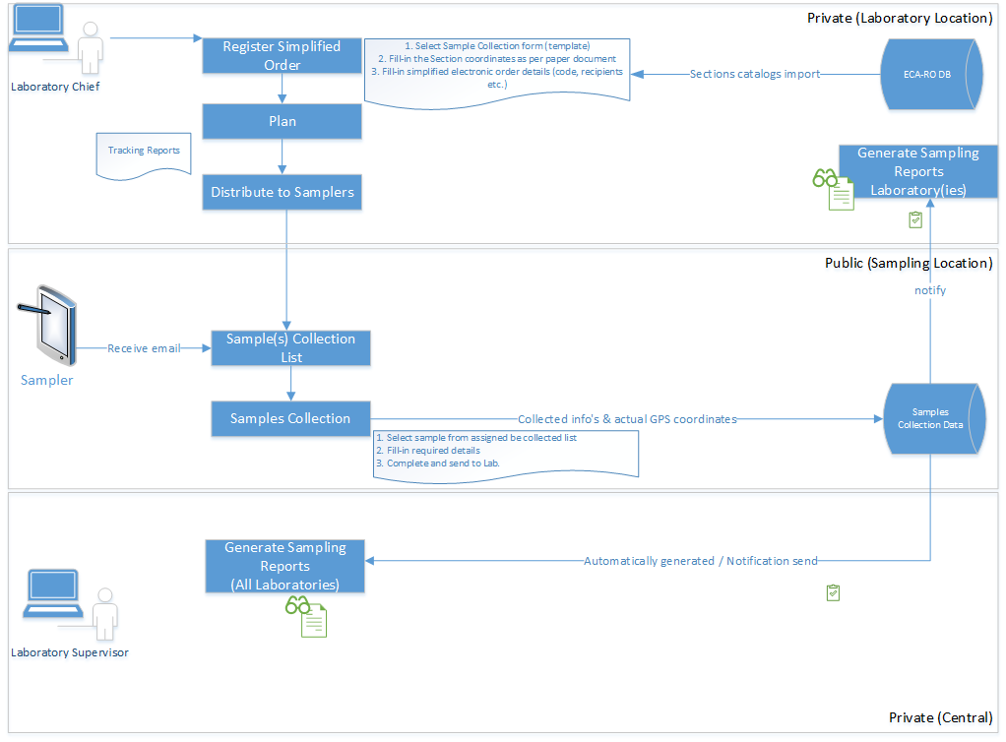Figure 6 – MVP business process applicable across all NARW Laboratories

As part of the future Laboratory Information Management System (LIMS) Minimum Viable Product (MVP), the selected Consultant will integrate the above-described modules and their associated processes into a single, unified and centralized web application.
At the initial MVP phase, the LIMS platform will be securely accessible only to key user groups, such as Laboratory Administrators, Laboratory Supervisors, and Samplers. Expected to function on dedicated and ZX10 fully-rugged Android tablets while also being accessible via modern web browsers on PCs and laptops.
The MVP of future LIMS expected to streamline and enforce the essential workflow outlined in Figure 6. It must be delivered to all NARW laboratories before the Pilot phase, serving as its core foundation, while ensuring efficiency, traceability, and compliance with laboratory procedures.
The detailed breakdown of the expected MVP business processes is as follows:
- The system must include a partial implementation of modules such as Master Data Management (MDM) and Laboratory Administration as part of the MVP, incorporating user administration and essential data catalogs. The system must support:
  - Importing standardized Section catalogs from the ECA-RO Database (DB) to ensure data consistency.
  - Importing and/or extracting Sampler catalogs from ASIS, with the flexibility for the Laboratory Chief to manually add new samplers and assign them to their respective laboratories.
  - All above along with users administering for Laboratory Chief, Supervisor and Sampler.
- The system must provide an electronic form derived from the paper-based Sample Collection template, allowing the Laboratory Chief to register a Simplified Order by initiating a new sampling order through the application. The system must automatically capture electronic order details, including unique order codes, recipients, and other relevant metadata. This functionality represents a partial implementation of the Laboratory Orders Manager module within the MVP.
- As part of the partial implementation of the Laboratory Workflow module within the MVP, once an order is registered, the Laboratory Chief can proceed with planning the sample collection process. The system is expected to facilitate this process by generating tracking reports to assist in monitoring and task assignment. Once a Sampler is assigned to one or multiple orders, they will automatically receive their orders electronically, which will be accessible on their tablets.
- As part of the partial implementation of the Laboratory Workflow module within the MVP, assigned Samplers will receive email notifications with details of their sample collection assignments, provided they have a registered email. They can then access the Sample Collection List on their tablets, which will display the location, sample type, and required parameters for each assigned task.
- As part of the partial implementation of the Laboratory Workflow module within the MVP, the Field Sampling Process will be conducted electronically using tablets. Assigned Samplers will select their orders, open the electronic Sample Collection form, and input the required details, including environmental conditions, metadata, and collection parameters. Once the sample collection is completed, the Sampler submits the form electronically, sending it directly to the laboratory. Simultaneously, the system will automatically capture and store the field GPS coordinates along with the registered data in a centralized database, ensuring accurate tracking and enabling future analysis.
- As part of the partial implementation of the Audit Trail and Alerts & Notifications modules, the system will ensure data synchronization and sample tracking by notifying relevant stakeholders about the status of sample collection, updating GPS-tagged sample data in real time to maintain traceability, and sending notifications to confirm the successful submission of samples and their readiness for laboratory processing.
- As part of the partial implementation of the Reporting and Alerts & Notifications modules, the system will facilitate sampling report generation by enabling the Laboratory Supervisor to oversee the finalization of reports, automatically generating reports based on collected sample data, and sending notifications to key personnel to ensure transparency and easy accessibility. Additionally, the system will support centralized report management by consolidating final sampling reports from all laboratories, allowing Laboratory Administrators and Supervisors to review, validate, and extract data as needed, while ensuring compliance with laboratory standards through structured data collection and reporting processes.
Conclusion: This MVP design lays the groundwork for a streamlined, digitized workflow, reducing manual errors, improving traceability, and enabling efficient sample tracking from collection to final reporting. Serving as the foundation and core component of the future LIMS system, this unified, secure, web-based application will centralize laboratory operations while ensuring restricted access to authorized personnel via ZX10 tablets.
Below comparison table outlines the incremental growth from an MVP focusing on core functionalities to a fully developed LIMS system with comprehensive features.

Category | MVP Requirements | Full LIMS Requirements (Pilot Phase) | Reference
User Access & Security | Limited access for key users (Lab Chiefs, Supervisors) via PCs or laptops and Samplers via ZX10 Android tablets | Role-based access control for all user types, including external stakeholders, with advanced security measures (MFA, encryption) | Chapters 3.2.1, 3.2.2
Order Management | Simplified electronic Sample Collection Order initiation | Full Laboratory Order Management with scheduling, modifications, and approval workflows | Chapter 3.2.6
Workflow Automation | Partial Laboratory Workflow module implementation, focusing on sample collection and tracking | Complete automation of laboratory workflows, including sample preparation, analysis, and validation | Chapter 3.2.6
Audit Trail & Compliance | Basic Audit Trail for sample tracking and data synchronization | Full compliance with regulatory standards (ISO, GDPR) with audit logs and traceability | Chapter 3.2.10
Data Synchronization & Tracking | GPS-tagged Sample Collection Data updated in real time | End-to-end traceability of all sample data from collection to final reporting, with history tracking | Chapter 3.2.10
Reporting & Notifications | Basic Sampling Report Generation, notifications to key personnel | Advanced custom reports, automated alerts, and real-time analytics dashboards | Chapters 3.2.9, 3.2.11
Centralized Report Management | Consolidation of sampling reports from all labs with manual validation | Fully automated report consolidation with integration into external databases and data visualization tools | Chapter 3.2.11
Sample Collection & Processing | Electronic form for sample collection, submission to lab, and GPS data logging | Full LIMS Sample Processing, including test execution, validation, and automated workflow routing | Chapter 3.2.6
Integration with External Systems | Limited integration with ECA-RO Database & ASIS for importing catalogs | Seamless integration with external LIMS, ERP, and third-party laboratory equipment for automated data exchange | Chapter 3.2.2, See Technical requirements in chapter 3.5
Scalability & Performance | Basic cloud/web-based LIMS MVP for initial user groups | Scalable enterprise-grade LIMS, supporting multiple labs, high user volumes, and complex workflows | See Technical requirements in chapter 3.5
User Interface & Accessibility | Web-based system accessible via secured tablets | Multi-platform access (PC, mobile, tablets) with an intuitive, customizable UI | See Technical requirements in chapter 3.5
Master Data Management (MDM) | Partial MDM module with user admin and imported catalogs | Full MDM module, supporting custom data fields, version control, and dynamic catalog updates | Chapter 3.2.2

Functional Performance Requirements of the System

Seq.  No. | Functional performance requirement shall include, as necessary, and without being limited to, the following requirements
35 | System Response Time  The system MUST be capable of processing and responding to user requests within an optimal timeframe.  The recommended response time aims to meet industry standards to ensure efficient user interactions would be:
35.1 | Web pages not reliant on aggregating or processing data from multiple business entities must load within 3 seconds.
35.2 | Pages that involve aggregating or processing data from multiple business entities must load within 5 seconds, ensuring performance is not affected by NARW network architecture. Testing will be conducted on the servers where the application is hosted.
35.3 | For complex reports using data from multiple sources, developed and/or optimized by the Consultant, the generation time within the reporting module must not exceed 10 seconds.
35.4 | For batch processing (e.g., sample data processing), the time should not exceed 2 minutes for standard tasks.
35.5 | Non-critical operations (e.g., reports generation) should be completed within 5-10 seconds depending on the complexity.
36 | Scalability: The system must be capable of handling a growing number of users, samples, and data without noticeable performance degradation. For more information on estimated capacity planning, please refer to Annex 7.
37 | Concurrency and Load Handling: LIMS must support multiple concurrent users without experiencing delays or timeouts, with the capacity to handle at least 50-100 concurrent users (refer to Annex 7 for estimated capacity planning) based on the laboratory size, and scale as needed to accommodate future demands.
38 | High Availability: The system must ensure a high level of availability, with up-time targets of 99.5% or higher, implement fail-over mechanisms, redundant components, and data replication to ensure continuous access to critical laboratory data.

Related Information Technology Issues and Initiatives
Seq.  No. | LIMS – Existing & Upcoming NARW IT Initiatives
39 | The existing laboratory relies on an Enterprise Resource Planning (ERP) system called ASIS; a standalone application used for manually extracting laboratory-specific inventory data. The future LIMS must integrate with all ASIS systems deployed across the various ABA (Basinal Water Administration) units, despite each being uniquely configured, to ensure seamless and efficient data flow.
40 | Like ASIS, the future LIMS must integrate with the existing standalone application ECA-RO, which is designed for monitoring water quality. This integration must enable bidirectional data transfer, including the input of specific catalogs and internal laboratory sample orders, as well as the output of laboratory test results for initiated orders. To ensure seamless and efficient data flow, the LIMS must transform and adapt data exclusively through REST APIs provided by ECA-RO.
41 | The LIMS reporting module is a key component of the system. The Beneficiary currently relies on SQL Server Reporting Services (SSRS) to generate various reports across NARW. To maintain consistency and ensure seamless report generation, the LIMS must integrate with NARW’s centralized reporting solution, which is expected to be built on SSRS. This integration may affect the LIMS design, so a comprehensive analysis of SSRS integration options, along with a clear proposal for the LIMS reporting module, is recommended.

Technical Requirements

3.5.1 General Technical Requirements
- The software development process must be flexible and adaptable, allowing for continuous refinement without causing significant project delays. A hybrid development methodology will be adopted, combining elements of both Waterfall and Agile approaches to ensure structured planning while maintaining implementation flexibility. This balanced methodology must ensure a structured yet adaptable development process, aligning with the MVP requirements detailed in Chapter 3.2.12 while supporting ongoing improvements.
  - Planning & Documentation Phase: The project will follow a Waterfall approach, ensuring clear milestones, detailed documentation, and a well-defined timeline to meet regulatory and operational requirements.
  - Implementation Phase: A DevOps methodology, incorporating Agile principles, will be used to support continuous integration, delivery, and collaboration. This will enable incremental development, with iterative updates based on feedback.
  - Prototype-Driven Development: Each phase will begin with discussions and agreements on prototype layouts to ensure alignment with the Beneficiary’s usability expectations. Once validated, the development will proceed iteratively, incorporating refinements as needed.
  - Compliance & Quality Assurance: This approach ensures compliance with NARW's rules and regulations while maintaining the flexibility to adjust functionalities based on evolving needs.
- The Consultant must deliver a custom-developed laboratory system, either built from scratch or customized from COTS (Commercial Off-The-Shelf) software. While artificial intelligence (AI) tools may assist during development, charging as if the work were entirely manual is unjustified, as such tools do not provide direct cost savings to the Beneficiary. Core functionalities should not fully rely on artificial intelligence (AI) or machine learning (ML) models; instead, they may be assisted and modified by developers to ensure compliance with operational and regulatory standards. This ensures the system remains deterministic, explainable, and verifiable. Incidental AI features in development tools (e.g., code completion) are acceptable if they do not compromise the solution's integrity or introduce any dependencies.
- Regarding future LIMS development technologies may include open-source* components only if they are encapsulated within COTS (Commercial Off-The-Shelf) products or frameworks, or if the Consultant provides explicit assurances regarding their support, maintenance, and compliance with security and licensing policies for the entire project lifecycle, i.e., including development and maintenance period. All open-source components must support enterprise licensing mechanisms (OAuth, activation keys), and include usage logging. be thoroughly vetted to ensure they meet organizational and regulatory standards. Furthermore, any dependencies must be fully documented and supported to guarantee the system's long-term sustainability and reliability.
(*) open-source software defined as programs developed by communities, companies, or individuals and distributed under licenses that grant free access to the source code

Important: To ensure that the proposed solutions are scalable, secure, and well-maintained; while offering flexibility for enterprise adoption and premium features, the technologies must meet the following requirements:
- Scalable Architecture & Modern Technologies – Supports microservices or modular monolith, modern programming languages (Python, Java, Go, Node.js), and scalable databases (SQL or NoSQL).
- Version Control & Continuous Deployment – Uses GitHub/GitLab, follows a clear branching strategy, automates builds with CI/CD, and supports Docker-based distribution.
- Security & Compliance – Implements OAuth 2.0, RBAC/ABAC, protects against SQL Injection, XSS, CSRF, ensures GDPR & ISO 27001 compliance, and includes automated vulnerability scanning.
- Integration & Extensibility – Provides RESTful API/GraphQL, webhooks, SDKs, plugin support, and admin CLI/UI for easy customization.
- Testing & Code Quality – Enables automated unit, integration, and end-to-end testing, enforces test coverage metrics, and optimizes performance through benchmarking.
- Community & Development Support – Encourages open-source contributions, maintains a public roadmap, supports forums, and automates code reviews.
- Premium Support & Maintenance – Includes ticketing, centralized monitoring/logging, SLA commitments for enterprise clients, and detailed technical documentation.

3.5.2 Computing Hardware Specifications

Hosting Requirements for LIMS Deployment
The Consultant shall design, configure, and deliver the solution to enable seamless deployment within the future Government Private Cloud, managed by the Authority for the Digitalization of Romania (ADR), based on Microsoft Azure Stack Hub or an equivalent platform. The LIMS must operate in a secure, high-performance, cloud-based environment fully compatible with this infrastructure.
Key Responsibilities of the Consultant
- Collaborate with NARW to define and size the Infrastructure-as-a-Service (IaaS) environment, detailing CPU, memory, storage, network, and security requirements.
- Propose a complete IT Architecture that includes all hardware, software, licenses, and services required for implementation and future maintenance.
- Ensure that all proposed components are technically and functionally justified, align with the agreed architecture, and are subject to Beneficiary approval following the analysis phase.
- Provide a license inventory (excluding pricing), including product name, version, model, quantity, duration, and purpose. Licenses will be procured and owned by the Client.
- Install and configure all required components in the Beneficiary’s cloud infrastructure, ensuring full functionality of the LIMS.
Core Architecture Requirements
The proposed architecture shall include, as necessary, and without being limited to the following:
- The architecture should support container-based deployment (e.g., Docker), allowing modularization of services, streamlined maintenance, and improved scalability. Where appropriate, orchestration tools such as Kubernetes, Azure Kubernetes Service (AKS) or equivalent may be proposed to manage service availability, scaling, and fault tolerance.
- Managed SQL Database or equivalent for secure and scalable data management.
- Virtual Machines (VMs) for flexible compute capacity.
- Application services for hosting web interfaces and REST APIs, ensuring integration with existing systems.
- Redundant storage with high availability and failover capabilities.
- Load balancers and VPN gateways to ensure secure and optimized network traffic flow.
- Resource management tools to enable hybrid cloud/on-premises integration.
- CI/CD pipelines, code repositories, and automation tools for efficient deployment and maintenance.
- Separation of environments (testing and production) for controlled validation and quality assurance.
- Active Directory integration with NARW’s existing environment for unified authentication.
- Automated backup, restoration, and failover mechanisms to support data protection and business continuity.
Below diagram presents an estimated on-premises architecture proposal, which can serve as a reference for adapting it to cloud-based architecture proposed by the Consultant.
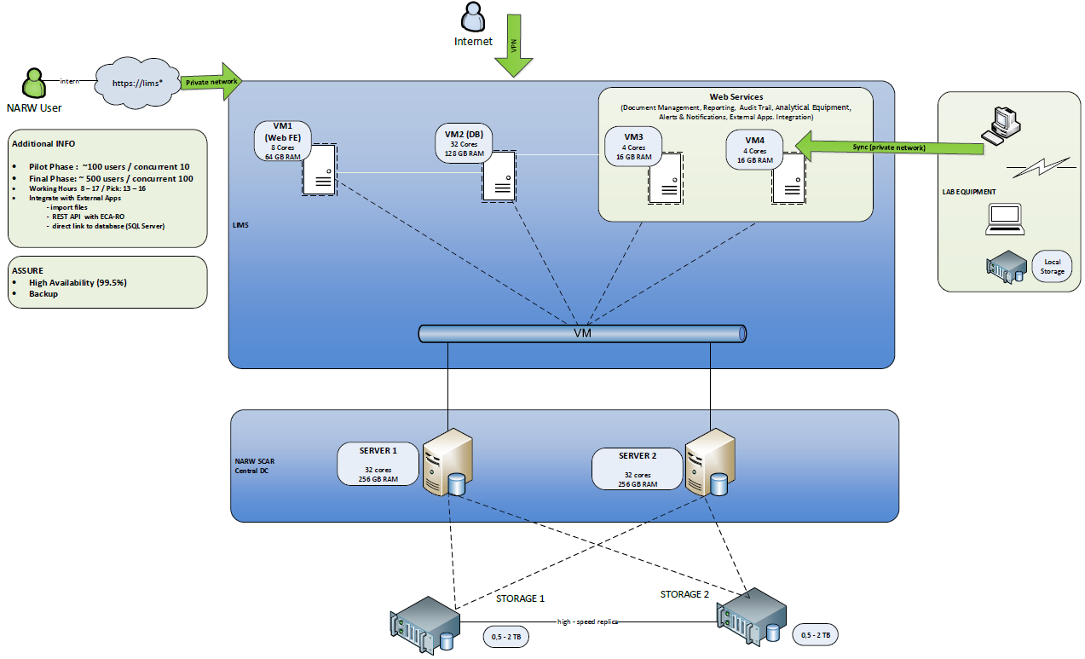
Figure 7
Additional Technical Considerations
- Resilient and cost-efficient Disaster Recovery protocols with synchronization to NARW’s SCAR storage systems.
- Regular automated backups ensuring data consistency and availability.
- The system must ensure a minimum uptime of 99.5%.
- Full alignment with data protection and privacy regulations.
- System access must be limited to authorized internal users through a secure private network.
- Architecture must support anticipated growth (e.g., new labs, more analyses, larger datasets), as outlined in Annex 7 – Estimated Capacity Planning.
Network and Communications Specifications
- LIMS must be capable of seamless integration with a variety of laboratory equipment, listed in Annex 3. This integration should support real-time data exchange, ensure compatibility with different device protocols, and enable efficient communication between the LIMS and all connected instruments for optimal workflow management and data accuracy.
- The LIMS must seamlessly integrate with GPS-enabled devices, as the Beneficiary's Getac ZX10* tablets, to capture and store geographic coordinates in real time during sample collection. This integration should facilitate automated data transfer, ensure compatibility with standard GPS protocols, and support efficient communication between the LIMS and GPS devices for accurate geolocation tracking and optimized workflow management.
(*) The Getac ZX10 is the lightest 10" fully-rugged Android tablet available, designed to endure tough environments. It is equipped with advanced AI capabilities, and here are the technical specs.

3.5.3 Software Specifications
The Consultant shall deliver the Laboratory Information Management System (LIMS) in three phases:
- MVP (Minimum Viable Product) – A functional core version to be tested in a controlled environment, serving as the basis for feedback and refinement.
- Pilot Phase – Deployment of the validated MVP in 7 laboratories, enabling real-world use and adjustments.
- Final Phase – Full rollout to the remaining 36 laboratories, ensuring full compliance with all business and technical requirements.
Each phase must align with the specifications in this chapter and be formally validated by the Beneficiary.

Core Software and Architecture may consider, as needed, the following
- The LIMS shall be based on a modular, object-oriented architecture, supporting microservices or modular monolith design, and developed using modern technologies.
- It shall include a centralized, relational database (e.g., SQL Server, PostgreSQL), ensuring ACID compliance, performance optimization (indexing, partitioning), and secure access (encryption, RBAC). Cloud scalability (e.g., Azure auto-scaling), high availability (clustering/load balancing), and disaster recovery are mandatory.
- The system shall allow future extensibility, integration of regulatory updates (GDPR, ISO, EU directives), and reuse of components via a centralized, documented software library.
User Access and Interface
- A unified web-based interface must be delivered, developed using modern frameworks (e.g., Angular, React, Vue.js), with cross-browser compatibility, responsive design, and centralized authentication.
- Single Sign-On (SSO) must be implemented using OAuth, SAML, or OpenID Connect, along with Multi-Factor Authentication (MFA).
- Hierarchical role-based access control (RBAC) must be enforced, with configurable permissions aligned to organizational roles.
Data Management and Security
- Full support for CRUD (create, read, update, delete) operations, data normalization, validation (at frontend, backend, and database level), and integrity enforcement using constraints, triggers, and stored procedures.
- Audit trails must be automatically generated for all data modifications and critical actions, stored immutably, exportable, and configurable by module or activity type.
- Logs and error messages must be securely recorded, timestamped, user-linked, and integrated into a workflow-based error reporting mechanism.
Integration and Reporting
- The system must expose secure, standards-based APIs (REST/GraphQL) for interoperability and include CLI or admin UI tools for extensibility.
- Seamless integration with existing NARW systems (e.g., ASIS, ECA-RO) is required.
- A reporting module must support both ad hoc and scheduled reports using SQL Server Reporting Services (SSRS) or equivalent, with features such as parameterized dashboards, exportable formats (PDF, Excel), and scalability to handle large datasets. Compatibility with tools like Power BI, Tableau or equivalent is encouraged.
Testing, Deployment, and Maintainability
- The system must use version control (e.g., Git), follow a branching strategy, and incorporate CI/CD pipelines for automated build, test, and deployment workflows.
- Automated units, integration, and end-to-end testing should be supported, along with code quality checks and performance benchmarking.
- Maintainability must be ensured through standard design patterns (e.g., MVC/MVVM), modular code, and thorough documentation (e.g., Software Design Document).
User Management and Licensing
- The system must support an unlimited number of users under a scalable licensing model and include onboarding tools for user setup and lifecycle management (activation/deactivation).
- The Consultant shall ensure the system supports organizational changes (e.g., staff turnover) with minimal administrative overhead.
Cloud-Native Features and Backup
- The LIMS must integrate with cloud-native storage and infrastructure, supporting automated full, incremental, and differential backups, cross-region replication, and disaster recovery aligned with business continuity best practices.
Intellectual Property
- The source code and all deliverables developed under this contract, including documentation, must become the property of the Beneficiary (NARW).

3.5.4 Extended Technical and Operational Specifications
System Monitoring and Maintenance
- The system must include real-time dashboards to monitor performance metrics (e.g., server health, database status, equipment connectivity) and provide alerts for incidents like capacity limits or integration failures.
- A cloud-based Service Desk platform must be provided for incident reporting, prioritization, and tracking, along with root-cause analysis tools for diagnosing errors.
- Remote diagnostics capabilities must support troubleshooting without the need for on-site interventions.
- All configuration parameters (e.g., workflows, instrument settings) must be version-controlled and centrally managed to ensure operational consistency.
Backup, Recovery, and Business Continuity
- The LIMS must support automated, scheduled cloud backups for sample data, results, and configurations, with cross-region redundancy and disaster recovery procedures to minimize downtime and data loss.
- Backup types (full, incremental, differential) and retention policies must align with business continuity standards.
Source Code Management and DevOps
- The Consultant must follow a DevOps methodology, ensuring fully automated CI/CD pipelines, quality gates at each build stage, and deployment automation for both testing and production environments.
- All source code, documentation, and deliverables must be maintained in a Git-based repository integrated with DevOps, managed by NARW.
- The Consultant must assist in configuring the full DevOps environment: pipelines, repositories, user roles, and access control.
- The recommended environments (as per Annex 9) must be set up to support continuous delivery and testing workflows.
User and Usage Management
- Role-Based Access Control (RBAC) must be implemented, defining permissions for all key LIMS user roles, including lab personnel, supervisors, administrators, and IT support.
- User provisioning must be integrated with NARW identity management system for centralized account management, with automated role assignments based on department or location.
- Usage analytics must track user activity (e.g., logins, task times, feature usage) to identify training needs or workflow bottlenecks.
- A self-service interface should allow users to request new workflows, imports, or minor configuration changes.
Security and Compliance
- The system must provide end-to-end encryption for data in transit and at rest, especially for test results and equipment communication.
- Multi-Factor Authentication (MFA) is mandatory for sensitive or administrative access.
- Full compliance with GDPR and ISO/IEC 17025:2017 is required, including features to support audits and data traceability.
- Intrusion detection, patch management, and vulnerability scanning shall be implemented, with security event logs retained and reviewable by NARW’s IT security team.
- Access control must follow least-privilege principles, limiting access strictly to role-appropriate functionalities and data.

3.5.5 Service Specifications

The Consultant shall perform all necessary services to ensure the successful development, deployment, and operation of the LIMS solution, that may include, as needed, the following:
Analysis, Development, and Deployment
- Conduct a detailed analysis of NARW laboratory workflows, legal and regulatory context (see Annex 1), and all technical and functional requirements outlined in this chapter.
- Review existing documentation provided by the Beneficiary and validate all assumptions through joint workshops.
- Develop the LIMS solution, perform functional and security testing, and support User Acceptance Testing (UAT) with documented test scenarios and guidance.
- Install, configure, and deploy the system on the agreed cloud-based infrastructure.
- Deliver full documentation, including technical specifications, user and maintenance manuals, and training materials as required.
- Provide training sessions and ensure post-deployment maintenance and support.
- All deliverables, documentation, and user materials must be provided in Romanian and approved by the Beneficiary.
System Integration
The Consultant must ensure seamless integration between the LIMS and the following systems and components:
- Identity and Email Systems: The LIMS must integrate with NARW’s existing identity and email systems to support Single Sign-On (SSO) for centralized authentication and access control. Additionally, the system must enable automated email notifications (e.g., alerts, test result reports), using configurable templates within the cloud-based environment.
- ECA-RO (existing Monitoring System): Enable secure, bidirectional API-based integration using JSON and token-based authentication for data exchange. Data synchronization must be real-time or scheduled and monitored via the LIMS administration interface.
- ASIS/ ATHOS (Financial Management System): Establish data connections to extract inventory data from distributed ASIS instances (Microsoft SQL Server-based), including support for the ATHOS system used in ABA Dobrogea-Litoral.
- Laboratory Equipment: Ensure direct integration with relevant instruments to capture test results automatically, where applicable. The Consultant must analyze the equipment list (Annex 3) and complete integration details during the analysis phase.
Expected Outcomes
- Fully integrated LIMS with centralized identity, automated email communication, real-time equipment data capture, and inventory synchronization.
- API connectors and integration mechanisms must be configurable and maintainable via the LIMS System Administration interface.
- All data exchanges must ensure encryption, secure authentication, logging, and compliance with applicable standards (e.g., GDPR, ISO/IEC 17025:2017).

Training and Training Materials

The following points should be taken into consideration when formulating a Training Program:
- If certain designated NARW personnel are unable to attend a session, the training may proceed as planned and be recorded, provided the Beneficiary grants approval.
- The training must accommodate all personnel nominated by NARW and be delivered to NARW personnel only – in-person or online if agreed with the Beneficiary.
- Sessions will only commence after the Beneficiary approves both the agenda and the proposed duration.
- For roles such Laboratory Operator and Validator, usual training manuals must be prepared with overview of topics and practical actions applicable on laboratory specifics as equipment.
- For administrative roles such as IT Administrator, Laboratory Administrator, etc., specific training manuals must be prepared, and a "Train the Trainer" approach may be implemented for NARW staff if agreed with the Beneficiary.
- The training manual for the Laboratory Administrator role must include detailed information on the responsibilities and functions of the Laboratory Operator and Validator, along with the specific modules and features relevant to the Administrator's role.
- The training sessions shall be conducted only on a fully finalized and installed system and should reference the version of the manuals that will be delivered with the final system.
- The trainer must have a good working knowledge of the system.
- The training sessions must be conducted in Romanian by a local trainer.
- Before the training sessions, the Consultant must prepare a package of methodological materials and a plan, which must be discussed and agreed upon in advance with the Beneficiary.
- This package should include at minimum:
  - Training program and agenda tailored per session and participant role
  - Overview of the training topics to be presented to the trainees
  - Practical tasks for the training course (where applicable)
  - The applicable GDPR compliance procedure and its consent form
  - Details of the documentation for reimbursement
  - Details of printed materials per session category and participant role
  - A dedicated training database shall be made available, which will be used for instruction and may be accessed by participants for system testing for a limited period, as mutually agreed by the parties.
  - A detailed training course schedule
- The evaluated Training Program for the Pilot (Phase I) implementation should, at a minimum, include the following:
  - Number of Training Sessions:
    - One (1) training session shall be conducted at the National Laboratory (LNCA) in Bucharest for at least fourteen (14) laboratory personnel.
    - Two (2) training sessions shall be conducted within ABA Siret: one in Bacău and the other at one of the ABA Siret laboratories selected by the Beneficiary, covering a total of at least thirty-five (35) laboratory personnel.
    - Separate training sessions shall also be provided for a total of at least eight (8) IT staff members designated by the Beneficiary, who are currently responsible for IT maintenance at laboratories located in Bucharest (LNCA) and within ABA Siret (Bacău, Suceava, Piatra Neamț, Focșani, and Pașcani). The IT training shall consist of one session in Bucharest for two (2) participants and one session in Bacău for at least six (6) participants.
    - The Beneficiary shall select the specific worksites in Bacău and regional laboratories where the sessions will take place.
  - Duration:
    - For laboratory personnel the training program is estimated to require a minimum of two (2) working days for ABA Siret and three (3) working days for the National Laboratory (LNCA) in Bucharest, in total estimated seven (7) full-working day sessions.
    - For IT personnel, an estimated two (2) on-site sessions at the Beneficiary’s premises are planned, each lasting approximately half a working day.
  - Training Material Preparation:
    - The estimated time for preparing training materials may be a minimum of 80 man-days, in addition to 50 man-days for administrative tasks.
    - The Contractor shall provide, at a minimum, training support materials tailored to each role (e.g., Administrator, Validator, Operator); a personalized dossier; printed documents including the agenda, evaluation questionnaires to be used during the training session(s), the GDPR procedure, and a GDPR consent form to be signed in advance by each participant; as well as a personalized pen and notebook for each participant.
  - Meal, Accommodation and Transportation:
    - Accommodation and transportation arrangements for the Beneficiary’s personnel shall be the responsibility of NARW and do not fall within the Contractor’s scope of work.
    - For all seven (7) training sessions dedicated to instructing laboratory personnel at the designated laboratory locations, the Contractor shall provide catering for each estimated full-day session, including: two open buffet breaks per session (one in the morning and one in the late afternoon) with warm, salty, and sweet options, as well as beverages such as water, coffee, tea, and juice; and one open buffet lunch per session.
  - Documentation for Reimbursement:
    - Upon completion, the following supporting documents shall be submitted together with the report: photographs demonstrating that the session took place; photographs of any hands-on training involving laboratory equipment, where applicable; completed evaluation questionnaires, where applicable; evidence of participants attendance; and GDPR consent form signed by each participant.

Important: For the second phase, the LIMS rollout to all 36 NARW laboratories will follow similar guidelines, incorporating lessons learned from the Pilot phase. Training sessions will be conducted on-site at each NARW Basinal Water Administration (ABA) headquarters in terms agreed further with Beneficiary. For details regarding personnel distribution per ABA, laboratories, and the project delivery phases, please refer to Annex 7, section "NARW Laboratory Units and Personnel Distribution".

Training Program for Users
The Training Program for Users must include the following key elements:
- Curricula: A minimum curriculum should cover essential topics such as basic computer skills, operation of the laboratory equipment integrated within the LIMS, and the usage of software applications incorporated into the system. The curriculum should be designed to ensure users can efficiently navigate and use the LIMS for sample tracking, data management, and reporting.
- Modes of Training: Training should be delivered through on-site sessions, remote webinars, and self-paced online courses to accommodate diverse learning preferences and schedules. Hands-on training should be prioritized for better user engagement and retention of knowledge.
- Modes of Testing: Regular assessments, including practical tests and quizzes, should be used to evaluate the effectiveness of training and ensure competency in using the LIMS. A certification process must be implemented to validate user proficiency.
- Training Materials: The training materials should include comprehensive user manuals, step-by-step guides, video tutorials, and FAQs, all tailored to different user roles (Operator, Validator). The materials must be accessible digital format..

Training Program for IT personnel
The technical training for system administrators and IT staff should cover the following:
- Curricula: The curriculum should focus on system maintenance, software updates, troubleshooting, and handling system integrations with external systems. The training must also address security protocols, backup procedures, and disaster recovery plans.
- Modes of Training: On-site workshops and detailed documentation should be provided, offering technical staff a deep understanding of the system's architecture, data flow, and fault diagnosis procedures.
- Modes of Testing: Technical assessments, such as simulation-based testing and hands-on troubleshooting exercises, should be conducted to ensure that the technical staff is fully prepared to manage, maintain, and support the LIMS.
- Training Materials: Detailed system architecture diagrams, API documentation, system logs analysis guides, and troubleshooting manuals should be provided. Additionally, access to a sandbox environment for testing system updates and configurations should be available.

Training Program for Laboratory Management Staff
Management training separated and mainly for users with Laboratory Supervisor role should focus on the oversight and strategic use of the LIMS within the organization:
- Curricula: The curriculum should address topics such as LIMS implementation planning, performance monitoring, compliance management, and leveraging data insights for decision-making.
- Modes of Training: Interactive workshops and case studies shall be used to illustrate real-life scenarios that emulate current paper-based processes in the laboratory, demonstrating how these are replaced by the application. They should also address potential challenges that may arise during functional activities and explain how these can be managed within the LIMS.
- Modes of Testing: Assessment can include scenario-based evaluations, where management is tested on their ability to handle hypothetical issues related to system use and integration.
- Training Materials: Strategic planning documents, reports on LIMS performance metrics, and guides for decision-makers should be provided to ensure that management can effectively oversee system operations and make informed decisions based on data insights.
Post-Training Deliverables
- The Consultant provides to the Beneficiary a list of all participants plus a training certificate for each of them according with the role. The certificates should be personalized, including the participant's full name, the module trained, and the training date, along with the Consultant's identifying information.
- Audio-video recordings of the training sessions must be provided.

Warranty, Support, and Maintenance

Warranty Coverage and Service Desk
The Consultant shall provide at least 20-month warranty starting from the Pilot Phase Go-Live acceptance. The warranty includes corrective, preventive, adaptive, and perfective maintenance, ensuring uninterrupted system functionality and compliance with all specifications. A Service Desk platform must be provided at no cost throughout the contract and warranty periods, allowing incident reporting, tracking, change requests, and reporting. A perpetual license for the Service Desk solution, supporting at least 15 IT staff, must remain the property of NARW.

Technical Support and Hotline Services
During the warranty period, the Consultant shall provide full technical assistance for LIMS components and associated cloud infrastructure. This includes:
- Incident management via Service Desk, email, and phone.
- Remote and on-site support.
- System checks, performance monitoring, and issue resolution in collaboration with the Beneficiary.
- A support structure with escalation procedures and monthly reporting.
Incident resolution timeframes (during NARW working hours):
- Priority 1 (Critical): Response in 2h, resolution within 4h
- Priority 2 (High): Resolution within 8h
- Priority 3 (Medium): Resolution within 16h
- Priority 4 (Low): Resolution within 24h
Preventive and Corrective Maintenance
- Preventive maintenance involves regular log reviews, performance checks, system health monitoring, and early detection of risks to ensure stable operations. Monthly activity reports must be submitted.
- Corrective maintenance covers incident resolution, bug fixes, and patching within specified SLAs, with continuous support until full system recovery is achieved.
Perfective and Adaptive Maintenance
- Perfective maintenance covers updates to meet evolving business or legal requirements, including minor structural or data model changes that do not trigger full system redesign.
- Adaptive maintenance includes adjustments needed for compatibility with infrastructure or third-party systems (e.g., OS upgrades, integration updates).
- All changes require prior approval from the Beneficiary and will be implemented during business hours, based on authorized requests.
Technical Assistance
The Consultant's support team will manage incidents, system optimization, performance issues, and change requests, with a clear escalation structure and collaboration procedures defined with NARW.
Post-Warranty Maintenance
After the initial two-year warranty, ongoing maintenance—including preventive, corrective, and performance support—will continue under a separate contract. The Service Desk must remain operational on NARW infrastructure to ensure continuity.

Documentation Requirements
The Consultant must deliver comprehensive documentation covering all aspects of LIMS implementation, operation, and maintenance. All documentation must be provided in Romanian, in editable (Word) and non-editable (PDF) formats, uploaded to the DevOps repository, and subject to version control and technical approval by the Beneficiary.

User Documentation
- User Manuals: The Consultant must provide comprehensive, role-specific manuals (e.g., Operator, Verifier, Supervisor, Administrator) containing step-by-step instructions and visual aids for performing all relevant system functions, tailored to each user role’s responsibilities.

- End-User Guides: The Consultant must deliver clear and concise guidance materials designed for non-technical users, outlining how to access, navigate, and utilize the system’s core functionalities effectively.
Technical Documentation
- Installation Manual: The Consultant must provide a comprehensive guide detailing the initial setup of the system, including all prerequisites, step-by-step installation instructions, required configuration settings, and any necessary installation scripts or tools.
- Maintenance Manual: The Consultant must deliver clearly documented procedures for routine system maintenance, covering daily, weekly, and monthly tasks such as backups, performance monitoring, system updates, virtualization management, and user administration.
- Software Requirements Specification (SRS): The Consultant must provide comprehensive technical documentation detailing the system’s functional, non-functional, and integration requirements, including user expectations, data structures, system interfaces, user interface specifications, and clearly defined acceptance criteria.
- Software Design Document (SDD): The Consultant must provide detailed technical documentation at minimum describing the internal structure and design of the system, including the technical architecture, data model, error code catalog, UML diagrams (static and dynamic), use case descriptions, and performance optimization strategies.
- IT Architecture Document: The Consultant must provide a detailed description of the system’s cloud and hybrid infrastructure, including cloud-native components, containerization strategies (e.g., Docker, Kubernetes), network architecture, integration with existing systems (such as Active Directory, Exchange, and ECA-RO), as well as security, compliance, and scalability considerations.
Additional Deliverables
- Internal test and security reports commented on source code, and version-controlled final documentation.
- A technical knowledge transfer plan and supporting materials for NARW staff.
- All documents must be digitally signed and aligned with the production-ready version of the application.
Intellectual Property
- All documentation, source code, and related materials developed under the contract shall become the exclusive property of the Beneficiary.
- The Consultant may not retain or reuse these materials outside the scope of the contract without written consent from the Beneficiary.

Testing and Quality Assurance Requirements

3.9.1 Inspections before delivery
Development Process: The Consultant must provide information on the development process to be used to deliver LIMS solution including:
- Development team structure and organization,
- Development methodology and process lifecycle,
- Code Review process,
- Source code Management,
- Continuous Integration Plan,
- Tools and Techniques to be used,
- Development Guidelines and rulebooks.

Pre-commissioning Tests

System integration Tests
The Consultant must ensure that the LIMS integrates seamlessly with external systems—either through an interoperability framework or direct connections (e.g., bidirectional exchange with ECA-RO and inventory retrieval from ASIS/ATHOS).
The integration testing process must validate both functional and non-functional requirements, including performance and security. The Consultant is required to provide full integration testing documentation, including:
- Integration methodology per external system
- Testing approach, procedures, and test data
- Detailed test results and analysis
Success criteria include reliable, low-latency data exchange, secure communication, and proper error handling for all integrated systems within the cloud environment.

Cloud Environment Tests
The Consultant must conduct a detailed suite of tests to validate that the cloud infrastructure supporting LIMS meets all functional, performance, scalability, availability, and security requirements as defined in the technical specifications.
Testing Scope and Documentation
Cloud testing must verify that the environment is correctly configured and capable of supporting expected operational loads, secure data handling, and recovery procedures. The Consultant must provide full test documentation, including:
- Cloud configuration overview
- Test scenarios, procedures, and test data
- Results and evaluation reports aligned with non-functional requirements
Key Cloud Test Categories and Success Criteria
- Infrastructure Validation: Confirm that the cloud environment (VMs, storage, networks) meets availability, scalability, and redundancy requirements.
- Scalability Testing: Simulate peak loads and increased data volumes to ensure the system can scale horizontally and vertically without performance degradation.
- Performance Testing: Validate system response times, throughput, and latency under concurrent usage. Response times must meet defined thresholds (e.g., <2 seconds).
- Disaster Recovery: Simulate failures and validate backup and recovery processes meet defined RTO/RPO metrics with no data loss.
- Security and Encryption: Ensure end-to-end data protection through encryption (at rest and in transit), proper access controls, and audit logging. No critical vulnerabilities should be identified.
- Availability Testing: Confirm the cloud environment maintains minimum uptime (e.g., 99.5%) under various operating conditions, including maintenance windows.
- Backup & Retention: Validate backup creation, data recovery processes, and compliance with defined data retention policies.
Overall Cloud Compliance
- The environment must adhere to security regulations (e.g., GDPR) and SLA targets, and support load, stress, and failover conditions without service interruption.
- All testing must be executed in coordination with NARW’s IT team and aligned with the cloud configuration finalized during the analysis phase.

User Access and Authentication Tests
The Consultant must validate the implementation of user authentication and authorization mechanisms within the cloud environment, including Single Sign-On (SSO), multi-factor authentication (MFA), and role-based access control (RBAC).
- Test Objective: Verify that all authentication methods function correctly and that access permissions are enforced according to defined user roles.
- Test Conditions: All user roles and associated access rights must be pre-configured and aligned with the system’s security specifications.
- Success Criteria: Users must only be able to access functionalities and data permitted by their assigned roles. Unauthorized access attempts must be denied, logged, and appropriately handled to ensure system integrity and data security.

4. Qualifications Requirements

Team Composition & Qualification Requirements for Key Experts

Qualifications Requirements for the Consultant's Team
The required services shall be delivered by the Consultant, who must demonstrate substantial expertise in providing advisory and consultancy services related to the design and development of IT systems, preferably within the context of funding schemes managed by public sector institutions. Furthermore, the Consultant should possess a solid background in managing and diversifying IT infrastructure architectures, including cloud-based, hybrid, and on-premises environments.
The Consultant must meet at least the following qualifications:
- The Consultant must have developed at least 3 institutional development projects (IT systems) for private or public institutions during the last 5 years with a cumulative value of at least EUR 3 million, proven with recommendations or similar documents. Previous experience in working for or with public institutions represents an advantage.
- Proven experience in the successful implementation and delivery of medium-to-large-scale Laboratory Information Management Systems (LIMS) projects or comparable IT system deployments represents an advantage. Preference will be given to projects that involve cloud-based hosting.
- Experience in the development of IT systems with similar complexity involving components such as project submission, evaluation, monitoring, implementation, and reporting is considered highly desirable.
- A proven track record in the successful delivery of comparable projects financed by the European Union or other international funding programs shall be considered a significant advantage.
- The experts are required to maintain confidentiality regarding any information shared during the implementation of the project. The exclusivity of the experts applies only to the actual working time spent on project activities carried out on behalf of the Consultant.
- The Consultant shall provide specialized personnel who will carry out the activities outlined in the contract to be awarded.
- The Consultant is required to nominate one (1) key expert corresponding to the profiles specified below as part of the proposed implementation team. Within the technical proposal, the Consultant shall provide a list of the personnel proposed for project implementation, clearly identifying the expert(s) nominated for each position, accompanied by a statement of availability, detailed CVs, and supporting documentation to demonstrate compliance with the minimum and mandatory requirements outlined in below sub-chapters. Supporting documents must include certified copies (certified as true to the original) of relevant academic qualifications and work experience detailed in the CVs. Furthermore, the Consultant shall provide copies of professional certifications, diplomas, recommendation letters from beneficiaries of previous projects/contracts, or other relevant documents to validate the claimed professional experience, as required under the terms of this specification document.
- In addition to the key expert, the Consultant may propose additional personnel with similar profiles, such as Senior Developer, Business Analyst, or Project Manager, who shall be designated as non-key experts and shall remain under the sole responsibility of the Consultant. Submission of CVs or supporting documentation for non-key experts is not mandatory at the bidding stage, but such documentation may be submitted within five (5) working days following contract signing.
- Nonetheless, the Consultant shall ensure that any non-key experts mobilized after contract award are suitably qualified and competent to perform the assigned activities, under the supervision and coordination of the designated key expert, and in accordance with the approved project implementation plan.
- The Client (the Client) reserves the right to request additional documents/information to clarify the claimed similar experience and to verify the accuracy of the information and evidence provided by the Consultants. If the certificates/diplomas/documents confirming the indicated professional experience are issued in a language other than Romanian, they must be submitted in the original language, along with a certified translation into Romanian.
- For experts who are not Romanian speakers, the winning Consultant must provide authorized interpreters/translators to facilitate communication with the Client’s personnel/beneficiary/economic operator and to ensure that deliverables are submitted in Romanian. All costs related to interpreters/translators are the responsibility of the winning Consultant.
- The Consultant is expected to present a team capable of meeting the requirements outlined in the terms of reference within the specified deadlines. The team must consist of at least 6 key experts, each with proven experience in their respective areas, such as the following:
  - Project Manager: Oversees the entire LIMS development lifecycle, managing timelines, budgets, resources, and stakeholder communication. Ensures the project aligns with defined goals and client expectations, coordinating cross-functional teams to deliver the solution on time and within scope. The role may be temporarily covered by the Technical Lead during periods of absence, such as holidays or medical leave.
  - Business Analyst: Acts as a bridge between stakeholders and the technical team, gathering and analyzing requirements for LIMS. They document processes, clarify functional needs, and ensure the system aligns with business objectives.
  - Architect: Leverages deep expertise in cloud, hybrid, and on-premises environments to design and manage the LIMS infrastructure, ensuring it meets high standards of scalability, security, and reliability. The Architect develops robust strategies for deployment, storage, and data handling in cloud platforms while addressing network, hardware, and server needs in on-premises and hybrid configurations to optimize overall system performance and availability. Key responsibilities include designing a comprehensive LIMS solution architecture that aligns with functional, technical, and compliance requirements. This involves creating a strategic blueprint detailing the system’s structure, modules, and workflow integrations to enable seamless operations. The Architect works in partnership with the Business Analyst to guarantee that the solution aligns with business objectives and user expectations.
  - Technical Lead: Drives the technical implementation of the LIMS solution, ensuring alignment with the overall architecture and adherence to functional, technical, and compliance requirements. Oversee the development, configuration, and integration of system components while ensuring technical feasibility, optimal performance, and scalability. Collaborates closely with the Architect to maintain consistency with the solution design and partners with Business Analysts to address user and business needs effectively. Provides hands-on guidance and support to development and technical teams throughout the project lifecycle, ensuring the successful delivery of the solution.
  - Senior Developer: Leads development efforts for the LIMS implementation, focusing on coding complex components, ensuring adherence to technical standards, and mentoring junior developers. Implements critical functionalities, system integrations, and optimizations, playing a key role in delivering a robust and efficient solution.
  - One Compliance Officer: Ensures the LIMS complies fully with ISO/IEC 17025:2017. Oversee the management of audits, documentation, and compliance processes to uphold regulatory integrity. Collaborate closely with Business Analysts to validate and verify that proposed system designs and workflows align with compliance requirements and gathered specifications. Plays a critical role in establishing best practices, mitigating risks, and ensuring the system meets all mandatory standards and operational excellence criteria.
- In addition to the minimum of 6 key experts, the following non-key profiles are also expected:
  - Three Tester/QA Specialist: Plays a critical role in ensuring the LIMS solution meets quality and reliability standards through rigorous testing processes. Conducts unit testing, integration testing, and user acceptance testing (UAT) to identify, document, and track bugs for resolution, guaranteeing a stable and robust system. Collaborates with Business Analysts to create comprehensive test scenarios and maintain detailed test documentation. Partners closely with senior developers to streamline bug-fixing efforts and improve overall system performance. Actively contributes to delivering a high-quality LIMS solution aligned with business requirements.
  - Three Trainers: Delivers comprehensive training to end-users on the effective use of the LIMS, ensuring proficiency and maximizing system utilization. Develops detailed training materials, conducts engaging sessions, and provides ongoing support to users. Works closely with stakeholders to tailor training programs to specific needs and ensure alignment with organizational goals and best practices.
Important:
- Refer to sub-chapters 4.2 and 4.3 for details on the required profiles of key and non-key experts proposed by the Consultant.
- The CVs of the proposed key experts’ profiles must be included in the bid.
- The CVs of the proposed non-key experts shall be submitted to the Beneficiary within five (5) working days from the date of contract signature to meet and certify the requirements related to the qualifications, minimum experience, and skills of the experts proposed in the bids, supporting documents must be submitted: diplomas, recommendations (from direct beneficiaries of the services provided by the Consultant), relevant certifications, and attestations for the field of expertise assumed in the project, as well as the individual project portfolio, which should include the projects/contracts demonstrating the experience gained in months specific to the proposed position, where the expert carried out similar activities to those in the current project, along with the personal contribution.
- All information provided by the Consultant will be considered in the evaluation procedure. If any key expert does not meet the minimum qualification requirements or if the Consultant fails to provide relevant information, the Consultant will be disqualified.
- A key expert can only be nominated for one position from those identified above.
- The Client can request the replacement of any key expert if their performance is deemed insufficient. This request must be made in writing with justification. The Consultant cannot request changes to the expert team within the first 6 months of the contract, except in cases of force majeure. After this period, the Consultant may propose an expert replacement, which must be approved in writing by the Beneficiary. The replacement proposal, along with supporting documents, must be submitted at least 10 days before the new expert begins. The replacement must have equal or higher qualifications and experience to ensure the integrity of the procurement process.
- The actual replacement of a key expert can only occur after receiving written approval from the Client. The Consultant must ensure that the replacement process does not disrupt the project and must take all necessary measures to ensure the timely transfer of information to the new expert. Key experts involved on the Consultant's side will sign confidentiality agreements before being introduced to the data structures and current software modules.
- All costs related to the replacement of the key experts are the sole responsibility of Consultant. Regardless of the situation, the Client will not make any payments for the period during which the expert or their replacement is absent.
- The Client may request activity reports from the key experts involved in the project whenever deemed necessary. Based on the analysis of these reports, the Client may ask the Consultant for additional information or documents to confirm the experts’ involvement in the project.

Key Expert Profiles

- Project Manager (8% effort/profile, estimated at 310 man-days, min. 1 person)
Future tasks or responsibilities
- Acts as the Single Point of Contact (SPOC) throughout the entire LIMS implementation lifecycle, including support and maintenance phases, ensuring effective communication, fostering strong relationships with Beneficiary, addressing their needs and feedback, and serving as a liaison between stakeholders, technical teams, and lab personnel to deliver a successful and sustainable solution.
- Contract management, scope management, change management, general planning of contract execution, risk management, problem management, communication management.
- Define project scope, objectives, and deliverables; create detailed work plans and schedules; allocate and manage resources effectively to meet contractual requirements.
- Identify risks, develop mitigation strategies, and address bottlenecks or unforeseen issues to maintain project momentum.
- Monitor project costs, approve expenditures, and adjust plans as necessary to stay within budget.
- Ensure deliverables meet required standards, stakeholder expectations, and quality benchmarks, including performance and compliance related to licenses and services.
- Maintain clear and consistent communication of objectives, updates, and progress to management, users, and stakeholders.
- Track the performance of related services and ensure adherence to deadlines as outlined in the delivery schedule.
- Conduct the final handover, oversee post-implementation reviews, and ensure smooth transition to the support phase.
Education and experience:
  - Bachelor's degree in relevant fields such as Business Administration, Management, Information Technology, Engineering, or related discipline.
  - A master’s degree is a plus, with certifications such as Project Management Professional (PMP), Prince2, or Agile considered an advantage.
  - 3+ years managing projects, leading technical teams.
  - Demonstrated success in developing and delivering at least two systems of similar complexity.
  - Experience managing the development of IT software solutions, particularly for LIMS applications, is an advantage.
  - Excellent communication and interpersonal skills, including experience in client-facing roles, to foster collaboration and stakeholder engagement.
  - Proficiency in managing timelines, budgets, and resources to ensure successful project delivery.
  - Work collaboratively with the technical team and the Beneficiary’s team, ensuring seamless coordination across roles to align technical solutions with compliance requirements and project objectives.
Note: The role may be temporarily covered by one of the Technical Leads (D) during periods of absence, such as holidays or medical leave.
- Business Analyst (17% effort/profile, estimated 170 man-days, min. 1 person)
Future tasks or responsibilities
- Understand and prioritize business requirements from multiple stakeholders, ensuring that the most critical needs are addressed first.
- Interpret complex business requirements and translate them into clear, actionable insights for top management, aiding in strategic decision-making.
- Develop solutions based on identified requirements, create change management proposals, and align efforts with the organization’s long-term goals.
- Work closely with Architects and the Development team to ensure the technical team fully understands the business requirements and can design appropriate solutions.
- Work in tandem with the Compliance Officer to ensure compliance requirements are incorporated into business solution designs, including adherence to ISO/IEC 17025:2017 standards.
- Organize and lead design sessions with the project implementation team to ensure all business requirements are captured and addressed.
- Ensure the accurate delivery of system design, business rules, and other key deliverables, ensuring they align with business objectives.
- Gather and analyze information from multiple organizational sources to identify data trends and provide informed recommendations to stakeholders.
- Translate technical and architectural requirements into clear, understandable terms for the entire project team to ensure seamless implementation.
- Actively engage with stakeholders to capture new business requirements, ensuring they are effectively communicated to the development team.
- Help management anticipate future business requirements and evolving processes, adapting to changing business models and environments.
Education and experience:
- 3+ years of experience as a Business Analyst in software development projects, with a proven track record of successful project delivery.
- Experience in gathering and documenting complex business requirements for at least two systems of similar complexity, ensuring alignment between business needs and technical solutions.
- Strong experience in developing technical and functional specifications for complex software applications, as outlined in chapter 5.9.4 (SRS), with a focus on ensuring alignment between system design and business objectives. Experience in this LIMS area is considered a distinct advantage.
- Experience in developing technical and functional specifications for similar software applications will be considered an advantage.
- Experience with elicitation techniques for gathering requirements from diverse stakeholders.
- Experience with process modeling tools (e.g., BPMN, UML) for mapping business processes and workflows.
- Experience with data modeling, including structuring data for reporting, analysis, and system integration.

Important: The Consultant is required to nominate at least one (1) Key Expert with a Business Analyst profile as part of the proposed implementation team. For the designated Key Expert, the Consultant shall submit a detailed Curriculum Vitae (CV) accompanied by relevant supporting documentation, including diplomas, professional certifications, and verifiable evidence of experience that meet the minimum qualification criteria set forth above. In addition to the Key Expert, the Consultant may propose an estimated minimum of three (3) additional personnel with a similar profile, who shall be considered Non-Key Experts. Submission of CVs or supporting documentation for Non-Key Experts will not be done during the tender stage, but within 5 working days from the entry into force of the contract. Their verification will be materialized by sending a notification of acceptance from the Purchaser Nevertheless, the Consultant shall be fully responsible for ensuring that any Non-Key Experts mobilized following contract award are appropriately qualified and competent to perform the assigned tasks, under the coordination and supervision of the Key Expert, and in full alignment with the project implementation plan.
- Architect (4% effort/profile, estimated 155 man-days, min. 1 person)
Future tasks or responsibilities
- Propose, design, and implement infrastructure solutions that ensure an optimal cost/benefit balance for integrating the LIMS with existing Beneficiary IT solutions, facilitating bi-directional data transfer efficiently and seamlessly.
- Design and implement integration strategies for seamless interaction between the LIMS and other systems (e.g., laboratory equipment, ASIS and ECA-RO systems, and regulatory databases), ensuring efficient data exchange and interoperability.
- Assess and design cost-effective integration strategies with legacy systems and existing IT infrastructure, ensuring minimal disruption during the implementation of the LIMS and optimizing the overall system performance.
- Ensure proposed infrastructure is scalable, cost-efficient, and optimized for long-term growth. Balance infrastructure costs with the need for enhanced system performance and reliability as the LIMS solution expands.
  - Plan and implement infrastructure upgrades and capacity expansion strategies to accommodate evolving business needs and technological advancements.
  - Ensure the creation of comprehensive technical documentation (e.g., Software Design Document and IT Architecture as outlined in chapter 5.9), including system design, architecture diagrams, and blueprint integrations, to guide both the implementation and ongoing maintenance of the LIMS solution.
  - Provide technical leadership to the internal development team and, when needed, to the Beneficiary’s technical teams. Mentor engineers and ensure the adoption of best software engineering practices throughout the project lifecycle.
  - Good communication skills, with experience liaising with internal and external stakeholders, ensuring alignment of infrastructure solutions with organizational needs.
Education and experience:
- Bachelor’s degree in a relevant field.
- 3+ years of hands-on software development experience.
- 3+ years designing and implementing systems of similar complexity data-intensive applications.
- Proven success in developing and delivering at least 3 systems of similar complexity
- Experience in cloud and hybrid infrastructure design, deployment strategies, and data handling.
- Proficiency in software architecture, API design, and the full development lifecycle, with a focus on performance optimization and continuous improvement.
- Skilled in risk management for compliance, data security, and performance in software development.
- Strong expertise in cloud platforms (e.g., Azure, AWS, Google Cloud) and cloud-native services.
- Proven experience in data storage, handling, and database management (e.g., SQL, NoSQL) with an emphasis on high availability, disaster recovery, and compliance.
- Proven expertise in designing cost-effective cloud / hybrid infrastructure would be a plus.
Note: The role may be temporarily covered by the Technical Lead (D) during periods of absence, such as holidays or medical leave.
- Technical Lead (9% effort/profile, estimated at 360 man-days, min. 1 person)
Future tasks or responsibilities
- Approving each development in DevOps, ensuring a unified development approach within the NARW system.
- Having an overall understanding of the entire IT system under development.
- Lead the technical execution of the LIMS solution, ensuring alignment with the overall architecture and adherence to functional, technical, and compliance requirements.
- Oversee the development, configuration, and integration of system components to deliver a cohesive and functional solution.
- Ensure the technical feasibility and optimal performance of all implemented components.
- Work closely with the Architect to ensure seamless deployment and alignment of infrastructure needs.
- Partner with the Business Analysts to address user requirements and business objectives effectively.
- Provide hands-on technical guidance and mentorship to build and support teams throughout the project lifecycle.
- Address challenges, provide solutions, and foster a collaborative development environment.
- Ensure technical consistency across all phases of the project, from design and implementation to deployment and ongoing support.
- Monitoring the performance of related services related to the provision of licenses.
- Elaboration and updating of the quality assurance plan related to the performance and quality indicators in tandem with Project Manager.
Education and experience:
  - Over 5 years of hands-on experience in software development, with a strong understanding of modern coding practices and technologies.
  - At least 3 years of experience leading technical teams, providing guidance and ensuring successful project outcomes.
  - Proven track record of successfully developing and delivering of at least 3 systems of similar complexity.
  - Experience in managing the development of IT software solutions for Laboratory Systems applications represents an advantage.
  - Deep knowledge of modern software architecture principles, including cloud-native systems development.
  - Proficiency in web development frameworks and relevant programming languages is essential to ensure efficient and effective development. Proven experience in designing and developing frameworks specifically for LIMS solutions is a key advantage.
  - Expertise in REST API development and integration, ensuring seamless communication between system components and external services.
  - Expertise in database design and management, particularly with Microsoft SQL database management system, and familiarity with SQL and NoSQL systems.
  - Excellent communication abilities, including client-facing experience, to collaborate effectively with stakeholders and team members.
  - Experience with DevOps principles and practices, including continuous integration (CI) and continuous delivery (CD) pipelines, to automate testing, deployment, and monitoring.
  - Knowledge of security best practices for cloud and hybrid solutions is essential to ensure the future LIMS system is secure, compliant, and resilient to vulnerabilities, experience in this area is highly desirable.

Note: The role may be temporarily covered by one of the Senior Developer (E) during periods of absence, such as holidays or medical leave.
- Senior Developer (34% effort/expert, estimated 230 man-days, min. 1 person)
Future tasks or responsibilities
- Lead the development of key components and functionalities within the LIMS solution, ensuring alignment with project requirements and technical specifications.
- Design, code, and optimize complex modules, ensuring system efficiency, scalability, and performance.
- Ensure adherence to coding standards, best practices, and maintainability throughout the development lifecycle.
- Mentor and provide guidance to junior developers.
- Collaborate with architects and business analysts to translate business requirements into technical solutions.
- Contribute to the design and implementation of system integrations, ensuring seamless data flow across the LIMS environment and with external systems.
- Review and ensure the quality of the software through comprehensive testing, debugging, and troubleshooting.
- Participate in code reviews, provide feedback to team members and continuously improve the development process.
- Collaborate closely with the technical lead and other team members to ensure timely delivery of milestones and successful project completion.
- Provide post-deployment support, addressing technical issues, optimizing system performance, and assisting in ongoing maintenance.
Education and experience:
- Bachelor’s degree in a relevant field.
- 3+ years of professional experience in software development, with a strong background in developing enterprise-level applications.
- Proven track record of successfully developing and delivering of at least 3 systems of similar complexity.
- Proven experience working with laboratory management software is a plus.
- Extensive and proven experience in object-oriented programming, system integration, and building scalable, efficient software solutions.
- Experience with web technologies, databases (SQL/NoSQL), and cloud services (Azure, AWS, etc.) is beneficial.
- Hands-on experience with version control systems (e.g., Git), continuous integration, and deployment practices.
- Proved experience in debugging, troubleshooting, and optimizing code for performance.
- Familiarity with regulatory standards in laboratory environments (e.g., ISO/IEC 17025:2017) is a plus.
- Certifications in relevant programming languages, software development methodologies (e.g., Agile, Scrum), or specific technologies related to LIMS systems (e.g., Java, .NET) represent an advantage.

Important: The Consultant is required to nominate at least one (1) Key Expert with the Senior Developer profile as part of the proposed implementation team. For the designated Key Expert, the Consultant shall submit a detailed Curriculum Vitae (CV) accompanied by relevant supporting documentation, including diplomas, professional certifications, and verifiable evidence of experience that meet the minimum qualification criteria set forth above. In addition to the Key Expert, the Consultant may propose an estimated minimum of five (5) additional personnel with a similar profile, who shall be considered Non-Key Experts. Submission of CVs or supporting documentation for Non-Key Experts will not be done during the tender stage, but within 5 working days from the entry into force of the contract. Their verification will be materialized by sending a notification of acceptance from the Purchaser. Nevertheless, the Consultant shall be fully responsible for ensuring that any Non-Key Experts mobilized following contract award are appropriately qualified and competent to perform the assigned tasks, under the coordination and supervision of the Key Expert, and in full alignment with the project implementation plan.

- Compliance Officer (2% effort/expert, estimated 80 man-days, min. 1 person)
Future tasks or responsibilities:
- Ensure that the LIMS system remains fully aligned with the ISO/IEC 17025:2017 standard, meeting all applicable legal, quality, and operational requirements.
- Manage and coordinate internal and external audits to ensure the LIMS complies with regulatory requirements. Maintain accurate and up-to-date compliance documentation, including audit trails, risk assessments, and audit reports.
- Work closely with the Senior Business Analyst to verify that the LIMS design, workflows, and processes align with both business requirements and regulatory compliance criteria. Ensure that all proposed system designs meet the necessary legal and industry standards.
- Identify potential compliance risks and implement best practices to mitigate them. Establish and promote standard operating procedures (SOPs) for compliance, ensuring continuous alignment with regulatory changes and updates.
- Lead the validation and verification of the LIMS system throughout its lifecycle, ensuring compliance at all stages from design to deployment and ongoing operations.
- Oversee the generation of compliance reports and documentation for regulatory authorities, ensuring all processes, data handling, and reporting activities meet the prescribed standards.
- Engage with stakeholders, including regulatory bodies and internal teams, to ensure clear communication of compliance expectations and requirements. Provide training and guidance to staff on compliance-related matters.
Education and experience:
- Bachelor’s degree in a relevant field.
- 3+ years of experience in regulatory compliance, quality assurance, or related fields, within the context of laboratory information management systems (LIMS).
- Proven experience working on projects certified under ISO/IEC 17025:2017 in applying and validating the standard’s requirements within Laboratory Information Management Systems (LIMS).
- Experience in managing audits, conducting risk assessments, and implementing corrective actions.
- Knowledge of compliance processes, including documentation, auditing, and validation.

Non-Key Expert Profiles
- Tester/QA Specialist (16% effort/profile, estimated 645 man-days, min. 3 persons)
Future tasks or responsibilities:
- Review software requirements for the LIMS system and develop comprehensive test scenarios that address all functional, technical, and compliance aspects, as outlined in the user manuals and user acceptance testing documentation.
- Execute tests on LIMS software usability, ensuring that the system functions as intended in real-world laboratory environments.
- Analyze test results, focusing on database impacts, system errors, bugs, and overall usability of the LIMS solution.
- Prepare comprehensive reports on test activities, documenting results and issues, and communicating findings to the development and design teams for resolution.
- Collaborate with stakeholders, including laboratory management and technical teams, to ensure clear understanding of product requirements and to align testing with business needs.
- Participate in design reviews, providing valuable feedback on requirements, product design, and potential issues that may affect system functionality, performance, and compliance.
- Trainer (10% effort/profile, estimated 420 man-days, min. 3 persons)
Future tasks or responsibilities:
- Develop and deliver comprehensive training programs for end-users on the effective use of the LIMS, ensuring proficiency and maximizing system utilization.
- Create detailed and user-friendly training materials, including manuals, guides, and instructional videos, tailored to different user roles and system functionalities.
- Conduct engaging, hands-on training sessions, webinars, and workshops, ensuring participants understand and can apply key LIMS features in daily operations.
- Assess and identify training needs in collaboration with stakeholders, ensuring that training content is aligned with the organization’s goals, workflows, and best practices.
- Provide ongoing support and troubleshooting for end-users, addressing inquiries, and resolving issues to ensure smooth adoption and optimal use of the LIMS.
- Regularly update training materials and content based on system updates, user feedback, and evolving business requirements.
- Work closely with the Beneficiary’s IT and laboratory teams to ensure that training is aligned with the overall LIMS implementation plan and operational objectives.
- Track training progress, collect feedback, and evaluate effectiveness to ensure continuous improvement and end-user satisfaction.
- Foster a culture of learning and self-sufficiency within the organization, encouraging users to adopt best practices and leverage the full capabilities of the LIMS system.
- Business Analysts (17% effort/profile, estimated 510 man-days, min. 3 persons)
Future tasks or responsibilities
- Understand and prioritize business requirements from multiple stakeholders, ensuring that the most critical needs are addressed first.
- Interpret complex business requirements and translate them into clear, actionable insights for top management, aiding in strategic decision-making.
- Develop solutions based on identified requirements, create change management proposals, and align efforts with the organization’s long-term goals.
- Work closely with Architects and the Development team to ensure the technical team fully understands the business requirements and can design appropriate solutions.
- Work in tandem with the Compliance Officer to ensure compliance requirements are incorporated into business solution designs, including adherence to ISO/IEC 17025:2017 standard.
- Organize and lead design sessions with the project implementation team to ensure all business requirements are captured and addressed.
- Ensure the accurate delivery of system design, business rules, and other key deliverables, ensuring they align with business objectives.
- Gather and analyze information from multiple organizational sources to identify data trends and provide informed recommendations to stakeholders.
- Translate technical and architectural requirements into clear, understandable terms for the entire project team to ensure seamless implementation.
- Actively engage with stakeholders to capture new business requirements, ensuring they are effectively communicated to the development team.
- Help management anticipate future business requirements and evolving processes, adapting to changing business models and environments.
- Senior Developer (34% effort /profile, estimated 1150 man-days, min. 5 persons)
Future tasks or responsibilities
- Lead the development of key components and functionalities within the LIMS solution, ensuring alignment with project requirements and technical specifications.
- Design, code, and optimize complex modules, ensuring system efficiency, scalability, and performance.
- Ensure adherence to coding standards, best practices, and maintainability throughout the development lifecycle.
- Mentor and provide guidance to junior developers.
- Collaborate with architects and business analysts to translate business requirements into technical solutions.
- Contribute to the design and implementation of system integrations, ensuring seamless data flow across the LIMS environment and with external systems.
- Review and ensure the quality of the software through comprehensive testing, debugging, and troubleshooting.
- Participate in code reviews, provide feedback to team members and continuously improve the development process.
- Collaborate closely with the technical lead and other team members to ensure timely delivery of milestones and successful project completion.
- Provide post-deployment support, addressing technical issues, optimizing system performance, and assisting in ongoing maintenance.

- Reporting Requirements and Time Schedule for Deliverables

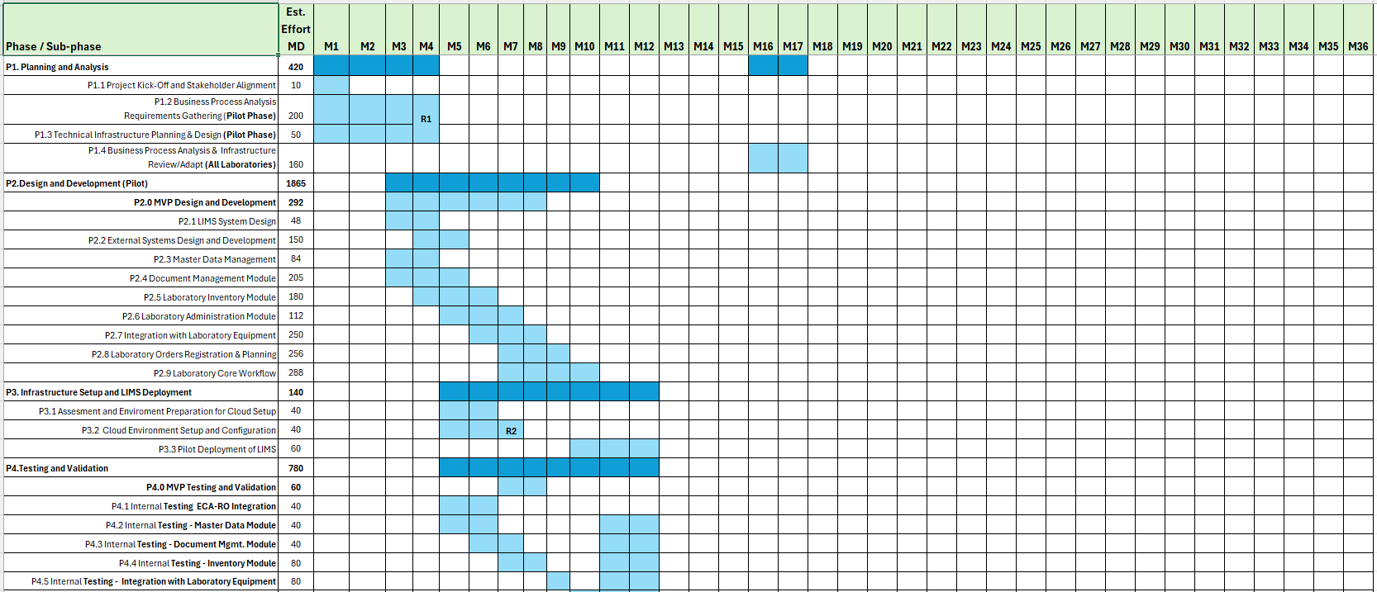
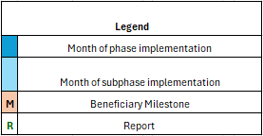
Indicative Implementation Time Schedule
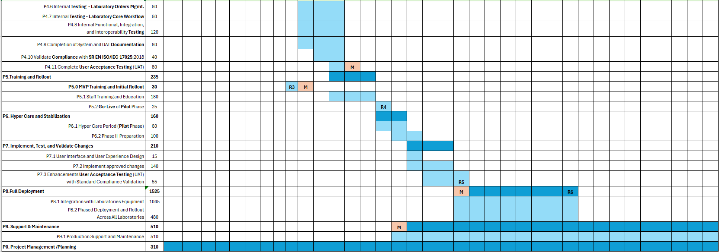

Indicative Time Schedule Delivery Phases

P1. Planning and Analysis: M1 – M4
P1.1 Project Kick-Off and Stakeholder Alignment, est. 10 working-days
Also known as Inception Phase, this sub-phase will include producing Project Initiation Document (PID) with initial plan of logistic and project organization and preparing Kick-off meeting to discuss the document.
The Consultant will organize a kick-off meeting to introduce project participants from both the Consultant and the Beneficiary, establish a contact list, present the primary project objectives, review the project methodology, and identify potential implementation risks.
The participants will agree on:
- the list of key roles from Beneficiary and the Consultant, their authority and responsibility,
- mutual communication,
- the manner of relevant documents exchange,
- project methodology,
- steps of deliverables acceptance procedure,
- progress reporting procedure,
- risks for the project implementation and mitigation plan.
P1.2 Business Process Analysis Requirements Gathering (Pilot Phase), est. 200 working-days
During this sub-phase, the Consultant will analyze all relevant business, functional, and technical requirements—focused exclusively on the 7 laboratories included in the Pilot phase. Based on this analysis, the Consultant will develop the LIMS architecture, design, and supporting specification documents. The Client will support this process by clarifying requirements as needed.
The Consultant will also prepare a very detailed Project Plan, which will include the development methodology, staged implementation plan, organizational structure, test and training plans, change management, documentation, deployment strategy, resource allocation, and a Quality Assurance Plan aligned with ISO/IEC 17025:2017.
Approval of the Project Plan will mark the formal conclusion of this sub-phase. For reference, the distribution of NARW laboratory units and personnel is detailed in Annex 7.
P1.3 Technical Infrastructure Planning & Design (Pilot Phase), est. 50 working-days
This phase focuses on designing a secure, scalable, and cloud-ready infrastructure to support the LIMS implementation, tailored to the Beneficiary’s specific requirements. The Consultant will assess the current NARW infrastructure to identify dependencies, risks, and optimization opportunities. The findings will be documented along with technical recommendations aligned with the industry’s best practices, particularly in networking, system configurations, and setup.
As a key deliverable, the Consultant shall produce the IT Architecture Documentation, outlining the containerized Infrastructure-as-a-Service (IaaS) model suitable for deployment in the ADR Private Cloud (or equivalent). The architecture must support centralized management and seamless integration with NARW’s existing systems, including identity management, email services, and laboratory equipment.
The Consultant’s Architect will collaborate with NARW technical staff at Pilot sites to conduct a detailed infrastructure assessment, considering business, technical, and compliance requirements, anticipated data volumes (see Annex 7), and system interoperability needs.
This phase focuses on planning and establishing the technical infrastructure required for the Laboratory Information Management System (LIMS). The key objectives are to design a secure and scalable cloud environment that is specifically tailored to meet the Beneficiary's needs and requirements.
P1.4 Business Process Analysis & Infrastructure Review/Adapt (All Laboratories), est. 160 working-days
This sub-phase is expected to occur after the Pilot delivery, acceptance, and go-live. Drawing from lessons learned during the Pilot implementation, ongoing work, feedback from end-users, and any additional business requirements, the Consultant will re-analyze the entire system. This analysis will cover business processes, functional and non-functional specifications, software, hardware, and any newly identified requirements. The result will be a revised and adapted plan, developed in collaboration with the Beneficiary stakeholders, to outline a stepwise implementation strategy for deploying the system across the remaining laboratories.

P2. Design and Development (Pilot): M3 - M10

Sub-phase | Description
P2.0 MVP Design and Development | The MVP will be developed as a foundational stage of the full LIMS Pilot, with its design and implementation progressing through key phases P2.3 to P2.9. The MVP effort will prioritize core components such as Master Data Management (Chapter 3.2.2), Laboratory Orders Management (Chapter 3.2.6), and Laboratory Workflow (Chapter 3.2.7). Other modules, including Document Management, Inventory and Equipment Integration, will be implemented in later phases after the MVP is validated.  By serving as the initial functional version of the LIMS, the MVP will provide practical testing ground, allowing for system validation and refinement before the full-scale design and development.
P2.1 LIMS System Design  (est. 160 working-days) | This sub-phase focuses on establishing the overall system architecture, defining core functionalities, user roles, and user interface (UI) requirements for the LIMS. It lays the foundation for all other components, ensuring alignment with system-wide standards and workflows.  In this sub-phase, the core functionalities of the LIMS will be designed and implemented based on the business requirements from Chapter 3.1 along with their corresponding functional requirements outlined in Chapter 3.2 and technical requirements from Chapter 3.5.
P2.2 External Systems Design and Development  (est. 150 working days) | Focuses on planning and building integrations with external systems, such as ECA-RO for extracting core catalogs and facilitating annual orders data exchange, and ASIS (the existing financial IT solution) for inventory data exchange. This sub-phase involves creating APIs and other data-exchange protocols to ensure smooth data flow and interoperability between the LIMS and these external systems.
P2.3 Master Data Management  (est. 120 working days) | In this sub-phase, the Consultant will design and implement the Master Data Management (MDM) module according to the Project Plan, ensuring that it meets the functional requirements outlined in Chapter 3.2.2. The implementation will cover, at a minimum, the business processes described in the same chapter, guaranteeing that all critical data management functions are integrated and aligned with the defined business workflows.
P2.4 Document Manager Module  (est. 205 working days) | In this sub-phase, the Consultant will design and implement the Document Management module, ensuring it meets the functional requirements specified in Chapter 3.2.8. The implementation will address, at a minimum, the business processes outlined in the same chapter and ensure seamless integration with other LIMS modules.
P2.5 Laboratory Inventory Module  (est. 180 working days) | In this sub-phase, the Consultant will design and implement the Laboratory Inventory Management module, ensuring it fulfills the functional requirements specified in Chapter 3.2.4. The implementation will cover, at a minimum, the business processes outlined in the same chapter and ensure smooth integration with other LIMS modules with restricted access to authorized personnel only.
P2.6 Laboratory Administration Module  (est. 160 working days) | In this sub-phase, the Consultant will design and implement the Laboratory Administration module, ensuring it meets the functional requirements outlined in Chapter 3.2.3. The implementation will cover, at a minimum, the business processes described in the same chapter, ensure seamless integration with other LIMS modules, and include security measures to restrict access to authorized personnel only.
P2.7 Integration with Laboratory Equipment  (est. 250 working days) | During this sub-phase, the Consultant will design and implement the integration with Laboratory Equipment, ensuring alignment with the functional requirements outlined in Chapter 3.2.5. The solution will facilitate seamless interoperability with other LIMS modules and enable secure data exchange between the LIMS and laboratory instruments across all Pilot laboratories. Furthermore, the integration will incorporate robust security measures to restrict access exclusively to authorized personnel and will feature a user-friendly, web-based interface for efficient management and maintenance.
P2.8 Laboratory Orders Registration & Planning  (est. 320 working days) | In this sub-phase, the Consultant will design and implement the Laboratory Orders Manager, ensuring it meets the functional requirements specified in Chapter 3.2.6. The implementation will ensure seamless integration with other LIMS modules and facilitate efficient management of laboratory orders and planning activities.
P2.9 Laboratory Core Workflow  (est.320 working days) | In this sub-phase, the Consultant will design and implement the Laboratory Workflow module, ensuring it meets the functional requirements specified in Chapter 3.2.7. The implementation will ensure seamless integration with other LIMS modules and optimize the flow of laboratory processes, from sample collection to result reporting. It will include security protocols to restrict access to authorized personnel only, and the module will be easily manageable and maintainable through an intuitive web-based interface.

P3. Infrastructure Setup and LIMS Deployment: M7 – M12
P3.0 MVP Initial Setup and Cloud Preparation (included in P3.1 – P3.3)
This sub-phase will focus on preparing the environment for MVP deployment, ensuring infrastructure readiness, and enabling the core functionalities necessary for the initial LIMS MVP validation. The MVP setup and deployment will be incrementally implemented alongside P3.1 to P3.3, ensuring:
- Infrastructure readiness before MVP deployment.
- Cloud environment configuration tailored for MVP needs.
- A validated MVP system, ready for real-world usage and testing before the full LIMS Pilot phase.
P3.1 Assessment and Environment Preparation for Cloud Setup (est. 40 working days)
In this sub-phase, the Consultant is responsible for completing all tasks outlined in Phase P1.3 to prepare NARW's infrastructure for cloud integration. This includes conducting a comprehensive inventory of Active Directory objects (users, groups, devices) to ensure smooth synchronization of cloud identities with the on-premises Active Directory. The Consultant should also evaluate virtual private network (VPN) and other connectivity options to support this integration. Furthermore, the Consultant must ensure smooth integration of LIMS IT system with existing mailbox solution (Exchange).
Note: The outcome for this sub-phase is the completion of all preparations on the Beneficiary’s infrastructure, aligned and agreed upon with the Beneficiary's IT experts, to ensure cloud-based LIMS integrate smoothly with existing on-premises solutions such Active Directory, Exchange, ECA-RO and ASIS. These preparations must be carried out in accordance with the approved IT Architecture documentation.
P3.2 Cloud Environment Setup and Configuration (est. 40 working-days)
During this sub-phase, the Consultant shall configure the cloud infrastructure for hosting the LIMS solution within ADR’s Private Cloud or an equivalent platform, in accordance with the technical architecture approved in sub-phase P1.3. As part of this process, the Consultant is responsible for installing and configuring all necessary licenses, as specified in the agreed architecture.
The Consultant must also ensure integration with existing identity and user management systems, as well as NARW’s Exchange-based mailbox solution. The cloud environment must support connectivity with external systems identified in sub-phase P3.1 (e.g., ECA-RO) and enable secure backup replication to NARW’s SCAR infrastructure.
Key Deliverable: A fully functional cloud-based environment with user account management from the cloud subscription, completed system integrations, and all required licenses installed and activated.
P3.3 Pilot Deployment of LIMS (est. 60 working-days)
This sub-phase involves supporting the configuration of the LIMS on the Beneficiary cloud infrastructure, specifically for the Pilot phase. The Consultant will deploy the LIMS software, configure the necessary modules, and ensure the system is operational within the cloud environment. Key activities will include integrating the LIMS with other systems, setting up user roles and permissions, and validating system functionality against the requirements for the Pilot phase. Testing will be conducted to ensure the system performs as expected in a real-world setting, with necessary adjustments made based on feedback.

P4. Testing and Validation: M5 – M12
Until the Beneficiary’s cloud environment becomes fully operational (end of phase P3.2), the Consultant shall conduct initial internal testing in their own cloud-based development environment. These tests aim to verify service configuration and functionality. Once the Beneficiary’s test environment is ready and approved (by the end of month 6), the Consultant will deploy the LIMS system and proceed with further testing in that environment.
During this phase, the Consultant shall also begin preparing all relevant testing documentation, including comprehensive user manuals for the LIMS platform and module-specific guides. Testing activities must be thoroughly documented, and the system adjusted based on test results. Retesting shall be carried out until all requirements are met.
Note: The Consultant will collaborate with the Beneficiary to define UAT test cases based on the requirements from earlier phases. Testing will cover system functionality, data integrity, and user interface validation. Any issues must be documented, resolved, and retested. All activities must be jointly planned, tracked, and documented by the Consultant in alignment with the Beneficiary.
Sub-phase | Description
P4.0 MVP Testing and Validation (est. 60 working days) | This sub-phase serves as a preliminary validation step before full-scale system testing, ensuring the MVP version of LIMS meets the minimum functional requirements for pilot deployment. Acting as an early-stage quality check, it verifies core functionalities in a controlled environment, reducing risks and identifying potential gaps before broader system testing. The targeted functional testing conducted during this phase will refine and inform later User Acceptance Testing (UAT) for the full LIMS system. This progressive validation approach helps minimize delays and ensures a smooth transition to full deployment, with a fully tested MVP serving as the foundation for the complete LIMS Testing and Validation phase.
P4.1 Internal Testing ECA-RO Integration  (est. 40 working-days) | In this sub-phase, the Consultant will conduct internal testing and evaluation sessions focused on integration, targeting key core components of the LIMS system as applicable to the pilot phase (spanning 7 laboratories).  Participation of Beneficiary-designated personnel is required, while the presence of the Consultant’s Compliance Officer is required.
P4.2 Internal Testing - Master Data Module  (est. 40 working-days) | In this sub-phase, the Consultant will conduct internal testing and evaluation sessions for the Master Data Management module as applicable to the pilot phase (covering 7 laboratories), focusing on validating functionality and performance against the business and technical requirements defined in sub-phase P2.3.  Participation of Beneficiary-designated personnel is required, while the presence of the Consultant’s Compliance Officer is required.
P4.3 Internal Testing - Document Mgmt. Module  (est. 40 working-days) | In this sub-phase, the Consultant will conduct internal testing and evaluation sessions for the Document Management module as applicable to the pilot phase (covering 7 laboratories), focusing on validating functionality and performance against the business and technical requirements defined in sub-phase P2.4.  Participation of Beneficiary-designated personnel is required, while the presence of the Consultant’s Compliance Officer is required.
P4.4 Internal Testing - Inventory Module  (est. 80 working-days) | In this sub-phase, the Consultant will conduct internal testing and evaluation sessions for the Laboratory Inventory Management module, as applicable to the pilot phase (covering 7 laboratories). The focus will be on validating the functionality and performance of the module against the business and technical requirements defined in sub-phase P2.5.  Participation of Beneficiary-designated personnel is required, while the presence of the Consultant’s Compliance Officer is required.
P4.5 Internal Testing - Integration with Laboratory Equipment  (est. 80 working-days) | In this sub-phase, the Consultant will conduct internal testing and evaluation sessions for the Laboratory Equipment module as applicable to the pilot phase (covering 7 laboratories), focusing on validating functionality and performance against the business and technical requirements defined in sub-phase P2.7.  Participation of Beneficiary-designated personnel is optional, while the presence of the Consultant’s Compliance Officer is required.
P4.6 Internal Testing - Laboratory Orders Mgmt.  (est. 60 working-days) | In this sub-phase, the Consultant will conduct internal testing and evaluation sessions for the Laboratory Orders module as applicable to the pilot phase (covering 7 laboratories), focusing on validating functionality and performance against the business and technical requirements defined in sub-phase P2.8.  Participation of Beneficiary-designated personnel is optional, while the presence of the Consultant’s Compliance Officer is mandatory.
P4.7 Internal Testing - Laboratory Core Workflow  (est. 60 working-days) | In this sub-phase, the Consultant will conduct internal testing and evaluation sessions for the Laboratory Workflow module as applicable to the pilot phase (covering 7 laboratories), focusing on validating functionality and performance against the business and technical requirements defined in sub-phase P2.9.  Participation of Beneficiary-designated personnel is required, while the presence of the Consultant’s Compliance Officer is mandatory.
P4.9 Internal Functional, Integration, and Interoperability Testing  (est. 120 working-days) | The Consultant must conduct comprehensive internal testing to validate that the LIMS system and its individual modules operate as intended and integrate seamlessly with external systems. This includes all necessary functional testing to confirm compliance with defined business and technical requirements, ensuring reliable performance under realistic operational conditions. Additionally, integration and interoperability testing must verify that the system interacts smoothly with all connected components, confirming that the LIMS is fully prepared for deployment.  Participation of Beneficiary-designated personnel is optional, while the presence of the Consultant’s Compliance Officer is mandatory.
P4.9 Completion of System and UAT Documentation  (est. 80 working-days) | In this sub-phase, the Consultant will finalize and complete all necessary documentation related to the system and User Acceptance Testing (UAT). This includes compiling comprehensive documentation of the system's architecture, configurations, and functionalities, as well as finalizing the UAT reports. The documentation will detail the testing process, results, any issues encountered, and the corresponding resolutions or system modifications made during the testing phases.
P4.10 Validate Compliance with SR EN ISO/IEC 17025:2017  (est. 40 working-days) | Following sub-phase P4.10, the UAT documentation will be updated to reflect the outcomes of this phase, including a compliance report demonstrating alignment with ISO/IEC 17025:2017 requirements, to support future audits.  To ensure LIMS compliance, the Consultant’s Compliance Officer must:  - Map ISO/IEC 17025:2017 requirements to LIMS functionalities  - Develop and execute ISO-specific test scenarios  - Validate audit trails, data integrity, and traceability  - Confirm tracking of equipment calibration and maintenance  - Ensure controlled access, document versioning, and availability  - Verify training, qualification, and access records compliance  - Test sample tracking and chain-of-custody features  - Validate result report accuracy and security  - Confirm non-conformity and corrective action tracking  - Prepare supporting documentation, including an audit-ready compliance report  These activities must demonstrate that the LIMS system meets all applicable ISO/IEC 17025:2017 standard.
P4.11 Complete User Acceptance Testing (UAT)  (est. 80 working-days) | In this sub-phase, the Consultant shall conduct complete User Acceptance Testing (UAT), as outlined in Chapter 3.3.5, to validate that the LIMS system meets all documented business, technical, security, and performance requirements. UAT will cover all system modules and components, verifying their functionality in realistic operational conditions.  The Consultant will collaborate with the Beneficiary to finalize test cases, scripts, and acceptance criteria based on the approved system specifications. End users will test key functionalities, including data workflows, external system integrations, user interfaces, reporting, and security features.  Security and performance testing will confirm that the system meets privacy, access control, speed, scalability, and reliability requirements. The Consultant will oversee test execution, document results, address user feedback, and correct any identified issues. Retesting will be performed to ensure full compliance before system acceptance.

P5. Training and Rollout: M12 - M14
The Consultant MUST develop training materials customized to the Beneficiary’s specific needs for designated laboratory roles—such as Admins, Supervisors, Verifiers, and Operators—as well as for IT Experts. These materials will support training sessions as specified in Chapter 3.6 - Training and Training Materials. The training approach may incorporate a mix of self-guided resources, train-the-trainer programs, e-learning modules, and, as needed, classroom or remote sessions, with the final format to be determined in agreement with both parties.
P5.0 MVP Training and Initial Rollout (*est. 30 working-days)
This sub-phase will provide targeted training and hands-on testing of the MVP version of LIMS, equipping key users with the necessary skills to operate the system while validating its functionality in a limited production environment before the full Pilot deployment and broader rollout.
The Consultant's key responsibilities include developing and delivering MVP-specific training materials, covering core functionalities such as Master Data Management (MDM), sampling order registration and tracking, basic laboratory workflow along with required reporting, and user access and security protocols. They will conduct targeted training sessions for Lab Chiefs, Supervisors, Samplers, and IT Staff, implement a train-the-trainer approach, and provide practical training on Getac ZX10 tablets to ensure user proficiency. Additionally, they will gather user feedback to refine system usability before full-scale training.
The outcome of this sub-phase is to ensure that key users are fully trained and equipped to operate the MVP version of LIMS, facilitating a seamless transition to the full LIMS training and rollout.
P5.1 Staff Training and Education (est. 180 working-days)
In this sub-phase, the Consultant shall deliver comprehensive training to the Beneficiary’s staff, ensuring they are fully prepared to operate the LIMS system. Training will cover all system modules and functionalities, tailored to different users, ranging from laboratory technicians to administrators.
The Consultant will provide role-specific training materials, including user manuals, quick guides, and online tutorials, and will ensure users are familiar with key security protocols such as authentication, data privacy, and role-based access control.
The objective is to ensure all relevant personnel can confidently use the system and perform their tasks effectively, enabling a smooth transition to full operational use.
P5.2 Go-Live of Pilot Phase (est. 25 working-days)
This sub-phase marks the successful deployment and transition of the LIMS system to full production use in the 7 laboratories included in the Pilot Phase. The system will be fully configured, integrated, and validated to ensure proper functionality, data integrity, and readiness for operational use.
Key activities include:
- Final system verification, data migration checks, and integration with external systems
- Delivery of a Final Report detailing system setup, performance, and key insights from the Pilot Phase
- Submission of all required documentation, including user guides, technical manuals, and ISO/IEC 17025:2017 compliance report from the Consultant’s Compliance Officer
- Completion of all contractual obligations, including training, configuration, and final testing
- Formal transfer of system administration and support responsibilities to the Beneficiary
Upon validation, the LIMS will be considered ready for production, confirming its alignment with business, technical, and operational requirements. Any post-Go-Live issues will be addressed in Phase P7, in preparation for wider rollout across additional laboratories.
(*) Integration of MVP Training & Rollout within phase P5
Sub-Phase | MVP Training & Rollout Focus | Full LIMS Training & Deployment
P5.0 MVP Training & Knowledge Transfer (New) | Early-stage training for key users, focused on MVP functionalities (described in chapter 3.2.12). | Comprehensive training for all end-users on full LIMS features.
P5.1 Staff Training and Education | Targeted MVP training for a select group of users. | Organization-wide training, including advanced modules.
P5.2 MVP Go-Live for Pilot Phase (New) | Initial deployment of MVP version in a controlled pilot setting. | Full-scale deployment and production rollout of LIMS system.

P6. Hypercare and Stabilization: M15 – M16

P6.1 Hypercare Period (Pilot Phase) (est. 60 working-days)
This phase follows the Go-Live of the LIMS system and spans approximately 8 weeks. Its primary goal is to ensure system stability, resolve any post-deployment issues, and support end-users during the transition to full operational use.
Key activities include:
- Enhanced monitoring of system performance, data integrity, and response times to promptly detect and address issues.
- Proactive end-user support, troubleshooting system access and workflow problems to minimize operational disruptions.
- System optimization through configuration adjustments to enhance speed, scalability, and reliability.
- Defect resolution and retesting, ensuring that identified bugs are fixed without introducing new issues.
- User feedback collection and implementation of usability improvements, in coordination with key personnel from the Beneficiary.
- Knowledge transfer and documentation updates to equip the Beneficiary’s team with the necessary skills for independent system management.
- Final stabilization, confirming that all components function correctly and the system is ready for standard operational use.
Upon completion, the system will transition into steady-state operation, supported by the post-warranty maintenance framework.

P6.2 Phase II Go-Live Preparation (est. 100 working-days)
Following the Hyper-Care period and based on feedback from the Pilot Go-Live (P7.1), the Consultant—together with the Beneficiary’s designated personnel—shall conduct a final analysis to ensure the LIMS system is fully prepared for nationwide deployment across all 42 NARW laboratories.
Key activities include:
- Finalizing system configurations to address the operational needs of each laboratory
- Verifying system readiness for full-scale rollout, including performance, scalability, and workflow adaptability
- Establishing user support and training structures to ensure consistent adoption during the phased Go-Live
The Consultant must provide:
- A clear list of required enhancements or adaptations, based on Beneficiary input and Consultant recommendations
- A final rollout project plan, detailing the implementation approach, effort estimates by role, and a stepwise deployment schedule for each laboratory
This sub-phase ensures that the system is fully aligned with operational requirements and ready for a smooth and efficient transition to full production use across all NARW units.

P7. Implement, Test, and Validate Changes: M17 – M19
P7.1 User Interface and User Experience Design (est. 15 working-days)
This sub-phase focuses on the design and development of enhancements identified during the P1.4 sub-phase, aimed at creating an intuitive, efficient, and visually appealing user interface for the LIMS system. The Consultant will collaborate closely with the Beneficiary to ensure the UI aligns with the specific workflows and operational needs of all laboratories, providing a seamless and effective user experience.
In this sub-phase, usability enhancements will be made to ensure the interface is intuitive and aligns with the Beneficiary’s expectations. Feedback from stakeholders during P1.4 will be incorporated into the design to refine the user interface (UI), ensuring the system is user-friendly and precisely tailored to the Beneficiary's specific requirements.
P7.2 Implement approved changes (est. 140 working days)
In this sub-phase, the Consultant will work closely with the Beneficiary to implement the approved LIMS changes, ensuring they align with the agreed-upon prioritization and meet the specific workflows and operational needs of all laboratories. The Consultant MUST ensure that these changes are smoothly deployed into the system, with minimal disruption to ongoing operations. Collaboration between the Consultant and the Beneficiary will focus on ensuring that the changes are effectively integrated, tested, and validated, maintaining system stability while enhancing its functionality to better support laboratory operations.
P7.3 Enhancements User Acceptance Testing (UAT) with Standard Compliance Validation (est. 55 working-days)
The Consultant must conduct a comprehensive round of User Acceptance Testing (UAT) for the entire LIMS system, focusing on validating the functionality of all system enhancements and optimizations. This test will ensure that the system meets the business, technical, security, and performance requirements outlined in the project documentation. The UAT documentation from the previous phase (P4.10) must be updated to incorporate the latest system improvements. Additionally, the Consultant’s Compliance Officer MUST be involved and certify that the LIMS solution is fully compliant with ISO/IEC 17025:2017 requirements, ensuring adherence to required quality management guidelines.

P8. Full Deployment: M20 – M27
This phase MUST be re-evaluated and re-estimated by both the Consultant and the Beneficiary, considering the timeline, laboratory equipment, phased rollout, and associated costs, after the delivery and acceptance of the Pilot (Phase I). The Beneficiary expects the Consultant to develop and deliver a detailed plan for the stepwise integration of the remaining 36 laboratories, based on experience and lessons learned from the Pilot phase involving 7 laboratories. The plan MUST focus on ensuring smooth operations, minimizing business disruptions, and accommodating the availability of Beneficiary personnel throughout the process.
Important: Due to the complexity and variability among laboratories, it is estimated that each laboratory will require a minimum of 30 working days of effort, including 20 days specifically allocated for the integration of laboratory equipment. In total, approximately 1,525 working days are projected across all 36 laboratories, ensuring a thorough and customized integration of laboratory equipment and LIMS deployment in each case.
P8.1 Integration with Laboratories Equipment
In this sub-phase, the Consultant shall design and implement the integration of laboratory equipment for the remaining laboratories, following the rollout plan agreed with the Beneficiary. The integration must ensure seamless communication between the LIMS and laboratory instruments, enabling accurate and reliable data exchange. Robust security protocols must be in place to restrict access to authorized personnel and protect sensitive information.
The integration solution must also be easily manageable and maintainable, featuring a web-based administrative interface that allows designated personnel to efficiently monitor, configure, and control connected equipment.
P8.2 Phased Deployment and Rollout Across All Laboratories
In this sub-phase, the Consultant shall manage the stepwise deployment of the LIMS system across all remaining laboratories, in alignment with the agreed rollout plan. Deployment will be conducted in phases to ensure smooth integration into each laboratory’s operations, while minimizing disruptions. The Consultant is responsible for configuring the system to meet the specific workflows and operational needs of each laboratory, including any identified special requirements. Close collaboration with the Beneficiary is required throughout this phase to support implementation, troubleshooting, and stabilization in each site prior to proceeding to the next stage of rollout.

P9. Support & Maintenance: M16 – M40
P9.1 Production Support and Maintenance
For a duration of 20 months or until May 2028 (whichever occurs first), the Consultant shall provide comprehensive maintenance and support services to ensure the LIMS system remains fully operational, aligned with the Beneficiary’s evolving needs.
This includes:
- Corrective, preventive, adaptive, and perfective maintenance as mentioned in Chapter 3.7
- Ongoing system updates, tested and implemented with minimal disruption
- Documentation updates reflecting all changes made to support future operations
Given the system's complexity, two dedicated Consultant profiles are expected: one for infrastructure support and one for LIMS application support. Additional expertise (e.g., Senior Developer, Team Lead, Business Analyst) may be involved as required.

P0. Project Management /Planning
Throughout this phase, the Consultant will oversee and coordinate all project activities to ensure the successful implementation of the LIMS, with an estimated effort of 310 working days until contract completion.
Key responsibilities include:
- Monitoring timelines, resources, and deliverables
- Ensuring alignment with technical, operational, and quality standards
- Maintaining proactive communication with Beneficiary
- Managing risks, adjusting plans as needed, and tracking progress
Core activities:
- Preparing and updating the project workflow plan
- Defining short-term tasks with clear deadlines
- Managing effective communication among all stakeholders
- Reporting regularly and ensuring timely issue resolution

Reports Delivery
During this Assignment, the Consultant MUST deliver the following Reports:
Milestone | Abr. | Report name | Purpose and key deliverables | Timeline
Analysis Phase completion | R1 | Analysis phase report | Report No. 1: This report marks the completion of the Planning and Analysis phase (M1 – M4). It encompasses all necessary planning, gathering requirements, and analysis to deliver the detailed project plans for the LIMS Pilot Phase implementation.  Key deliverables:  - Software Requirements Specifications (SRS) documentation  - IT Architecture documentation  - Installation Manual  - Software Design Document  It ensures that all technical and operational requirements are thoroughly addressed, providing a detailed foundation for the proposed solution. Additionally, the report should assess the estimated Governmental Cloud or equivalent resource requirements, including compute, storage, and network sizing.  All annexed materials and documents delivered must be approved by the Acceptance Committee to ensure they align with the project's objectives and adhere to established standards. | T0 + 4 months  Estimated 260 working days contract signing (T0)
Completion of Hosting Infrastructure | R2 | Infrastructure Setup and Configuration report | Report No. 2: This report implies the setup, configuration, and deployment of the cloud-based infrastructure for LIMS hosting. These activities have been carried out in accordance with the detailed and approved IT Architecture documentation. The report marks the completion of project phases P3.1 and P3.2, which refer to the Cloud Environment Setup and Configuration – a prerequisite for the MVP Testing and Validation Phase (P4.0).  Key deliverables:  - Cloud Environment Provisioning: The Client will provide the complete cloud infrastructure, including computing, storage, and network components, necessary for hosting the LIMS system within the ADR Private Cloud (or an equivalent platform). The Consultant shall collaborate with the Client’s IT team to configure and prepare this environment for LIMS deployment.  - License Management: All licenses required for the operation of the LIMS, as specified in the Consultant’s proposed architecture and detailed in the IT Architecture documentation, shall be procured and owned by the Client. The Consultant is responsible for the proper deployment, configuration, and activation of the developed application and licenses within the cloud environment provided by the Client.  - Tested and Validated Cloud Hosting Environment: The Consultant shall deliver a fully functional cloud infrastructure for LIMS hosting, which must be tested and validated to ensure compliance with all technical and operational requirements.  The report must be reviewed and approved by the Acceptance Committee to ensure that the planned infrastructure is properly delivered, implemented and aligned with the project’s objectives and requirements. | R1 + 3 months  Estimated 80 working days from R1 approval
Completion of MVP Implementation and Deployment | R3 | MVP Implementation and Deployment Report | Report No. 3: marks the completion of phases P2.0, P3.0, P4.0, and P5.0, representing the successful implementation and delivery of the Minimum Viable Product (MVP) across all NARW laboratories.  Key Deliverables  - Formal validation that the Minimum Viable Product (MVP) has been successfully deployed across all NARW laboratories.  - The MVP meets all minimum functional requirements outlined in Chapter 3.2.12.  - Confirmation that the system is fully operational and technically stable.  - Delivery of user training sessions to ensure proper use and adoption of the MVP.  - Transition from deployment to live operations within the laboratory infrastructure.  - Upon approval of Report No. 4, testing and validation of the MVP (Phase P4.0) must be conducted within the Beneficiary’s cloud-based infrastructure (as provisioned in Report No. 3) to verify correct functionality.  The Beneficiary Acceptance Committee will review and approve the report to verify that the MVP aligns with project objectives and is ready for the next phase. NARW laboratory personnel and key stakeholders will assess system performance, user accessibility, and integration readiness, ensuring a smooth transition to the full LIMS rollout. | R2 + 2 months  Estimated 382 working days from R2 approval
Completion of Pilot Implementation and Deployment | R4 | Pilot Implementation and Deployment Report | Report No. 4: This report marks the successful completion of the Pilot implementation phase (Go-Live) for the LIMS system, with the system fully deployed and operational across all 7 laboratories involved in the pilot. The Consultant will carry out the User Acceptance Testing (UAT) as outlined in subphase P4.11 out of this chapter, following the successful completion of subphases P4.8 through P4.10. The results of UAT must be documented and delivered as part of subphase P4.11, which serves as the formal test, validation, and approval phase for LIMS Phase I (Pilot).  At this stage, all staff training should be completed in line with the Training Requirements outlined in Chapter 3.6.  Key deliverables:  - Documenting all outcomes of the UAT, including feedback and any identified issues.  - Formal validation that all system components function as intended in line with specified requirements.  - Confirmation that the LIMS system is ready for deployment, based on UAT results.  - Finalized staff training completion report  - All project deliverables stored in the centralized repository  - Re-analysis of the entire LIMS system to incorporate lessons learned from the Pilot, feedback from end-users, and any newly identified business requirements  - Report detailing proposed system changes and enhancements, including purpose, scope, and impact, along with a schedule plan including timelines and estimated resources for each key profile  The UAT report and results will be reviewed and formally approved by the Acceptance Committee, ensuring compliance with all criteria for production readiness.  This report will be submitted for review and approval by the Acceptance Committee and will serve as a strategic roadmap for future updates and optimizations. | R3 + 6 months  Estimated 2558 working days from R3 approval
Finalize LIMS Pilot Enhancements | R5 | LIMS Pilot Enhancements Report | Report No. 5: This report marks the completion of all activities outlined in Phase P7, including the implementation, testing, and validation of changes and their associated subphases. The Consultant is required to conduct and deliver the final User Acceptance Testing (UAT) for enhancements, which must be validated and approved in accordance with ISO/IEC 17025:2017 standard. The report UAT will encompass all change requests approved by the Beneficiary, as well as any enhancements recommended by the Consultant as extracted from Report No. 4 deliverables.  Key deliverables:  - updated source code.  - updated training manuals.  - updated test scenarios report proposed for LIMS compliance verification  - updated internal testing reports (functional, performance, security and UAT) including the adjustments or new functionalities of the LIMS system  - final testing and acceptance report that should certify that the LIMS system meets all functional, security, and performance requirements, as defined in this ToR.  The report will be submitted for review and formal approval by the Acceptance Committee. | R4 + 5  Estimated 530 working days from R4 approval
Beneficiary Milestone | M | Beneficiary Milestone | The "Beneficiary Milestone" (M) as mentioned in Schedule Table, marks the point when the Beneficiary approves the Consultant's planning for the rollout of the LIMS across the rest of 36 NARW laboratories, authorizing the Consultant to proceed with delivering LIMS as outlined in Phase P9.  As part of Phase P9: Full Deployment, the Consultant and Beneficiary must jointly conduct a thorough assessment to ensure precise planning for the LIMS rollout. This evaluation should address critical aspects, including timelines, laboratory equipment readiness, phased deployment strategies, and associated costs. The assessment's findings will form the basis of a comprehensive deployment plan, mutually agreed upon by both parties, with a clear framework for reporting and monitoring progress throughout the implementation.
Final LIMS Deployment and Operational Readiness | R6 | Final LIMS Deployment Report | Report No. 6: This report signifies the successful completion of the full-scale deployment of the LIMS across all NARW laboratories.  Key deliverables:  - Updated source code of the LIMS system.  - Revised training manuals reflecting the latest system functionalities.  - An updated report on test scenarios, proposed for use in verifying LIMS compliance.  - Refreshed internal testing documentation—including functional, performance, security, and user acceptance testing (UAT)—incorporating all adjustments and newly implemented features.  - The final testing and acceptance report, certifying that the LIMS system fully meets the agreed functional, security, and performance requirements. | R5 + 6  Estimated 1525 working days from R5 approval

Important:

Starting 120 calendar days after approval of Report 5 (Pilot Go-Live), the Consultant shall submit a Support Activity Report every 120 days. Each report must include:
- Summary of user-reported issues and resolutions
- System health and performance check results
- Applied patches and configuration changes
- Helpdesk activity logs
The report format and submission process will be agreed upon post-kickoff and coordinated by the Beneficiary’s Project Manager.

Therefore, for the support and maintenance activities, the Purchaser will pay 8% of the Contract value in arrears, as follows:
- 3% after the first report approval
- 3% after the second report’s approval (6 months later)
- 2% after the final report’s approval, no later than May 2028

All payments will only be made upon formal approval of each report by the Purchaser.

- Client’s Input and Counterpart Personnel

  - Services, facilities and property to be made available to the Consultant by the Client:
- The Client shall provide access to the necessary hosting environment for the solution, including provisioning of an ADR Cloud subscription (or an equivalent cloud infrastructure). Furthermore, the Client shall ensure the availability of all licenses and cloud resources required and recommended by the Consultant for the proper deployment and operation of the LIMS solution.
- In addition, the Client shall ensure the availability of a functional and documented bidirectional API with the ECA-RO system, as well as the required access credentials, test environments, and any integration-related support necessary to enable proper data exchange and synchronization.
- The Client shall also provide the necessary access to credentials, documentation, and technical support for the integration with NARW’s existing identity management and email systems (e.g., Active Directory/Entra ID, Exchange Online), to enable secure authentication, user management, and automated notifications.
  - Professional and support counterpart personnel to be assigned by the Client to the Consultant’s team: _____________________________ [list/specify]
  - Annexes Provided by the Client
- Annex 1. A detailed overview of the current operating processes at NARW laboratories
- Annex 2. Details about Annual Operating Manual Templates
- Annex 3. A comprehensive list of all current NARW laboratory equipment, including detailed information on their specifications and capabilities (as currently known).
- Annex 4. A list of master data catalogs identified as essential for LIMS
- Annex 5. Samples with calculation formulas required for both simple and complex laboratory indicators.
- Annex 6. A sample list of analysis standards for each indicator from one of the NARW laboratories.
- Annex 7. Provides an outline of the estimated capacity planning, personnel distribution across laboratories, the number of orders processed annually at NARW laboratories, the estimated number of sample analyses conducted in one laboratory, and the annual volume of documents generated in that laboratory.
- Annex 8. A sample of requirements specified for compliance with ISO/IEC 17025:2017 standard, clause 7.11
- Annex 9. Details of recommended development and testing environments (cloud based).

Annex 1

Current Laboratory Processes

- Summary of Laboratory Information System
The business process description starts with an overview of the LIMS information system and its users.

Distribution of NARW Laboratory Units
The image below illustrates the distribution and organization of laboratory units within the National Administration "Romanian Waters" (NARW). It aims to enhance understanding of the terms (abbreviations) used throughout this document. Additionally, it outlines the NARW units which influence the laboratories' roles and functions within the NARW framework, contributing to effective water management, quality monitoring, and environmental compliance.
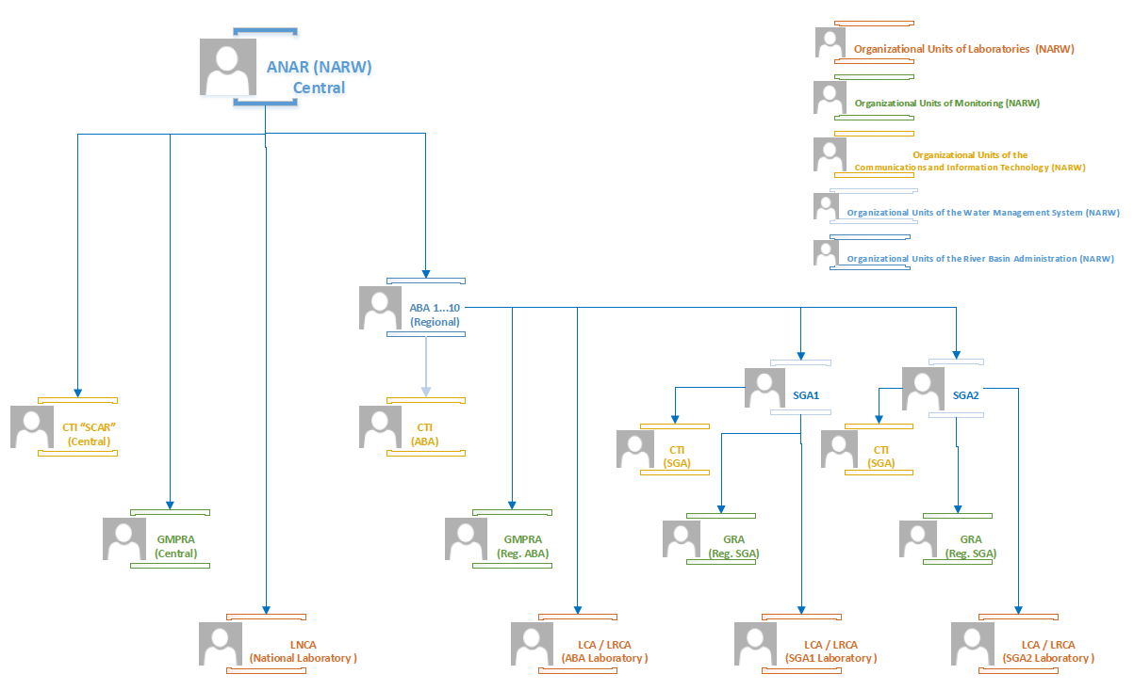

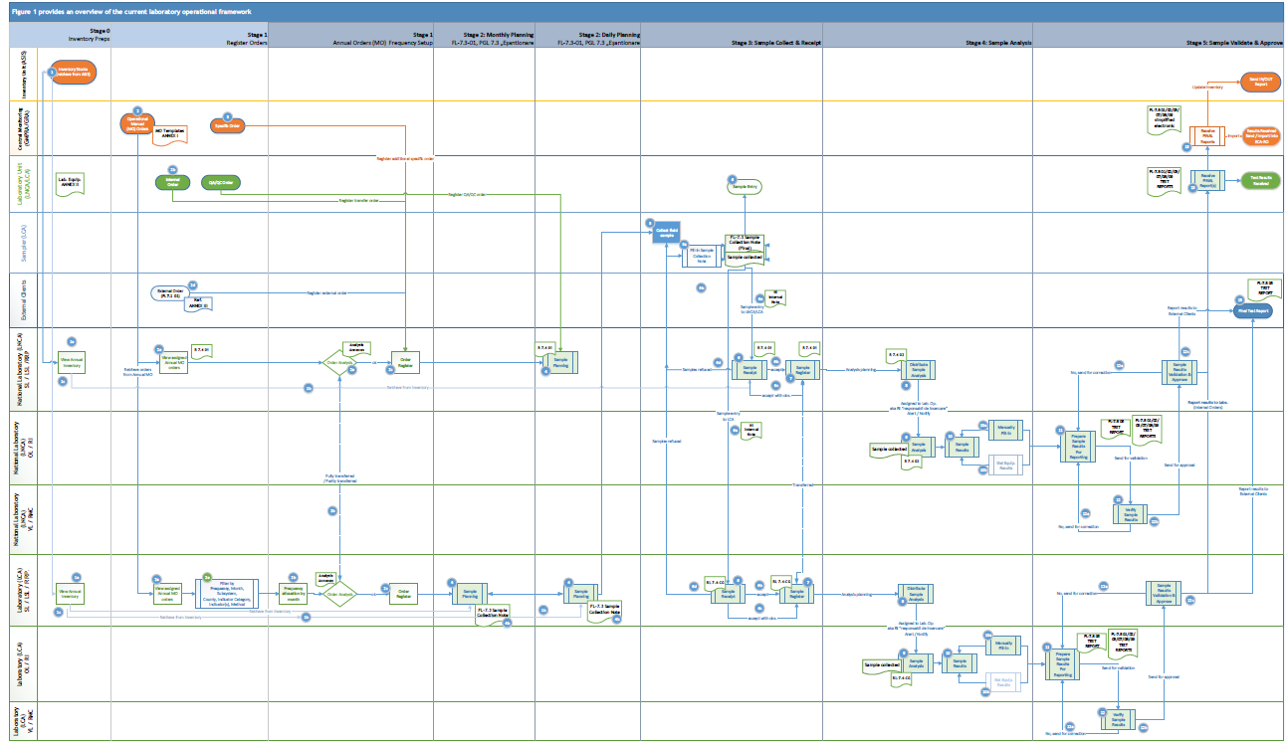
Current Framework
Figure 1

The framework illustrated in the above image (referred to as Figure 1 in subsequent pages) outlines the workflows and roles of all 42 NARW laboratories. Currently, operations and data management rely on paper records, Excel spreadsheets, and, in one laboratory, a partial IT system, depending on the circumstances, in accordance with RENAR accreditation and internal procedures. Implementing a Laboratory Information Management System (LIMS) would centralize data management and standardize workflows, enhancing efficiency across all laboratories. Therefore:
- Laboratory Structure: As detailed in the laboratory units table above, there are 41 laboratory units organized under 11 River Basin Administration units (ABAs) and 1 National Laboratory, all of which are centrally managed. Each laboratory is assigned specific functions that contribute to the overarching objective of administering, operating, and maintaining the national water resources quality monitoring system.
- Current Processes: Currently, nearly all NARW laboratories manage and track operational processes manually, utilizing paper-based methods for sample collection, analysis, and reporting.
- Data Management: Data entries are manually collected between entities using email, official documents (paper-based) and / or Excel files.

Roles & Terms
Role | Term | Term Description
Chief Laboratory | SL | SL – “Sef laborator”
Deputy Laboratory Chief | LSL | “Locțiitor Șef laborator” may overlap with Verifier
Verifier Laboratory | VL | May overlap with Deputy Laboratory Chief or Quality Management Responsible roles.
Authorized Testing Officer | RI | The role of “Responsabilul de încercare autorizat” may overlap with that of the Laboratory Operator, who, according to internal authorization, is responsible for preparing test reports for both internal and external Clients and forwarding them to RMC for management.
Operator Laboratory | OL | May overlap with Authorized Testing Officer role.
Quality Management Responsible | RMC | The "Responsabil cu Managementul Calității" may also serve as the Verifier or Deputy Laboratory Chief, overseeing test reports, approving them when the Laboratory Chief is absent, and canceling non-compliant reports.
Sampler | P | The Sampler or "Prelevator" is responsible for collecting and submitting samples for testing. This role involves documenting key information for each sample—such as the date, time, location, and sampling conditions—in the Sample Collection Report.
Authorized Sample Reception Officer | RRP | This role ensures that the responsibility of sample reception is designated, aligns with internal procedures, and differentiates it from the Laboratory Operator. It also suggests an authorized level (aligning with VL or SL roles), maintaining confidentiality over sample handling and data.
Territorial Water Inspection | ITA | In Romanian "Inspecția teritorială a Apelor" represents the organizational unit within a Water Management System (SGA) or River Basin Administration (ABA).

Acronyms Used in Laboratories
Term | Definition
Sampling | An action that involves extracting a representative sample for the purpose of examining defined characteristics.
Sample | An ideal representative sample taken from a whole for the purpose of examining certain characteristics.
Sample for Analysis | A portion of a sample that is subjected to analysis.
River | A natural body of water that flows continuously or intermittently in a defined direction towards an ocean, sea, lake, swamp, or another watercourse.
Stream | A watercourse—water that flows continuously or intermittently in a defined direction, like a river, but generally with a significantly lower flow rate.
Groundwater | Water that is held and can generally be recovered from an underground rock formation.
Sediment | A generally stratified accumulation of minerals and organic matter deposited on the surface of the earth.
Biota | Any groups of living aquatic organisms that can be analyzed and used as indicators of pollution, such as fish, mussels, and invertebrates.
Sampling Point | A location chosen according to certain rules for the purpose of collecting a representative sample from the water body.
“NI” | Internal Note
“RI”  ("Raport de Încercare") | Known as Test Report, it represents a document that shows the test results for a specific sample, includes agreed-upon information with the Beneficiary, and provides details needed for interpreting the results and meeting method requirements. Paper-based format is illustrated below in chapter TEST REPORT (“RAPORT DE ÎNCERCARE”) FORM.
National Accreditation Mark | A graphic representation whose characteristics are established in accordance with the Government Ordinance No. 23/2009. The holder of the national accreditation mark is the Ministry of Economy, as per Government Ordinance No. 23/2009. The right to the national accreditation mark is transferred to the National Accreditation Body, RENAR, by the Ministry of Economy, as per the law.
Accreditation Symbol | A symbol issued by RENAR to accredited conformity assessment bodies (CAB), containing the national accreditation mark for each accreditation activity.
QA/QC | Represents the calibration and quality assurance samples for measurements conducted in NARW laboratories.
ASIS | Represents the existing financial IT system that is implemented and managed independently by each ABA unit. Laboratory inventory is generated from ASIS and is subsequently provided to the Laboratory Manager.
ECA-RO | Represents the existing IT system operated by the Central Monitoring Unit (Central GMPRA), which will function as the Client for the future LIMS by placing internal orders. Furthermore, it acts as the Beneficiary when analysis results are transferred from LIMS to ECA-RO for additional statistics and reporting. There must be interoperability between LIMS and ECA-RO to facilitate data input and output.
MO | Represents the Operating Manual, which is generated annually by the monitoring units and distributed to laboratories in both electronic and paper formats as internal orders for analysis and/or sample collection, depending on the laboratory's activities.

- Stage 0: Inventory Setup
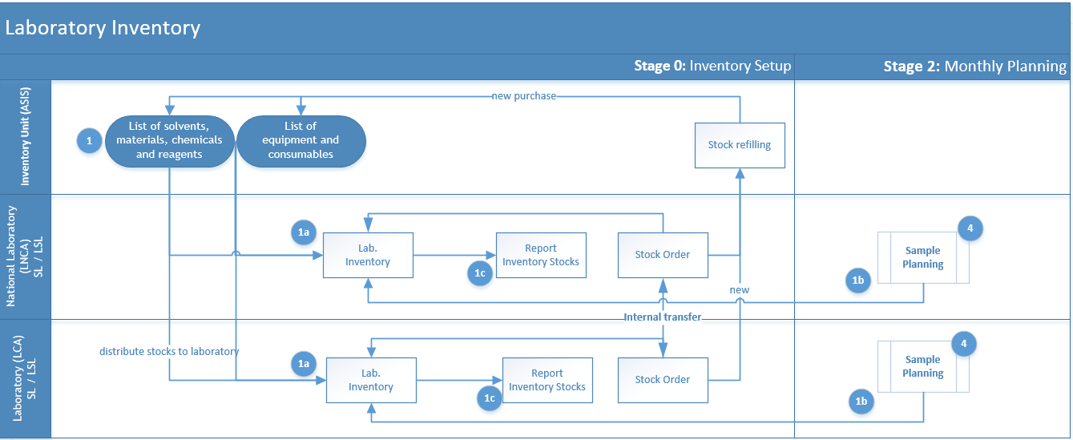
- Each laboratory manages its own inventory and equipment stock, manually extracting data from ABA’s financial system (1), ASIS, along with related information. There are 11 ABAs in NARW, each using a locally maintained financial system (ASIS).
- A laboratory inventory typically includes laboratory resources such as solvents, materials, chemicals, reagents, equipment, and other consumables. The laboratory inventory management process is locally maintained, either in an Excel file or on paper.
- The Laboratory Chief (SL) and their designated backup (LSL) are responsible for retrieving and coordinating the annual inventory of laboratory stocks from the financial department (1a), managing local consumption (1b), and initiating orders for additional materials, equipment, solvents, etc.
- Upon receiving the annual inventory stock available from the financial system, the Laboratory Chief (SL or LSL) stores and oversees it at the laboratory level (1a).
- If additional inventory is needed, SL initiates a purchase order to the financial organization unit or coordinates with another laboratory for an internal stock transfer, both actions currently handled on paper.
• Below are two examples of how the National Laboratory LNCA conducts its processes (1a) and (1b), demonstrating the current management and maintenance of the inventory stock list in one of the NARW laboratories.

A.1 Sample Inventory of equipment and consumables data entry (INPUT):
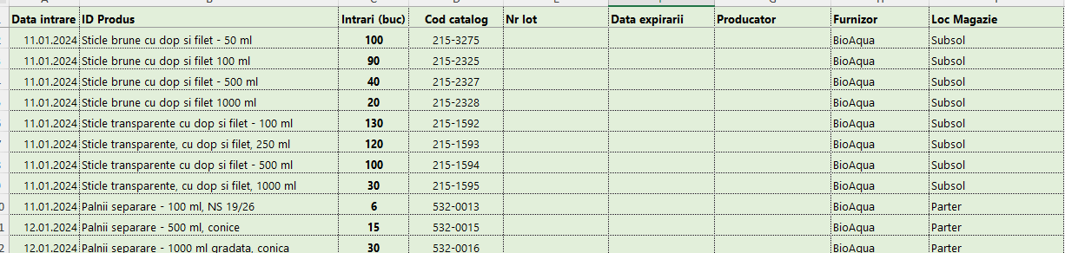
The inventory list for equipment and consumables (1a) must include at a minimum the following details:
- Entry date
- Product name (description)
- Available number of units
- Catalog code (unique and extracted from ASIS external database)
- "Lot number" refers to a unique code assigned to a specific batch of products or materials,
- Expiration date
- Manufacturer
- Consultant
A.2 Sample Inventory of equipment and consumables (OUTPUT):
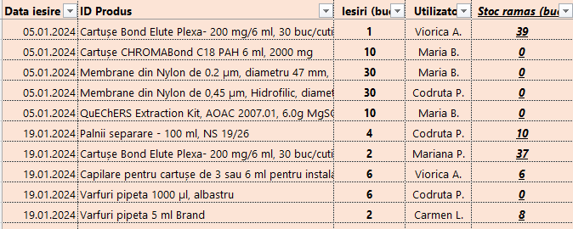
As output (1b), once equipment and consumables are utilized, the entries must be recorded with the following minimum information:
- Exit Date
- Product ID (must be unique and identifiable based on the previous list)
- Number of Units Consumed
- Username (typically the name of the Laboratory Chief, Verifier, or Operator)
- Remaining Stock Units after consumption.
B.1 Sample Inventory of solvents, materials, chemicals and reagents (INPUT): 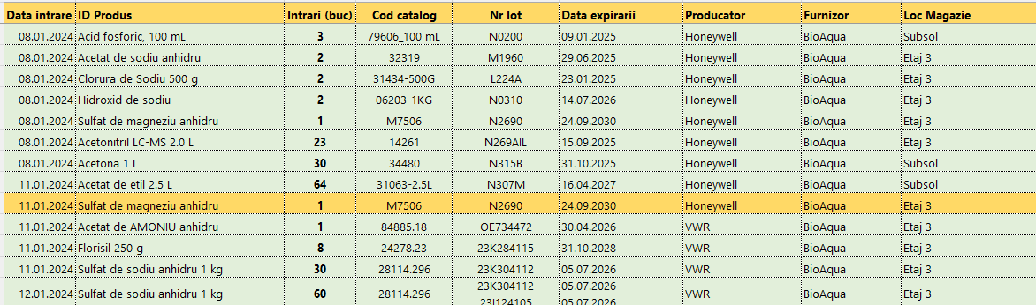
The inventory list for solvents, materials, chemicals and reagents, part of process 1a must include at a minimum the following details:
- Entry date
- Product name (description)
- Available number of units (entries)
- Catalog code (unique and extracted from ASIS external database)
- "Lot number" refers to a unique code assigned to a specific batch of products or materials,
- Expiration date
- Manufacturer
- Consultant
- Storage location (room)
B.2 Sample Inventory of solvents, materials, chemicals and reagents (OUTPUT):
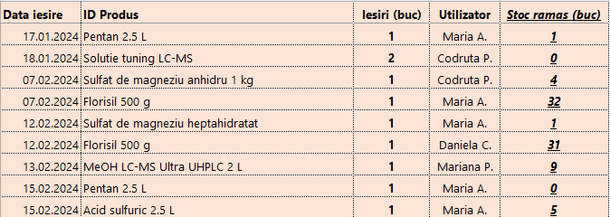
As output (1b), once equipment and consumables are utilized, the entries must be recorded with the following minimum information:
- Exit Date
- Product ID (must be unique and identifiable based on the previous list)
- Number of Units Consumed
- Username (typically the name of the Laboratory Chief, Verifier, or Operator)
- Remaining Stock Units after consumption.
- Upon request or for stock verification purposes, the laboratory chief (SL) manually generates a report on stock levels for a specified period, coded with (1c) in the above process figure. Typically, these reports provide a comparison of the number of units entered versus the number consumed for each type of product over a selected period.
A.3 Sample Inventory of equipment and consumables Report
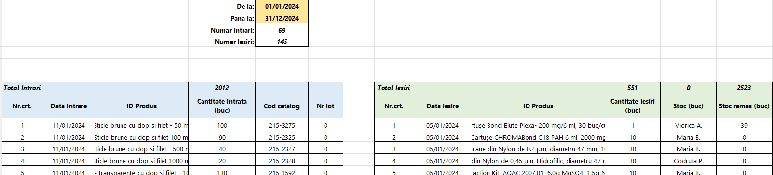
B.2 Sample Inventory of solvents, materials, chemicals and reagents Report
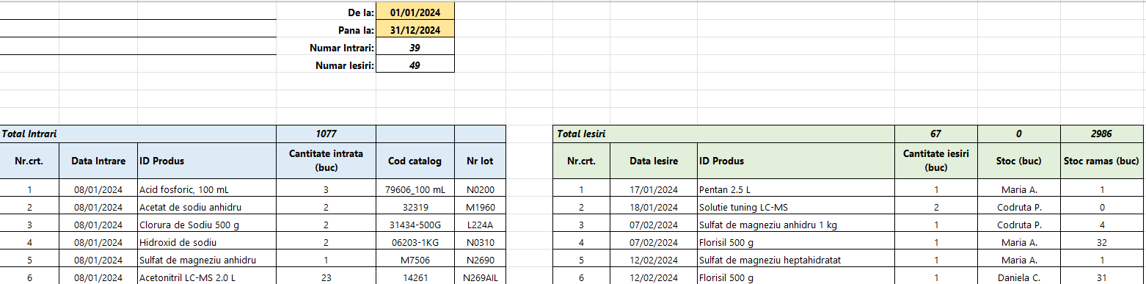

Important: The setup and management of inventory in NARW laboratories can vary considerably. In some cases, consumption is recorded and tracked using Excel files, as illustrated in the LNCA sample, while in others, it is managed through paper-based systems that utilize standardized document templates for input, output, and registration. This variation in inventory management practices reflects the distinct operational requirements and resource availability of each laboratory.
- Stage 1: Orders Register
Currently, NARW’s laboratories process both internal orders from within its laboratory units and external requests from Clients outside of the NARW laboratories.
Most NARW laboratories both collect and analyze their own samples, except for the National Laboratory (LNCA), which only analyzes samples collected by other NARW laboratories.

Internal Orders
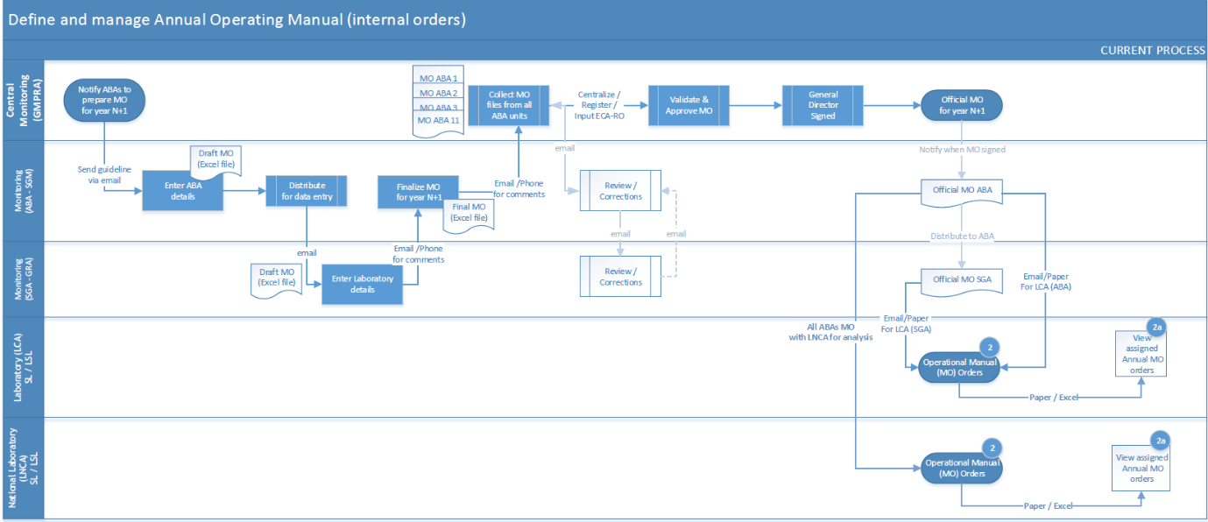
- In the third quarter of the current year, the Central Monitoring Unit (Central GMPRA) will notify all monitoring units (GMPRA) within the ABAs to begin preparing their individual operating manuals. Each monitoring unit will then distribute a request within their respective SGA (GRA) to gather proposed activities for the upcoming year. After gathering proposals, each ABA will consolidate, review, and validate the information to finalize its own operating manual. This finalized manual will be submitted to the Central Monitoring Unit (GMPRA) for further validation and approval. Once Central GMPRA receives, centralizes, validates, and approves the manuals from all 11 ABA monitoring units (GRA/GMPRA), which are delivered based on statistical data and requirements from ABA/SGA, it will present the proposal to the NARW General Manager for final approval and signature. After receiving the signature, the consolidated manual will serve as the official operating manual for the upcoming year and will be returned through the hierarchical chain for distribution to the laboratories as part of process (2) illustrated in the above figure.
- As the National Laboratory (LNCA) will not handle sample collection as part of Process (2), it will instead receive the official operating manuals from all 11 ABAs that have designated LNCA as the laboratory responsible for analysis.
- Typically, the main internal beneficiary for each laboratory is the National Administration "Romanian Waters" (NARW). The immediate recipient of the test results reported by the laboratory is either the local (SGA) monitoring unit or, if the laboratory is managed by a Basin Water Administration (ABA), the monitoring unit within the respective ABA. Once validated and approved, the results are returned through the hierarchical chain and ultimately recorded electronically in ECA-RO, the NARW IT system maintained by the Central Monitoring Service Unit (GMPRA).
- So, according to NARW's annual operating manual (aka MO), each laboratory unit receives internal orders (2) as well as additional requests (3) from their local monitoring unit (GMPRA/GRA) and / or requests from ITA in the event of inspections or pollution separately managed.
- The electronic operating manual (MO) is primarily an Excel file, organized into sheets tailored to the specific requirements of each ABA laboratory. These sheets are divided by subsystems (also referred to as matrices), such as surface water (rivers and lakes), groundwater, wastewater, suspended solids, sediments, drinking water sections, and international conventions. For certain subsystems, such as "surface water," additional Excel sheets are used to categorize different indicator groups or classes, including “biological”, “physico-chemical”, “heavy metals”, and “organic Micropollutants”, among others.
Typically, each subsystem (part of MO file) should include details such as:
- the name of the watercourse,
- sampling section,
- type of monitoring program,
- section code,
- water body code,
- longitude and latitude of the section,
- marking of protected areas,
- reference areas,
- monitored indicators,
- their frequency,
- total number of determinations per year,
- and indicators by water type.
The format for submitting orders (entries in MO) varies between Physicochemical and Biological analyses and could reach up to 15 different data submission forms.
Upon receiving the Operating Manuals (MO), the Laboratory Chief (SL) assesses the laboratory's capacity to ensure it has the required physical, human, and informational resources to meet Beneficiary demands (2a).
  - The results of this analysis are recorded in an Order Analysis Form (FL-7.1 3) and filed in the Laboratory Order Analysis File (DL-7.1).
  - In a similar manner, a Performance Parameters form for the analytical methods used at the laboratory level (FL 7.2.06) is prepared. This form declares the laboratory's competence for the tests conducted, including detection and quantification limits, and submitted to the GMPRA department of the respective ABA.
Note: (a) and (b) actions are communicated and maintained outside future LIMS.
- Specifically for the micro-pollutant subsystem, the analysis is conducted only based on analysis orders generated by the laboratories responsible for sample collection, following the operating manuals specific to each basin water administration. This condition shall be considered in LIMS.
- If the Laboratory Chief (SL) decides to transfer an order (2b from Figure 1) to another laboratory unit, the minimal required information would be:
  - name of the order issuer (ABA / SGA)
  - the name of laboratory (LCA) that collected the samples listed in the order
  - the order number and date of issuance
  - container codes for the samples and quantity,
  - name (usually codes) of the requested indicators
  - name and signature of the person who issued the analysis order
- Usually Orders transferred from/to internal Clients is accompanied by copies of the sampling reports/bulletins. Upon receiving internal analysis orders, the Laboratory Chief checks whether the analysis requests correspond to the requirements outlined in the Laboratory’s Operating Manual.
- After verifying all relevant information, the orders must be registered in the registry code R 7.4 01 (in LNCA), and the samples are received in the laboratory; each analysis order is assigned an internal entry number upon receipt.
- In the case of additional orders from internal Clients, such as analyses for inspections or accidental pollution, or amendments to the Operating Manual, these are sent to the laboratory in writing, specifying the indicators to be determined, sub-process (2b) out of Figure 1.

External Orders
- External Clients submit their analysis orders, sub-process (2d) out of Figure 1, accompanied by the signed annex, via fax or to the email addresses provided in the price offer response. The external analysis orders sent by Clients registered at the NARW Headquarter and assigned to the laboratory post management approval.
- Currently, in the National Laboratory (LNCA), the laboratory provides external clients with a standardized order form upon request, known as the External Clients Analysis Order (FL 7.1 01). This form is accompanied by additional documents that contain information regarding:
  - sample collection, preservation, and transportation
  - the required sample quantity for analyses,
  - analysis methods and their performance parameters (quantification limit and measurement uncertainty),
  - the reporting format for results.
The standardized documents, such as the External Clients Analysis Order in LNCA, may differ from one laboratory to another.
In the National Laboratory (LNCA), external orders are communicated through email and documented in the laboratory's internal registry, which includes at a minimum the following essential details:
Entry number,
  - Beneficiary name and address,
  - Number of orders delivered,
  - Sample description,
  - No. Sample Collection (description),
  - Collected sample date (or Received Date),
  - Sample Results No. (registered Test Report “RI”) and/or Sample Code,
  - Names and Signatures for the Operator (OL) and Manager (SL)
- Upon receiving external orders, the identification numbers for the samples are logged into an internal registry (e.g., code R18 01) as part of the sample reception process, referring to Stage 3 for details.
Note: This information is communicated and managed outside of the LIMS; however, the LIMS should still allow for the registration of external orders along with any relevant materials.

Complaints
Complaints from external clients directed to the laboratory unit are documented in the internal Laboratory Complaint Registry (registry code RL-7.9-01 for LNCA; this code and the collected details may vary for other laboratories). Each entry must include at least the following essential information:
- No (unique identifier)
- Register Date
- Information about Complainer
- Complain Info
- Solving method
- Notes
Note: Complaint analysis and resolution methods are managed outside of the LIMS; however, the LIMS should still facilitate the registration of external complaints, along with any relevant documents and essential information identified during analysis.

Present State of Digitalization
Currently, two electronic methods are available for managing orders, both allowing the Laboratory Chief (SL) to review and monitor all detailed information from the Operating Manual (MO).
(A) Through an internal IT system, one of NARW’s ABA laboratories enable authorized end-users (typically the SL) to preview, and filter imported order entries (2e) from the approved annual MO, received electronically and uploaded by the solution provider. Users can filter data by frequency, subsystem type, indicator group, sample source or destination county code, and water section, supporting a clearer understanding of orders designated for analysis or collection.
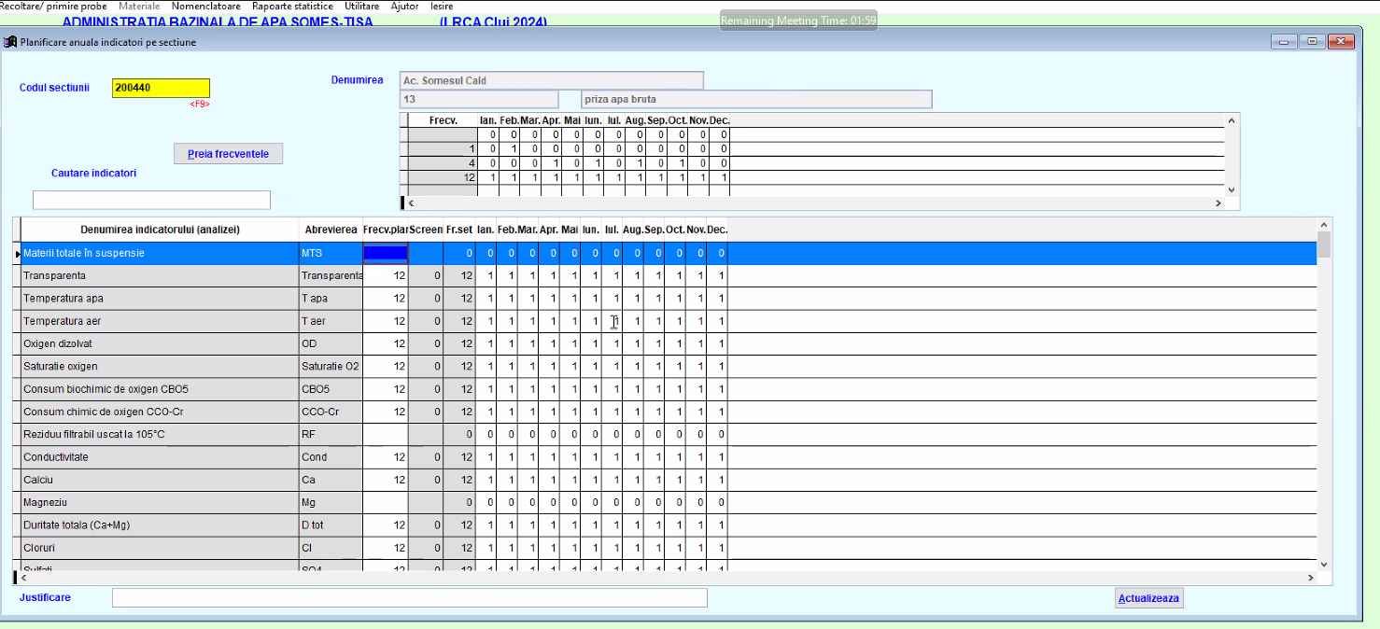
Note: The Frequency – represents a number from 0 to 12:
- The 0 value indicates that sampling is not required.
- A value of 4 indicates that sampling should be scheduled four times per year, with the laboratory chief determining the specific months for this activity.
- A value of 12 indicates that a sample should be scheduled and analyzed once per month.
(B) The second approach currently in use involves the Laboratory Chief (SL) manually registering and maintaining a local record, either in Excel or on paper, to estimate the annual sampling schedule for assigned indicators. This schedule is planned according to the frequencies specified in the Operating Manual for each indicator.
For instance, here is a sample of value 4 frequency setup for 5 indicators that must be scheduled for a specific section.
Minimal set of info | ABA | SGA/  LCA | County | Matrix | Section Name | Section Description |  | Section  code | Frequency | Indicator(s) / Group of indicators
Sample values out of MO | ABAAO | VL | VL | L | Acumulare Govora | Mijloc lac |  | RO80132020 | 4
  Chinoxifen | Aclonifen | Bifenox | Terbutrin | Cibutrin
Represents | ABA units | Laboratories  Units | Counties | Codes of subsystem catalog | All details regarding Sections are sourced from the MO. |  | Extract from MO |  |  |  | The codes/names of indicators scheduled for analysis are extracted from the MO.

This approach facilitates a smooth transition to the next stage by providing an overview of the entire year, detailing which samples collected and analyzed by the laboratory or transferred (2b) to other NARW laboratory unit for reasons such as equipment malfunctions or staff shortages.
- Stage 2: Monthly & Daily Planning
In this stage, the Laboratory Chief (SL) reviews any estimated monthly plan created in the previous phase, either manually or electronically, and specifies the actual dates for sample collection according to the collection frequency outlined in the MO, in accordance with regulatory guidelines and standards. Additionally, at this stage, the Laboratory Chief (SL) may choose to initiate a transfer order if necessary (2b).
Note: Since the National Laboratory (LNCA) does not conduct sample collection, monthly or daily scheduling is not required. Samples are registered only on the day they are received from the requested laboratory. Therefore, process (4), Sample Planning for LNCA, involves creating the R 7.4 01 electronic Registry in an Excel format, which consolidates all ABA orders outside of MOs where LNCA has been designated as the analysis laboratory. External orders are also recorded in this registry.
At this stage, due to data confidentiality, only the laboratory chief (SL) and their designated backup (LSL) will carry out the orders planning activities.

Plan Sample Collection
- At this stage of process (4), the estimated plan should be developed monthly, followed by daily planning. Alternatively, one can directly proceed with the daily planning of all internal and/or external orders registered in the laboratory. This includes starting with the order details and concluding with an estimated schedule for when sampling should take place, who will collect the samples, what needs to be sampled, and which appropriate containers will use for sample collection.
- The planning process (4) as illustrated in Figure 1 involves managing at least the essential required information:
- Order No (text), represents an alphanumeric code either registered in the laboratory or transferred from other laboratories.
- Order Date (date) would be the date the order was registered in the laboratory.
- Reception No (text), represents the alphanumeric code for an order registered in the laboratory (part of laboratory entry log).
- Reception Date (date and time) represents the actual date and time when order registered in the laboratory.
- Reception Responsible (text), would refer to the name of the individual responsible for placing the order.
- The minimal set of information for this section, as outlined in the previous phase, includes ABA, SGA/LCA, Section Name, Section Code, Section Description, County, Matrix (subsystem type) and list of Indicator(s) planned be analyzed according with the order. These details are provided in the Operational Manual, basically part of the orders registration.
- “RI No” (unique number) is either automatically incremented when the laboratory uses Excel files for registration or manually assigned as a unique identifier for the final Test Report, known as “Raport Încercare”. It represents a unique number assigned outside the order, specific to a section and matrix.
- Laboratory Code (text) is utilized to maintain uniqueness between “RI No” and the subsystem (matrix) designated for sample analysis. For instance, in the National Laboratory naming convention, it combines the value of “RI No” with the matrix code (such as U, R, etc.), resulting in codes like “1087R”. Only the laboratory chief (SL) and their backup (LSL) have access to all information related to this section. During the analysis phase, laboratory operators will use this code alongside the indicators that need to be analyzed, without knowing any additional details about the assigned code itself.
- Sampling Number (text), an alphanumeric code registered in the laboratory in case the laboratory collects samples or there is an entry from other laboratories.
- Sampling Date (date) represents the estimated planned date to take the sample.
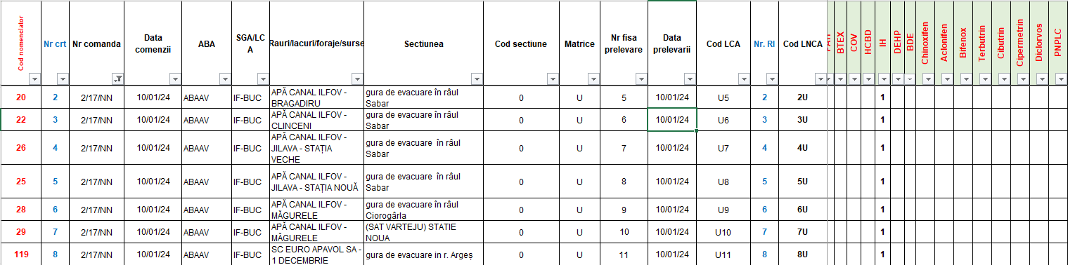
- Sampler (text) refers to the name of the individual responsible for collecting the sample from the field.
Note1: The above picture illustrates the monthly planning of sample collections assigned to the laboratory through internal and external orders. This example is drawn from a laboratory that executes this stage electronically.
Note2: The details mentioned and illustrated under Figure 2 are registered, planned, and monitored in the National Laboratory (LNCA) by the SL / LSL using a local Excel file coded and known as R 7.4-01 (sub-process (4a) out of Figure 1).

Generate “Sample Collection” Report
The images below (Sample 1 – Sample 3) offer examples of the different formats of the FL-7.3 Sample Collection Report, commonly known as the "Buletin de Prelevare," "Raport de Prelevare," or “Notă de Prelevare”. Typically, the report type itself and information needs to be collected differs between physical-chemical indicators, biological indicators or biota.
This document serves as the primary output for this stage (identified as sub-process 4b in Figure 1) and may either be generated as an official report or directly provided to the designated Sampler without a registration number. In the latter case, it allows the Sampler to record all necessary details on-site during the sample collection process.
Sample 1: Physical-Chemical Indicators Sampling Report

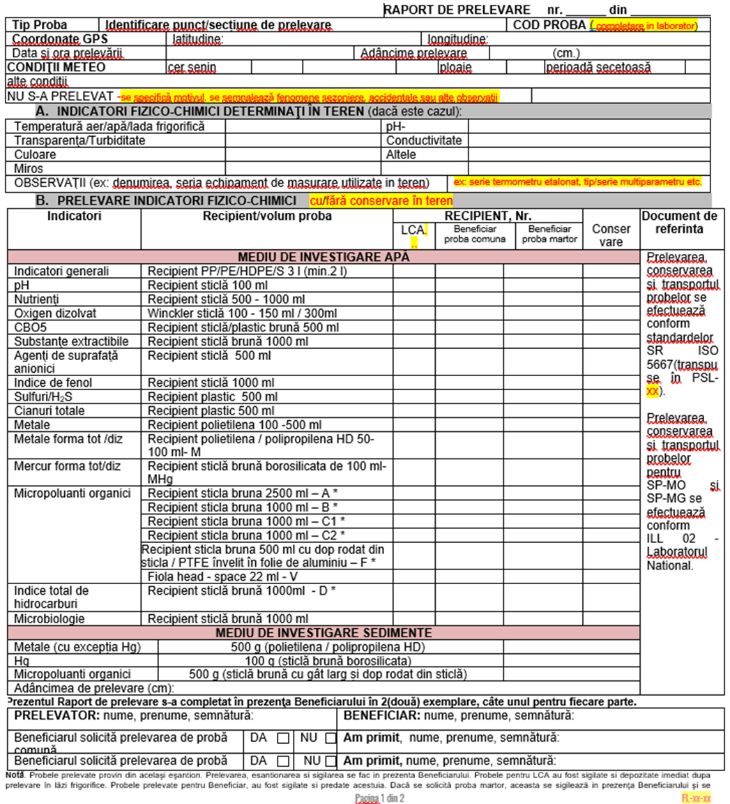

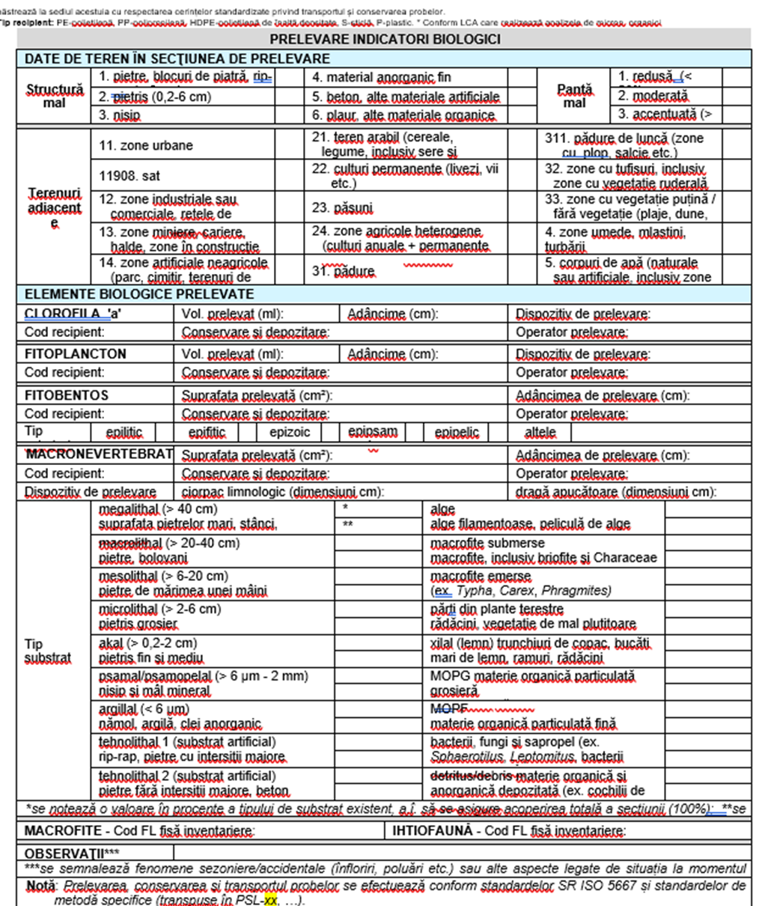
Sample 2: Ichthyofauna Sampling Bulletin - Siret River Basin Administration – Rivers
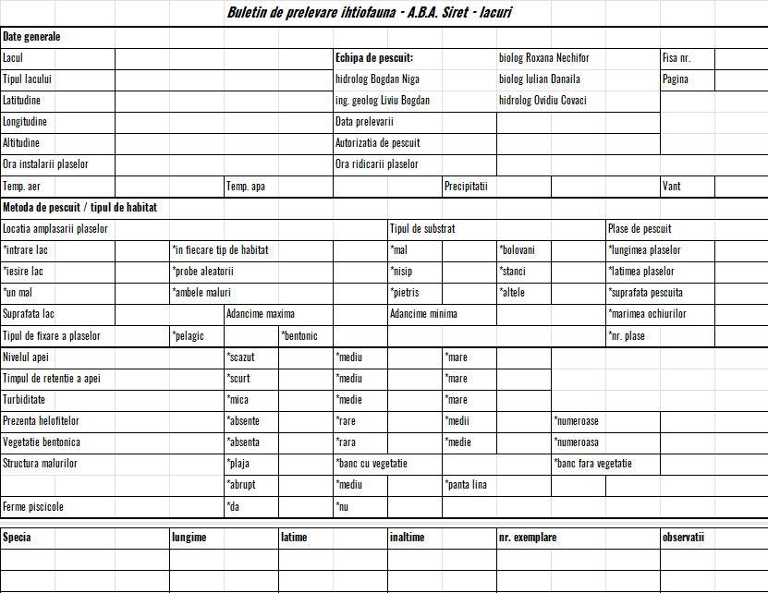
Sample 3: Ichthyofauna Sampling Bulletin - Siret River Basin Administration – Lakes

Important Note: Since the National Laboratory (LNCA) does not perform sample collection, direct registration will take place in Stage 3, where samples will be transferred pre-collected from other laboratories. In contrast, any NARW laboratory that is responsible for both sample collection and analysis will supply an unfilled paper version of the sample collection report (standard document, as illustrated in Samples 1 – 3 above) for the required sample category, without assigning a registration number.
The outcome of this stage may involve preparing the Sampling Reports, as exemplified above, or providing the document template on paper with the designated sampler to facilitate the sample collection process (illustrated with step (5) in Figure 1).
Note: Some laboratories generate this type of report electronically, while others manually fill in the information on a predefined printed document template. Currently, all reports, whether generated electronically or manually, are recorded in various internal laboratory registries, typically organized by sampling matrix.
- The minimal and mandatory fields part of in such a report are:
- Register Number, unique number assigned per laboratory
- Register Date
- Sample type, basically related to subsystems like water, underwater, wastewater, etc.
- Mark Indicators categorized on sampling matrix
- Recipients with details such name / type / volume / quantity / measure unit
- Designate the document or standard code as a reference for internal laboratory standards
- Designate the document or standard code as a reference for preserving sampler
Note: Although there is a predefined template for sample collection illustrated above, each laboratory utilizes its own specific extended template, resulting in a variety of formats tailored to individual needs. For instance, it starts with FL-7.1 and is further divided into FL-7.1 01, FL-7.1 02, for different types of subsystems.
- As part of the process, based on the materials and containers available in the laboratory inventory (1), the laboratory chief (SL) will allocate and record the necessary materials, container codes, quantities, and measurement units into the FL-7.1 Sample Collection Report, in accordance with standard internal procedures and regulations. Each retrieval from inventory is executed manually (1b) out of Figure 1.

Scenarios
During monthly or daily planning, various scenarios may arise, which are currently tracked through internal laboratory registries in a paper-based format and communicated via email. Examples of these scenarios include:
- Using the same container for multiple samples within the same order.
- Transferring or requesting containers and/or materials to another laboratory.
- May be transfers from one laboratory to another for sample analysis if justified.
- For a given order, some indicators may be designated for analysis by the initially assigned laboratory, while other indicators (or groups of indicators) may be transferred to a different laboratory for sampling and/or analysis.
Important: To comply with laboratory standards, all entries and exits must be auditable and traceable in the future LIMS. Currently, each action is documented in internal laboratory registries, also known as “Internal Note.” For instance, when initiating an order transfer, the minimum required information includes the Source Laboratory Registry Number and Date (for exit) and the Destination Laboratory Registry Number and Date (for entry). Likewise, future LIMS should provide this type of information to ensure traceability.

- Stage 3: Sample Collect & Receipt
This stage involves the collection of samples by designated Samplers (aka "Prelevator", assigned with role code “P”), who adhere to the directives outlined in the assigned report ("RAPORT DE PRELEVARE"), as detailed in Stage 2. This is followed by registering, illustrated as process (6) out of Figure 1, the collected samples and their information with the laboratory that requested them.
Note: The actual collection of samples (5) and related communications occur outside of the LIMS; however, the LIMS should enable the registration and validation of the received samples.

Sample Collection
During this process illustrated with (5) in Figure 1, the samplers adhere to established protocols to ensure that samples are collected accurately and representatively, in line with the specified criteria for each sampling location and type. Proper documentation is maintained throughout, capturing essential details (sub-process (5a) from Figure 1) such as the date, time, and conditions of the sampling to ensure traceability and compliance with laboratory standards.
First and foremost, the assigned Sampler will collect the actual sample from the field and then manually complete the FL-7.3 Sample Collection Note with all required information (sub-process (5a) from Figure 1) before returning to the laboratory with the sample containers for registration, as outlined in process (6) from Figure 1.

Sample Reception
The sample reception process numbered (6) in Figure 1, at the National Water Quality Laboratory (LNCA) and/or other regional NARW Laboratories (LCA), involves several sub-processes performed by designated Responsible Reception Personnel (RRP):

Verification of Samples for Reception
Water, sediment, and biota samples sent by the 11 Water Basin Administrations (ABAs) of NARW can be received at LNCA or another LCA only when accompanied by an Internal Note prepared and transmitted by the LCA that collected the samples (6a) out of Figure 1. Each Internal Note must be provided in two copies: Copy 1 remains with LNCA, while Copy 2 is returned to the collecting LCA. Both copies are identified by the exit number from the responsible LCA and the entry number at LNCA/LCA.
Usually, the Internal Note (NI) sent by the LCA of NARW is registered in the LNCA’s (or LCA’s) Internal Correspondence Register in electronic format (for example NARW code F-RS-3). The entry number from this register is noted on both copies of the Internal Note (NI) accompanying the samples being received at LNCA (LCA).
Samples are verified against the criteria outlined regarding:
- Integrity of the sample
- Type of containers used
- Sealing method of the containers
- Degree of container fill
- Adequate sample quantity for all requests specified in the Internal Note
- Proper preservation and transportation of the samples

Acceptance Without Comments and Sample Registration
Samples that meet the specified requirements above are accepted without comments (6b) from Figure 1 and enter the electronic registration stage within the controlled records system at LNCA, see RL-7.4-01 file code out of Figure 1. In regional laboratories LCAs this process initiated and maintained paper-based using internal registries.
The acceptance of the samples is confirmed by the RRP signing both copies of the Internal Note accompanying the samples without any comments upon reception at LNCA.

Acceptance With Comments and Sample Registration
If samples entering LNCA or LCA do not meet certain requirements (e.g., inappropriate container, insufficient sample volume for quantitative analysis of all indicators listed in the Internal Note, complete leakage of the container, improper preservation, etc.), the discrepancies are noted on both copies of the Internal Note and signed by the RRP. Specific to LNCA only, these observations are recorded in the Sample Reception Register (code R 7.4 01) under the Observations column. This represents the sub-process (6c) from Figure 1.

Refusal of Samples
Samples entering laboratories (LNCA/LCA) for reception that do not meet the representativeness criteria specific to NARW laboratories activities (e.g., wastewater samples containing a substantial layer of petroleum product for which an index determination is requested) will be refused (sub-process (6d) from Figure 1).
Once the samples are collected, validated, and registered in the laboratory registry, the next step is to determine the values of the sample indicators that need to be measured.
Each NARW laboratory adheres to strict work procedures regarding how laboratory equipment and materials (reagents) are prepared for each type of indicator. These procedures outline the specific protocols for selecting, calibrating, and maintaining the equipment, as well as the proper preparation and handling of reagents to ensure accurate and reliable test results. By following these guidelines, laboratories can maintain consistency in their analyses and uphold quality standards across all operations.

Sample Registration (paper-based)
All sample receptions are recorded in the destination laboratory's internal registry, typically categorized by the type of collected sample. For example, below are some instances of how sample entries are manually registered on paper in one of the NARW laboratories.
- The header of Laboratory Register RL-7.4-01 contains essential information with minimal details such as:
  - Sample Code
  - Container Number / Code
  - Date of reception
  - Date of sample collection
  - Collection note / summary number, represents the number of “Sampe Collection Report” (see 3.1.5.2 sub-chapter)
  - Identification and name of the sample
  - Type and range of physico-chemical, biological, bacteriological indicators
  - “RL” (Laboratory Register No.) where sample can be found
  - Receipt with Person name and signature
  - Information about Test Report
    - Number of RI
    - Issue date of RI
    - Prepared by, with person name and signature
    - Verified by, with person name and signature
    - Delivered by , with person name and signature
- Similar as the above headers of Laboratory Registries RL-7.4-02 - 05 contains essential information with minimal details such as:
  - Date of sample collection / Date sample registration
  - Container Number
  - Location of Sample collection
  - Collection notes
  - Indicators per category type
  - Code / Number of assigned Test Report
  - Prepared by, with person name and signature
  - Verified by, with person name and signature
- The header of Laboratory Registry RL-7.4-06, used for recording accidental pollution events/inspections, includes essential information presented in a concise format, such as:
  - Date of sample collection / Date sample registration
  - Container Number
  - Location of Sample collection
  - Collection notes
  - Indicators per category type
  - Code / Number of assigned Test Report
  - Prepared by, with person name and signature
  - Verified by, with person name and signature
- The header of Laboratory Registry RL-7.4-07, used for recording samples collection of macroinvertebrates, includes essential information presented in a concise format, such as:
  - Sample Code
  - Date of sample collection / Date sample registration
  - Water course / Sampling section
  - Type of sample
  - Harvested area (surface)
  - Sorted area
  - Reported area
  - Specific Composition
  - Author / year
  - Taxonomy (order / family /. subfamily)
  - Density Taxonomic
  - Indicator / Total Density
  - Number of families
  - Number of tax
  - Density (algal units/ml)
  - Code / Number of assigned Test Report
  - Prepared by, with person name and signature
  - Verified by, with person name and signature
- The header of Laboratory Registry RL-7.4-08, used for recording samples collection of phytoplankton from rivers, includes essential information presented in a concise format, such as:
  - Sample Code
  - Date of sample collection / Date sample registration
  - Water course / Sampling section
  - Type of sample / Settled volume (ml)
  - Utermohl chamber surface / Optical field surface / Number of fields
  - Taxonomic composition
  - Number of algal objects in the Utermohl chamber
  - Density (algal units/ml)
  - Total density (algal units/ml) / Chlorophyll “a” (µg/L)
  - Code / Number of assigned Test Report
  - Prepared by, with person name and signature
  - Verified by, with person name and signature
- The header of Laboratory Registry RL-7.4-09, used for recording samples collection of phytoplankton from lakes, includes essential information presented in a concise format, such as:
  - Sample Code
  - Date of sample collection / Date sample registration
  - Water course / Sampling section
  - Type of sample / Settled volume (ml)
  - Utermohl chamber surface / Optical field surface / Number of fields
  - Taxonomic composition
  - Number of algal objects in the Utermohl chamber
  - Density (algal units/ml)
  - Algal object biovolume (µm³)
  - Algal object biomass (mg/L)
  - Total density (algal units/ml) / Chlorophyll “a” (µg/L)
  - Code / Number of assigned Test Report
  - Prepared by, with person name and signature
  - Verified by, with person name and signature
- The header of Laboratory Registry RL-7.4-10, used for recording samples collection of phytobenthos, includes essential information presented in a concise format, such as:
  - Sample Code
  - Date sample registration
  - Date of sample collection
  - Location of Sample collection
  - Type (range) of indicators
  - Code / Number of assigned Test Report
  - Prepared by, with person name and signature
  - Verified by, with person name and signature
- The header of Laboratory Registry RL-7.4-11, used for recording samples collection of bacteriology, includes essential information presented in a concise format, such as:
  - Sample Code
  - Date of sample collection / Date sample registration
  - Water course / Sampling section
  - Type of sample
  - Taxonomic composition
  - Density (algal units/ml)
  - Total density (algal units/sample) IBD – rivers; TDI – lakes
  - Code / Number of assigned Test Report
  - Prepared by, with person name and signature
  - Verified by, with person name and signature
- The headers of Laboratory Registries RL-7.4-12 - 15, used for recording samples for metal analysis includes essential information presented in a concise format, such as:
  - Sample Code / Sample Code from assigned LCA
  - Date of sample collection / Date sample registration
  - Sample collection number
  - Range of indicators (T/D)
  - Code / Number of assigned Test Report
  - Prepared by, with person name and signature
  - Verified by, with person name and signature
- Like the above headers, there are those for Laboratory Registries RL-7.4-GC1 to GC4, which are used for the analysis of organic micropollutants.
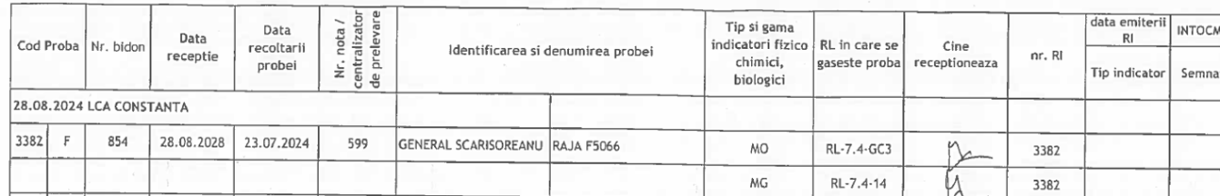
Note: For reference, the paper-based registration appears as below picture.

Sample Registration (electronic)
Water, sediment, and biota samples, accepted with or without observations, enter the electronic registration stage within the controlled recording system of National Laboratory (LNCA), specifically in the LNCA Reception Register (code R 7.4 01) – illustrated in Figure 1 as part of processes (4) and (7). The “R 7.4 01” is a document with the following characteristics:
- An exclusively electronic document in MS Office Excel format, with access restricted by a password established at the beginning of each year by the Laboratory Chief (SL) to maintain data confidentiality.
- Access to the file is granted only to personnel responsible for sample reception at LNCA (RRP); the nomination of authorized personnel for this responsibility is carried out by the Laboratory Chief (SL) through the Authorization Form included in the LNCA Job and Activity List (FL 6.2 02).
- The file consists of three worksheets:
  - The worksheet "Order," in which all samples received at LNCA are recorded, with or without observations; this worksheet includes all the information contained in the Internal Notes accompanying the samples sent by the LCAs of NARW; other relevant information for the sections from which the samples are collected (description of the sampling point from the wastewater discharge source, sampling section code) is taken from the corresponding Operating Manual of the ABA of NARW. The "Order" file contains the types of information outlined in Stage 1 and its flow through processes illustrated in Figure 1.
  - The worksheet "Nomenclator": the function that prepares/updates the FL 7.4 01 annually also creates the "Nomenclator" worksheet, which contains all sections and types of samples per section, as mentioned in the 11 Operating Manuals of LNCA, transmitted by the ABA of NARW; each section and each type of sample from that section is assigned a unique numeric code, entered in column A of the "Nomenclator" worksheet (if a section includes multiple types of samples, a unique numeric code is entered for each type of sample by repeating the section name in column B of the "Nomenclator" worksheet); the codes associated with each type of sample are presented in Table 1.
  - The "Pollutions" worksheet contains information entered (typed) by the Responsible Reception Personnel (RRP), taken from each internal Beneficiary's order and the corresponding Internal Note, which specifies that the samples to be sent to LNCA are related to accidental pollution or a suspicion of accidental pollution. The code associated with these samples is "P".
Table 1: Symbols used in LNCA, and partly in other laboratories, indicate the type of matrix from which the samples received at LNCA originate.
Investigated Matrix | Symbol | Investigated Matrix | Symbol
Rivers and Surface Watercourses | R | Sediment | S
Lakes | L | Coastal / Marine Waters | C
Groundwater (Boreholes) | F | Biota (Fish) | Bp
Wastewater | U | Biota (Mollusks) | Bm
Accidental Pollution | P | PT Scheme | PT
Internal Control Sample | QC | Sample from ILC (Interlaboratory Comparison) | ILC

- Stage 4: Sample Analysis and Data Capture

Distribution of Samples for Analysis (or sub-sampling)
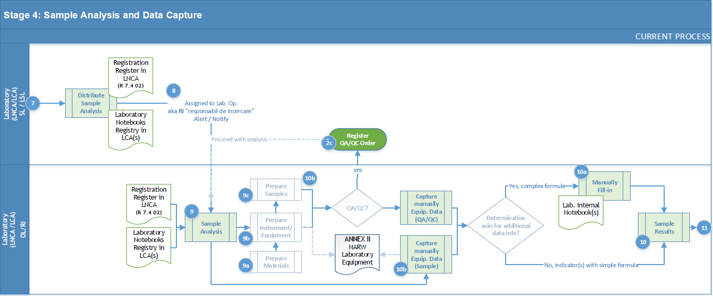
At this stage, the Laboratory Chief (SL) assigns collected and registered samples for analysis tasks to laboratory operators (OL) using either a manual paper method through internal laboratory notebooks or an electronic approach via specialized software or a shared Excel file.
In the paper-based method, an internal laboratory notebook is utilized to record important details, including the assignment date, sample code, indicators, and the signatures of the parties involved. Conversely, in the electronic method, tasks are assigned using an Excel file or a specialized software application (FITERO).
This process is known as “sub-eșantionare” illustrated in Figure 1 with (8) and documented in the internal procedures with reference R 7.4 02. Regardless of the method used, the laboratory must ensure a systematic and traceable assignment of tasks, fostering effective communication and accountability among team members.
In National Laboratory (LNCA) the allocation of samples for analysis is performed by the RRP (Laboratory Chief (SL), their deputy, or another designated individual) after each completed reception (Stage 3). This is recorded in the LNCA Sampling Register, code R 7.4 02, which is an MS Office Excel document maintained electronically with the following characteristics:
- Access to the file is restricted to personnel responsible for conducting tests within LNCA (“RI” Authorized Testing Officer), with responsibilities outlined in the Authorization Sheet included in the LNCA Functions and Activities List (FL 6.2 02).
- The Excel file consists separated worksheets “Eșantionare_MO” for samples intended for analyses of organic micropollutants and “Eșantionare_MET” for samples designated for metal analyses.
- The column structure is based on sample codes from LNCA and compound classes from LNCA's analytical portfolio (as specified in R 7.4 01). Each column representing a compound class is followed by a column labeled "status," which is filled in by each RI according to the procedure described below.
The Sampling Register R 7.4 02 is automatically populated with necessary and relevant information extracted from the Reception Register (R 7.4 01) using Excel formulas.
The process is as follows:
- The file format ensures compliance with confidentiality and impartiality requirements while providing traceability of results relative to samples received in LNCA. For instance, out of R 7.4 01 is prefilled the reception date, the sample code from LNCA unique identifier ensuring traceability of results associated with the sample—is recorded and all indicators associated with the compound class.
For each sample and its corresponding compound class, R 7.4 02 includes a status column where each RI is populated with values based on activity. Based on entered value a gray circle in the intersecting cell, indicating that the sample in R 7.4 01 does not have an analysis order for that class (e.g., cell C2 in Figure 2). If a sample in R 7.4 01 has an analysis order for a specific compound class (indicated by the digit 1), this "order" is automatically transferred to the intersecting cell in R 7.4 02, marked by a yellow circle, signifying "sample taken (awaiting processing by RI)” for instance, cell C3 in below Figure 2. Each RI completes this cell as follows: where a sample is allocated for analysis of a compound class (indicated by a yellow circle in the compound class cell), the corresponding intersecting cell is filled accordingly.
- In the "status" column, when the RI enters the number "2," a green circle automatically appears, indicating "sample collected," for example, in cell D3.
Figure 2: Extract (template) from the Sample Sampling Register in LNCA – R 7.4 02, with fields automatically populated from the LNCA Reception Register (R 7.4 01) and by the RI within LNCA.
Another method for distributing samples for analysis to Authorized Testing Officers (RI) utilizes a paper-based internal laboratory notebook. This notebook includes essential information such as:
- Sample Code: This can be an internal code or one derived from a transfer. It serves as a unique identifier for tracking the sample throughout its lifecycle.
- Reception Date: This refers to the date when the sample is received and officially registered in the laboratory’s system, marking the beginning of its processing.
- Sampling Date: This specifies the exact date and time when the sample was collected by the sampler, providing crucial information for traceability and analysis timelines.
- “Nr.N.P/Centralizator”: This represents an internal registration number used for organizing and tracking samples within the laboratory’s records.
- Range of indicators: This field contains the codes or types of indicators planned for analysis, allowing for clear identification of the parameters that will be evaluated during testing.
- Name / Receive Signature: These fields are where the assigned operator will confirm the collection of the sample for analysis, ensuring accountability and traceability within the sampling process.

Select, Verify and Validate the Analytical methods
Before commencing actual sample analysis, it is crucial for each laboratory to carry out the selection, verification, and validation of analytical methods, adhering to the laboratory's Validity Assurance Plan. Ensuring the validity of results encompasses a series of preventive activities systematically designed to maintain the accuracy and effectiveness of the quality system, thereby guaranteeing the performance of the Laboratory for Water Quality (LNCA) and achieving results at an appropriate level of confidence.
Validity assurance serves as a multifaceted control mechanism that provides information and evidence regarding:
- The suitability of testing methods.
- The awareness of personnel regarding their activities.
- Intermediate equipment verification.
- Supervision of staff.
Monitoring the validity of results should include:
- The use of reference materials and/or quality control materials.
- The employment of calibrated alternative equipment to provide traceable results.
- Functional checks of testing and measurement equipment.
- Use of calibration or working standards, with control charts when applicable.
- Intermediate checks of measurement equipment.
- Repeated testing using the same or different methods.
- Retesting of archived samples, when applicable.
- Correlation of results for different characteristics of a sample.
- Analysis of reported results.
- Participation in inter-laboratory comparisons and proficiency testing programs.
To ensure the validity of test results, each laboratory must establish an internal "Validity Assurance Plan" (for reference, see Sample Monitoring Plan for Ensuring Result Validity chapter), which outlines the key verification methods, the criteria used, and the frequency of their application. For example, in the National Laboratory LNCA validity and quality assurance of results are implemented through functional and intermediate checks of equipment, as well as monitoring the validity of results obtained in the laboratory.

Intermediate Equipment Verification
Between two calibrations (excluding chromatographic equipment, where applicable), the laboratory conducts functional checks of its measuring equipment against available standards and Certified Reference Materials. The intermediate checks are performed by testing responsible personnel (RI) using prepared solutions from available inventory, solid substances, calibration weights, and comparative measurements of temperatures and volumes with volumetric glassware. Any deviations from their basic characteristics will lead to appropriate identification, verification, recording, management, and disposal. Records of these checks are maintained in laboratory notebooks. The assessment of intermediate checks is managed by RI/SDC and is stored in secured documents. The physical management of reference materials is the responsibility of RI.
Intermediate equipment verification is conducted periodically according to the “Program for Intermediate Equipment Verification Between Two Calibrations” (code FL 6.4 07 in LNCA).

Monitoring Validity of Test Results
Monitoring the validity of test results is achieved using available reference materials, repeated testing, and participation in planned inter-laboratory proficiency testing schemes.
Monitoring activities are structured at multiple levels, as follows:
- The primary control level includes:
- Performing tests on control samples made from reference materials and/or certified reference materials to construct Shewhart control charts.
- Conducting repeated tests (duplicate samples, double sampling under repeatability conditions).
- Statistical evaluation of the calibration function and estimation of method performance characteristics if applicable.
- The secondary control level comprises the following verification and testing activities to ensure precision and reliability:
    - Interpersonal Testing: The same sample is tested by different operators under reproducibility conditions to compare results.
    - Testing on Unknown Samples: Performing tests on samples with unknown concentrations to assess consistency and accuracy.
    - Calibration-Curve Matching Tests: Testing with samples that have identical concentrations to specific calibration curve points to confirm measurement alignment.
    - Testing on Fortified Samples: Conducting analyses on samples fortified to a known concentration level. Typically, fortification is set to SCM (Specific Concentration Measure), CMA (Certified Maximum Allowable), or LOQ (Limit of Quantitation).
    - Recovery values from fortified samples are evaluated through two methods:
      - Each recovery value is compared against the acceptable range specified in the PSL (Standard Testing Procedure) and its respective Validation Report.
      - A control chart for recovery values is maintained according to the criteria outlined in ISO 7870-2:2013. This control chart is developed and monitored by the Laboratory Manager or designated Supervisory Control Officer (SCO).
Testing results are meticulously recorded in work logs, categorized by each indicator.
The primary data from these logs are then transferred by the Laboratory Manager into the Secondary Control Validity Assurance Record (Code FL 7.7 02), an Excel file dedicated to processing and validation.
The Laboratory Manager (SL) is responsible for performing these evaluations.
- The tertiary control level is aimed at assessing the laboratory’s overall performance and ensuring the reliability of reported results at the expected confidence level. This level of control includes:
- Participation in Interlaboratory Comparisons and Proficiency Tests (PT): Engaging in standardized tests across multiple laboratories to validate accuracy and consistency.
- Testing with Certified Reference Materials: Conducting tests using high-standard reference materials to benchmark and validate analytical processes.
Each year, laboratories set the number of indicators or groups for proficiency testing, guided by the Proficiency Testing Participation Plan (Form FL 7.7 05 in LNCA).
This plan ensures all accredited indicators are evaluated at least once per accreditation cycle to uphold credibility and performance standards.
The Laboratory Manager prepares the plan, which is then approved by the Deputy General Director (DGA).
Important note: Each laboratory defines a tailored validity assurance plan for each designated indicator or class of indicators. This plan outlines specific details, including:
- The indicator or the class of indicators designated be analyzed
- The analysis method within its levels such: primary, secondary and tertiary
- The frequency when indicating the sample count required before re-evaluation
- Criteria for accepting and evaluating obtained results established by SL in collaboration with Testing Responsible (RI) and the Quality Control Supervisor (SDC), along assigned documentation – laboratory notebooks and conformity documents.
- The performance parameters are set by the Laboratory Manager (SL) in collaboration with the Testing Responsible (RI) and the Quality Control Supervisor (SDC), alongside the relevant documentation, including laboratory notebooks and compliance records.

Sample Monitoring Plan for Ensuring Result Validity
No. | Analysis Name | Quality Assurance Measure | Month |  |  |  |  |  |  |  |  |  |  |  |  |  |  |  |  |  |  |  |  |  |  | Performed By | Verified By
No. | Analysis Name |  | 1 |  | 2 |  | 3 |  | 4 |  | 5 |  | 6 |  | 7 |  | 8 |  | 9 |  | 10 |  | 11 |  | 12 | Performed By
1 | pH | Internal calibration | x |  | x |  | x |  | x |  | x |  | x |  | x |  | x |  | x |  | x |  | x |  | x | OL | RI
1 | pH | Control point (verification standard) | x - for each set of determinations |  |  |  |  |  |  |  |  |  |  |  |  |  |  |  |  |  |  |  |  |  |  | OL | RI/RMC
1 | pH | Duplicate sample (repeated sample) | x |  |  |  |  |  |  |  | x |  |  |  |  |  |  |  | x |  |  |  |  |  |  | OL | RI/SL/RMC
1 | pH | Double-sampled duplicate |  |  |  |  |  |  |  |  |  |  |  |  |  |  |  |  |  |  |  |  | 1 |  |  | OL | SL
1 | pH | Blank sample testing |  |  |  |  |  |  |  |  |  |  | 1 |  |  |  |  |  |  |  |  |  |  |  |  | OL | SL
1 | pH | **Participation in proficiency testing (PT) | x- ref. FL-7.7-02 |  |  |  |  |  |  |  |  |  |  |  |  |  |  |  |  |  |  |  |  |  |  | OL | SL
2 | CCOCr — Chemical Oxygen Demand (COD) | Control point (verification standard) | x - for each set of determinations |  |  |  |  |  |  |  |  |  |  |  |  |  |  |  |  |  |  |  |  |  |  | OL | RI/RMC
 |  | Duplicate sample (repeated sample) | x |  |  |  |  |  |  | x |  |  |  |  |  |  |  | x |  |  |  |  |  |  |  | OL | RI/SL/RMC
 |  | blank sample (control) | x - for each set of determinations |  |  |  |  |  |  |  |  |  |  |  |  |  |  |  |  |  |  |  |  |  |  | OL | SL
 |  | Blank sample testing |  |  |  |  |  | 1 |  |  |  |  |  |  |  |  |  |  |  |  |  |  |  |  |  | OL | SL
 |  | re-testing of stored items |  |  |  |  |  |  |  |  |  | 1 |  |  |  |  |  |  |  |  |  |  |  |  |  | OL | SL
 |  | **Participation in proficiency testing (PT) | x- ref. FL-7.7-02 |  |  |  |  |  |  |  |  |  |  |  |  |  |  |  |  |  |  |  |  |  |  | OL | SL
3 | ammonium content | Control point (verification standard) | x - for each set of determinations |  |  |  |  |  |  |  |  |  |  |  |  |  |  |  |  |  |  |  |  |  |  | OL | RI/RMC
 |  | Duplicate sample (repeated sample) | x |  |  |  |  |  |  | x |  |  |  |  |  |  |  | x |  |  |  |  |  |  |  | OL | RI/SL/RMC
 |  | Blank sample testing |  |  |  |  |  | 1 |  |  |  |  |  |  |  |  |  |  |  |  |  |  |  |  |  | OL | SL
 |  | **Participation in proficiency testing (PT) | x- ref. FL-7.7-02 |  |  |  |  |  |  |  |  |  |  |  |  |  |  |  |  |  |  |  |  |  |  | OL | SL

Sample Analysis
The responsibility for managing samples after their sampling process (8) in the laboratory falls to the Authorized Testing Officers (RI).
The RI consults the Sampling Register (R 7.4 02) daily basis, at designated intervals, to retrieve the samples assigned for analysis process (9).
During the processing of water, sediment, and biota samples for instrumental analysis, the operations performed on these samples are recorded by the RI in the Laboratory Notebooks for Sample Processing (CL 1) according to the type of matrix and the group of indicators being analyzed (see associated codes in the table below).
No. | Description | Code
1 | Internal Correspondence Register of LNCA (electronic format) | F-RS-3
2 | Sample Reception Register in LNCA (MS Office Excel format) | R 7.4 01
3 | Sample Registration Register in LNCA (MS Office Excel format) | R 7.4 02
4 | Sample Collection Sheet by External Beneficiary | FL 7.4 03
5 | Laboratory Work Instruction – Cleaning of Sampling Containers and Laboratory Glassware for Samples Intended for Analysis of Organic Micropollutants and Metals | ILL 01
6 | Laboratory Work Instruction – Sampling, Transporting, and Preserving Samples Intended for Analysis of Organic Micropollutants and Metals | ILL 02
7 | Workbook for Processing Water Samples for Organic Micropollutants | CL 1-01
8 | Workbook for Processing Sediment and Biota Samples for Organic Micropollutants | CL 1-02
9 | Workbooks for Recording Analyzed Sample Sequences | CL 2-01...CL 2-10
10 | Workbooks for Recording Sample Result Calculations | CL 3-01...CL 3-10
11 | Workbook (Sample Record, Recording Intermediate and Final Results) – Hg for Water Samples | CL 6
12 | Workbook (Record and Processing of Samples, Recording Intermediate and Final Results) – Hg for Sediment Samples | CL 7
13 | Workbook (Record and Processing of Samples, Recording Intermediate and Final Results) – Hg for Biota Samples | CL 8
14 | Workbook (Sample Record, Recording Results) – Metals ICP-MS for Water Samples | CL 9
In LNCA during instrumental analysis, the RI records the samples in the Laboratory Notebooks for the sequences processed (CL 2), and the results (preceded by the relevant calculations) are documented in the Laboratory Notebooks for Result Calculations (CL 3 – CL 9), meaning pictured above sub-processes (10a) and/or (10b).
In one of the NARW laboratories, there are dedicated paper-based laboratory notebooks for recording physicochemical and bacteriological determinations, as well as for biological indicators such as:
- Laboratory Notebook for Turbidity Determination CL-7.7-01 with information such as: sample code, date of collection, date of execution, vial number, dilution, turbidity value (units NTU), calculation result, signatures for operator and verifier.
- Laboratory Notebook for Determination of pH, Electrical Conductivity, and Filterable Residue CL-7.7-02 implies determine information for each type of method:
  - Iodometric method with information about: sample code, date of collection, date of execution, room temperature, fixed oxygen bottle number, volume of titration Na2S2O3, ml titrated, concentration, mg O2/l , T°C, O2 saturation plus signatures for operator and verifier.
  - Electrochemical method with information about: sample code, date of collection, date of execution, room temperature, fixed oxygen bottle number, concentration, mg O2/l , T°C, O2 saturation plus signatures for operator and verifier.
- Laboratory Notebook for Determination of Biochemical Oxygen Demand CL-7.7-05
- Laboratory Notebook for Determination of Fluoride CL-7.7-24.
- Laboratory Notebook for Determination of Substances Extractable with n-Hexane CL-7.7-25
- Laboratory Notebook for Sample Processing by Digestion CL-7.7-37
There are two types of indicators:
- simple indicators, which are directly measured and obtained from laboratory equipment (10), and
- complex indicators, which necessitate calculation formulas based on additional information such as volumes, concentrations, and dilution factors. The future Laboratory Information Management System (LIMS) will support both methods by allowing users to fill out a form (10a) with the necessary information based on predefined formulas to determine the result of the analyzed indicator, as well as enabling the direct extraction of results from laboratory equipment that can provide digital outputs (10b).

Note: For reference and guidance, please consult Annex 5 document, which contains a list of various sample indicators, along with both simple and complex formulas.

- Stage 5: Sample Validate & Approve
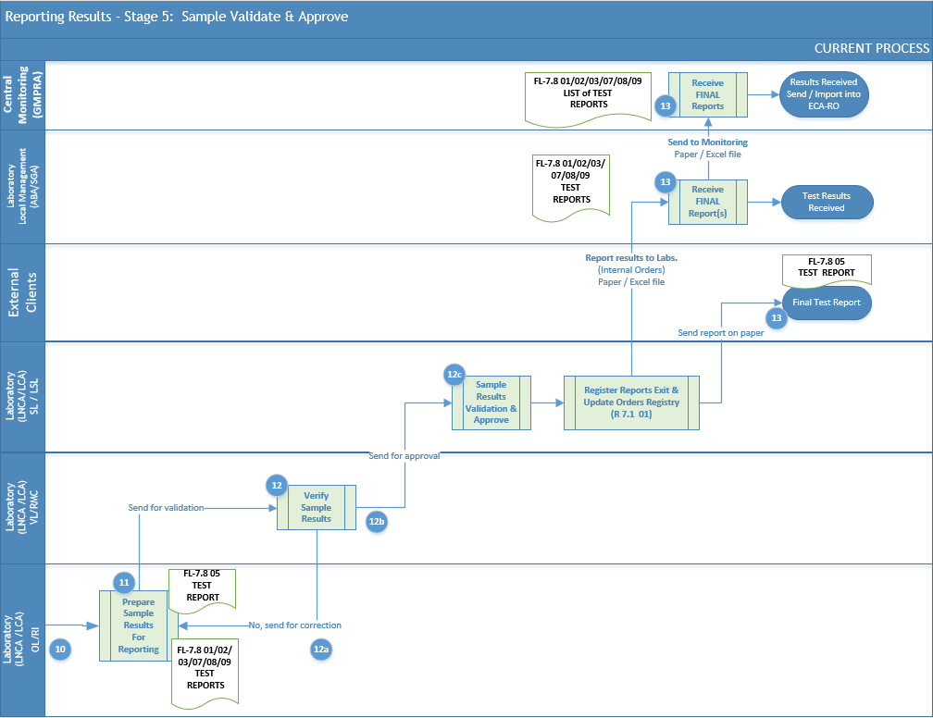
The above stage outlines how the laboratory reports test results and uses the accreditation symbol. It applies to staff in each ABA’s laboratories involved in preparing, reviewing, and approving test reports.
- Once the sample results (10) are received, the laboratory operator, authorized as the Responsible for Testing (RI), prepares test reports for external and internal Clients according to internal authorization as part of process (11), and submits them to the laboratory verifier, authorized as the Quality Management Responsible (RMC), for review and approval.
- According to the laboratory rules and regulations, all test reports must first be reviewed and validated (12) by the individual designated as the Quality Management Responsible (RMC). This validation process includes a thorough review of laboratory notebooks, verification of the accuracy of calculation formulas, and cross-checking the reported results to ensure compliance with internal standards and regulatory requirements. The Verifier (RMC) ensures that all data, procedures, and documentation adhere to the laboratory’s quality management protocols before giving final approval for the release of the test reports.
- If results need to be revised and corrected (12a), the RMC will notify the Responsible for Testing (RI) with justifications for the review and correction. Currently, communication occurs verbally and through email; however, the future LIMS will integrate this functionality to ensure traceability of actions.
- If the results submitted by the RI to the RMC have been verified and approved (12b), the RMC will record and sign the activity in the internal laboratory registry (e.g., R 7.1 01 registry from LNCA) and forward it to the Laboratory Chief (SL) for final verification and approval.
Note: The future LIMS should streamline the verification process by enabling easy tracking of past actions and providing the ability to view, preview, and manage generated or scanned documents related to sample result collection (10).
- Similarly, the Laboratory Chief (SL) is responsible for validating and approving the analysis results after Verifier (RMC) approval (12c). This process ensures that all data has been accurately reviewed and meets the necessary quality and regulatory standards before final approval.
- Once the test results are validated and approved, they are recorded and signed by all relevant parties. The results are then sent to external beneficiaries for external orders or transmitted internally—either on paper or electronically—to the GMPRA and other laboratories involved in the transfer of orders.

Reporting Results for Internal Orders (GMPRA)
The content of the Test Report for internal Clients (GMPRA), in accordance with internal laboratory procedures, must include specific details to ensure that each sample is uniquely identifiable and to minimize the risk of misinterpretation or misuse. The following key points outline the necessary information to be included in the report:
- Laboratory Information: The report must display the lab's name, address, and contact details directly under the institution's logo.
- RENAR Accreditation: The report should include the RENAR accreditation mark.
- Sample Identification: Unique identification of the issued report, matching the sample number for which results are being reported, along with the date of reception. It should be prepared immediately after sample decoding, with the report's issuance date clearly declared.
- Request Identification: Include identifying details of the request that led to the test report (e.g., request number and date).
- Beneficiary Information: Identification of the entity requesting the test report.
- Sample Details: Type and code of the sample (e.g., wastewater, code U...), along with the date and time the sample was collected.
- Sampling Information: Include sample collection data, such as report number, collector's name, and sampling location.
- Laboratory Reception: Date and time the sample was received in the lab, including details like the amount of sample, type of container used, whether the sample was preserved, and any accompanying documents.
- Test Information: The period during which the tests were performed, the requested test types (e.g., biological indicators), and the results, including the unit of measurement.
- Test Methodology: The reference document for the method used, along with its quantification limits.
- Measurement Uncertainty: Expanded uncertainty of the measurement, declared in the same unit as the result, and estimated for a confidence level of 95%.
- Special Mentions:
  - Declaration of personnel responsible for sample collection, preservation, and transport.
  - Statement that the test results pertain exclusively to the received sample.
  - If the laboratory performed field sampling, it should be noted that this is an accredited procedure in accordance with the RENAR certification.
  - If biological tests are requested and species identification is necessary, this report must include an appendix with the requested information.
- Other Mentions:
  - Details of any witnesses’ present during the sampling process.
  - Storage conditions of the sample before testing.
  - If sampling, storage, or transport conditions are not followed (e.g., inadequate containers or delays), the lab must inform the Beneficiary that these deviations may affect the results, and the lab does not guarantee the accuracy of the results under accreditation in such cases.
- Notes:
  - The test report can only be reproduced in full without the written approval of the Water Quality Laboratory.
  - Measurement uncertainty estimation is performed in accordance with the "Evaluation of Measurement Uncertainty" procedure.
  - If the result is below the quantification limit, it is recorded as "<LOQ."
  - The lab does not provide opinions or interpretations.
  - Tests marked with "*" are not covered by RENAR accreditation (e.g., transparency, turbidity, color, and temperature).
- Footer details such:
  - Page Numbering: Ensure the pages are numbered to uniquely identify all parts of the report.
  - Authorization: Identification of the person authorizing and issuing the test report.
  - End of Report: Clearly indicate the end of the test report.
Note: The listed elements represent the minimum requirements for test reports issued to internal Clients on paper. The Consultant must ensure that all relevant details gathered during the business analysis phase are thoroughly incorporated into these reports.
Important: The following section illustrates the design and information details of the Test Report model, presented in its native language. This model is currently in use at one of the laboratories scheduled to participate in the LIMS Pilot phase.

LABORATORUL DE CALITATEA APELOR – S.G.A. SUCEAVA
Adresa: Str. Universității nr. 48, Suceava, jud. Suceava
Exemplar nr. din 2
RAPORT DE ÎNCERCARE
Nr. din
Test Report No. FL-7.8-09 / Edition 06 / Revision 4
- Client: G.R.A. S.G.A. Suceava, Comanda nr.: Manual de Operare -
- Beneficiar: G.R.A. S.G.A. Suceava,
- Date privind identificarea probei:
  - Tipul și codul probei: apă suprafaţă/ R
  - Data recoltării: ora:
  - Nota de prelevare: nr.
  - Recoltat de:
  - Loc de prelevare: Romania Râu Siret – graniţă – aval 1km graniţă cu Ucraina
  - Data recepției: ora:
  - Perioada de analiză:
- Conditii meteorologice la prelevare:
- Alte constatari:
- Date privind rezultatele obținute:

Nr.  crt. | Indicatorul de calitate a apei | Unitate de măsură | Valori de concen-traţie obținute | Metoda de  analiză / documente  de referință | Limita cuantifi-care (LOQ)
0 | 1 | 2 | 3 | 4 | 5
- MEDIU DE INVESTIGARE: APA
- INDICATORII REGIMULUI DE OXIGEN
1.
2.
3.
.....
- INDICATORII REGIMULUI DE NUTRIENȚI
5.
6.
….
- ALȚI INDICATORI FIZICO-CHIMICI GENERALI
12.
13.
14.
….
- INDICATORI DE SALINITATE
16.
17.
18.
….
- METALE GRELE
24.
25.
26.
….
- ALȚI INDICATORI RELEVANȚI
33.
34.
35.
….
- MEDIU DE INVESTIGARE: SUSPENSII
- INDICATORII REGIMULUI DE NUTRIENȚI
37. |  |  |  |  | -
…. |  |  |  |  | -
- METALE GRELE
39. |  |  |  |  | -
40. |  |  |  |  | -
- Menţiuni speciale
  - Prelevarea, conservarea și transportul probei au fost efectuate de către reprezentantul laboratorului conform declaratiilor de la pct. 3.3 si 3.4 si conform PGL 7.3 Esantionare si PSL-SV-41.
Da | x |  |  | Nu
  - Rezultatele încercării se referă exclusiv la proba recepționată.
  - Prelevarea efectuata de laborator este o activitate realizată pe teren, acreditată în conformitate cu Anexa nr. 3 la Certificatul de Acreditare nr. LI 474.
  - Alte mentiuni referitoare la prelevare (probe/ probe martor), condiții de păstrare, persoane prezente la prelevare conform notei de prelevare mentionate la pct. 3.3.
- Note
  - * Încercare neacreditată - Încercările marcate cu (*) NU sunt acoperite de acreditarea RENAR
  - Înregistrarea „<LOQ” reprezintă faptul ca valoarea determinată este mai mică decât limita de cuantificare a metodei sau de aplicabilitate a standardului.
  - Rezultatele se refera numai la obiectul incercat si este numai pentru uz intern ;
  - Fără aprobarea scrisă a Laboratorului de Calitatea Apelor acest raport de încercare nu poate fi reprodus decât integral.
  - Laboratorul nu emite opinii si interpretări.
Autorizat,
Şef laborator
Întocmit,
Responsabil tip de probă
_______

Reporting Results to Internal Orders (Simplified Test Report)
Upon request from the internal Beneficiary (Department of Water Resources Management, Monitoring, and Protection – GMPRA), the results for samples under internal orders are reported in a simplified electronic format via email, following the Operating Manual of the Monitoring System of ABA Laboratories for the year. This is done using read-only, password-protected electronic test report forms (codes FL – 7.8.-01, FL – 7.8.-02, FL – 7.8-07, FL – 7.8-08).
The test report must include the following details to ensure each matrix subsystem is uniquely identifiable and to minimize the risk of misinterpretation or misuse:
- Title: "Simplified Test Report for Physico-Chemical Tests, Issued by the Water Quality Laboratory..."
- Report Identification: Include pages for physico-chemical tests, total metals tests, dissolved metals tests, and sediment tests.
- Report Number: Corresponding to the month’s calendar for which the reporting is done, along with the date the report was issued.
- Internal Beneficiary Identification: The internal Beneficiary is identified as the GMPRA/GRA Department.
- Internal Order: Specify the internal order—Operating Manual of the Monitoring System of ABA’s Laboratories for the year ..., order number and date.
- Sample Collection Report Number: Indicate the sample collection report number.
- Sample Code: Include the code of the sample.
- Sample Name/Subsystem: Specify the name of the sample or subsystem being tested.
- Sampling Section: Indicate the section where the sample was collected.
- Sample Collection Date and Time: Provide the date and time of sample collection.
- Sample Reception Date and Time: Provide the date and time of sample reception.
- Testing Period: Indicate the period during which the tests were performed.
- Matrix Undergoing Testing: Identify the matrix undergoing testing.
- Physico-Chemical and Biological Indicators: List the tested indicators, and for biological tests, provide useful information for data interpretation, such as latitude, longitude, altitude, fishing net surface, bank structure, sediment type, etc.
- Observations: Record GPS coordinates of the sampling location, the appearance of the sample, environmental conditions at the site, and any issues encountered during testing.
- Other Notes than Observations:
  - The reported results apply only to the tested object.
  - Tests marked with (*) are not covered by RENAR accreditation.
  - Sample collection, preservation, transport, and sampling are done according to SR ISO 5667 and PSL 01 standards.
  - Measurement uncertainty is estimated in accordance with ISO/IEC 98-3, Eurachem CITAC Guide, and PGL 7.6. "Evaluation of Measurement Uncertainty."
  - A record of "<LOQ" indicates that the determined value is below the quantification limit of the method.
  - This report is for internal use only, provided exclusively to the internal Beneficiary, and reproduction or distribution is prohibited.
Note 1: The listed elements represent the minimum requirements for test reports issued to internal Clients on paper. The Consultant must ensure that all relevant details gathered during the business analysis phase are thoroughly incorporated into these reports.
Note 2: Currently, the internal Beneficiary is informed about the analytical methods used by the laboratory and their performance parameters, such as detection limits, quantification limits, and uncertainties, within the Water Quality Laboratory (code FL-7.8.-06). Future LIMS should integrate this information directly into the reports.
Note 3: In special cases (such as disputes), upon the internal Beneficiary's request, the GMPRA service and the laboratory may issue a test report using the format for external Clients (FL – 7.8.-05), bearing the RENAR logo.
Note 4: There are approximately 15 models of simplified test reports. Below, various types of these reports will be categorized by subsystems (or matrices) for reference.
Model for Simplified Physicochemical Test Report
Issued by the Water Quality Laboratory
Beneficiary:
Month
Orders:
No | Rivers/Lakes/Wells/Sources | Section | Sample Collection No | Sample Collection Date | RI No | Matrix | Sample Code | Indicator
 | Analysis Method
 | Unit of Measurement
 | Detection Limit
 | Quantification Limit
1
NOTE
• The laboratory is accredited by RENAR according to accreditation certificate no. LI474.
• Unaccredited test – Tests marked with (*) are NOT covered by RENAR accreditation.
• The registration "<LOQ" indicates that the determined value is below the quantification limit of the method or the applicability of the standard.
•The reproduction and/or distribution of data from this form to external clients is prohibited.
• The results refer only to the tested subject and are for internal use only.
• Sample collection is performed according to PGL 7.3.
• The evaluation of measurement uncertainty was conducted according to PGL 7.6.\
Authorized,
Laboratory Chief (SL)

Authorized, Prepared by,
Laboratory Chief Sample Responsible.
Fl-7.8-01/editia06/revizia 2

Model for Simplified Test Report for Metal Analysis Issued by the Water Quality Laboratory
Beneficiary:
Month
Orders:
No | Rivers /Lakes /Wells/ Sources | Section | Sample Collection No | Sample Collection Date | RI No | Matrix | Sample Code/ LCA Sample Code | Reception Date | Remarks
 | Analysis Method
 | Unit of Measurement
 | Detection Limit
 | Quantification Limit
1
NOTE
• The laboratory is accredited by RENAR according to accreditation certificate no. LI474.
• Unaccredited test – Tests marked with (*) are NOT covered by RENAR accreditation.
• The registration "<LOQ" indicates that the determined value is below the quantification limit of the method or the applicability of the standard.
•The reproduction and/or distribution of data from this form to external clients is prohibited.
• The results refer only to the tested subject and are for internal use only.
• Sample collection is performed according to PGL 7.3.
• The evaluation of measurement uncertainty was conducted according to PGL 7.6.
Authorized,
Laboratory Chief (SL)

Authorized, Prepared by,
Laboratory Chief Sample Responsible.
Fl-7.8-03/editia06/revizia 2

Simplified Test Report for Biological Analysis from Rivers
No. from
Sample Code:
River / section
Sample collection date
Sampler
Sample type | - Phytoplankton  - Benthic algae  Macroinvertebrate

Phytoplankton:
No | Taxonomic Composition | Density (algal units/ml)
Total density: units of algae/ml
Chlorophyll "a": μg/
Test responsible:
Phytobenthos:
No | Taxonomic Composition | Density (algal units/sample)
Densitate totală: unităţi algale/probă
IBD:
Macroinvertebrate
No | Taxonomic Composition | Density (ind/m²)
Number of Families:
Authorized,
Laboratory Manager
Prepared by,
Responsible for Phytobenthos Testing,
Responsible for Phytoplankton Testing,
Responsible for Macroinvertebrate Testing
• The laboratory is accredited by RENAR according to accreditation certificate no. ..
Unaccredited test – Tests marked with (*) are NOT covered by RENAR accreditation.
The report pertains only to the specified sample and is issued in simplified form solely for the internal use of ABA Siret.
Without written approval from the Water Quality Laboratory, this test report cannot be reproduced in any form except in its entirety.
Copy Report no. FL – 7.8 – 05 / Edition 06 / Revision
Simplified Test Report for Biological Analysis from Lakes
No. from
Sample Code:
Lake / section
Sample collection date
Sampler
Sample type | - Phytoplankton  - Benthic algae  Macroinvertebrate

Phytoplankton:
No | Taxonomic Composition | Density (algal units/ml)
Total density: units of algae/ml
Chlorophyll "a": μg/
Test responsible:
Phytobenthos:
No | Taxonomic Composition | Density (algal units/sample)
Densitate totală: unităţi algale/probă
IBD:
Macroinvertebrate
No | Taxonomic Composition | Density (ind/m²)
Number of Families:
Authorized,
Laboratory Manager
Prepared by,
Responsible for Phytobenthos Testing,
Responsible for Phytoplankton Testing,
Responsible for Macroinvertebrate Testing
• The laboratory is accredited by RENAR according to accreditation certificate no. ..
Unaccredited test – Tests marked with (*) are NOT covered by RENAR accreditation.
The report pertains only to the specified sample and is issued in simplified form solely for the internal use of ABA Siret.
Without written approval from the Water Quality Laboratory, this test report cannot be reproduced in any form except in its entirety.
Copy Report no. FL – 7.8 – 06 / Edition 06 / Revision

Reporting Results to External Orders

TEST REPORT (“RAPORT DE ÎNCERCARE”) FORM
------------------------------------------Start of Document-------------------------------------------------------
Laborator de Calitate a Apei MARCA
Adresa: NAȚIONALĂ DE
ACREDITARE Exemplar nr. 1 din 3
RAPORT DE ÎNCERCARE
Nr. … din data….
- Beneficiary: Serviciu GMPRA/GRA....., ABA/SGA..….., Comanda / Notă internă nr. …/…./……. (LCA Nr. …./…./….)
- Beneficiar: S.C. Agent economic
- Date privind identificarea probei
  - Tipul și codul probei: apă uzată, 000 U
  - Data recoltării: 10.06.2021, ora: 09⁵⁰
  - Raport / Buletin de prelevare: nr…../ data……
  - Recoltat de: Ion Popescu, reprezentant al .....
  - Loc de prelevare: ieșire stație epurare / canal colector (informație preluată din Comandă și Raport / Buletin de prelevare)
  - Cod recipient: D1
  - Data recepției: 11.06.2021, ora 11⁰⁰
  - Cantitatea de probă recepționată: 1 L, recipient din sticlă brună
  - Perioada de analiză: 11.06.2021
- Date privind rezultatele obținute
Nr. crt. | Indicatori analizați (clasa și denumirea chimică) |  | Valori de concentrație obținute  (mg/L) |  | Metoda de analiză/documente de referință |  | Limita de cuantificare (LOQ) (mg/L) |  | Incertitudinea de măsurare  UM_{ext}  (mg/L)
1. | Clasă |  |  |  | Tehnica de analiză
Nr. crt. |  | Indicatori analizați (clasa și denumirea chimică) |  | Valori de concentrație obținute  (mg/L) |  | Metoda de analiză/documente de referință |  | Limita de cuantificare (LOQ) (mg/L) |  | Incertitudinea de măsurare  UM_{ext}  (mg/L)
1.1 |  | Indicator |  | < LOQ |  | SR EN ISO |  | 0,108 |  | 0,410

- Mențiuni speciale
  - Prelevarea, conservarea și transportul probei au fost efectuate de către reprezentantul laboratorului, conform declarațiilor de la pct. 3.3. și 3.4. și conform PGL 7.3. ”Eșantionare”
da ☐ nu ☐
  - Rezultatele încercărilor efectuate se referă exclusiv la eșantionul (proba) furnizată de către reprezentantul laboratorului / reprezentantul Beneficiaryului (proba recepționată).
  - Prelevarea efectuată de laborator este o încercare efectuată pe teren, acreditată în conformitate cu Anexa nr. 1 la Certificatul de Acreditare RENAR nr. ….. din …….
  - Alte mențiuni referitoare la probe / contraprobe:
- înregistrarea eventualilor martori prezenți la activitatea de prelevare: (prin nume/ prenume, funcție, semnătură) conform raportului de prelevare identificat la punctul 3.3
- înregistrarea perioadei și a condițiilor de păstrare a probei supuse încercării:
- Note
  - Rezultatele încercării se referă exclusiv la proba recepționată.
  - Fără aprobarea scrisă a LCA, acest Raport de încercare nu poate fi reprodus decât integral.
  - Evaluarea incertitudinii de măsurare s-a efectuat conform PGL 7.6, Ed.04, Revizia 0.
  - Înregistrarea „<LOQ” reprezintă faptul ca valoarea determinată este mai mică decât limita de cuantificare declarată a metodei.
  - Laboratorul nu emite opinii și interpretări.
  - * încercare neacreditată – încercările marcate NU sunt acoperite de acreditarea RENAR.
AUTORIZAT,
ȘEF LABORATOR
Responsabil analiză,
Întocmit,
------------------------------------------End of Document-------------------------------------------------------

TEST REPORT (“RAPORT DE ÎNCERCARE”) Details
- Name, address, and contact information of the laboratory (immediately below the institution’s logo).
  - RENAR accreditation mark.
  - Identification of the issued document.
- Title of the document issued: "Test Report".
- Unique identification of the report for each sample: the report number should match the sample’s current number and the date of its receipt. It is prepared immediately after the sample is decoded, and the report issuance date is declared.
- Name and contact details of the external Beneficiary (beneficiary).
- Identification details of the order/contract on which the test report is based (number/date).
- Type and code of the sample (e.g., wastewater, code T...).
- Date and time of sample collection.
- Identification details of the collection report (current sample reception number/date, if applicable).
- Identification details of the person who collected the sample (name, surname, collector, representative of the company...).
- Sampling location (exact identification of the collection site, as per the order/contract).
- Date and time of sample reception in the laboratory.
- Information about the sample received (amount received, type of container used, capacity, unique identification code, conservation method, type of conservation reagent, volume of reagent used, and relevant accompanying documents).
- Testing period.
- Name of the test (for biological indicators, register details such as phytoplankton density or biomass, aquatic macroinvertebrate density, ichthyofauna density).
- Test result obtained.
- Measurement unit of the test result.
- Reference document for the method used.
- Quantification limit of the method used.
- Expanded measurement uncertainty, stated in the same unit of measure as the tested value, estimated for a 95% confidence level, and a declared coverage factor. This uncertainty includes sampling process uncertainty, if the laboratory performed the sampling.
- Special notes regarding:
  - Declaration of personnel involved in sample collection, conservation, and transport.
  - The test results apply only to the sample provided by the Beneficiary to the laboratory.
  - If the laboratory conducts the sample collection, it is considered an on-site test accredited according to Annex ... of the RENAR Accreditation Certificate No. ... dated ...
  - If biological tests and species identification are requested, an annex with the required information is attached to the test report.
- Other notes regarding samples/counter-samples:
  - Recording of any witnesses present during sample collection.
  - Recording of the storage period and conditions of the tested sample.
  - If sampling, storage, or transport conditions are not met (e.g., the sample was collected in an inappropriate container or delivered to the laboratory beyond the recommended stability period), the laboratory informs the Beneficiary that these deviations may affect the test results, and the results might not reflect the real concentration at the time of sample collection. In such cases, the laboratory does not declare these results under accreditation.

Annex 2

Templates Included in the Annual Operating Manual
Important: The current operating manual templates are not entirely uniform across all NARW ABAs; each template contains its own unique details tailored to the specific requirements of each ABA.
- Sample from National Laboratory
Below are the detailed templates that are stored and maintained by the National Laboratory, which analyzes samples received from regional laboratories but does not collect samples itself. In this case LNCA (National Laboratory) template files are split and organized by subsystems, such as (A) Rivers, (B) Lakes, (C) Underground Waters, and (D) Wastewaters.
(A) Rivers Subsystem All below templates samples include general information about Rivers, as detailed in the table below, about the sections assigned to each NARW Laboratory Unit. These sections will be prefilled upon display or download based on the selected laboratory unit.
Column Name | Column Type | Column  value sample | Data source / Notes
Nr. corpuri | Number | 1 | System
Nr. secțiuni | Number | 1 | System
Nume râu | String | Crișul Alb | Master Data Rivers Catalog
Denumire corp de apă | String | Crișul Alb - izvor - am. Ac.Mihăileni + Afluenți | Master Data Water Body Catalog
Codul corpului de apă | String | RORW3-1_B1 | Master Data Water Body Catalog
Tipologie corp de apă | String | RO01 | Master Data Water Body Catalog
Denumire  secțiune | String | Dragu - Brad | Master Data Sections Catalog
Județ | String | HD | Master Data Counties Catalogs
Codul  secțiunii | String | RO01 | Master Data Sections Catalog
Altitudine | Decimal | 555.3
Tip program | String (1 char) | S | Master Data Program Types Catalog  (could be S, O, S1, P or Null)
Zone protejate | String (1 char) | P | True/False, if true then Protected Area
Referința/CBSD | String | CBSD | True/False, if true then prefill “CBSD”
Altele | String | P, EIONET | Multiple values allowed
Laborator care prelevează probele | String | ABAC | Select from Master Data NARW Units Catalog, allow to add new entry (external 3rd party)
Laborator executant | String | ABAC | Select from Master Data NARW Units Catalog, allow to add new entry (external 3rd party)
A.1. Sample of Template for Rivers - General Physico-Chemical Indicators
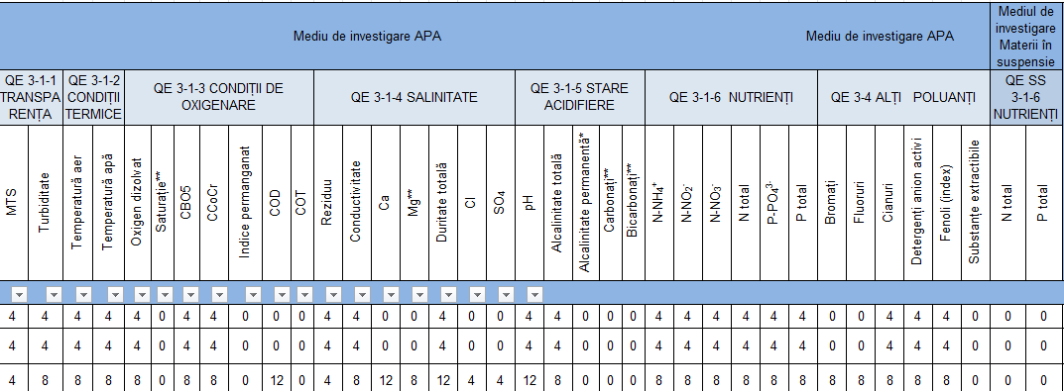
A.2. Sample of Template for Rivers – Metals Indicators

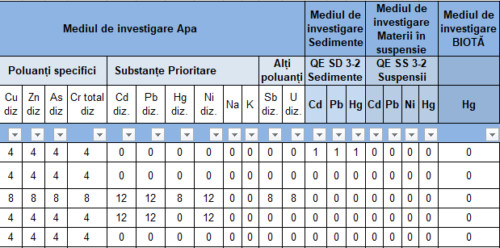
A.3. Sample of Template for Rivers – Micropollutants Indicators

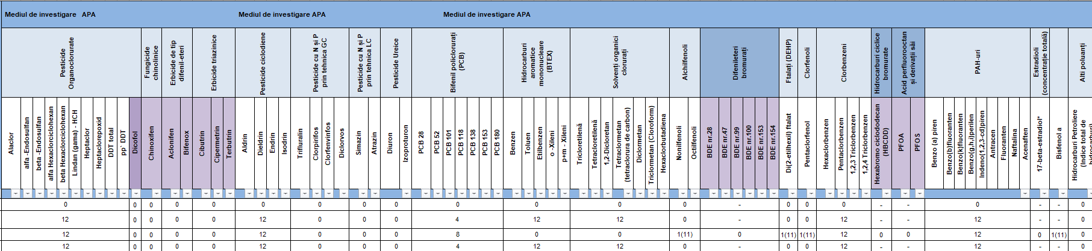

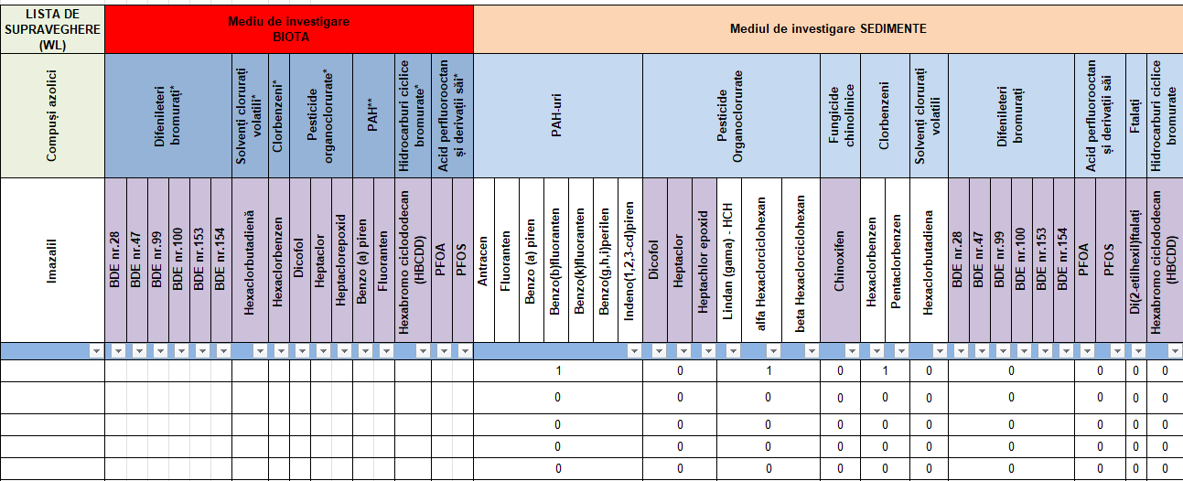

A.4. Sample of Template for Rivers – Biological Indicators

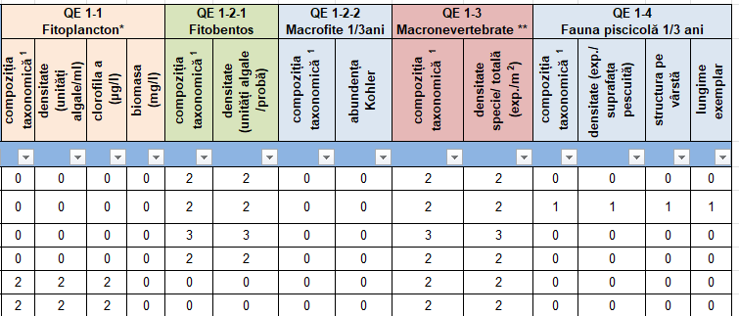
(B) Lakes Subsystem All below templates samples include general information about Lakes, as detailed in the table below, about the sections assigned to each NARW Laboratory Unit. These sections will be prefilled upon display or download based on the selected laboratory unit.
Column Name | Column Type | Column  value sample | Data source / Notes
Nr. corp | Number | 1 | System
Nr. crt. | Number | 1 | System
Denumire corp de apă | String | Gut -Ac.Rovina | Master Data Water Body Catalog
Codul corpului de apă | String | ROLW3-1-37_B2 | Master Data Water Body Catalog
Denumire curs de apă | String | Gut | Master Data Water Course Catalog
Nume lac | String | Rovina | Master Data Lakes Catalog
Tipologie | String | ROLA01 | Master Data Water Body Catalog
Nume secțiune | String | Rovina - mijloc | Master Data Sections Catalog
Codul secțiune | Decimal | 119.6 | Master Data Sections Catalog
Tip program | String (1 char) | S | Master Data Program Types Catalog  (could be S, O, S1, P or Null)
Zone protejate | String (1 char) | P | True/False, if true then Protected Area
Altele | String | P, EIONET | Multiple values allowed
Laborator executant | String | ABAC | Select from Master Data NARW Units Catalog, allow to add new entry (external 3rd party)

B.1. Sample of Template for Lakes - General Physico-Chemical Indicators
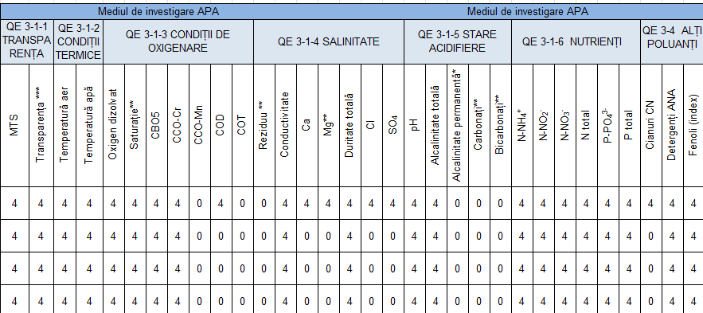

B.2. Sample of Template for Lakes – Metals Indicators 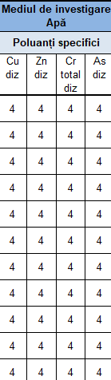
B.3. Sample of Template for Lakes – Biological Indicators

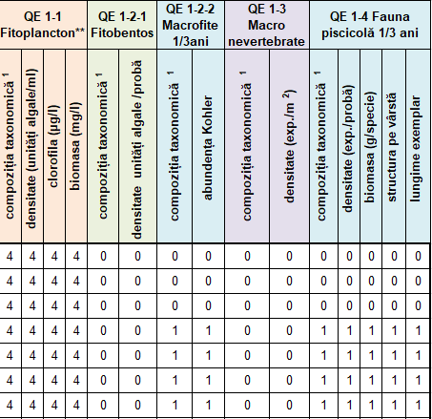

(C) Underground Waters Subsystem All below templates samples include general information about underground waters, as detailed in the table below, about the sections assigned to each NARW Laboratory Unit. These sections will be prefilled upon display or download based on the selected laboratory unit.
Column Name | Column Type | Column  value sample | Data source / Notes
Nr. crt | Number | 1 | System
Denumire foraj | String | Căuaş | System
Ind. for./ord | String | F3 | Master Data Rivers Catalog
Denumire corp de apă | String | Oradea - Câmpia de Vest | Master Data Water Body Catalog
Cod foraj | String | RO035263846046 | Master Data Water Body Catalog
Corpul de apă subterană | String | ROCR01 | Master Data Water Body Catalog
Județ | String | HD | Master Data Counties Catalogs
Tip program  secțiunii | String | O; E;CI; | Multiple selection allowed prefill from Master Data Program Type Catalog
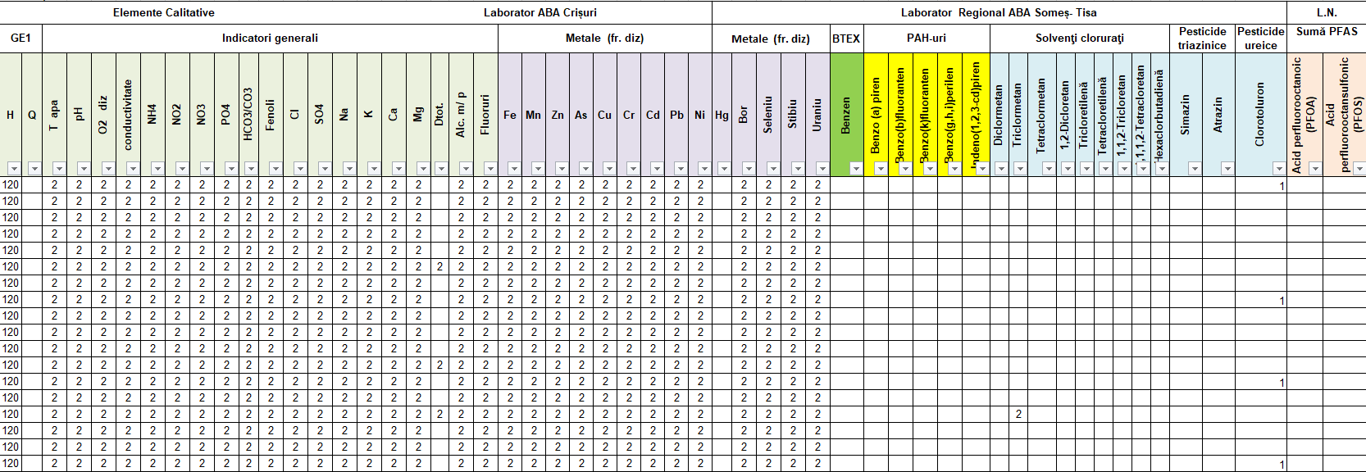
The above sample collects all underwaters indicators for all laboratories units of ABA.
(D) Waste Waters Subsystem All below templates samples include general information about wastewater, as detailed in the table below, about the sections assigned to each NARW Laboratory Unit. These sections will be prefilled upon display or download based on the selected laboratory unit.
Column Name | Column Type | Column  value sample | Data source / Notes
Nr. crt | Number | 1 | System
Agenți economici autorizați pt evacuare în emisar | String | C.N. C.A.F. MINVEST SA DEVA FILIALA BRADMIN SA | Master Data “Authorized Economical agents” Catalog
Nume evacuare | String | Ev. Exploatarea miniera Brad | Manual entry is permitted if not available in the catalog
Județ evacuare | String | HD | Master Data Counties Catalogs
Tip apă uzată | String | Ape de mina | Multiple selection allowed prefill from Master Data Wastewater Type Catalog
Tip unitate | String | NON-IED | Master Data Catalogs

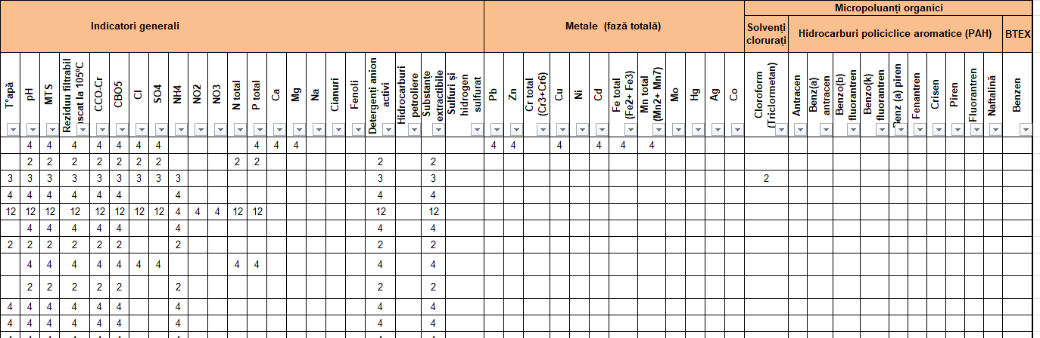
- Sample from ABA Siret

- Surface water (A)
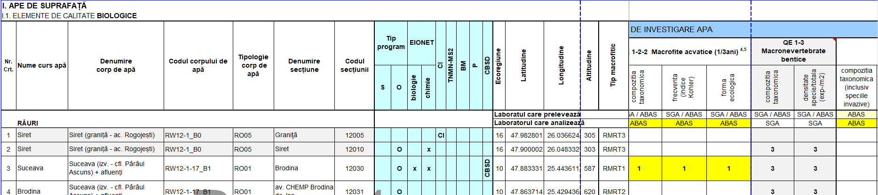
Biological indicators (with INVESTIGATION MEDIUM: WATER)

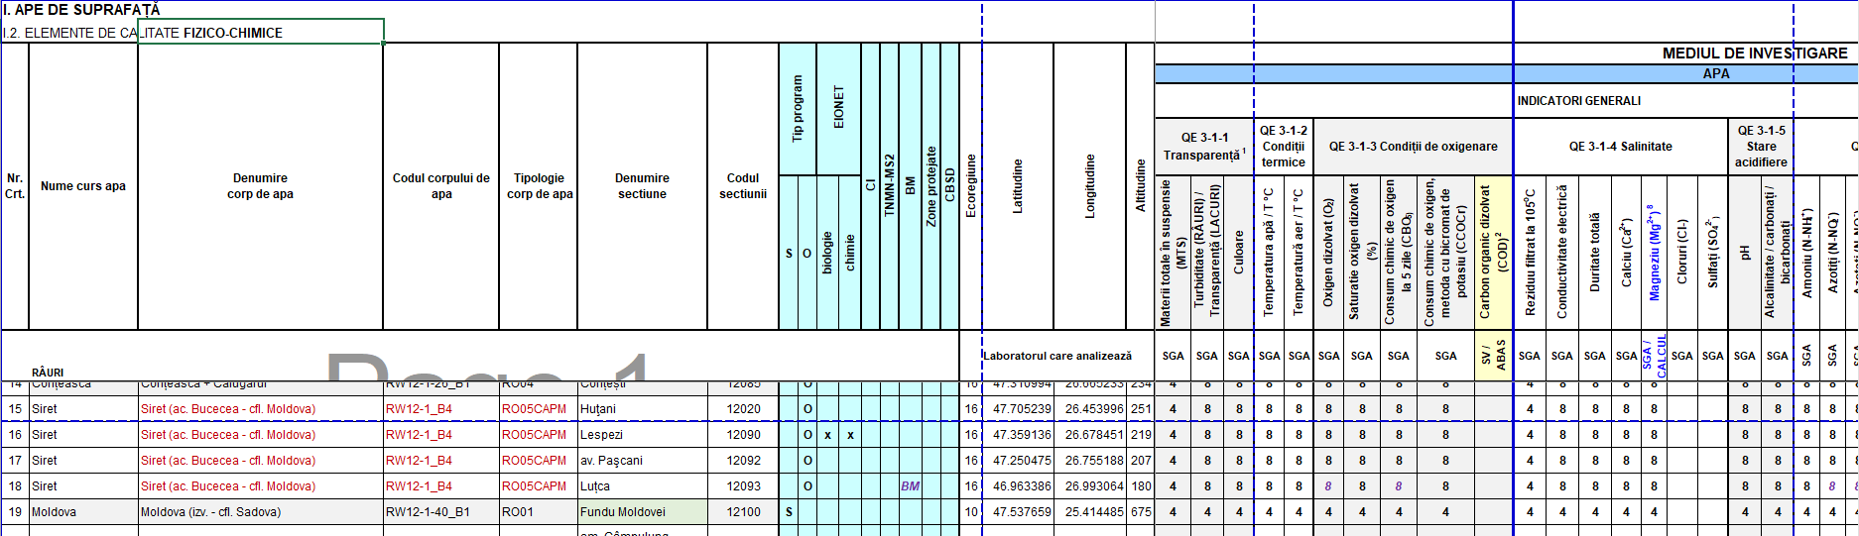
Physico-chemical indicators (with INVESTIGATION MEDIUM: WATER)

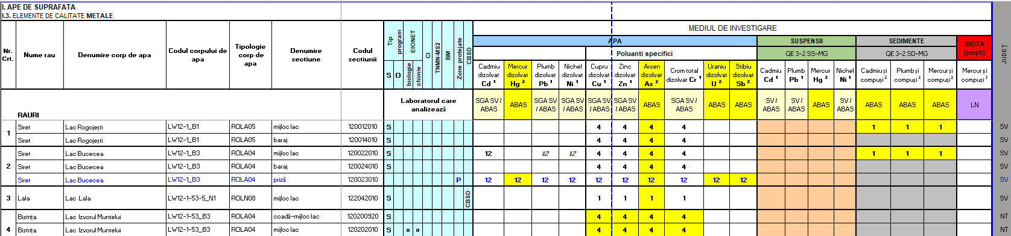
Heavy metals indicators for WATER, SEDIMENTS, SUSPENDED SOLIDS
Organic micropollutant indicators for WATER, SEDIMENTS, BIOTA

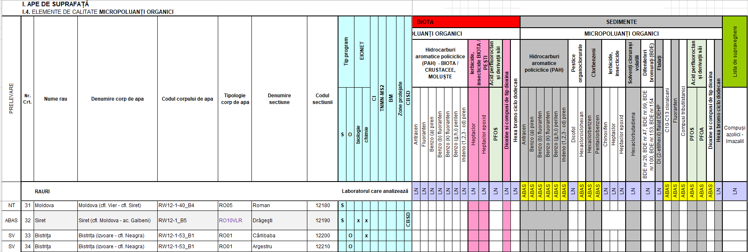

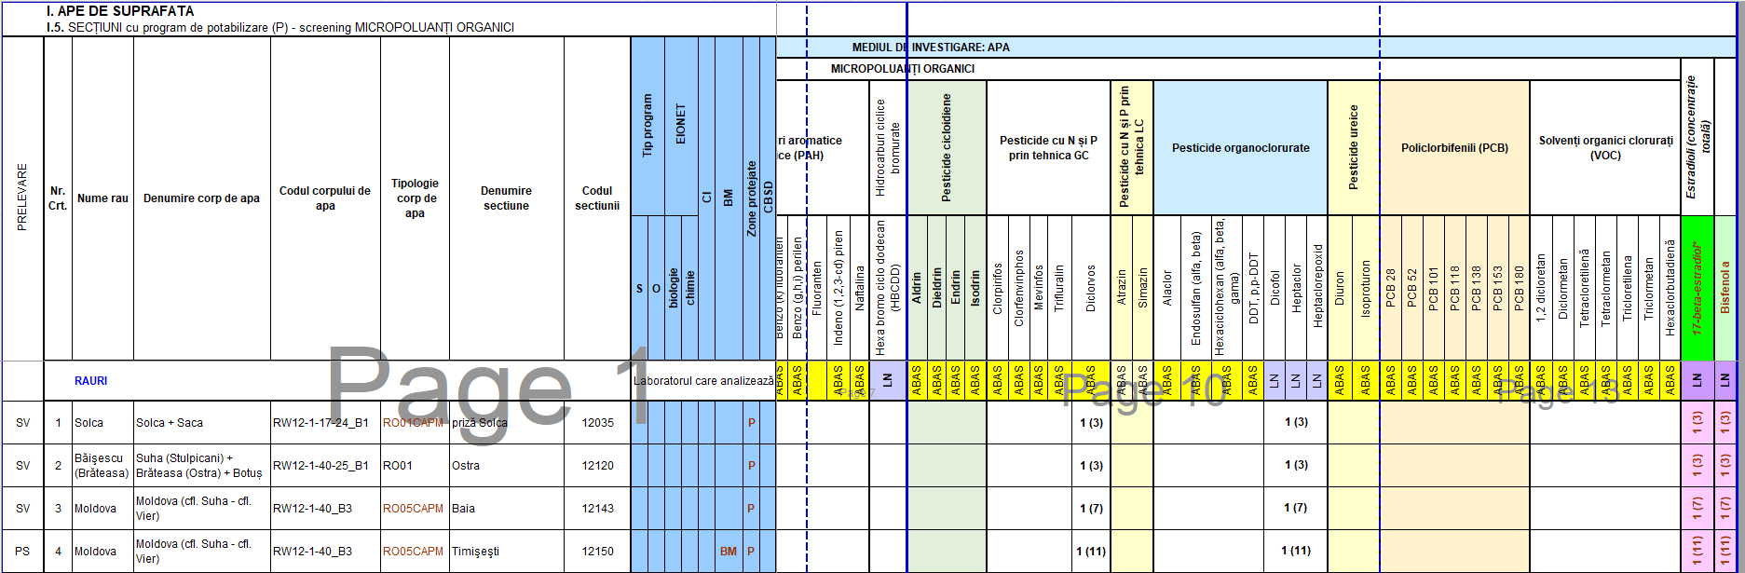
Organic micropollutant indicators for Sections with Drinking Water Treatment

- Groundwater
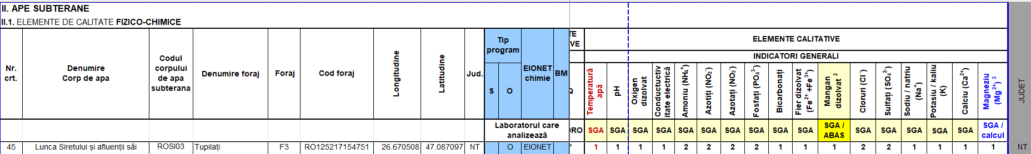
Physico-chemical indicators

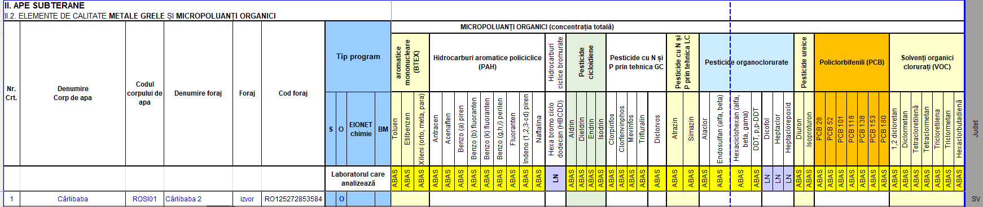
Heavy metals indicators & Organic micropollutant indicators

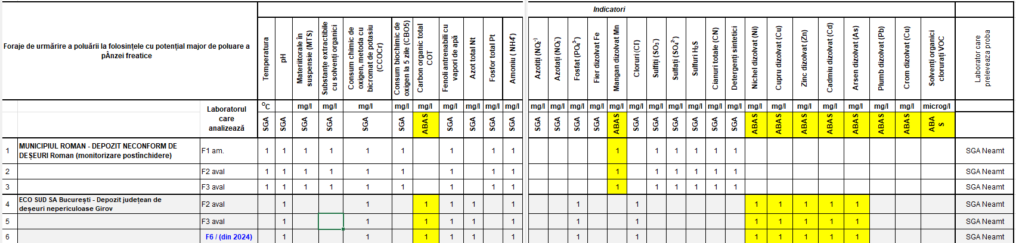
Waste Deposits
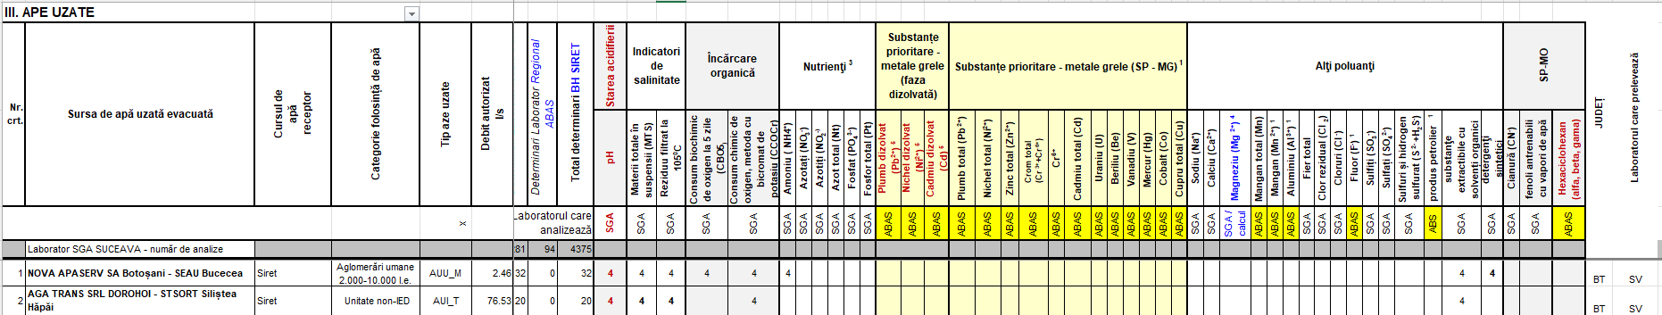
- Wastewaters

Annex 3

NARW Laboratory Equipment

ABA | SGA | Location | Manufacturer | Equipment Description | Equipment Model | Installed Software | Results Output format  (*.*.csv / *.*.pdf / *.xls / display)
ABA Siret | Bacau | SEDIU 1 (Bogdan Nicolae Lascar) | Shimadzu Handelsgesellschaft mbH | Gaz cromatograf cu dublu spectrometru de masa (sistem triplu quadrupol) (GC-MS-MS) | GCMS-TQ 8050 NX | LabSolution GC | DISPLAY
ABA Siret | Bacau | SEDIU 1 (Bogdan Nicolae Lascar) | Shimadzu Handelsgesellschaft mbH | Gaz cromatograf (GC) cu detectori modulari (GC-ECD) | Nexis - 2030 | LabSolution GC | DISPLAY
ABA Siret | Bacau | SEDIU 1 (Bogdan Nicolae Lascar) | Shimadzu Handelsgesellschaft mbH | Gaz cromatograf cuplat cu spectrometru de masa (GC-MS) | Nexis GC 2030 | LabSolution GC | DISPLAY
ABA Siret | Bacau | SEDIU 1 (Bogdan Nicolae Lascar) | Shimadzu Handelsgesellschaft mbH | Lichid cromatograf de presiune ultrainalta (UHPLC) | Nexera LC 40 X3 | LabSolution LCMS | DISPLAY
ABA Siret | Bacau | SEDIU 1 (Bogdan Nicolae Lascar) | Shimadzu Handelsgesellschaft mbH | Lichid cromatograf de inalta presiune cu detector DAD si detector de fluorescenta (HPLC-FLD/DAD) | Nexera LC 40 XR | LabSolution | DISPLAY
ABA Siret | Bacau | SEDIU 1 (Bogdan Nicolae Lascar) | Shimadzu Handelsgesellschaft mbH | Lichid cromatograf cu dublu spectrometru de masa (sistem triplu quadrupol) (LC-MS-MS) | LCMS 8050 | LabSolution LCMS | DISPLAY
ABA Siret | Bacau | SEDIU 1 (Bogdan Nicolae Lascar) | Altium International S.R.L. | Spectrometru de absorbtie atomica (AAS) | DUO 280FS/280Z | Spectr AA | DISPLAY
ABA Siret | Bacau | SEDIU 1 (Bogdan Nicolae Lascar) | Altium International S.R.L. | Spectrometru de masa cu plasma cuplata inductiv (ICP-MS) | 7900 | ICPMS MassHunter | DISPLAY
ABA Siret | Bacau | SEDIU 1 (Bogdan Nicolae Lascar) | S.C. Analytik Jena Roamania SRL | Analizor Hg cu autosampler | Mercur DUO Plus | WinAAS WinAAS Technique: Mercur | DISPLAY
ABA Siret | Bacau | SEDIU 1 (Bogdan Nicolae Lascar) | Analytik Jena AG | Analizor TOC / TN (Multi N/C3100) | (Multi N/C3100) | multiWin pro Software multiWin 4.05-Serial No: N3-147/I | CSV , PDF , DISPLAY
ABA Siret | Bacau | SEDIU 1 (Bogdan Nicolae Lascar) | Shimadzu Corp | Gaz-cromatograf cu detector de ionizare în flacără (FID) şi detector cu captură de electroni (ECD) şi autosampler AOC-20i | GC-2010 | LabSolution- GC Solution/Versiune 2.3 upgrade 2.44 | DISPLAY
ABA Siret | Bacau | SEDIU 1 (Bogdan Nicolae Lascar) | Shimadzu Corp | Gaz-cromatograf cu detector de ionizare în flacără (FID) şi detector cu captură de electroni (ECD)/ 2 şi autosampler HT200H (headspace) | GC-2010 | LabSolution/Versiune 5.97 SP1 | DISPLAY
ABA Siret | Bacau | SEDIU 1 (Bogdan Nicolae Lascar) | Shimadzu Corp | Gaz-cromatograf cu detector azot-fosfor (FTD) şi detector cu captură de electroni (ECD) şi autosampler AOC-20i | GC-2010 | LabSolution/Versiune 5.97 SP1 | DISPLAY
ABA Siret | Bacau | SEDIU 1 (Bogdan Nicolae Lascar) | Shimadzu Corp | Gaz-cromatograf cu detector de ionizare în flacără (FID) | GC-2030 | LabSolution Single GC/Versiune 5.92 | DISPLAY
ABA Siret | Bacau | SEDIU 1 (Bogdan Nicolae Lascar) | Shimadzu Corp | Gaz-cromatograf cu detector azot-fosfor (NPD) | GC-2030 | LabSolution Single GC/Versiune 5.93 | DISPLAY
ABA Siret | Bacau | SEDIU 1 (Bogdan Nicolae Lascar) | Agilent Technologies | Gaz-cromatograf (GC-2017) cu detector de ionizare în flacără (FID) | INTUVO 9000 | LabSolution Single GC/Versiune 5.93 | DISPLAY
ABA Siret | Bacau | SEDIU 2 (Cuza-Voda) | OLYMPUS | Invertoscop OLYMPUS / T5-8J13380 | IX 51 | OpenLab CDS System OpenLab CDS CHEMSTATION C 01.07 SR3 | DISPLAY
ABA Siret | Bacau | SEDIU 1 (Bogdan Nicolae Lascar) | Shimadzu Corp | Lichid cromatograf cu detector câmp de diode (DAD) şi detector de fluorescenţă (FLD) / serie şi autosampler Shimadzu CTO-20AC | LC-20AD | Olympus CellSense | DISPLAY
ABA Siret | Bacau | SEDIU 1 (Bogdan Nicolae Lascar) | Shimadzu Corp | Lichid cromatograf cu detector câmp de diode (DAD) şi detector de fluorescenţă (FLD) şi autosampler Shimadzu CTO-20AC | LC-20AD | LC Solution/Versiune 5.97 SP1 | DISPLAY
ABA Siret | Bacau | SEDIU 2 (Cuza-Voda) | OLYMPUS | Microscop OLYMPUS | BX 43 | LC Solution/Versiune 5.97 SP1 | DISPLAY
ABA Siret | Bacau | SEDIU 2 (Cuza-Voda) | OLYMPUS | Microscop OLYMPUS | CX 31 | Olympus CellSense | DISPLAY
ABA Siret | Bacau | SEDIU 2 (Cuza-Voda) | Analytik Jena AG | Spectrofotometru UV/VIS | SPECORD 200 | Olympus CellSense | Excel , DISPLAY
ABA Siret | Bacau | SEDIU 2 (Cuza-Voda) | Shimadzu | Spectrofotometru UV/VIS | UV 1900i | ASpect UV Winaspect versiunea 2.2.7.0 | CSV, DISPLAY
ABA Siret | Bacau | SEDIU 1 (Bogdan Nicolae Lascar) | Analytik Jena AG | Spectrofotometru de absorbţie atomică | Zeenit 700 | LabSolutions UV-Vis software (standard) | PDF, DISPLAY
ABA Siret | Bacau | SEDIU 1 (Bogdan Nicolae Lascar) | Analytik Jena AG | Spectrofotometru de fluorescenţă atomică (Hg) | Mercur Plus | ASpect LS WinAAS Ver: 4.7.7.0 | PDF, DISPLAY
ABA Siret | Bacau | SEDIU 1 (Bogdan Nicolae Lascar) | Agilent Technologies | Spectrofotometru de masa cu plasmă inductivă | 7500cxICP-MS | WinAAS WinAAS Technique: MercurVersion3.22.0 | PDF, DISPLAY
ABA Siret | Bacau | SEDIU 2 (Cuza-Voda) | OLYMPUS | Stereomicroscop OLYMPUS | SZ61 | CHEMSTATIONATION V. B 03.07 | Excel , DISPLAY
ABA Siret | Suceava | Suceava | Schimatzu | Analizor Carbon organic Total | TOC-LCPH FA | nume: Stream Start.Ink ; descriere: XV Image Processing Olympus CellSense | PDF, DISPLAY
ABA Siret | Suceava | Suceava | Analytik Jena GmbH | Spectrofotometru cu absorbíe atomica | AAS VARIO 6 | WINAAS ver.4.7.7 | DISPLAY
ABA Siret | Suceava | Suceava |  | Spectrofotometru cu absorbíe atomica
ABA Siret | Suceava | Suceava | Analytik Jena GmbH | Spectrofotometru UV VIS | SPECORD 200 | ASpect UV Winaspect versiunea 2.2.7.0
ABA Siret | Suceava | Suceava | SHIMADZU GERMANIA | Spectrofotometru UV VIS | UV 1800 | UV Probe, model LabSolutions UV-Vis SOFT UV PROBE 2.62 | PDF, DISPLAY
ABA Siret | Suceava | Suceava | SHIMADZU GERMANIA | Spectrofotometru UV VIS | UV 1800 | UV Probe, model LabSolutions UV-Vis SOFT UV PROBE 2.52 | PDF, DISPLAY
ABA Siret | Focșani | Focșani | SHIMADZU Corp. Japonia | Spectrofotometru UV VIS | UV 1800 | UV Probe, model LabSolutions UV-Vis | PDF, DISPLAY
ABA Siret | Focșani | Focșani | OLYMPUS OPTICAL CO. | Microscop | CX3RBSF | Olympus CellSense Entry 4.2 | DISPLAY
ABA Siret | Focșani | Focșani | OLYMPUS OPTICAL CO. | Stereomicroscop | SZX2-FO | Olympus CellSense Entry 4.2 | DISPLAY
ABA Siret | Focșani | Focșani | OLYMPUS OPTICAL CO. | Microscop inversat | CKX53SF-1-3 | Olympus CellSense Entry 4.2 | DISPLAY
ABA Siret | Focșani | Focșani | OLYMPUS OPTICAL CO. | Camera digitala cu adaptor pentru microscop OLYMPUS | DP 28 | Olympus CellSense Entry 4.2 | DISPLAY
ABA Siret | Focșani | Focșani | SHIMADZU Corp. Japonia | Spectrofotometru UV VIS | UV 1900 | UV Probe, model LabSolutions UV-Vis | PDF, DISPLAY
ABA Siret | Focșani | Focșani | S.C. Analytik Jena Roamania SRL | Analizor Carbon Organic Total | Multi N/C 3100 | multiWin pro Software | CSV , PDF , DISPLAY
ABA Siret | Piatra Neamț | Piatra Neamț | ANALYTIK JENA GERMANIA | Spectrofotometru UV VIS | specord 205 | WinASPECT, versiunea: 2.2.1.0 | CSV , PDF , DISPLAY
ABA Siret | Piatra Neamț | Piatra Neamț | SHIMADZU JAPONIA | Spectrofotometru UV VIS | UV 1800 | UVProbe, versiunea: 2.71 | CSV , PDF , DISPLAY
ABA Siret | Piatra Neamț | Piatra Neamț | SHIMADZU JAPONIA | Spectrofotometru UV VIS | 1900i | UVProbe, versiunea: 2.70 | CSV , PDF , DISPLAY
ABA Siret | Piatra Neamț | Piatra Neamț | CARL ZEIZZ GERMANIA | Microscop | Full-Köhler- Primostar 3+ camera: Axiocam 208 color | ZEN 3.0 | PDF, DISPLAY
ABA Siret | Piatra Neamț | Piatra Neamț | S.C. Analytik Jena Roamania SRL | Analizor Carbon Organic Total | Multi N/C 3100 | multiWin pro Software | CSV , PDF , DISPLAY
ANAR | Laborator Național | București | Shimadzu | Gaz-cromatograf cu injecție lichida | GC 2010 | GC Solution v. 2.44 | display
ANAR | Laborator Național | București | Shimadzu | Gaz-cromatograf MS-QP 2010 PLUS | GC 2010 MS QP2010 PLUS | GC Solution v. 2.44 | display
ANAR | Laborator Național | București | Agilent Technologies | GC CU DETECTOR MS-MS, GC-MS QTOF | 7200B | MASSHUNTER DATA ACQUISITION | *.csv , display
ANAR | Laborator Național | București | Shimadzu | Gaz-cromatograf MS-QP 2020 | GC 2010 MS QP2020 PLUS | GC Solution v. 2.44 | display
ANAR | Laborator Național | București | Shimadzu | Gaz-cromatograf cu injecție tip HS | GC 2010 | GC Solution v. 2.44 | display
ANAR | Laborator Național | București | Shimadzu | Gaz-cromatograf cu injecție tip HS | GC 2010 | GC Solution v. 2.44 | display
ANAR | Laborator Național | București | Agilent Technologies | Gaz-cromatograf cu injecție lichida | 7890B | OpenLab Chermstation v 2015 | *.xls , display
ANAR | Laborator Național | București | Shimadzu | Gaz-cromatograf cu injecție lichida | GC 2010 | GC Solution v. 2.44 | display
ANAR | Laborator Național | București | Shimadzu | Lichid-cromatograf de înaltă presiune | Prominence | LC SOLUTION V1,25 | display
ANAR | Laborator Național | București | Shimadzu | Lichid-cromatograf de înaltă presiune | Prominence | LC SOLUTION V1,25 | display
ANAR | Laborator Național | București | Agilent Technologies | Lichid-cromatograf | 6460 | MASSHUNTER DATA ACQUISITION | *.csv , display
ANAR | Laborator Național | București | Analytik Jena AG | Analizor de Hg din lichide | Mercur Plus | WinAAS | *.pdf, display
ANAR | Laborator Național | București | Milestone | Analizor de Hg din solide prin tehnica DMA | DMA 80 Tricell | DMA 80 | display
ANAR | Laborator Național | București | Agilent Technologies | Spectrometru de masă cu plasmă cuplată inductiv | 7500cx | CHEMSTATION | display
ANAR | Laborator Național | București | Agilent Technologies | Gaz-cromatograf cu injecție lichida | GC 7890B | OpenLab Chermstation v 2015 | *.xls , display
ANAR | Laborator Național | București | Agilent Technologies | Lichid-cromatograf de ultra-înaltă presiune | 1290 Infinity LC | MASSHUNTER DATA ACQUISITION | *.csv , display
ANAR | Laborator Național | București | Shimadzu | Gaz-cromatograf cu injecție lichida | QP 2010 | GC Solution v. 2.44 | display
ANAR | Laborator Național | București | Shimadzu | Gaz-cromatograf MS 2030 | GC 2030 | GC Solution v. 2.45 | display
ANAR | Laborator Național | București | Analytik Jena AG | Analizor de Hg din lichide | Mercur Plus | WinAAS | *.pdf, display
ABA JIU | Craiova | Craiova | c | Spectrofotometru UV-VIS | UV-1800 | UVProbe 2.42 | *.pdf, display
ABA JIU | Craiova | Craiova | Shimadzu | Spectrofotometru UV-VIS | UV-1800 | UVProbe 2.33 | *.pdf, display
ABA JIU | Craiova | Craiova | Shimadzu | Spectrofotometru UV-VIS | UV-1800 | UVProbe 2.43 | *.pdf, display
ABA JIU | Craiova | Craiova | Shimadzu | Analizor TOC/TN şi autosampler ASI-V | TOC-V_{CPN} / TNM-1 | TOC-Control V Ver. 2.30 | *.csv, display
ABA JIU | Craiova | Craiova | Analytik Jena AG | Spectrofotometru de absorbţie atomică | ZEEnit 700P | ASpect LS 1.5.3.0 | *.pdf, display
ABA JIU | Craiova | Craiova | Leica Microsystems | Invertoscop | DMi 8 | Leica Application Suite X 3.0.3.16319 | display
ABA JIU | Craiova | Craiova | Leica Microsystems | Invertoscop | M165 C | Leica Application Suite X 3.0.1423224 | display
ABA JIU | Gorj | Targu Jiu | Shimadzu | Spectrofotometru UV-VIS | UV-1800 | UVProbe version 2.71 | *.pdf, display
ABA JIU | Gorj | Targu Jiu | Shimadzu | Spectrofotometru UV-VIS | UV-1800 | UVProbe version 2.71 | *.pdf, display
ABA JIU | Gorj | Targu Jiu | Shimadzu | Spectrofotometru UV-VIS | UV-1900 | UVProbe version 2.71 | *.pdf, display
ABA JIU | Gorj | Targu Jiu | Leica Microsystems | Microscop | DM3000 LED | Leica Application Suite X version 3.0.3.16319 | display
ABA JIU | Mehedinți | DR.Tr.Severin | Analytik Jena AG | Spectrofotometru de absorbţie atomică | ZEEnit 700 P | ASpect LS 1.5.3.0 | *.pdf, display
ABA JIU | Mehedinți | DR.Tr.Severin | LEEMAN LAB INC | Analizor de Hg | Hydra AF | WIN Hg Runner 1.7 | display
ABA JIU | Mehedinți | DR.Tr.Severin | Shimadzu | Spectrofotometru UV-VIS | UV-1900 | UVProbe version 2.7 | *.pdf, display
ABA JIU | Mehedinți | DR.Tr.Severin | Shimadzu | Spectrofotometru UV-VIS | UV-1900 | UVProbe version 2.7 | *.pdf, display
ABA Prut - Bârlad | Botoșani | Botoșani | SHIMADZU JAPONIA | Spectrofotometru UV VIS | UV 1800 | UV Probe, model LabSolutions UV-Vis SOFT UV PROBE 2.70 | *.pdf, *.xls, display
ABA Prut - Bârlad | Botoșani | Botoșani | SHIMADZU JAPONIA | Spectrofotometru UV VIS | UV 1800 | UV Probe, model LabSolutions UV-Vis SOFT UV PROBE 2.70 | *.pdf, *.xls, display
ABA Prut - Bârlad | Iași | Iași | ANALYTIK JENA | Spectrofotometru UV VIS | Specord 200 Plus | WinAspect Plus Vs. 4.2.0.0 | *.pdf, *.xls, display
ABA Prut - Bârlad | Iași | Iași | SHIMADZU | Spectrofotometru UV VIS | UV 1800 | UV Probe, Vs. 2.33 | *.pdf, *.xls, display
ABA Prut - Bârlad | Iași | Iași | SHIMADZU | Analizor Carbon organic Total /Azot total | TOC-VCPN | TOC-Control V, Vs. 2.50 | *.pdf, *.xls, display
ABA Prut - Bârlad | Iași | Iași | ANALYTIK JENA | Spectrofotometru cu absorbtie atomica | ZeeNit 700P | ASpect LS, Vs: 1.7.2.0 | *.pdf, *.xls, display
ABA Prut - Bârlad | Iași | Iași | ANALYTIK JENA | Spectrofotometru cu absorbtie atomica | ContrAA 700 | ASpect CS, Vs: 2.2.2.0 | *.pdf, *.xls, display
ABA Prut - Bârlad | Iași | Iași | SHIMADZU | Spectrofotometru cu absorbtie atomica | AA 6300 | WizAArd Vs: 4.20 | *.pdf, *.xls, display
ABA Prut - Bârlad | Iași | Iași | ANALYTIK JENA | Analizor mercur | Mercur | Win AAS, Vs. 4.7.9.0 | *.pdf, *.xls, display
ABA Prut - Bârlad | Iași | Iași | AGILENT Scientific | Gaz cormatograf-HS-MS cu detector de ionizare în flacără (FID) | GC 6890N-HS 7697A - MS 5973 Inert | GC Chem Station, Rev. B 04.036 [16] | *.pdf, *.xls, display
ABA Prut - Bârlad | Iași | Iași | AGILENT Scientific | Gaz cormatograf-MS cu detector cu captură de electroni (ECD)/detector azot-fosfor (NPD) | GC 7890B - MS 5977B | Mass Hunter Workstation Software, Vs. B.07.05 | *.pdf, *.xls, display
ABA Prut - Bârlad | Vaslui | Vaslui | SHIMADZU | Spectrofotometru UV VIS | UV 1800 | UV Probe, model LabSolutions UV-Vis, Soft UV Probe, Vs. 2.33 | *.pdf, *.xls, display
ABA Prut - Bârlad | Vaslui | Vaslui | SHIMADZU | Spectrofotometru UV VIS | UV 1900 | UV Probe, model LabSolutions UV-Vis, Soft UV Probe, Vs. 2.70 | *.pdf, *.xls, display
ABA Prut - Bârlad | Vaslui | Vaslui | SHIMADZU | Analizor Carbon organic Total /Azot total | TOC-LCPH FA | TOC-Control L, Vs. 1.09 | *.pdf, *.xls, display
ABA Prut - Bârlad | Galați | Galați | SHIMADZU JAPONIA | Spectrofotometru UV VIS | 1900i | UVProbe, Vs. 2.70 | *.pdf, *.xls, display
ABA Prut - Bârlad | Galați | Galați | Analytik Jena GmbH | Spectrofotometru UV VIS | SPECORD 200 PLUS | ASpect UV Winaspect, Vs. 4.2.0.0 | *.pdf, *.xls, display
ABA Argeș-Vedea | Pitești | Pitești | Shimadzu | Analizor TOC-L CPH/ TNM-L ROHS | TOC-L CPH/ CPN | TOC-L Sample Table Editor | .tlx / print / display
ABA Argeș-Vedea | Pitesti | Pitesti | Shimadzu | Spectrofotometru UV-VIS | 1900i | UV Probe, versiunea 2.70 | .pho / print / display
ABA Argeș-Vedea | Pitești | Pitești | Shimadzu | Spectrofotometru UV-VIS | 1800 | UV Probe, versiunea 2.33 | .pho / print / display
ABA Argeș-Vedea | Pitesti | Pitesti | Analytik Jena AG | Spectrofotometru UV-VIS | SPECORD 202 | WinASPECT, versiunea 2.2.7.0 | .coc / print / display
ABA Argeș-Vedea | Pitesti | Pitesti |  | Spectrofotometru UV-VIS
ABA Argeș-Vedea | Pitești | Pitești | Shimadzu | Spectrofotometru cu absorbție atomică | AA-6300 | WizAArd, versiunea 4.0 | .aa / print / display
ABA Argeș-Vedea | Pitești | Pitești | ATI UNICAM | Spectrofotometru cu absorbție atomică | SOLAAR S4 GFS 97 | SOLAAR Thermo, versiunea 10.02 | .srl / print / display
ABA Argeș-Vedea | Pitești | Pitești | LEICA | MICROSCOP | DM 3000 LED | LAS X, Leica Aplication Suite X versiunea 3.0.3.16319 | display
ABA Argeș-Vedea | Pitești | Pitești | LEICA | MICROSCOP INVERSAT CU CAMERA DIGITALA | DML LED | LAS Core Version 4.0. Leica Microsystems | display
ABA Argeș-Vedea | Giurgiu | Giurgiu | SHIMADZU | Spectrofotometru UV-VIS | UV 1900i | UV Probe, versiunea 2.71 | .pho / print / display
ABA Argeș-Vedea | Giurgiu | Giurgiu | ANALYTIK JENA | Spectrofotometru UV-VIS | specord 200 PLUS | WinASPECT PLUS | .coc / print / display
ABA Argeș-Vedea | Giurgiu | Giurgiu | ANALYTIK JENA | Analizor TOC / TN | Multi N/C3100
ABA Argeș-Vedea | Giurgiu | Giurgiu | OLYMPUS CO. | Microscop | CX41 | Olympus CellSense | display
ABA Argeș-Vedea | Giurgiu | Giurgiu | OLYMPUS CO. | Microscop inversat | CKX41 | Olympus CellSense | display
ABA Argeș-Vedea | Teleorman | Alexandria | SHIMADZU | Spectrofotometru UV-VIS | 1900i | UV Probe, versiunea 2.70 | .pho / print / display
ABA Argeș-Vedea | Teleorman | Alexandria | Analytik Jena | Spectrofotometru UV-VIS | SPECORD 200 | ASpect UV Winaspect versiunea 2.2.7.0 | .coc / print / display
ABA Argeș-Vedea | Teleorman | Alexandria | Analytik Jena | Analizor TOC / TN | Multi N/C3100
ABA Argeș-Vedea | Teleorman | Alexandria | LEICA | Microscop inversat cu cameră digitală | DMIL LED | LAS v4.12 | TIF
ABA Argeș-Vedea | Ilfov - București | București | Thermo Electron LED | Multiparametru de laborator/ Thermo Versa Star | VSTAR92 | Thermo Electron LED | .coc / print / display
ABA Argeș-Vedea | Ilfov - București | București | Analytik Jena AG | Spectrofotometru UV-VIS | SPECORD 200 | WinASPECT, versiunea: 2.2.7.0 | .coc / print / display
ABA Argeș-Vedea | Ilfov - București | București | Analytik Jena AG | Spectrofotometru UV-VIS | SPECORD 200 PLUS | WinASPECT, versiunea: 4.2.0.0 | .coc / print / display
 | Ilfov - București | București | Analytik Jena AG | Spectrofotometru UV-VIS (NOU)
ABA Argeș-Vedea | Ilfov - București | București | Analytik Jena AG | Spectrofotometru de absorbție atomică | Zeenit 700 | ASpect LS WinAAS Ver: 4.7.6.0 | .*.pdf / print / display
ABA Argeș-Vedea | Ilfov - București | București | Analytik Jena AG | Spectrofotometru de absorbție atomică | Zeenit 700P | ASpect LS WinAAS Ver: 1.5.3.0 | .*.pdf / print / display
ABA Argeș-Vedea | Ilfov - București | București |  | Spectrofotometru de absorbție atomică
ABA Argeș-Vedea | Ilfov - București | București | Analytik Jena AG | Analizor TOC / TN | Multi N/C3100 | multiWin pro Software multiWin 4.09 | .ajd / print / display
ABA Argeș-Vedea | Ilfov - București | București | LEICA MICROSYSTEMS CMS | Microscop | DMi8 | LASX.ink | .jpg / display
ABA Argeș-Vedea | Ilfov - București | București | OLYMPUS OPTICAL CO. | Stereomicroscop | SZX10 | Olympus CellSense Entry 2.2 | .jpg / display
ABA Banat | Timisoara | Timisoara | Shimadzu Corp | Gaz-cromatograf SHIMADZU NEXIX GC 20230 detector ( FID ) ionizare in flacara autosampler AOC- 30i | GC-2010 | LabSolution Ink | *.pdf, display
ABA Banat | Timisoara | Timisoara | Laboratorium | Analizor de azot, carbon organic total | Formacs Skalar | HT-Access version 3.09.1 Release | *.pdf, display
ABA Banat | Timisoara | Timisoara | SHIMADZU Corp. Japonia | Spectrofotometru UV VIS | UV 1900 | UV Probe 2.70 | *.pdf, display
ABA Banat | Timisoara | Timisoara | SHIMADZU Corp. Japonia | Spectrofotometru UV VIS | UV 1800 | UV Probe 2.33 | *.pdf, display
ABA Banat | Timisoara | Timisoara | Analytik Jena AG | Spectrofotometru UV/VIS | SPECORD 200 | ASpect UV Winaspect versiunea 2.2.7.11 | *.xls , display
ABA Banat | Timisoara | Timisoara | Analytik Jena AG | Analizor de Hg din lichide | Mercur Plus | WinAAS | *.pdf, display
ABA Banat | Timisoara | Timisoara | Agilent Technologies | Spectrofotometru de absorbtie atomica | Duo 280FS+280 Z | Spectr AA 5.5 | *.pdf, display
ABA Banat | Timisoara | Timisoara | Leica | Invertoscop -Leica Microsystems | DMi8 manual | LAS V4.12 | display
ABA Banat | Timisoara | Timisoara | Zeiss | Microscop- Carl Zeiss Microscopy | Axio Scope. A1 | ZEN 2.6 lite(blue edition) | display
ABA Banat | Timisoara | Timisoara | Leica | Stereomicroscop -Leica Microsystems | S8Apo Stereozoom1.0x8.0x | LAS V4.12 | display
ABA Banat | Timisoara | Timisoara | Zeiss | Stereomicroscop-Carl Zeiss Microscopy | Discovery V8 | ZEN 2012 blue edition | display
ABA Banat | Timisoara | Timisoara | Hach Lange GmbH | Spectrofotometru UV/VIS | DR 3900 | LZV791 | *.*.csv, *.txt , display
ABA Banat | Caras-Severin | Resita | Analytik Jena AG | Spectrofotometru UV/VIS | SPECORD 200 | ASpect UV Winaspect versiunea 2.2.7.11 | *.xls , display
ABA Banat | Caras-Severin | Resita | Hach Lange GmbH | Spectrofotometru UV/VIS | DR 6000 | LZV935 | *.*.csv, *.txt , display
ABA Banat | Caras-Severin | Resita | SHIMADZU GERMANIA | Spectrofotometru UV VIS | UV 1800 | UV Probe, model LabSolutions UV-Vis SOFT UV PROBE 2.33 | *.pdf, display
ABA Banat | Caras-Severin | Resita | Carl Zeiss Ag | Camera video stereomicroscop Discovery | V8 | ZEN 2.6 | *.czi, display
ABA Dobrogea-Litoral | Tulcea | Tulcea | Analytik Jena AG | Analizor TOC / TN (Multi N/C3100) | (Multi N/C3100) | multiWin pro Software multiWin 4.05-Serial No: N3-147/I | *.csv , *.pdf , display
ABA Dobrogea-Litoral | Tulcea | Tulcea | Analytik Jena AG | Spectrofotometru de absorbţie atomică | Zeenit 700 | ASpect LS WinAAS Ver: 4.7.7.0 | *.pdf, display
ABA Dobrogea-Litoral | Tulcea | Tulcea | Shimadzu Corp | Spectrofotometru UV VIS | UV 1800 | UV Probe, model LabSolutions UV-Vis SOFT UV PROBE 2.52 | *.pdf, display
ABA Dobrogea-Litoral | Tulcea | Tulcea | Agilent Technologies USA | Spectrofotometru UV VIS | Carry 60 | Cary winUV | *.pdf, display
ABA Dobrogea-Litoral | Tulcea | Tulcea | Analytik Jena AG | Spectrofotometru UV VIS | specord 200+ | WinASPECT, versiunea: 2.2.1.0 | *.csv , *.pdf , display
ABA Dobrogea-Litoral | Tulcea | Tulcea | Olympus UK LTD Anglia | Microscop | CX31 RSF | Olympus CellSense | display
ABA Dobrogea-Litoral | Tulcea | Tulcea | Hund Germania | Stereomicroscop | SM 22
ABA Dobrogea-Litoral | Tulcea | Tulcea | Olympus UK LTD Anglia | Invertoscop | CX41 | Olympus CellSense | display
ABA Dobrogea-Litoral | Tulcea | Tulcea | Euromex | Stereomicroscop | NEXIUS ZOOM
ABA Dobrogea-Litoral | Tulcea | Tulcea | Euromex | Camera digitala cu adaptor pentru microscop NEXIUS
ABA Dobrogea-Litoral | Constanța | Constanța | Analytik Jena AG | Spectrofotometru UV VIS | specord 200 | ASpect UV Winaspect versiunea 2.2.7.0 | *.xls , display
ABA Dobrogea-Litoral | Constanța | Constanța | Analytik Jena AG | Spectrofotometru de absorbţie atomică | Zeenit 700 | ASpect LS WinAAS Ver: 4.7.7.0 | *.pdf, display
ABA Dobrogea-Litoral | Constanța | Constanța | Analytik Jena AG | Analizor de Hg din lichide | Mercur Plus | WinAAS | *.pdf, display
ABA Dobrogea-Litoral | Constanța | Constanța | Schimadzu | Analizor Carbon organic Total | TOC-L CPN | TOC-Control L ver. 1.09 | *.pdf, display
ABA Dobrogea-Litoral | Constanța | Constanța | Agilent Technologies | Gaz-cromatograf cu detector FID, NPD si ECD | GC 7890B | System OpenLab CDS CHEMSTATION A.02.02 | *.pdf, display
ABA Dobrogea-Litoral | Constanța | Constanța | Olympus UK LTD Anglia | Microscop | BX41 TF | Olympus CellSense | display
ABA Dobrogea-Litoral | Constanța | Constanța | Olympus UK LTD Anglia | Invertoscop | CKX41 | Olympus CellSense | display
ABA Dobrogea-Litoral | Constanța | Constanța | Olympus UK LTD Anglia | Stereomicroscop OLYMPUS | SZ61 | Olympus CellSense | display
ABA Dobrogea-Litoral | Constanța | Constanța | UNICAM , Anglia | Spectrofotometru UV VIS | ATI UNICAM UV2-300 | VISION 32 Thermo Spectronic | display
ABA Dobrogea-Litoral | Constanța | Constanța | UNICAM , Anglia | Spectrofotometru UV VIS | HELIOS-GAMMA | VISION MFC Thermo Spectronic | *.xls , display
ABA Olt | Olt | Slatina | Shimadzu Corp | Spectrofotometru UV VIS | UV 1800 | UVProbe, versiunea: 2.33 | display
ABA Olt | Olt | Slatina | Analytik Jena AG | Spectrofotometru UV VIS
ABA Olt | Olt | Slatina | Analytik Jena AG | Analizor TOC / TN (Multi N/C3100) | Multi NC 3100
ABA Olt | Covasna | Sfântu Gheorghe | Shimadzu | Spectrofotometru UV VIS | UV 1800 | UVProbe, versiunea: 2.33 | display
ABA Olt | Covasna | Sfântu Gheorghe | Analytik Jena AG | Spectrofotometru UV VIS NOU
ABA Olt | Covasna | Sfântu Gheorghe | Analytik Jena AG | Analizor TOC / TN (Multi N/C3100) | Multi NC 3100
ABA Olt | Covasna | Sfântu Gheorghe | HELMUT HUND Gmbh | Stereomicroscop HUND | WETZLAR
ABA Olt | Covasna | Sfântu Gheorghe | OLYMPUS OPTICAL CO. | Microscop OLYMPUS | OLYMPUS CX 21FS1 | ISPY VERS 6.9.0.0 | display
ABA Olt | Harghita | Miercurea Ciuc | SHIMADZU JAPONIA | Spectrofotometru UV VIS | UV 1800 | UVProbe, versiunea: 2.42 | display
ABA OLT | Harghita | Miercurea Ciuc | NIKON | Invertoscop | Nikon Eclipse TS 100 | NIS ELEMENTS D3.1 | display
ABA Olt | Sibiu | Sibiu | Shimadzu Corp | Spectrofotometru UV-VIS | UV 1800 | UV Probe 2.33 | display
ABA Olt | Sibiu | Sibiu | Leica Microsystems GmbH Germania | Invertoscop Leica | Leica Dmi8 | Leica LAS X 3.0.3.16319 | display
ABA Olt | Sibiu | Sibiu | Olympus Optical Co GmbH Germania | Microscop Olympus | CX 31 | Olympus Master 1.31 si Life View TVR 3.21.400 | display
ABA Olt | Sibiu | Sibiu | Hund GmbH Germania | Stereomicroscop Hund | Hund SM 33 | Life View TVR 3.21.400 | display
ABA Olt | Sibiu | Sibiu | Analytik Jena AG | Spectrofotometru UV-VIS
ABA Olt | Sibiu | Sibiu | Analytik Jena GmbH | Analizor TOC / TN (Multi N/C3100) | Multi N/C 3100
ABA Olt | Brașov | Brașov | Analytik Jena AG | Spectrofotometru UV-VIS
ABA Olt | Brașov | Brașov | Altium | Spectrofotometru de absorbţie atomică
ABA Olt | Brașov | Brașov | SHIMADZU Japonia | Analizor TOC / TN | LCPH | TOC-L Sampler Table Editor | *.pdf, display
ABA Olt | Brașov | Brașov | Olympus Japonia | Microscop | CX31 | Camedia Master 4.2 | display
ABA Olt | Brașov | Brașov | Leica Germania | Invertoscop | DMi8
ABA Olt | Rm.Valcea | Rm.Valcea | SHIMADZU Japonia | Gaz-cromatograf cu detector cu captură de electroni (ECD) şi autosampler AOC 5000 (headspace)-pentru VOC-uri | GC-2010 | GC Solution | display
ABA Olt | Rm.Valcea | Rm.Valcea | SHIMADZU Japonia | Gaz-cromatograf cu detector cu FID şi autosampler HT 250 pentru BTX-uri | GC-2010 | GC Solution | display
ABA Olt | Rm.Valcea | Rm.Valcea | SHIMADZU Japonia | Gaz-cromatograf cu detector cu ECD şi autoinjector AOC 20i plus pentru organoclorurate | GC-2030 | LabSolution | display
ABA Olt | Rm.Valcea | Rm.Valcea | SHIMADZU Japonia | Gaz-cromatograf cu detector NPD şi autoinjector AOC 20i plus pentru compusi cu N si P | GC-2030 | LabSolution | display
ABA Olt | Rm.Valcea | Rm.Valcea | Agilent Technologies | Gaz-cromatograf cu detector FID şi autoinjector G4513A pentru produs petrolier | 7890B | Control Panel-GC-ALS | display
ABA Olt | Rm.Valcea | Rm.Valcea | SHIMADZU Japonia | Gaz-cromatograf cu detector MS şi autoinjector AOC 20i pentru confirmari MS(PAH) | GCMS-QP2010Plus | GC Solution | display
ABA Olt | Rm.Valcea | Rm.Valcea | SHIMADZU Japonia | Gaz-cromatograf cu detectori modulari (GC-ECD) | NOU
ABA Olt | Rm.Valcea | Rm.Valcea | SHIMADZU Japonia | Gaz-cromatograf cu dublu spectrometru de masa (sistem triplu quadrupol) (GC-MS-MS) | NOU
ABA Olt | Rm.Valcea | Rm.Valcea | SHIMADZU Japonia | Gaz-cromatograf cuplat cu spectrometru de masa (GC-MS) | NOU
ABA Olt | Rm.Valcea | Rm.Valcea | SHIMADZU Japonia | Lichid cromatograf cu detector câmp de diode (DAD)(pentru triazine) şi detector de fluorescenţă (FLD) şi autosampler Shimadzu CTO-20AC | LC-20AD | LC Solution/Versiune 5.97 SP1 | display
ABA Olt | Rm.Valcea | Rm.Valcea | SHIMADZU Japonia | Lichid cromatograf (pentru PAH-uri) şi 2 detectoare de fluorescenţă (FLD) şi autosampler Shimadzu CTO-20AC | RF-20AD | LC Solution/Versiune 5.97 SP1 | display
ABA Olt | Rm.Valcea | Rm.Valcea | SHIMADZU Japonia | Lichid cromatograf de presiune ultraînaltă(UHPLC) | NOU
ABA Olt | Rm.Valcea | Rm.Valcea | SHIMADZU Japonia | Lichid cromatograf de presiune înaltă cu detector DAD și detector de fluorescență (HPLC-FLD/DAD) | NOU
ABA Olt | Rm.Valcea | Rm.Valcea | Altium | Spectrometru de masă cu plasmă cuplată inductiv | NOU
ABA Olt | Rm.Valcea | Rm.Valcea | Agilent Technologies | Spectrometru de masă cu plasmă cuplată inductiv | ICP-MS 7500cx | CHEMSTATION | display
ABA Olt | Rm.Valcea | Rm.Valcea | Analytik Jena AG | Spectrometru de absorbtie atomica (SAA) | Zeenit 700 |  | display
ABA Olt | Rm.Valcea | Rm.Valcea | Altium | Spectrometru de absorbtie atomica (SAA) | NOU
ABA Olt | Rm.Valcea | Rm.Valcea | Analytik Jena AG | Analizor Hg cu autosampler |  | WINAAS | display
ABA Olt | Rm.Valcea | Rm.Valcea | Analytik Jena AG | Analizor Hg cu autosampler | NOU
ABA Olt | Rm.Valcea | Rm.Valcea | Analytik Jena AG | Spectrofotometru UV VIS | specord 200 | WinASPECT, versiunea: 2.2.1.0 | *.csv , *.pdf , display
ABA Olt | Rm.Valcea | Rm.Valcea | Analytik Jena AG | Spectrofotometru UV VIS | NOU
ABA Olt | Rm.Valcea | Rm.Valcea | Analytik Jena AG | Analizor Multi NC 2000 cu NDIR si CLD | NC 2000 | MultiWin | display
ABA Buzau Ialomita | Buzău | Buzău | Shimadzu Corp | Analizor TOC cu autosampler TOC-VCPN unit TNM-1+ ASI-V | Analizor TOC / TN (TOC-VCPN ) | TOC-Control V/Versiune 2.10 | display / export ASCII (.txt) delimited -> .*.csv
ABA Buzau Ialomita | Buzău | Buzău | Shimadzu Corp | Spectrofotometru UV VIS | UV 1800 | UV Probe/Versiune 2.33 | display
ABA Buzau Ialomita | Buzău | Buzău | Shimadzu Corp | Spectrofotometru UV VIS | UV 1900i | LabSolution UV-VIS/Versiune 1.13 care include UV Probe/Versiune 2.71 | disply / export .*.csv
ABA Buzau Ialomita | Buzău | Buzău | Analytik Jena AG | Spectrofotometru cu absorbtíe atomica | ZEENIT 700P* | ASpectLS/Versiune 1.5.5.0 | display /print report ca .txt, .*.pdf, HTML, XML /save results ca .*.csv / posibilitate transmitere la PC prin RS-232C
ABA Buzau Ialomita | Prahova | Ploiești | Shimadzu Corp | Analizor TOC cu autosampler TOC-LCPH FA, E200 | Analizor TOC / TN (TOC-LCPH ) | TOC-Control L/Versiune 1.04 | display /print report ca .txt, .*.pdf, HTML, XML /save results ca .*.csv
ABA Buzau Ialomita | Prahova | Ploiești | Shimadzu Corp | Spectrofotometru UV VIS | UV 1800 | Program UV Probe/Versiune 2.33 | display /print report ca .txt, .*.pdf, HTML, XML /save results ca .*.csv
ABA Buzau Ialomita | Prahova | Ploiești | Shimadzu Corp | Spectrofotometru UV VIS | UV 1900i | Program UV Probe/Versiune 2.71 | display /print report ca .txt, .*.pdf, HTML, XML /save results ca .*.csv
ABA Buzau Ialomita | Prahova | Ploiești | VARIAN SUA | Spectrofotometru cu absorbtíe atomica | Spectra AA Duo(240FS+240ZEEMAN) | Program SpectrAA Worksheet AA Software, Vers. 5.4 PRO | display /print report ca .txt, .*.pdf, HTML, XML /save results ca .*.csv
ABA Buzau Ialomita | Brăila | Brăila | Shimadzu Corp | Spectrofotometru UV VIS | UV 1800 | UV Probe/Versiune 2.33 | display
ABA Buzau Ialomita | Brăila | Brăila | Shimadzu Corp | Spectrofotometru UV VIS | UV 1900i | LabSolution UV-VIS/Versiune 1.12 care include UV 1900Series USB DRIVE for 1900Series /Versiune 6.7.4.261 | disply / export .*.csv
ABA Buzau Ialomita | Ialomița | Slobozia | Analytic Jena, Germania | Spectrofotometru UV VIS | Specord 200 PLUS | WinASPECT PLUS validation for SPECORD PLUS version 4.2 | display / export ASCII or JCAMP format -> .*.csv or dx
ABA Buzau Ialomita | Ialomița | Slobozia | Shimadzu Corporation | Spectrofotometru UV VIS | UV 1800 | UV Probe/Versiune 2.62 | disply / export .*.csv
ABA Buzau Ialomita | Călărași | Călărași | Shimadzu Corp | Spectrofotometru UV VIS | UV 1800 | UV Probe/Versiune 2.33 | display
ABA Buzau Ialomita | Călărași | Călărași | Shimadzu Corp | Spectrofotometru UV VIS | UV 1900i | LabSolution UV-VIS/Versiune 1.13 care include UV Probe/Versiune 2.71 | disply / export .*.csv
ABA Buzau Ialomita | Dâmbovița | Târgoviște | Shimadzu Corp | Spectrofotometru UV VIS | UV 1800 | UV Probe/Versiune 2.33 | disply / export .pho, .std, .pmd, .txt
ABA Buzau Ialomita | Dâmbovița | Târgoviște | Shimadzu Corp | Spectrofotometru UV VIS | UV 1900i | LabSolution UV-VIS/Versiune 1.12 care include UV 1900/Versiune 6.7.4.261 | disply / export .pho, .std, .pmd, .txt
ABA Buzau Ialomita | Prahova | Ploiești |  | AAS
ABA Buzau Ialomita | Buzău | Buzău |  | gaz cromatograf
ABA Buzau Ialomita | Călărași | Călărași |  | SAM
ABA Buzau Ialomita | Brăila | Brăila |  | SAM
ABA Buzau Ialomita | Ialomița | Slobozia |  | SAM
ABA Buzau Ialomita | Dâmbovița | Târgoviște |  | SAM
ABA Someş-Tisa | Cluj-Napoca | Cluj-Napoca | Shimadzu Corp | Analizor TOC / TN | TOC-LCPH FA |  | *.csv , *.pdf , display
ABA Someş-Tisa | Cluj-Napoca | Cluj-Napoca | Shimadzu Corp | Gaz cromatograf cu detector cu ionizare în flacără şi detector cu captură de electroni FID/ECD | GC-2010 | GC Solution/Versiune 2.44.00 | display
ABA Someş-Tisa | Cluj-Napoca | Cluj-Napoca | Shimadzu Corp | Gaz cromatograf cu detector cu ionizare în flacără şi detector cu captură de electroni, head space FID/ECD/HS | GC-2010 | GC Solution/Versiune 2.44.00 | display
ABA Someş-Tisa | Cluj-Napoca | Cluj-Napoca | Shimadzu Corp | Gaz cromatograf cu detector cu captură de electroni şi detector cu termoionizare în flacără ECD/FTD | GC-2010 | GC Solution/Versiune 2.44.00 | display
ABA Someş-Tisa | Cluj-Napoca | Cluj-Napoca | Shimadzu Corp | Gaz cromatograf cu detector cu ionizare în flacără şi injector PTV FID/PTV | GC-2010 Plus | GC Solution/Versiune 2.44.00 | display
ABA Someş-Tisa | Cluj-Napoca | Cluj-Napoca | Shimadzu Corp | Gaz cromatograf cuplat cu spectrometru de masă | GCMS-QP2020 | GCMS solution 4.45.SP1 | display
ABA Someş-Tisa | Cluj-Napoca | Cluj-Napoca | Shimadzu Corp | Lichid cromatograf de înaltă performanţă cu detector diode array şi detector de fluorescenţă | Prominence (HPLC/DAD/FLD) | LC solution 1.21.SP1 | display
ABA Someş-Tisa | Cluj-Napoca | Cluj-Napoca | Shimadzu Corp | Lichid cromatograf de înaltă performanţă cu detector diode array şi detector de fluorescenţă | Prominence (HPLC/DAD/FLD) | LC solution 1.21.SP1 | display
ABA Someş-Tisa | Cluj-Napoca | Cluj-Napoca | Agilent Technologies SUA | Spectrometru de masă cu plasmă cuplată inductiv | ICP-MS 7500cx | ICP-MS Chemstation B.03.07 | display
ABA Someş-Tisa | Cluj-Napoca | Cluj-Napoca | Analytik Jena Germania | Spectrofotometru UV-VIS | Specord 200 | WinASPECT, versiunea: 2.2.7.0 | display
ABA Someş-Tisa | Cluj-Napoca | Cluj-Napoca | Analytik Jena Germania | Spectrofotometru UV-VIS | Specord 200 | WinASPECT, versiunea: 2.2.7.0
ABA Someş-Tisa | Cluj-Napoca | Cluj-Napoca | Analytik Jena Germania | Spectrofotometru UV-VIS | Specord 200 | WinASPECT, versiunea: 2.2.7.0 | display
ABA Someş-Tisa | Cluj-Napoca | Cluj-Napoca | Analytik Jena Germania | Spectrometru de fluorescenţă atomică (analizor de mercur) | Mercur | WinAAS Vers: 3.22.0 | display
ABA Someş-Tisa | Cluj-Napoca | Cluj-Napoca | Hach SUA | Multiparametru staţionar | HQ440d, cu 2 canale de măsurare |  | display
ABA Someş-Tisa | Cluj-Napoca | Cluj-Napoca | Mettler Toledo AG Elveţia | Multiparametru de laborator | SevenDirect Duo pH/Cond SD23 |  | display
ABA Someş-Tisa | Cluj-Napoca | Cluj-Napoca |  | Analizor Hg cu autosampler
ABA Someş-Tisa | Cluj-Napoca | Cluj-Napoca |  | Gaz cromatograf (GC) cu detectori modulari
ABA Someş-Tisa | Cluj-Napoca | Cluj-Napoca |  | Lichid cromatograf de presiune ultraînaltă (UHPLC)
ABA Someş-Tisa | Cluj-Napoca | Cluj-Napoca |  | Lichid cromatograf de înaltă performanţă cu detector diode array şi detector de fluorescenţă
ABA Someş-Tisa | Cluj-Napoca | Cluj-Napoca |  | Gaz cromatograf cu dublu spectrometru de masă (sistem triplu quadrupol) (GC-MS-MS)
ABA Someş-Tisa | Cluj-Napoca | Cluj-Napoca |  | Lichid cromatograf cu dubluLichid cromatograf cu dublu spectrometru de masă (sistem triplu quadrupol) (LC-MS-MS)
ABA Someş-Tisa | Cluj-Napoca | Cluj-Napoca |  | Spectrometru de masă cu plasmă cuplată inductiv (ICP-MS)
ABA Someş-Tisa | Cluj-Napoca | Cluj-Napoca | Carl Zeiss Microscopy Germania | Invertoscop | Axio Vert.A1 | Zen 2012 (blue edition)
ABA Someş-Tisa | Cluj-Napoca | Cluj-Napoca | Motic Spania | Microscop cu cameră optică | BA310E
ABA Someş-Tisa | Bistriţa | Bistriţa |  | Analizor TOC / TN (Multi N/C3100) | (Multi N/C3100) | multiWin pro Software multiWin 4.05-Serial No: N3-147/I | *.csv , *.pdf , display
ABA Someş-Tisa | Bistriţa | Bistriţa | Agilent Technologies | Spectrofotometru UV-VIS | 8453 |  | display
ABA Someş-Tisa | Bistriţa | Bistriţa | Agilent Technologies | Spectrofotometru UV-VIS | Cary 60 versiunea 2 |  | display
ABA Someş-Tisa | Bistriţa | Bistriţa | Leica Germania | Microscop | Leica DM3000 LED | Lasx hardware 3.0.3.16319 | display
ABA Someş-Tisa | Zalău | Zalău |  | Analizor TOC / TN (Multi N/C3100) | (Multi N/C3100) | multiWin pro Software multiWin 4.05-Serial No: N3-147/I | *.csv , *.pdf , display
ABA Someş-Tisa | Zalău | Zalău | SHIMADZU GERMANIA | Spectrofotometru UV-VIS dublu fascicul Shimadzu | UV-1900i |  | display
ABA Someş-Tisa | Zalău | Zalău | SHIMADZU GERMANIA | Spectrofotometru UV VIS | UV 1800 |  | display
ABA Someş-Tisa | Zalău | Zalău | Agilent Technologies | Spectrofotometru UV-VIS | Cary 60 versiunea 2 |  | display
ABA Someş-Tisa | Zalău | Zalău | Leica Microsystems CMS GmbH Germany | Microscop | DM3000 LED | Lasx hardware 3.0.3.16319 | display
ABA Someş-Tisa | Baia Mare | Baia Mare |  | Analizor TOC / TN (Multi N/C3100) | (Multi N/C3100) | multiWin pro Software multiWin 4.05-Serial No: N3-147/I | *.csv , *.pdf , display
ABA Someş-Tisa | Baia Mare | Baia Mare | Optika | Microscop cu camera optica | B-380PLi |  | display
ABA Someş-Tisa | Baia Mare | Baia Mare | Perkin Elmer, SUA | Spectrofotometru cu absorbţie atomică | PinAaccle 900T |  | display
ABA Someş-Tisa | Baia Mare | Baia Mare | Agilent Technologies | Spectrofotometru UV-VIS (mono canal) | 8453 |  | display
ABA Someş-Tisa | Baia Mare | Baia Mare | Agilent Technologies | Spectrofotometru UV-VIS | Cary 60 |  | display
ABA Someş-Tisa | Baia Mare | Baia Mare |  | Spectrofotometru cu absorbţie atomică |  |  | display
ABA Someş-Tisa | Satu Mare | Satu Mare |  | Analizor TOC / TN (Multi N/C3100) | (Multi N/C3100) | multiWin pro Software multiWin 4.05-Serial No: N3-147/I | *.csv , *.pdf , display
ABA Someş-Tisa | Satu Mare | Satu Mare | Thermo Fischer Scientific | Spectrometru cu absorbţie atomică | iCE3500AA System |  | display
ABA Someş-Tisa | Satu Mare | Satu Mare | Shimadzu | Spectrometru UV-VIS | UV 1800 |  | display
ABA Someş-Tisa | Satu Mare | Satu Mare | Agilent Technologies | Spectrometru UV-VIS | Cary 60 |  | display
ABA Someş-Tisa | Satu Mare | Satu Mare | OLYMPUS | Microscop | CX41RF-5 |  | display
ABA Crișuri | Oradea | Oradea | Thermo Electron Corporation | Spectrofotometru cu absorbție atomică 2 | M5 | Solaar Data Station Ver. 11.03 | PDF, DISPLAY
ABA Crișuri | Oradea | Oradea | Thermo Scientific | Spectrofotometru cu absorbție atomică 3 | ICE3500 | Solaar Data Station Ver. 11.10 spectrometer Softwer Ver. 1.30 | PDF, DISPLAY
ABA Crișuri | Oradea | Oradea | Shimadzu | Spectrometru cu absorbție moleculară UV -VIS | UV -1800 | UV Probe Ver 2.33 | PDF, DISPLAY
ABA Crișuri | Oradea | Oradea | Shimadzu | Spectrometru cu absorbție moleculară UV -VIS | UV -1800 | UV Probe Ver 2.33 | PDF, DISPLAY
ABA Crișuri | Oradea | Oradea | Hach Lange | Spectrometru cu absorbție moleculară | DR 6000 | DR 6000/3900 Operating Sofrtwer Ver 1.0.0.3 | DISPLAY
ABA Crișuri | Oradea | Oradea | Shimadzu | Analizor carbon total | TOC-V CPN | TOC-Control V Ver.2.60 | PDF, DISPLAY
ABA Crișuri | Oradea | Oradea | Bruker | Gazcromatograf | 430 - GC | Galaxie Ver 1.9.302.952 | DISPLAY
ABA Crișuri | Oradea | Oradea | Olympus | Microscop cu inversie cu micrometru obiectiv | CKX41SF |  | DISPLAY
ABA Crișuri | Oradea | Oradea | Olympus | Microscop cu micrometru obiectiv | CX41RF |  | DISPLAY
ABA Crișuri | Oradea | Oradea | Carl Zeiss | Microscop cu accesorii | Axio Lab.A1 |  | DISPLAY
ABA Crișuri | Oradea | Oradea | Carl Zeiss | Microscop cu inversie | Axio Vert.A1 |  | DISPLAY
ABA Crișuri | Oradea | Oradea | Olympus | Stereomicroscop | SZ61 |  | DISPLAY
ABA Mureș | Tg. Mureș | Tg. Mureș | Shimadzu | Gaz cromatograf cu detector (FID) şi detector cu captură de electroni (ECD) | GC 2030 | Labsolution Software Single GC | excel,PDF, DISPLAY
ABA Mureș | Tg. Mureș | Tg. Mureș | Shimadzu | Gaz-cromatograf cu detector azot-fosfor (NPD) | GC-2030 | Labsolution Software Single GC | excel,PDF, DISPLAY
ABA Mureș | Tg. Mureș | Tg. Mureș | Shimadzu | Spectrometru de masă cu plasmă cuplată inductiv | ICPMS-2023 | Labsolution Software Single GC | excel, PDF, DISPLAY
ABA Mureș | Tg. Mureș | Tg. Mureș | Shimadzu | Spectrofotometru UV VIS | 1900i | UVProbe, versiunea: 2.70 | excel , PDF , DISPLAY
ABA Mureș | Tg. Mureș | Tg. Mureș | Analytik Jena AG | Analizor TOC / TN (Multi N/C3100) | (Multi N/C3100) | multiWin pro Software multiWin 4.05-Serial No: N3-147/I | CSV , PDF , DISPLAY
ABA Mureș | Tg. Mureș | Tg. Mureș | Analytik Jena AG | Spectrofotometru de fluorescenţă atomică (Hg) | Mercur Plus | WinAAS WinAAS Technique: MercurVersion3.22.0 | PDF, DISPLAY
ABA Mureș | Tg. Mureș | Tg. Mureș | Agilent Technologies | GC cu detector FID | GC 7890 A | CHEMSTATION | PDF, DISPLAY
ABA Mureș | Tg. Mureș | Tg. Mureș | Agilent Technologies | GC cu detector detector cu captură de electroni (ECD) | GC 7890 A | CHEMSTATION | PDF, DISPLAY
ABA Mureș | Tg. Mureș | Tg. Mureș | Agilent Technologies | Lichid cromatograf cu detector câmp de diode (DAD) şi detector de fluorescenţă (FLD) | Agilent 1290 Infinity II | MASSHUNTER DATA ACQUISITION | PDF, DISPLAY
ABA Mureș | Tg. Mureș | Tg. Mureș | GBC Australia | Spectrofotometru cu absorbtie atomica GBC, Australia, Flacara, Generator de hidruri | AVANTA PM HG3000 | GBC Avanta ver.2.0.1 | DISPLAY
ABA Mureș | Tg. Mureș | Tg. Mureș | GBC Australia | Spectrofotometru cu absorbtie atomica GBC, Australia, Cuptor de grafit | AVANTA PM GF 3000 | GBC Avanta ver.2.0.1 | DISPLAY
ABA Mureș | Tg. Mureș | Tg. Mureș | Zeiss Germania | Stereomicroscop trinocular- | STEMI 508 |  | DISPLAY
ABA Mureș | Tg. Mureș | Tg. Mureș | LEICA | Invertoscop | 2017 |  | DISPLAY
ABA Mureș | Tg. Mureș | Tg. Mureș | Zeiss Germania | Microscop Axiolab cu accesorii AXIO LAB A1 | AXIO LAB A1 |  | DISPLAY
ABA Mureș | Alba Iulia | Alba Iulia | SHIMADZU | Spectrofotometru UV VIS | UV 1800 | SOFT UV PROBE 2.33 | PDF, DISPLAY
ABA Mureș | Alba Iulia | Alba Iulia | Agilent Technologies | Spectrofotometru cu absorbtie atomica flacara | Agilent 280FS | SpectrAA 5.4 Pro | PDF, DISPLAY
ABA Mureș | Alba Iulia | Alba Iulia | Carl Zeiss | Microscop | Axio Lab A1 + camera Zeiss Axiocam 105 color | ZEN 2.5 Lite | PDF, DISPLAY
ABA Mureș | Alba Iulia | Alba Iulia | Carl Zeiss | Stereomicroscop | Stemi 500 + camera Zeiss Axiocam 105 color | ZEN 2.5 Lite | PDF, DISPLAY
ABA Mureș | Alba Iulia | Alba Iulia | Analytik Jena AG | Analizor TOC / TN (Multi N/C3100) | (Multi N/C3100) | multiWin pro Software multiWin 4.05-Serial No: N3-147/I | CSV , PDF , DISPLAY
ABA Mureș | Deva | Deva | Analytik Jena GmbH | Spectrofotometru UV VIS | SPECORD 210 Plus | ASpect UV Winaspect PLUS versiunea 4.3.0.0 | PDF, DISPLAY
ABA Mureș | Deva | Deva | Analytik Jena GmbH | Analizor TOC / TN (Multi N/C3100) | (Multi N/C3100) | multiWin pro Software multiWin 4.05-Serial No: N3-147/I | CSV , PDF , DISPLAY
ABA Mureș | Arad | Arad | GBC Australia | Spectrofotometru cu absorbtie atomica GBC, Australia, Flacara, Generator de hidruri | AVANTA PM GF 3000 | GBC Avanta ver.2.0.1 | DISPLAY
ABA Mureș | Arad | Arad | Analytik Jena GmbH | Spectrofotometru UV VIS | SPECORD 210 Plus | ASpect UV Winaspect PLUS versiunea 4.3.0.0 | PDF, DISPLAY
ABA Mureș | Arad | Arad | Analytik Jena GmbH | Analizor TOC / TN (Multi N/C3100) | (Multi N/C3100) | multiWin pro Software multiWin 4.05-Serial No: N3-147/I | CSV , PDF , DISPLAY
ABA Mureș | Arad | Arad | Carl Zeiss | Microscop | Axio Vert A1 + camera Zeiss Axiocam 105 color | ZEN 2.5 Lite | PDF, DISPLAY
ABA Mureș | Tg. Mureș | Tg. Mures | Shimadzu | Gaz cromatograf cuplat cu spectrometru de masa MS | GC-MS
ABA Mureș | Tg. Mureș | Tg. Mures | Shimadzu | Gaz cromatograf cu dublu spectrometru de masa | GC-MS-MS
ABA Mureș | Tg. Mureș | Tg. Mures | Shimadzu | Lichid cromatograf de presiune inalta UltraHPLC | UHPLC
ABA Mureș | Tg. Mureș | Tg. Mures |  | Spectrometru AAS

Annex 4

Estimated Master Data Catalogs with References
# | Catalog Label  (in RO) | Catalog Label  (in ENG) | Catalog Code | Values sample | Core Attributes | Reference to Catalog (1) | Reference to Catalog (2) | Reference to Catalog (3) | Master Source
1 | Administrația Bazinală de Apă | Water Basin Administration | ABA_UNIT | ABAAV  ABA | Code  Name  Version |  |  |  | ECA-RO
2 | Laboratorul de Calitatea Apei | Water Quality Laboratory | LAB | IF-BUC  AG  GR  TR | Code  Name  Version | ABA_UNIT |  |  | ECA-RO
3 | Judete | County | COUNTY | CJ  B  IF | Code  Name |  |  |  | ECA-RO
4 | Tip Sectiune | Section Type | SECTION_TYPE | Rivers  Lakes  Undergrounds  Wastewaters | Code  Name |  |  |  | ECA-RO
5 | Sectiuni | Section | SECTION | Apa Canal Ilfov -Domnesti  Rovina - mijloc | Code  Name  Description  GIS Coordinates  Source  Location  Protected Area (YES/NO) | SGA_UNIT | SECTION_TYPE | WATER_BODY | ECA-RO
6 | Subsistem / Matrice /tip proba | Matrix | MATRIX | F - foraje  L - lac  M - ptr proba martor  R - rau  S - sediment  U-uzata  Bp - biota pesti  Bm - biota moluste  P - Poluare | Code  Name | SECTION |  |  | ECA-RO
7 | Corpuri Apa | Water Body | WATER_BODY | Gut -Ac.Rovina | Code  Name  Description |  |  |  | ECA-RO
8 | Curs de Apa | Water Course | WATER_COURSE | Gut | Code  Name  Description |  |  |  | ECA-RO
9 | Categorii echipamente | Equipment categories | EQUIP_CATEG |  |  |  |  |  | LIMS
10 | Equipment | Equipment | EQUIP |  |  | TIP_E | SGA | ABA | LIMS
11 | Categorii documente | Document categories | DOC_CATEG |  |  |  |  |  | LIMS
12 | Documente | Document | DOC |  |  | TIP_DOC | SGA | ABA | LIMS
13 | Registrii | Registry | REGISTRY |  |  |  |  |  | LIMS
14 | Grupe indicatori  (Clase de compusi) | Indicators categories | IND_CATEG | Conditii termice  Conditii de oxigenare  Clorbenzeni  Compusi organici volatili  Salinitate  Nutrienti | Code  Name | SECTION |  |  | ECA-RO
15 | Indicatori | Indicators | IND | Chinoxifen  1,2,3-triclor benzen  Pentaclorbenzen | Code  Name  Description  UM  Zecimal No  Dilution Factor  Limits | IND_CATEG | UM |  | ECA-RO
16 | Limite Indicatori | Indicators Limits | LIM_IND |  | LAB  UM  Quantification Limit (value)  Detection Limit (value) | LAB | UM | IND | LIMS
17 | Metoda de analiza (standard de metoda utilizata poate fi diferita per laborator si indicator) | Method of Analysis | MTH_A | SR ISO 6468:2000  SR ISO 6468:2000  SR ISO 10382:2007 | Code  Name | IND |  |  | LIMS
18 | Unitate de masura | Unit of measure | UM | µg/l | Code  Name |  |  |  | ECA-RO
20 | Tip apă uzată | Type of Wastewater | WWASTE_RELEASE | Apa de mina | Code  Name | LAB |  |  | ECA-RO
21 | Evacuare | Wastewater release | WWASTE_CATEG | Ev. Exploatarea miniera Brad | Code  Name  Description | COUNTY | SECTION_TYPE (Wastewater) |  | ECA-RO
22 | Agenți economici autorizați pt evacuare în emisar | Authorized Economical agents | AEA | C.N. C.A.F. MINVEST SA DEVA FILIALA BRADMIN SA | Code  Name  Description  CIF  Other details. |  |  |  | LIMS/ASIS  ECA-RO
23 | Foraje | Drilling | DRILL | Căuaş | Code  Name  Description | COUNTY | SECTION_TYPE (Undergrounds) | WATER_BODY | ECA-RO
24 | Tip Program | Program Type | PRG_TYPE | O  E  CI  S, O, S1, P or Null | Code  Name |  |  |  | LIMS/ ECA-RO
25 | Nivel de control | Control level | LVL_CTL | primary control level  secondary control level  tertiary control level | Code  Name |  |  |  | LIMS
26 | Masuri de control | Quality Assurance Measure | MEAS_CTL | Internal calibration  Control point (verification standard)  PT | Code  Name  Ref. to control level | LVL_CTL |  |  | LIMS
27 | Criterii de acceptabilitate | Acceptability criteria | CA |  | Code  Name  Limit Min  Limit Max  Ref. to Quality Assurance Measure | LVL_CTL | MEAS_CTL |  | LIMS

Annex 5

Sample Calculation Formulas for Indicators
Example Calculation Method – Organic Micropollutants for WATER
- Cp represents the final concentration value that is recorded in the test report.
- Cex represents the concentration read/measured by the equipment, an intermediate value (found in the generated PDF/Excel report from the equipment).
Calculation Method (a): The concentration C_{p} of the analyte of interest from the analyzed sample, expressed in µg/L, is calculated using the following formula:
C_{p} = C_{ex} ⋅ V_{ex} ⋅ R / V_{p}
Where:
- C_{p} = final reported value, expressed in µg/L
- C_{ex} = concentration of the analyte read in the extract of the analyzed sample, in µg/L
- V_{ex} = final volume of extract obtained during the sample pretreatment stage, in milliliters
- V_{p} = volume of processed sample, in milliliters
- R = recovery value, expressed as (%)-1
Calculation Method (b): In this case, for calculating C_{p} of the analyte in the analyzed sample, the classical formula from external standard chromatography is used:
Cp (µg/l) = Ap / Aet ⋅ Cet ⋅ Vex ⋅ R / Vp
Where:
- Ap and Aet represent the areas of the chromatographic peaks corresponding to the same peak in the chromatogram of the unknown sample and in the chromatogram of the standard solution.
- Cet = concentration of the analyte in the standard solution, expressed in µg/L.
- Other parameters (Cp, Vex, Vp, and R) have the same meanings as described in Method (a).

Note: As a guide for understanding how organic micropollutant sample processing is recorded and audited today, the table below presents in native language (Romanian) the Processing Notebook for Organic Micropollutants (Laboratory Code CL-7.4-04). This notebook serves as an essential reference for maintaining accurate documentation and ensuring compliance with established laboratory protocols.
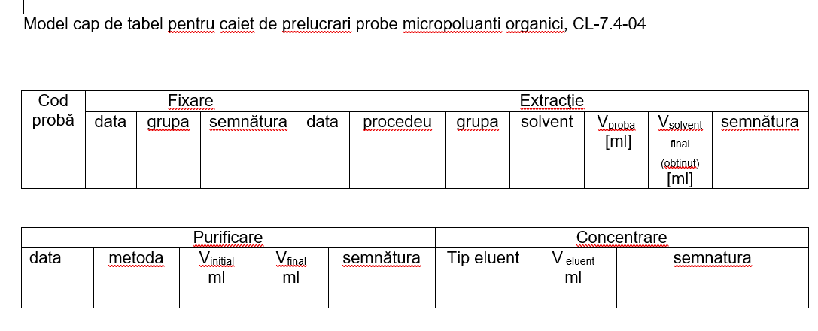
Example Calculation Method – Organic Micropollutants for SEDIMENT
Calculation Method (a): The concentration of analyte X (e.g., CBz, HxCBuD, POC, etc.) in the analyzed sediment sample is calculated using the following formula:
C_{p} = C_{ex} ⋅ V_{ex} ⋅ R / m_{p} ⋅ Su
Where:
- C_{p} = concentration of analyte X in the analyzed sample (final reported value), expressed in µg/kg (for sediment sample).
- C_{ex} = concentration of the same analyte X in the extract of the analyzed sample, in µg/L
- V_{ex} = volume of extract obtained during the sample pretreatment stage, in milliliters.
- m_{p} = mass of sediment taken for extraction, in grams.
- Su = moisture content, expressed as (%).
- R = recovery value, expressed as (%)-1.
Calculation Method (b): This method is applied in cases of very small peaks surrounded by interfering peaks, or when the peaks cannot be correctly integrated due to baseline fluctuations in the chromatogram.
In this variant, the term C_{ex} in the calculation formula from Method (a) is replaced by the expression:
C_{ex} = C_{et} ⋅ A_{p} / A_{et}
​Where:
- A_{p} and A_{et} represent the areas of the chromatographic peaks corresponding to the same analyte X in the unknown sample and in the standard solution.
- C_{et} = concentration of analyte X in the standard solution, expressed in µg/L.
- Other parameters (C_{p}, V_{ex}, Vp , m_{p}, and R) have the same meanings as described in Method (a).

Example Calculation Method – Organic Micropollutants for BIOTA
Calculation Method (a): The concentration of analyte X (e.g., CBz, HxCBuD, POC, etc.) in the analyzed biota sample is calculated using the following formula:
C_{p} = C_{ex} ⋅ V_{ex} ⋅ R / m_{p}
Where:
- C_{p} = concentration of analyte X in the analyzed sample (final reported value), expressed in µg/kg (for biota sample).
- C_{ex} = concentration of the same analyte X in the extract of the analyzed sample, in µg/L
- V_{ex} = volume of extract obtained during the sample pretreatment stage, in milliliters.
- m_{p} = mass of the sample taken for extraction, in grams.
- R = recovery value, expressed as (%)-1.
Calculation Method (b): This method is applied in cases of very small peaks surrounded by interfering peaks, or when the peaks cannot be correctly integrated due to baseline fluctuations in the chromatogram.
In this variant, the term C_{ex} in the calculation formula from Method (a) is replaced by the expression:
C_{ex} = C_{et} ⋅ A_{p} / A_{et}
Where:
- A_{p} and A_{et} represent the areas of the chromatographic peaks corresponding to the same analyte X in the unknown sample and in the standard solution.
- C_{et} = concentration of analyte X in the standard solution, expressed in µg/L.
- Other parameters (C_{p}, V_{ex} ,V_{p} , m_{p} si R) have the same meanings as described in Method (a).

Example Calculation Method - General Indicators
Determination of Suspended Solids (TSS)
The content of suspended solids is expressed in milligrams per liter (mg/L) and is calculated using the following formula:
$$ρ=\frac{\left[1000*\left(b-a\right)\right]}{V}$$
Where:
- ρ – represents the content of suspended matter, expressed in milligrams per liter (mg/L)
- b – represents the mass of the filter after the sample filtration stage, expressed in milligrams (mg)
- a – represents the mass of the filter before the filtration stage, expressed in milligrams (mg) V – represents the volume of the filtered sample, expressed in milliliters (mL). If the sample has been weighed, 1 g is considered equivalent to 1 mL

Extractable Substances
The content of substances extractable with n-hexane is expressed in milligrams per liter (mg/L) and is calculated using the formula:

$Extractable Substances=\frac{\left[\left(m2-m1\right)-\left(m4-m3\right)\right]}{V}x1000$ mg/l

Where:
- m1 – mass of the capsule without the sample residue, in grams (g)
- m2 – mass of the capsule with the sample residue, in grams (g)
- m3 – mass of the capsule without the control sample residue, in grams (g)
- m4 – mass of the capsule with the control sample residue, in grams (g)
- V – volume of the sample used, in liters (L)
Chemical Oxygen Demand (COD-Cr), expressed in mgO₂/L, is calculated using the following formula:
$$CCO=\frac{\left[8000×c×\left(V1-V2\right)\right]}{V0}$$
Where:
- c – concentration of the iron (II) ammonium sulfate solution,
- V0 – volume of the sample to be analyzed or diluted, in mL,
- V1 – volume of the iron (II) ammonium sulfate solution used for titrating the control sample, in mL,
- V2 – volume of the iron (II) ammonium sulfate solution used for titrating the sample to be analyzed, in mL,
- 8000 – molar mass of ½ O₂, in mg.
Or, considering the molar masses and purities of the substances, the formula will be as illustrated:
Where:
- C[COD-Cr] = chemical oxygen demand, mg/L
- mK₂Cr₂O₇ – mass of K₂Cr₂O₇ in the K₂Cr₂O₇ solution in moles/L used to determine the concentration of Mohr's salt
- PK₂Cr₂O₇ – purity of potassium dichromate
- MK₂Cr₂O₇ – molar mass of K₂Cr₂O₇
- mMohr's salt – mass of Mohr's salt in the Mohr's salt solution used for titrating the dichromate, mL
- PMohr's salt – purity of Mohr's salt
- MMohr's salt – molar mass of Mohr's salt
- V1 – volume of Mohr's salt used in titrating the control sample, mL
- V2 – volume of Mohr's salt used in titrating the sample, mL
- V0 – volume of the sample to be analyzed, mL
- 0.12 moles/L – theoretical concentration of Mohr's salt
- 6 – ratio between the equivalent of potassium dichromate and the equivalent of Mohr's salt
- 8 – conversion factor for expressing the result in mg O₂/L
- 1000 – conversion factor from mL to L
Nitrite Content The nitrite content is expressed in µg and is calculated using the formula:
$$Ar=As-Ab$$
Or, if a correction for color is made, it is given by the equation:
$$Ar=As-Ab-Ac$$
Where:
- As – absorbance measured for the sample
- Ab – absorbance of the control sample solution
- Ac – absorbance of the solution prepared for color correction

The concentration of N-NO₂⁻ is calculated using the formula:
$C\text{(N-NO2-)}\text{ = m}\text{(N-NO2-)}\text{/V}$ mg/l N-NO₂⁻

Where:
- mN-NO₂⁻ - mass of nitrites read on the device (µg)
- V - volume of the sample taken for analysis

The concentration of nitrites in mg/L NO₂⁻ is calculated using the formula:
$C\text{(NO2-)}\text{ = m}\text{(NO2-)}\text{/3,29}$ mg/l NO₂⁻

Annex 6

Analysis Standards by Indicator in NARW Laboratory
No. | Indicator | Analysis Standards
General indicators
1 | Fosfor total | SR EN ISO 6878:2005
2 | Ortofosfați | SR EN ISO 6878:2005
3 | CCOCr | SR ISO 6060:1996
8 | Substanțe extractibile | Method 1664 US EPA / revizia B-2010
9 | Agenți de suprafață anionici (detergenților) | SR EN 903:2003
10 | Indice de fenol | SR ISO 6439:2001
10 | Indice de fenol | SR ISO 6439:2001 / C91 2006
11 | Sulfuri | SR 7510:1997
12 | Sulfuri | Metoda Merck 1.14779.000.1
13 | Sulfuri | Metoda HACH - 8131
14 | Azot total | SR EN ISO 20236:2021
15 | Azot total | SR EN ISO 11905-1: 2003 / Anexa C
16 | Amoniu | SR ISO 7150-1:2001
Organic Micropollutants
46 | Clorbenzeni
46 | 1,2,4 Triclorbenzen | SR EN ISO 6468:2000
46 | Pentaclorbenzen | SR EN ISO 6468:2000
46 | Hexaclorbenzen | SR EN ISO 6468:2000
Metals
57 | Mercur | SR EN ISO 17852:2008
58 | Crom | SR EN ISO15586:2004
59 | Aluminiu | SR EN ISO15586:2004
60 | Nichel | SR EN ISO15586:2004
Bacteriology
99 | Coliformi fecali | ISO 9308-2:1990
100 | Coliformi totali | ISO 9308-2:1990
Biology
102 | Clorofila "a" | SR ISO 10260:1996
103 | Fitobentos | SR EN 14407:2014
104 | Fitoplancton | SR EN 15204:2007
104 | Fitoplancton | SR EN 16695:2016
Sampling
108 | Water Quality. Sampling. Part 1: Guide for Establishing Sampling Programs and Techniques | SR EN ISO 5667-1:2023
109 | Guide for Sampling, Preservation, Transport, and Identification of Samples | SR ISO 5667-3:2018

Annex 7

Estimated Capacity Planning

NARW Laboratory Units and Personnel Distribution:
NARW River Basin Administration (ABA) | Water Quality Laboratory (LCA) | Location | Est. users | Part of Phase
ANAR | National Laboratory (LNCA) | Bucharest | 10 | I
ABA Siret | Working point 1 - Bacau | Bacau | 19 | I
ABA Siret | Working point 2 - Bacau | Bacau | 19 | I
ABA Siret | Suceava | Suceava | 12 | I
ABA Siret | Neamt | Piatra Neamt | 6 | I
ABA Siret | Vrancea | Focsani | 6 | I
ABA Siret | Pascani | Pascani | 1 | I
ABA Somes-Tisa | Cluj | Cluj | 16 | II
ABA Somes-Tisa | Bistrita | Bistrita-Nasaud | 5 | II
ABA Somes-Tisa | Salaj | Zalau | 4 | II
ABA Somes-Tisa | Maramures | Baia Mare | 9 | II
ABA Somes-Tisa | Satu Mare | Satu Mare | 8 | II
ABA Mures | Tg. Mures | Targu Mures | 19 | II
ABA Mures | Alba Iulia | Alba Iulia | 8 | II
ABA Mures | Arad | Arad | 6 | II
ABA Mures | Deva | Deva | 7 | II
ABA Crisuri | Crisuri | Oradea | 13 | II
ABA Banat | Timisoara | Timisoara | 13 | II
ABA Banat | Resita | Resita | 8 | II
ABA Jiu | Craiova | Craiova | 11 | II
ABA Jiu | Tg. Jiu | Targu-Jiu | 10 | II
ABA Jiu | Tr. Severin | Drobeta Turnu-Severin | 9 | II
ABA Olt | M. Ciuc | Miercurea Ciuc | 5 | II
ABA Olt | Sf. Gheorghe | Sfantu Gheorghe | 4 | II
ABA Olt | Brasov | Brasov | 6 | II
ABA Olt | Sibiu | Sibiu | 5 | II
ABA Olt | Rm. Valcea | Ramnicu Valcea | 12 | II
ABA Olt | Slatina | Slatina | 6 | II
ABA Buzau - Ialomita | Buzau | Buzau | 10 | II
ABA Buzau - Ialomita | Ploiesti | Ploiesti | 8 | II
ABA Buzau - Ialomita | Targoviste | Targoviste | 4 | II
ABA Buzau - Ialomita | Braila | Braila | 4 | II
ABA Buzau - Ialomita | Calarasi | Calarasi | 6 | II
ABA Buzau - Ialomita | Slobozia | Slobozia | 5 | II
ABA Arges-Vedea | Pitesti | Pitesti | 14 | II
ABA Arges-Vedea | Bucuresti | Bucuresti | 12 | II
ABA Arges-Vedea | Giurgiu | Giurgiu | 5 | II
ABA Arges-Vedea | Alexandria | Alexandria | 6 | II
ABA Prut-Barlad | Botosani | Botosani | 6 | II
ABA Prut-Barlad | Iasi | Iasi | 13 | II
ABA Prut-Barlad | Vaslui | Vaslui | 9 | II
ABA Prut-Barlad | Galati | Galati | 6 | II
ABA Dobrogea-Litoral | Constanta | Constanta |  | II
ABA Dobrogea-Litoral | Tulcea | Tulcea |  | II

Estimated number of orders registered in NARW Laboratories
Phase I (Pilot): The laboratories slated for inclusion in the Pilot phase encompass nearly 275 "documents," categorized as follows:
  - 74 existing documents that serve as registries
  - 11 existing documents that represent various types of reference materials
  - 37 existing documents that consist of paper-based reports
Final Phase (All Laboratories): While a similar volume of types and categories is anticipated, it would be prudent to plan for approximately 450 "documents" to ensure optimal capacity management.

Estimated number of samples analysis* in NARW Laboratories
Phase I (Pilot):
  - ABA Siret laboratories approximately 45.000 – 50.000 analysis / year
  - National Laboratory (LNCA) approximately 45.000 – 50.000 analysis / year
Final Phase (All Laboratories):
  - For all 42 laboratories LIMS must be prepared to process between 520k – 700k analysis yearly.
Note: (*) It is important to note that each analysis refers to the individual indicator that must be assessed according to the order outlined in the Annual Operating Manual.
For reference, the table below highlights the number of analyses per year as outlined in the 2024 Annual Operating Manual for ABA Siret (part of Pilot phase).
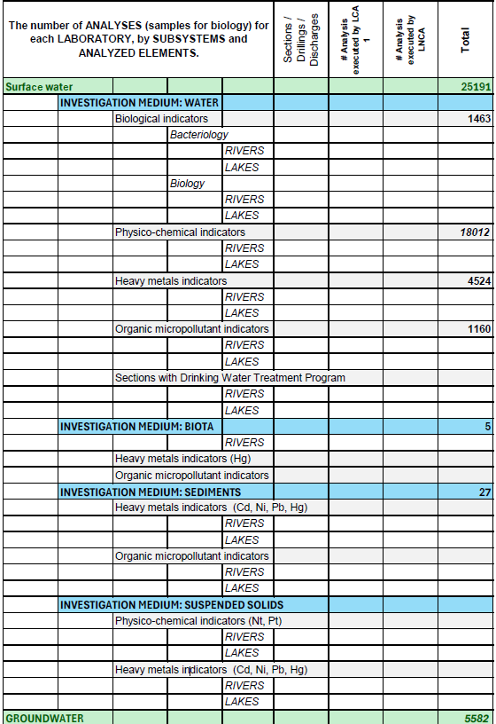
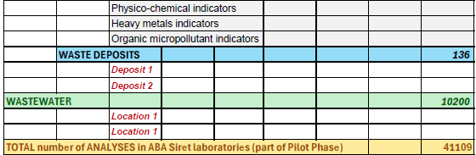
Estimated Documents stored in NARW Laboratories

Document Category / Laboratory Document (Registry) | INPUT | OUTPUT
Laboratory Notebooks | 144 | 144
CL-7.4-03 - Laboratory Notebook for Monitoring Sample Collection Conditions | 5 | 5
CL-7.4-05 - Laboratory Notebook for Analyzing Organic Micropollutants | 1 | 1
CL-7.7-01 - Laboratory Notebook for Determining Turbidity | 5 | 5
CL-7.7-02 - Laboratory Notebook for Determining pH, Electrical Conductivity, and Filterable Residue Conductometrically | 5 | 5
CL-7.7-03 - Laboratory Notebook for Determining Dissolved Oxygen Content | 5 | 5
CL-7.7-04 - Laboratory Notebook for Determining Permanganate Index | 5 | 5
CL-7.7-05 - Laboratory Notebook for Determining Biochemical Oxygen Demand (BOD₅) | 5 | 5
CL-7.7-06 - Laboratory Notebook for Determining COD-Cr (Titrimetric) | 5 | 5
CL-7.7-07 - Laboratory Notebook for Determining Suspended Solids Content | 5 | 5
CL-7.7-08 - Laboratory Notebook for Determining Ammonium Content | 5 | 5
CL-7.7-09 - Laboratory Notebook for Determining Nitrite Content | 5 | 5
CL-7.7-10 - Laboratory Notebook for Determining Nitrate Content | 5 | 5
CL-7.7-11 - Laboratory Notebook for Determining Phosphates and Total Phosphorus | 5 | 5
CL-7.7-12 - Laboratory Notebook for Determining Total Nitrogen | 5 | 5
CL-7.7-13 - Laboratory Notebook for Determining Alkalinity and Chlorides | 5 | 5
CL-7.7-14 - Laboratory Notebook for Determining Filterable Residue | 5 | 5
CL-7.7-15 - Laboratory Notebook for Determining Sulfate Content | 5 | 5
CL-7.7-17 - Laboratory Notebook for Determining Anionic Surfactants Content | 5 | 5
CL-7.7-19 - Laboratory Notebook for Determining Phenol Index | 5 | 5
CL-7.7-20 - Laboratory Notebook for Determining Sulfide Content | 5 | 5
CL-7.7-21 - Laboratory Notebook for Weighing and Preparing Solutions | 5 | 5
CL-7.7-22 - Laboratory Notebook for Determining CCOMn | 5 | 5
CL-7.7-23 - Laboratory Notebook for Determining TOC – DOC | 4 | 4
CL-7.7-24 - Laboratory Notebook for Determining Fluorides | 2 | 2
CL-7.7-25 - Laboratory Notebook for Extractable Substances with n-Hexane | 5 | 5
CL-7.7-26 - Laboratory Notebook for Determining Chlorophyll a Content | 4 | 4
CL-7.7-35 - Laboratory Notebook for Determining Mercury | 1 | 1
CL-7.7-36 - Laboratory Notebook for Determining Metals by ICP-MS Method | 1 | 1
CL-7.7-37 - Laboratory Notebook for Sample Processing via Digestion | 1 | 1
CL-7.7-43 - Laboratory Notebook for Recording Sequences - GC-ECD/FID | 1 | 1
CL-7.7-44 - Laboratory Notebook for Recording Sequences - GC-ECD/FID-Headspace | 1 | 1
CL-7.7-45 - Laboratory Notebook for Recording Sequences - GC-FTD&ECD | 1 | 1
CL-7.7-46 - Laboratory Notebook for Recording Sequences - LC-DAD&FLD - Triazines | 1 | 1
CL-7.7-47 - Laboratory Notebook for Recording Sequences - LC-DAD&FLD - PAH | 1 | 1
CL-7.7-48 - Laboratory Notebook for Recording Sequences - GC-FID INTUVO | 1 | 1
CL-7.7-49 - Laboratory Notebook for Recording Sequences - GC 2030-FID | 1 | 1
CL-7.7-50 - Laboratory Notebook for Recording Sequences - GC 2030-NPD | 1 | 1
CL-7.7-51 - Laboratory Notebook for Recording Sequences - GC-MS | 1 | 1
CL-7.7-52 - Laboratory Notebook for Reading Chromatograms and Calculating Concentrations - GC-ECD/FID | 1 | 1
Document Category / Laboratory Document (Registry) | INPUT | OUTPUT
CL-7.7-53 - Laboratory Notebook for Reading Chromatograms and Calculating Concentrations - GC-ECD/FID - Head Space | 1 | 1
CL-7.7-54 - Laboratory Notebook for Reading Chromatograms and Calculating Concentrations - GC-FTD&ECD | 1 | 1
CL-7.7-55 - Laboratory Notebook for Reading Chromatograms and Calculating Concentrations - LC-DAD&FLD - Triazines | 1 | 1
CL-7.7-56 - Laboratory Notebook for Reading Chromatograms and Calculating Concentrations - LC-DAD&FLD - PAH | 1 | 1
CL-7.7-57 - Notebook for Reading Chromatograms and Calculating Concentrations - GC-FID INTUVO | 1 | 1
CL-7.7-58 - Notebook for Reading Chromatograms and Calculating Concentrations - GC-2030-FID | 1 | 1
CL-7.7-59 - Notebook for Reading Chromatograms and Calculating Concentrations - GC-2030-NPD | 1 | 1
CL-7.7-61 - Laboratory Notebook for Recording Processed Sediment Samples | 2 | 2
CL-7.7-62 - Laboratory Notebook for Confirming Compounds (GC ECD) | 1 | 1
Field Sheets | 4 | 4
FL-7.3-06 - Field Sheets for Ichthyofauna ABA Siret - Rivers | 1 | 1
FL-7.3-07 - Field Sheets for Ichthyofauna ABA Siret - Lakes | 1 | 1
FL-7.3-08 - Field Sheets for Macrophytes - Rivers | 1 | 1
FL-7.3-09 - Field Sheets for Macrophytes - Lakes | 1 | 1
Sampling Notes | 5 | 5
FL-7.3-01 - Sampling Notes | 5 | 5
Reagents Receipt-Delivery Protocol | 10 | 10
FL-6.6-01 - Reagents Receipt-Delivery Protocol | 5 | 5
FL-6.6-02 - Reagents Receipt-Delivery Protocol between Laboratories within the Basin Administration | 5 | 5
Testing Reports |  | 6
FL-7.8-01 - Simplified Physical-Chemical Testing Report |  | 1
FL-7.8-02 - Testing Report |  | 5
FL-7.8-01 - Simplified Physical-Chemical Testing Report |  | 16
FL-7.8-03 - Simplified Testing Report for Metals Analysis |  | 4
FL-7.8-04 - Simplified Testing Report for Micropollutants Analysis |  | 2
FL-7.8-05 - Simplified Testing Report for Biological Analysis of Rivers |  | 1
FL-7.8-06 - Simplified Testing Report for Biological Analysis of Lakes |  | 4
FL-7.8-08 - Simplified Testing Report for Total Nitrogen / Fluorides / TOC / DOC / Cyanides |  | 4
External Orders Register |  | 1
RL-7.1-01 - External Orders Register | 5 | 5
Laboratory Register | 5 | 5
F-RS-3 - Laboratory Register with Internal Correspondence | 64 | 65
RL-04-01 - Laboratory Register for Monitoring Transactions with Restricted Explosive Precursors | 5 | 5
RL-7.4-01 - Register of Sample Entries / Reporting of Testing Results | 5 | 5
RL-7.4-02 - Laboratory Register for Samples - RIVERS | 5 | 5
RL-7.4-03 - Laboratory Register for Samples - LAKES | 5 | 5
RL-7.4-04 - Laboratory Register for Samples - GROUNDWATER | 5 | 5
RL-7.4-05 - Laboratory Register for Samples - WASTEWATER | 5 | 5
RL-7.4-06 - Laboratory Register for Samples - ACCIDENTAL POLLUTION / CHECKS | 5 | 5
RL-7.4-07 - Laboratory Register for Samples - MACROINVERTEBRATES | 5 | 5
Document Category / Laboratory Document (Registry) | INPUT | OUTPUT
RL-7.4-08 - Laboratory Register for Samples - PHYTOPLANKTON FROM RIVERS | 3 | 3
RL-7.4-09 - Laboratory Register for Samples - PHYTOPLANKTON FROM LAKES | 4 | 4
RL-7.4-11 - Laboratory Register for Samples - PHYTOBENTHOS | 4 | 4
RL-7.4-12 - Laboratory Register for Samples - Metals Analysis from ABA Siret | 4 | 4
RL-7.4-13 - Laboratory Register for Samples - Metals Analysis from ABA Prut Bârlad | 1 | 2
RL-7.4-14 - Laboratory Register for Samples - Metals Analysis from ABA Dobrogea Litoral | 1 | 1
RL-7.4-15 - Laboratory Register for Samples - Metals Analysis from ABA Buzău Ialomița | 1 | 1
RL-7.4-FLUX - Laboratory Register for Samples - FLUX ANALYSIS | 1 | 1
RL-7.4-GC1 - Laboratory Register for Samples - Organic Micropollutants Analysis from ABA Siret | 1 | 1
RL-7.4-GC2 - Laboratory Register for Samples - Organic Micropollutants Analysis from ABA Prut Bârlad | 1 | 1
RL-7.4-GC3 - Laboratory Register for Samples - Organic Micropollutants Analysis from ABA Dobrogea Litoral | 1 | 1
RL-7.4-GC4 - Laboratory Register for Samples - Organic Micropollutants Analysis from ABA Buzău Ialomița | 1 | 1
Complaints Register | 1 | 1
RL-7.9-01 - Laboratory Complaints Registration Register | 5 | 5
Laboratory Personnel List | 5 | 5
FL-6.2-03 - Laboratory Personnel List | 5
Personnel Authorization Sheet | 5
FL-6.2-05 - Personnel Authorization Sheet | 5
Weekly Sampling Program | 5
FL-7.1-02 - Weekly Sampling Program |  | 5
Laboratory Analysis Nomenclature |  | 5
FL-7.1-05 - Laboratory Analysis Nomenclature | 5
Determined Indicators and Performance Parameters | 5
FL-7.2-04 - Determined Indicators and Performance Parameters | 5
Centralized List of Internal Documents | 5
FL-8.3-03 - Centralized List of Internal Documents | 5
Archiving Record | 5
FL-8.3-05 - Archiving Records |  | 5
Centralized List of Records | 5
FL-8.4-01 ed4/rev0 - Centralized List of Records | 5
Laboratory Notebook with Analytes | 5
CL-7.4-01 - Laboratory Notebook with Analytes | 5
Laboratory Notebook for Heavy Metals Indicators | 2
CL-7.4-02 - Laboratory Notebook for Heavy Metals Indicators | 2
Laboratory Notebook for Processing Organic Micropollutant Samples | 1
CL-7.4-04 - Laboratory Notebook for Processing Organic Micropollutant Samples | 1
TOTAL – PHASE 1 (PILOT) | 275 | 270
Phase I (Pilot): The laboratories slated for inclusion in the Pilot phase encompass nearly 275 "documents," categorized as follows:
  - 74 existing documents that serve as registries
  - 11 existing documents that represent various types of reference materials
  - 37 existing documents that consist of paper-based reports
Final Phase (All Laboratories): While a similar volume of types and categories is anticipated, it would be prudent to plan for approximately 450 "documents" to ensure optimal capacity management.

Estimated Number of Users (personnel) from NARW Laboratories
- Phase I (Pilot): estimated that there will be around 100 users, with an expectation that 10 of them will be using the system concurrently.
- Final Phase (All Laboratories): It is estimated that there will be around 500 users, with an expectation that 100 of them will be using the system concurrent

Annex 8

Ensuring conformity with ISO/IEC 17025:2017 standard, clause 7.11
Quoted from the standard requirements documentation:

7.11 Data Control and Information Management
7.11.1 The laboratory must have access to all necessary data and information to carry out laboratory activities.
7.11.2 The laboratory's information management system(s) used for collecting, processing, recording, reporting, storing, or retrieving data must be validated by the laboratory for functionality, including the proper operation of system interfaces, before being put into use. Any changes, including laboratory software configuration or modifications to commercial off the shelf software, must be authorized, documented, and validated before implementation.
Note 1 – In this document, the term “laboratory information management system(s)” includes the management of data and information contained in both computerized and non-computerized systems. Some requirements may be more applicable to computerized systems than to non-computerized ones.
Note 2 – Commercial off-the-shelf software generally used within its designed application range may be considered sufficiently validated.
7.11.3 The laboratory information management system(s) must:
a) Be protected against unauthorized access;
b) Be protected against unauthorized modification and loss;
c) Operate in an environment that meets the Consultant’s or laboratory’s specifications, or in the case of non-computerized systems, provide conditions that guarantee accuracy in manual recording and transcription;
d) Be maintained in a manner that ensures data and information integrity;
e) Include records of malfunctions and appropriate and immediate corrective actions.
7.11.4 When a laboratory information management system is administered and maintained offsite or through an external provider, the laboratory must ensure that the provider or system operator meets all applicable requirements of this document.
7.11.5 The laboratory must ensure that instructions, manuals, and relevant reference data for the laboratory information management system(s) are readily accessible to staff.
7.11.6 Calculations and data transfers must be verified in an appropriate and systematic manner.

Annex 9

Recommended Development and Testing Environments
The following development and testing environments recommended are established to support the Continuous Integration (CI) / Continuous Delivery (CD) process:

1. Local Environment
- Purpose: Personal workspace for a developer to implement and validate changes.
- Best Practices:
  - Use version control to track changes (e.g., Git).
  - Run unit tests to ensure individual components function as expected.
  - Conduct integration tests with mocks to validate interactions between components.
  - Perform UI testing to verify the user interface behaves correctly.

2. Integration Environment (CI)
- Purpose: Verify changes in isolation and identify early-stage issues when integrating with other developers’ work.
- Best Practices:
  - Automate the environment setup with tools like Jenkins, GitHub Actions, etc.
  - Run unit tests and integration tests with mocked dependencies for quick feedback.
  - Perform basic UI testing with dummy data to validate visual and functional aspects.

3. Testing Environment
- Purpose: Test functionality in a sprint-oriented context using near-production-like data.
- Best Practices:
  - Create a dataset that resembles production data but ensures sensitive data is anonymized.
  - Focus on exploratory testing to uncover usability and user experience issues.
  - Validate user stories and sprint requirements for functional completeness.
4. Staging/Acceptance Environment
- Purpose: Provide a final validation step in an environment nearly identical to production.
- Best Practices:
  - Use a production-like dataset to simulate realistic conditions.
  - Conduct system testing to validate end-to-end functionality.
  - Run load, performance, and scalability tests to ensure the system handles expected traffic.
  - Perform security testing to identify vulnerabilities.

5. Production Environment
- Purpose: Host the live application accessible to end-users.
- Best Practices:
  - Automate deployment with a reliable CI/CD pipeline.
  - Monitor performance and errors in real time using tools like New Relic, Datadog, or Prometheus.
  - Maintain a robust backup and rollback strategy for deployments.
  - Ensure compliance with security and data privacy regulations.

Comanda reprezintă Manualul de Operare al LCA aprobat pentru anul respectiv sau Comandă identificată prin nr. și dată
Informație furnizată de către client, conform comenzii XXX, identificat conform punctului 1
UMext – incertitudinea extinsă a metodei evaluată cu un factor de acoperire k =2 și un nivel de încredere de 95 %, se raportează în unitatea de măsură a indicatorului analizat și conține inclusiv contribuțiile provenite din procesul de eșantionare, în cazul în care procesul de eșantionare a fost făcut de laborator.
Se va indica tehnica de analiză utilizată
UMext – incertitudinea extinsă a metodei evaluată cu un factor de acoperire k =2 și un nivel de încredere de 95 %, se raportează în unitatea de măsură a indicatorului analizat și conține inclusiv contribuțiile provenite din procesul de eșantionare, în cazul în care procesul de eșantionare a fost făcut de laborator.

