NOTIFICATION OF AN AFFECTED PARTY OF THE PROPOSED ACTIVITY UNDER ARTICLE 3 OF THE CONVENTION FOR THE EIA REPORT IN THE CROSSBORDER CONTEXT

1. INFORMATION ON THE PROPOSED ACTIVITY
(i) Information about the nature of the proposed activity
Type of proposed activity: | The project provides for the construction of a high-speed connection (motorway and express road) between the municipality of Suceava and DN2H (as a motorway) and between DN2H and the Siret Border (as an express road), this being part of the road project with the generic name "Siretului Road", indicative Express Road 5, included in MPGT (Pașcani – Suceava – Siret).
Is the activity listed in Appendix I of the Convention? | The project limit is approx. 0.8 km from the border with Ukraine. The project represents a section of the Express road 5 "Drumul Siretului" that will connect directly with the E85 road in Ukraine. The activity is listed in Appendix I of the Espoo Convention.
Purpose of the proposed activity:  (Ex. the main activity and any/all peripheral activities that require assessment) | The project aims to create a motorway sector between the municipality of Suceava and DN2H and an express road between DN2H and Siret Frontier, this being part of the road project with the generic name "Drumul Siretului", indicative Express Road 5 included in the MPGT (Paşcani - Suceava – Siret).
Evaluation of the proposed activity  (eg size, production capacity, etc.) | The Suceava - DN2H motorway and DN2H – Siret Border Express Road project will have a total length of approx. 56 km.  The proposed project does not involve the realization of production processes, but the creation of a motorway and an express road. During the exploitation period, the project will be intended for road traffic.
Description of the proposed activity: | The activity involves carrying out construction works for the Suceava - DN2H motorway and DN2H – Siret Border Express Road and the development of road traffic on it, in the operational stage.  The proposed works will not be different from the works normally provided for a road infrastructure project. Embankment construction works, interchanges, bridges, viaducts, hydrotechnical works, consolidation works, environmental protection works, etc. are foreseen. The project does not provide for the construction of tunnels.
Description of the reason for the proposed activity: | The Suceava – Siret investment priority is provided for in Romania's General Transport Master Plan, which refers to improved mobility for the population and goods within the basic and comprehensive TEN-T network, by building a motorway and a network of express roads, to reduce travel time, accident risks and implement sustainable economic and environmental projects.  The construction of the motorway and the express road can contribute significantly to the fluidization of road traffic in the border area between Ukraine and Romania.
The reason for proposing the activity (e.g. socio-economic, physical and geographical bases) | The general objective is to improve the economic competitiveness of Romania by developing the transport infrastructure, thus contributing to the development of the internal market with the aim of creating the conditions for increasing the volume of investments, promoting sustainable transport and cohesion in the European road network.  In addition to its national importance, this project will serve in good conditions, the national transit traffic of goods and people from the territory of Romania and to Ukraine. Depending on the state of rehabilitation of national roads or under rehabilitation, through them the motorway can receive and distribute road traffic through its nodes, it will ensure the necessary traffic capacity and appropriate traffic conditions related to the TEN-T road network with minimal negative effects at the level environment and land use.
Additional information/comments
(ii) Information on the temporal and spatial bases of the proposed activity
Location: | The Suceava - DN2H motorway and the DN2H - Siret Border Express Road - cross the administrative territory of several UATs in Suceava county, respectively: Suceava (km 0+000), Mitocul Dragomirnei (km 3+700), Suceava (km 7+200), Pătrăuţi (km 9+230), Dărmăneşti (km 14+520), Grăniceşti (km 23+715), Milisauti (km 26+375), Calafindeşti (km 33+925), Bălcăuţi (km 39+400), Siret (km 46+240), Muşeniţa (km 48+210), Siret (km 49+475), Museniţa (km 51+150), Siret (km 53+860).  The Suceava - DN2H motorway and the DN2H – Siret border Express Road are connected by an interchange to the DN2, north of Siret. The closest area to the border with Ukraine is represented by the roundabout south of Siret Customs.
Location description:  (e.g. socio-economic, physical-geographical bases) | The Suceava - DN2H motorway and the DN2H – Siret border Express Road are located in the north-eastern part of Romania, in Suceava county. It has its starting point near the Municipality of Suceava, to the east of it, in the vicinity of the Suceava International Airport (ASCV). This road sector will connect the Suceava Municipality area with the Paşcani-Suceava motorway section. The project continues relatively parallel to DN2 (which it crosses several times), bypasses the town of Siret through its western part and connects with DN2 to the north of it, near Siret customs.
The reason for the location of the proposed activity (e.g. socio-economic, physical and geographical bases) | The project is an important one both nationally and internationally. In addition to its national importance, this project will serve in good conditions the transit traffic of goods and people from the territory of Romania and from and to Ukraine.  The realization of the project will contribute to the socio-economic development of the region and to the facilitation of economic relations with Ukraine.
Timing of the proposed activity (e.g. time and duration of construction and operation) | The execution duration of the proposed objective is estimated at around 30 months.  The operating time is unlimited.
Maps and other pictorial documents related to information on the proposed activity | 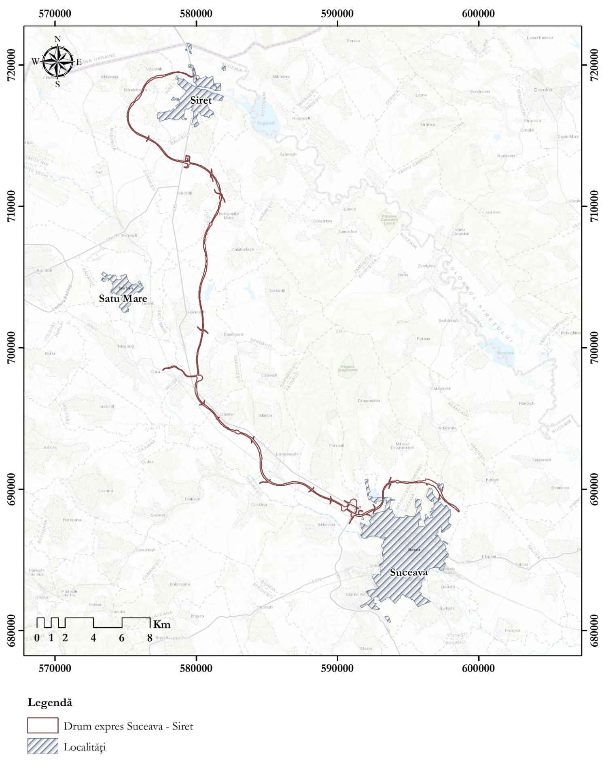  Spatial location of the Suceava – DN2H motorway project and DN2H– Siret border express road
Additional information/comments
(iii) Information on the predicted impact on the environment and proposed mitigation measures
The purpose of the evaluation  (Ex. Considerations on: cumulative impact,  Evaluation of alternatives, development issues, impact on peripheral activity, etc.) | The project falls under Annex no. 1 of Law 292/2018 regarding the assessment of the impact of certain public and private projects on the environment, at point 7, letter b) "Construction of motorways and express roads", thus requiring the assessment of environmental impacts.  The purpose of the evaluation will be to analyze the potential impacts generated by this project and to identify the necessary avoidance and reduction measures to ensure an insignificant residual impact.
Expected environmental impact of the proposed activity  (eg type, location, magnitude) | The Suceava - DN2H motorway and the DN2H – Siret border Express Road may be able to generate potentially significant forms of impact on several environmental components. The main components on which the project can generate a significant impact are:  - biodiversity: Potential significant impact on several species of fauna from the sites ROSCI0075 Pădurea Pătrăuţi, ROSCI0380 Suceava Liteni River and ROSPA0110 Rogojeşti - Bucecea Accumulations; Potentially significant impact as a result of affecting the ecological connectivity in the area; Potentially significant impact as a result of increased noise levels, especially on nesting bird species; Uncertain impact as a result of the increase in the level of light pollution in the area of ​​the motorway / and express road;  - Abiotic components: Potential significant impact on water bodies as a result of the hydrotechnical works proposed in the project;  - The social environment: Potential significant impact on the population by decreasing air quality and increasing the noise level in the area of ​​several localities.
Entry  (e.g. raw material, energy sources, etc.) | The raw materials needed to complete the project are the following: asphalt mixes, natural aggregates stabilized with cement, ballast, asphalt concrete, form layer of stabilized soil, topsoil, concrete, cement, water, reinforcement, diesel, lubricants.  Electricity will be provided in the site organizations, through connection to the existing network and through generating sets.  The necessary technological water and that used for domestic purposes will be ensured by connecting to the network in the area, where it exists, or it will be ensured by purchasing it from third parties and it will be brought to the site with the help of car tankers.
Output  (e.g. Amount and type of: disposal in air, disposal in water, solid waste, etc.) | The project will not involve the production of quantities of materials or other similar activities.  The project will involve the evacuation of rainwater as well as the evacuation of household waste water from the service spaces. Rainwater will be pre-purified through sedimentation basins, hydrocarbon separators and retention basins.  The domestic waste water will be directed through the internal sewage network to the existing networks or to drainable basins, from where it will be collected and transported to the existing treatment plants in the project area by the companies authorized under the concluded contracts.
Transboundary impact (eg types, location, magnitude) | The Suceava - DN2H motorway and the DN2H - Siret border express road will run in the north of the country. The minimum distance between the project location and the country's borders is approximately 0.8 km in the northern direction, up to the border with Ukraine.  The potential cross-border impact can occur in the case of several components:  - Emerald Sites: The project is located at a distance of 15 km from the site Emerald UA0000085 Chernivetskyi Regional Landscape Park in Ukraine, not far from the capital of the Chernivtsi region. In the site, several habitats and species of flora and fauna are the object of conservation. Between the project area and the site area, no hydrological connections were highlighted, which could affect the ichthyofauna that is the object of conservation in the site. The habitats and species of plants, invertebrates and herpetofauna are unlikely to be affected, considering the great distance between the project area and this site. This distance is large enough to prevent the movement of these species from the site area to the project area.  The only species potentially exposed to an impact generated by the project are bird species, especially birds of prey. In this case, the occurrence of some victims as a result of the collision of individuals with car traffic cannot be excluded. However, the distance between the project and the site, as well as the presence in the southern area of ​​the site of many agricultural lands, where raptor species can feed, make the probability that individuals of these species reach the project area a low, strictly accidental one. The appearance of any victim can thus only be an accidental, temporary situation, which is not able to significantly decrease the populations of the bird species in this Emerald site.  - Ecological connectivity: Regarding the ecological connectivity in the area of ​​Ukraine, it is unlikely that it will be affected by the project. According to the ConnectGREEN project, which analyzed the ecological connectivity in the Carpathians, the area close to the motorway is not characterized by the presence of ecological corridors. The project will cross local ecological corridor areas for deer and wolves, but the location of these corridors is in the southern half of the project, near the town of Suceava.  - The presence of sensitive receptors (locations): Regarding the potential effects on some sensitive receptors (eg localities), the project is located about 2.3 km from the nearest locality in Ukraine, Horbivtsi. This distance is large enough to consider it improbable that it will be affected by atmospheric pollutants generated by the project or by the level of noise generated by car traffic.
Proposed improvement measures  (e.g. If known, proposed improvement measures, improvements, mitigations, compensation for environmental effects) | The main environmental protection measures included up to this point in the project are related to the provision of sound-absorbing panels and anti-collision panels, as well as wildlife crossings. Their exact locations will be finalized within the studies developed in the impact assessment procedure.
Additional Information/Comments
(IV) Proposer/developer:
Name, address, telephone and fax number | Romanian National Company of Road Infrastructure Administration SA  Bld. Dinicu Golescu no. 38, Sector 1, Bucharest, 010873, Romania  Phone: 021.264.32.00, fax: 021.312.09.84  E-mail: office@andnet.ro , Web: www.cnadnr.ro
(V) EIA documentation
Is the documentation (eg EIA or EIS report) included in the notification? | The Project Presentation Memorandum is included in the notification.
If not/partial, description of additional documentation to be submitted and (approximate) date(s) when documentation will be valid | The EIA procedure is currently in the Screening Stage.
Additional information/comments
2. POINTS OF CONTACT
(i) Points of contact for Parties of Parties possibly affected:
Affected authorities for coordination of EIA-related activities (decision I/3, appendix):  Name, address, telephone and fax number | Ms. Maryna Shymkus  Director of the Department of Environmental Assessments  Ministry of Environmental Protection and Natural Resources of Ukraine  35 Mytropolyta Vasylya Lypkіvskogo Str.  Kyiv 03035  Telephone: +380 44 206 31 13  E-mail: espoo.nfp(at)mepr.gov.ua; shymkus.m(at)mepr.gov.ua
List of affected parties to whom notice was sent | Ukraine
(ii) Points of contact for the Source Party
Authority responsible for coordinating EIA-related activities (Decision I/3, appendix)  Name, address, telephone and fax number | Ministry of Environment, Waters and Forests  12, Blvd. Libertatii, Sector 5, Bucharest, Romania -040129  Telephone: +40 21 408 9595  Point of contact:  Ms. Dorina MOCANU  Deputy General Director  General Directorate for Impact Assessment, Pollution Control and Climate Change  Ministry of Environment, Waters and Forests  E-mail: dorina.mocanu(at)mmediu.ro  Ms. Sorina Bara  Counsellor  Unit for Impact Assessment  General Directorate for Impact Assessment, Pollution Control and Climate Change  E-mail: sorina.bara(at)mmediu.ro
The decision-making authority if other than the authority responsible for coordinating EIA-related activities  Name, address, telephone and fax number | Suceava Environmental Protection Agency  Str. Bistriței no. 1A, Suceava, Code 720264  Telephone: 0230 - 51.40.56, 0230 - 51.39.22  Fax: 0230 - 51.40.59  Suceava Environmental Protection Agency issues the final EIA Decision.  Ministry of Environment, Waters and Forests is in charge with the transboundary EIA procedure.
INFORMATION RELATED TO THE EIA PROCESS IN THE COUNTRIES WHERE THE PROPOSED ACTIVITY IS LOCATED
(i) Information on the EIA process applied to the proposed activity
Timetable:
Opportunities for affected party(ies) to engage in EIA | Ukraine may decide to participate in the environmental impact assessment (EIA) procedure.  A response to the notification is expected by 15 June 2023.
Opportunities for the affected party(ies) to review and comment on the EIA notification and documentation | Comments and requirements for the scoping document are expected by 30 June 2023.  Ukraine is also invited to send information regarding the potentially affected environment under its jurisdiction, so that the information can be used for the preparation of the EIA documentation.
The nature and schedule of the possible decision: | EIA decision to be issued possibly during this year.
The process for approving the proposed activity: | In Romania, the EIA procedure is developed according to Law 292/2018 on environmental impact assessment of certain public and private projects.  The EIA procedure includes the participation of the Romanian authorities and public and the participation of the Parties likely to be affected.
Additional information/comments
4. INFORMATION ON THE PUBLIC PARTICIPATION PROCESS IN THE COUNTRY OF ORIGIN
Public participation procedure | When a project is likely to affect the environment of other Parties, the national competent authority for environmental protection notifies the potentially affected Party, as soon as possible. Then, the environmental authority from the affected Party informs its own public from the potentially affected areas and its concerned authorities. In 6 weeks from sending the notification, the Party of origin expects from the affected Party the summary of its public and competent authorities‛ comments, in English. The scoping documents will include the requests sent by the affected Party, as a response to the notification.  After its elaboration, the EIA documentation is made available to the public, which is given 30 days to express its opinion. The EIA documentation is also sent to the affected Parties, which then send their public and competent authorities‛ comments, in English, to the Party of origin.  A public hearing is organized in the area of the project. If the affected Party finds it necessary, a public hearing can be held on its territory, as well.  The final EIA decision takes into consideration the comments received from the affected Party the same way as those of the national public and authorities.
Time and duration of public consultations | After the elaboration of the EIA documentation, the public is given 30 days to express its opinion. Also, a public hearing is organized in the area of the project, which is announced at least 30 days before the hearing. If the affected Party finds it necessary, a public hearing can be held on its territory, as well.
Additional information/comments
5. DEADLINE FOR RESPONSE
Date: | Expected response to the notification is 15 June 2023.

